In this project I used function App to load data from Wroclaw MPK API, and publish it to Azure Event Hub

From there I created streaming job, that created a snapshot of data in cloud storage.

Second consumer Group was used to send Data to Databrics, in which I Analyzed the data, and calculated real time speeds of the Buses.

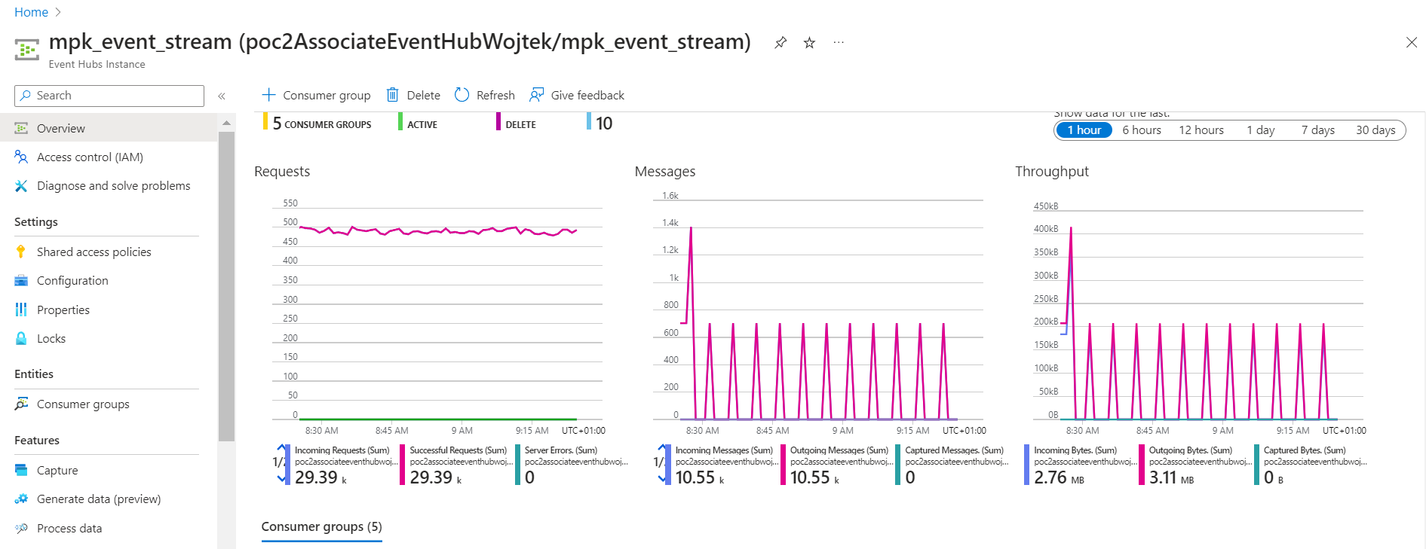

Data published to event Hub

I monitored the streaming job with azure log workspace:

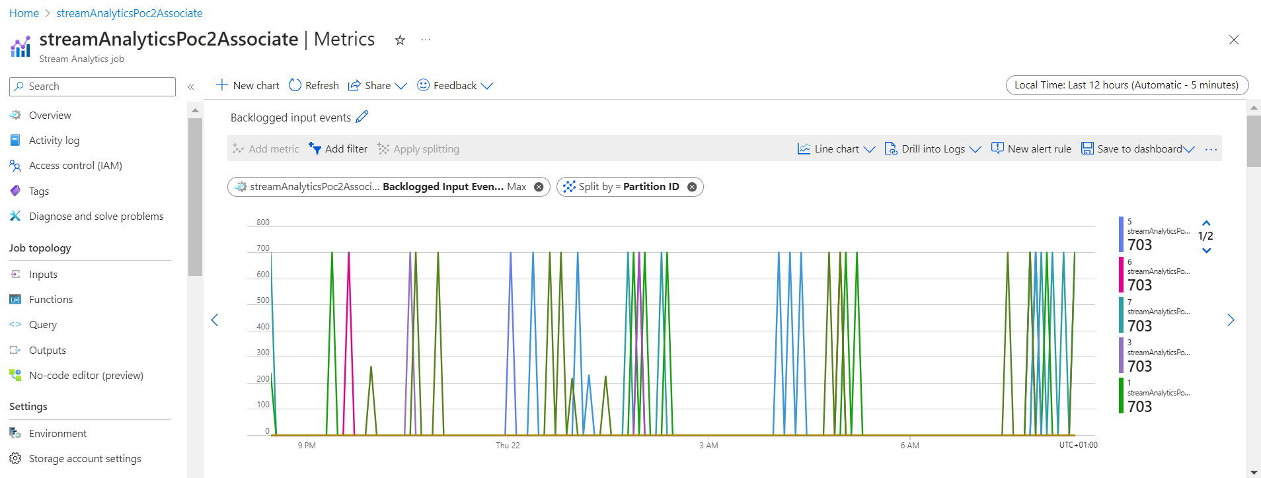

Data snapshot:

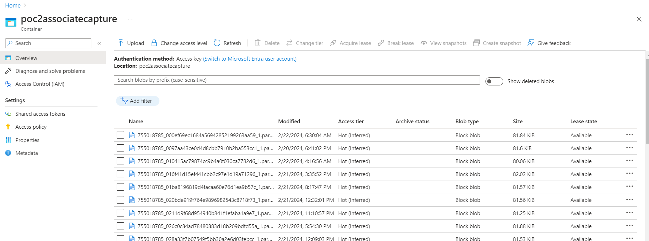

In Databricks notebook data are being streamed into Databricks from Azure event Hub.

Using medallion Architecture data are progressing toward a more refined version

Then from table with redundant data for each batch, an upsert is made into the final table to later calculate speeds, and not overwrite the data

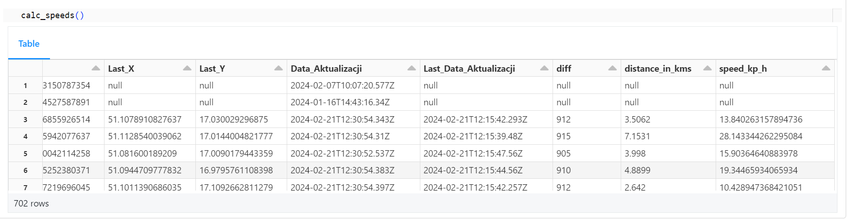

Near real time speed of busses.

In this approach I made this solution work without using delta live tables which is a nice thing