

**Considering the amount of money put in current sea technology, it is worth to investigate and upgrade remote monitoring systems, that can help engineers to protect and maximize the performance of marine machinery.**

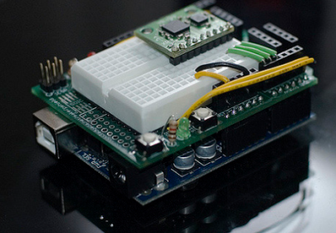As marine technology has become more complex and clients demand more options, measurements and higher precision from their monitoring systems, in order to maximize the performance of many engineering processes. In order to meet the expectations of current market we decided to produce a system of sensors that would be ready to set on ships. Of course there would be a few possible sets of sensors adapted to collect data in specified rooms, every “box” of sensors is prepared to communicate with main module that can display values collected from each room. This workstation monitoring system would be supplied by the passive Power over Ethernet technology. Cost of such solution would be lower comparing to that of current denouement and replacement of each module can be easy and quick.

Set of elements that our main product, ready to implement on every ship, will be build of is presented in *Table 1.* , of course there is a possibility to upgrade system and add other sensors accordingly to the needs of customer.

|  |  |  |
| --- | --- | --- |
| Number | Element ( Chosen accordingly to each monitored room) | Measuring range |
| 1. | Onion omega2 | - |
| 2. | Onion Omega2 Arduino Dock | - |
| 3. | Sensor of humidity DHT 22 | Temperature -40°C ÷ 80°C  Humidity 0 ÷ 100%RH |
| 4. | Phototransistor LIRT5B-870 | Sensivity for wave 870 nm |
| 5. | Ultrasonic Sensor US-015 | Range 2 ÷ 400cm |
| 6. | Accelerometer SparkFun LIS3DH | Adjustable range :  ±2g, ±4g, ±8g, ±16g |
| 8. | DFRobot LCD Keypad Shield | - |
| 9. | Electricity sensor ACS709 | Current ± 75 A |

*Table 1. Set of elements used to build main procuct.*