Xtern Application 2020

FoodieX Dataset Findings

Finding 1: The food types. There is a good variety of food delivered by the listed restaurant. Further analysis is required to confirm whether food type depends on restaurant location / proximity to one another.

Finding 2: Top rated restuarants. The ratings ranged from 2.5 up to 4.8, with some restarants not having a rating.

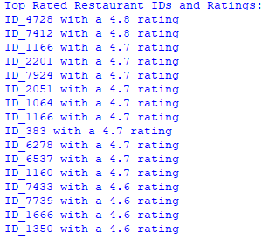

Finding 3: Top voted restaurants. The votes go from 0 to 9054.

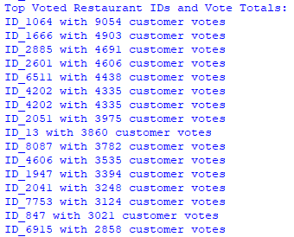

Finding 4: The geolocations of the restaurant geolocations seems to be random, but they can be clustered into regions based on their proximity and density.

Future Suggestions:

1. Gather data and determine the possible relationship between food frequency and their geolocations.
2. Determine relationship between rating, customer votes, and reviews.
3. Use excel or prewritten libraries (or whatever is most convenient) to cluster restaurants into regions.

Note from author. Done in 70 minutes.