POLITECHNIKA POZNAŃSKA – POZNAŃ UNIVERSITY OF TECHNOLOGY

Wydział Informatyki i Telekomunikacji – Faculty of Computing and Telecommunications

**Computer Aided Design**

*Project Task: Analyze a Quartz Oscillator Circuit*

AUTHOR

Wojciech Rościszewski Wojtanowski, Index No. 140062

SUPERVISOR

Dr. Eng. Sławomir Michalak

Poznań, 2021.

# **Copyright**

Copyright © Wojciech Rościszewski Wojtanowski, 2021

All rights reserved.



**_____________________**

Wojciech Rościszewski Wojtanowski

140062

# **Abstract**

For the purpose of this project we shall simulate a given circuit. The values of certain elements are given and have been chosen to best present the operation of our circuit system as well as the process of operation including temperature elements and all else. Therefore, given are suitable known analyzes as well as simulations of chosen circuit including the modifications of one model parameters.

# **Table of Contents**

**1.** **Copyright** 2

**2.** **Abstract** 3

**3.** **Table of Contents** 4

**4.** **List of Tables and Figures** 5

**5.** **Introduction** 6

**6.** **LTSPICE Simulation** 8

**7.** **Conclusion** 25

# **List of Tables and Figures**

Figure 1 Wide-Range Oscillator Circuit Design. 6

Figure 2 LTSPICE Oscillator Circuit with Quartz Element. 8

Figure 3 LTSPICE Result of XTAL Analysis. 9

Figure 4 LTSPICE Result of XTAL Analysis Zoomed In. 9

Figure 5 LTSPICE Quartz Crystal Equivalent Circuit. 10

Figure 6 LTSPICE Measured Amplitude Response of a Quartz Crystal Equivalent Circuit. 10

Figure 7 LTSPICE Wide range oscillator with Equivalent Circuit. 11

Figure 8 LTSPICE Result from Wide range oscillator with Equivalent Circuit. 11

Figure 9 10 LTSPICE Wide range oscillator with CS capacitance change. 12

Figure 11 +/-20% output waveform. 12

Figure 12 Source: https://www.electronics-tutorials.ws/oscillator/crystal.html. 13

Figure 13 LTSPICE Wide range oscillator with CS Temperature Change. 13

Figure 14 Temperature Change Results – Interesting. 13

Figure 15 LTSPICE Wide range oscillator with R3 parameter change (20%). 14

Figure 16 Output characteristic of +/- 20% change. 14

Figure 17 LTSPICE Wide range oscillator with R3 parameter change (5%). 15

Figure 18 Output characteristic of +/- 5% change. 15

Figure 19 LTSPICE Wide range oscillator with R3 parameter change (5%) with TEMP. 15

Figure 20 Output characteristic of parameter change with temp change. 16

Figure 21 WC Analysis. 16

Figure 22 Output Waveform. 16

Figure 23 Original waveform of our generator at minimal values. 17

Figure 24 Beta value parameter step. 17

Figure 25 Transistor Value Change. 18

Figure 26 MULTISIM equivalent circuit. 19

Figure 27 Measured Amplitude Response of a Quartz Crystal Equivalent Circuit. 19

Figure 28 LTSPICE Result of XTAL Analysis Zoomed In. 20

Figure 29 Circuit design. 20

Figure 30 Oscilloscope Window. 21

Figure 31 More accurate waveform from oscilloscope. 21

Figure 32 CS Parametric. 21

Figure 33 Capacitor CS results. 22

Figure 34 R3 Parametric (+/- 5%). 22

Figure 35 Output waveform issue. 23

Figure 36 Slight Correction for Temperature Sweep on Resistor R3. 23

Figure 37 WC Output. 24

Figure 38 Beta value change, 316, 416 (original), 516. 24

Figure 39 Zoomed in version. 25

# **Introduction**

For the system with the following schema, design the receiving and broadcasting system by selecting the appropriate active and passive elements from the defined group of components.

For the following simulations I will simulate the given circuit in Figure 1. This is an oscillator circuit that uses two transistors, according to specification it should be operational with any 50kHz to 10MHz series resonant crystals, therefore we will design our resonant quartz crystal which will enable the operation of this circuit. Note, I will conduct in fact two projects in one where I will conduct the analysis of the behavior of our resonant quartz crystal under necessary testing methods as well as substituting the circuit into our oscillator design where we will test the effects of the same parameters.

I will now briefly conduct my visual analysis of the circuit and expand on the wiring demonstrated of the Figure 1. We see firstly the Q2 resistor, here we see an emitter follower design else known common collector amplifier it is a basic BJT amplifier. In this particular combination we see that from Q2 emitter leg is the output signal that is being lead back towards the input of the Q1 emitter, see the wire with the capacitor (C2) and we see that this signal also quite clearly travels into our (XTAL) Quarts crystal series-resonant crystal element. We then see that the Q1 transistor is then wired in such manner that the circuit from that loop has a common base – therefore, we can say that this is a common base amplifier.

To conclude: we have a common base amplifier, a common collector / emitter follower and a resonant quartzcrystal design.

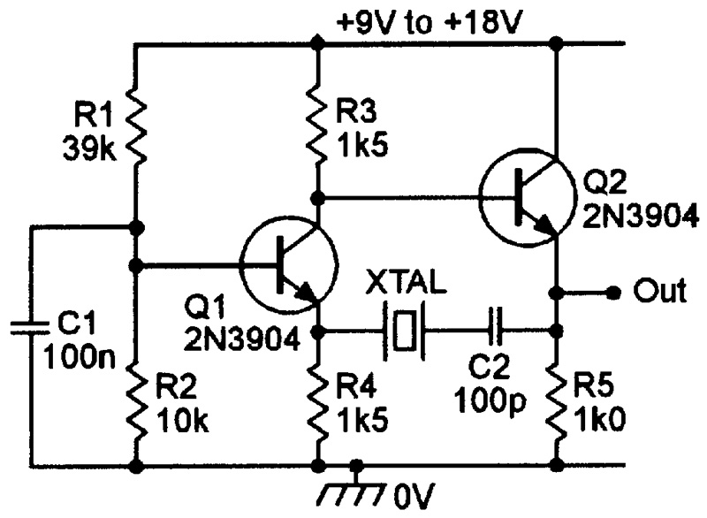

Figure Wide-Range Oscillator Circuit Design.

Therefore, knowing all of these necessary combinations of details we are able to connect the dots and perform our calculations. Not exactly, because we firstly need to describe our parameters. To have some consistency throughout this project an equivalent circuit of the quartz crystal will be made, these please see the drawing below presenting the mentioned equivalent circuit that will be used throughout this entire project in our wide-range oscillator circuit design.

As it can be quite clearly noticed in the drawing (figure 2), we see that the “quartz crystal” will have a series resonance (see, Cs and Ls) as well as our parallel resonance. We will later perform a frequency sweep (AC Analysis) in order to see how our circuit really works and how in more advance it performs, therefore we will be able to test-fix if our calculations have been correct. But firstly, we need to know the values of R, Cs, Ls and Cp. Please note that one calculation for all won’t be enough.

In the below please see in detail the variables used as well as their descriptions:

* Cp – Holder Capacitance,
* Fs – Series Resonance Frequency,
* Fp- Parallel Resonance Frequency,
* R – dynamic losses.

I would like to achieve a 4MHz resonating crystal element, therefore for this case I will select fs to be 4MHz.

# **LTSPICE Simulation**

For the purpose of this project we will use necessary tools in this case our LTSPICE environment in order to perform our simulation. The goal here is to generate as much sufficient data from the program to see deeper into our phenomenon, in this case with the use of the LTSPICE system it is possible to set different parameters and experiment with our circuit design.

To begin conduction analysis of my parameters I firstly remake the entire circuit in LTSPICE environment, as seen in the figure below I have designed an almost identical system as presented in our original circuit (Figure 1 for reference). Please notice that this is not exactly our circuit since we are using a predefined symbol of our XTAL quartz resonating crystal. I have made the following circuit only in attempts to see how the system should behave ideally. Parameters used to conduct this circuit can be found in the below. I have also found that this circuit is quite limited as it can only operate between ideally the ranges of 50kHz and 10MHz, however this will be discussed later.

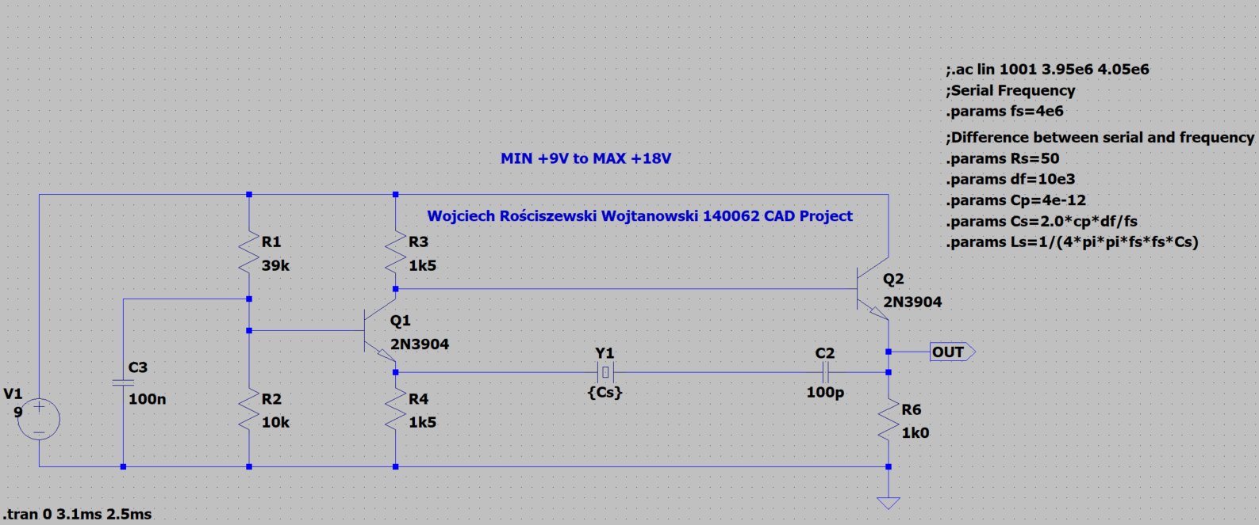

Figure LTSPICE Oscillator Circuit with Quartz Element.

As seen the circuit has been constructed. Below I have included the following formulas which enabled me to calculate the ideal parameters that I will need for my quartz crystal to operate. I have had many tries at this I must say, however I think I’ve found that the higher the value results in poorer results whereas too little isn’t very sufficient so it was quite a challenge to find some ideal “in between” values that can be sufficient enough for this simulation to be demonstrated as accurately as possible. Please refer to the calculations from the introduction stage of this project.

In the figure below please see a graph presenting the output waveform of the entire system, this analysis has been conducted in the time domain and we see that the oscillator is oscillating between 9.3V to 3V.

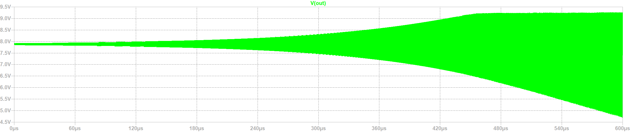

Figure LTSPICE Result of XTAL Analysis.

In the figure below please see the output waveform just zoomed in. We see that the sinusoidal signal is generated successfully (note that no other sources except from a DC voltage has been inserted into the simulation).

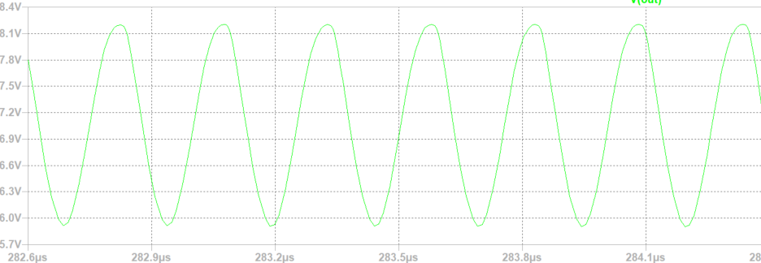

Figure LTSPICE Result of XTAL Analysis Zoomed In.

In the figure below please see my design of the equivalent circuit from the introduction sections, however with significant modifications so that it is operational within out simulation environment. I have performed frequency analysis (AC Analysis) in order to present the characteristic of the operation of our designed quartz crystal equivalent circuit. Below we see the resistors that are 50 ohm, we add this as in real life we would have some cables right, so this is the resistance of the cables in our system. However, this will not be used later in our project.

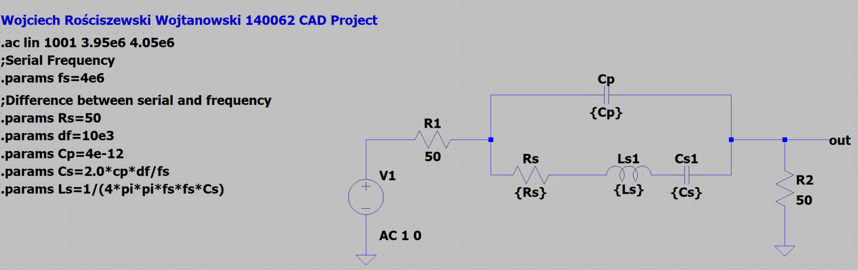

Figure LTSPICE Quartz Crystal Equivalent Circuit.

In the figure below please see the output waveform of our signal, this is the frequency analysis as mentioned in the point above. To add some overall description this is our series / parallel resonance frequency of our resonating oscillator circuit. So how does this phenomenon occur? Well the first peak (going up) is the series resonance of our frequency as this is the connection between the voltage source (here we have 1V of alternating current AC) and the load. So the maximum amplitude is our first peak, this is our fs (so Ls = Cs). The minimum amplitude (second peak doing down) is our fp (so for Ls, Cs, Cp). In short, this is our fundamental mode. All other frequencies that are generated in the example above and quite possibly in our application in the main circuit we should see some spurious frequencies that might affect how the waveform looks like however should be minimal since our amplifier is tuned between a range of parameters, this will be overviewed later.

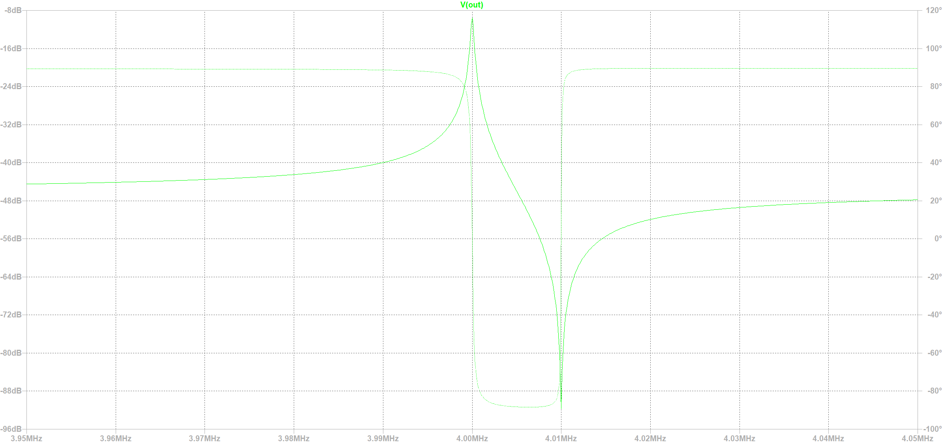

Figure LTSPICE Measured Amplitude Response of a Quartz Crystal Equivalent Circuit.

In the below please see our wide range oscillator circuit but with the minor difference with the insertion of our equivalent circuit. There is nothing much to describe, we know the minimal and maximal values therefore I apply here the voltage of 10V to fit within the range, I don’t really want to go over the top since the number of oscillations are dependent on this.

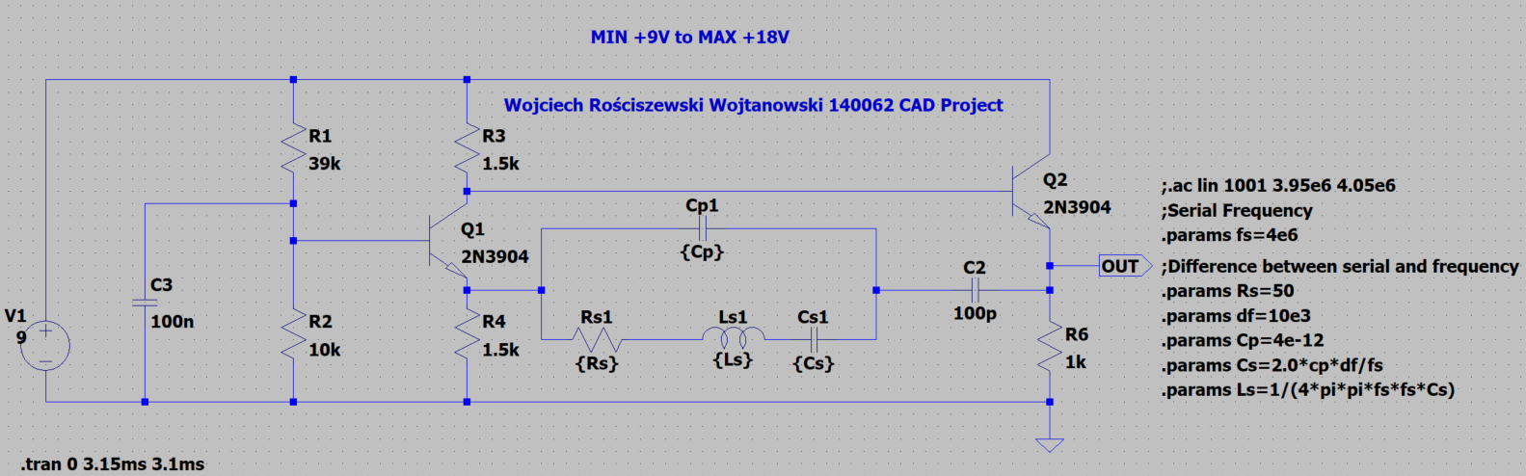

Figure LTSPICE Wide range oscillator with Equivalent Circuit.

In the below please see our output waveform, our results seem to be correct as the values are limited between 9.3V to 3.0V therefore this is ideally the same as the first assumption of our circuit hence why we can say that this circuit has been redesigned successfully. From this we can now carry on and perform various parameter changes and asses the performance of our circuit. Please notice that our signal is oversteered, and the sinusoidal shape is looking more like a square wave, I suspect that the culprit for this issue is the resistor R3 however more on this below.

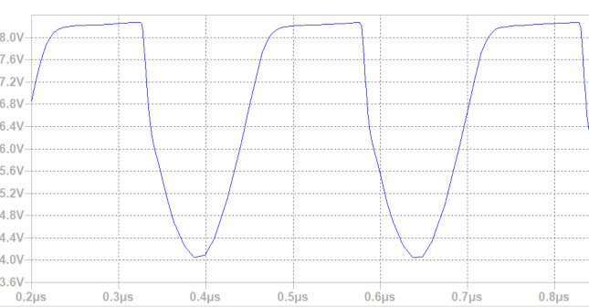

Figure LTSPICE Result from Wide range oscillator with Equivalent Circuit.

We will now follow up on our previous experiments in the laboratory and perform some parametric analysis on some of our components. Firstly, because we have this other circuit inside our “main” circuit I will present how the equivalent quartz crystal oscillator behaves and then I will move onto our main circuit of the generating oscillator. The first component I would like to analysis is the capacitor CS with the capacitance of 20fF.

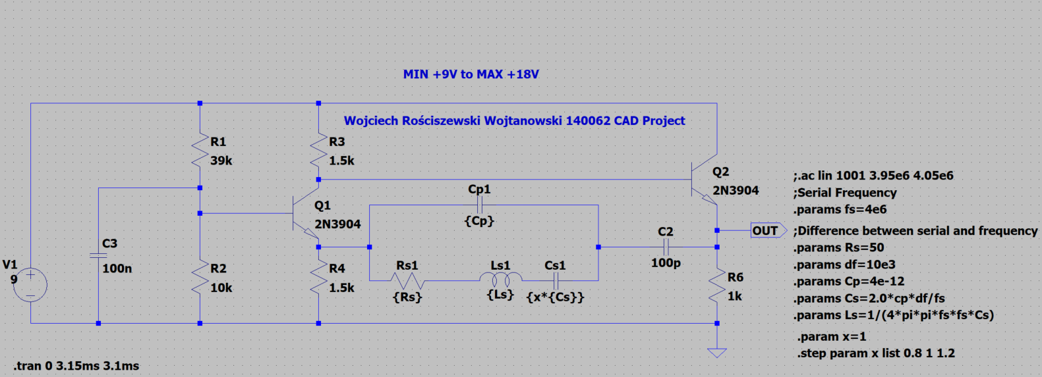

Figure LTSPICE Wide range oscillator with CS capacitance change.

Therefore, we will firstly swing our values +/- 20% of our CS capacitor, in the equivalent quartz crystal circuit and we will see how the generator behaves. I will do this using the param command and my affecting the value of the capacitor directly. Please see in the below how I have modified my circuit in order to do this analysis.

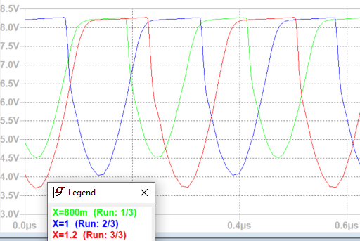

Figure +/-20% output waveform.

From the above we see that if we shift the values by +/- 20% the output oscillations change. Allow me to explain why this is the case. What really changes is the parallel resonance, notice that the falling edge of our waveform is in fact changed, see that if we increase the capacitance by 20% the waveform changes into a longer shape whilst for a decrease of 20% the waveform peak is reduced in length. More on this allow be to explain the rest in the figure below:

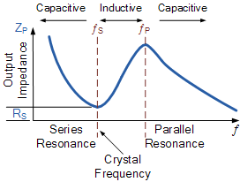

Figure Source: <https://www.electronics-tutorials.ws/oscillator/crystal.html>.

I have then moved on and I wanted to see how the capacitor behaves under the influence of temperature change. Please see the circuit below where I adjusted for this to work. I have used room temperature of 27 degrees as our base, but just added and taken away +/- 27 degrees Celsius to make our simulation more “realistic”.

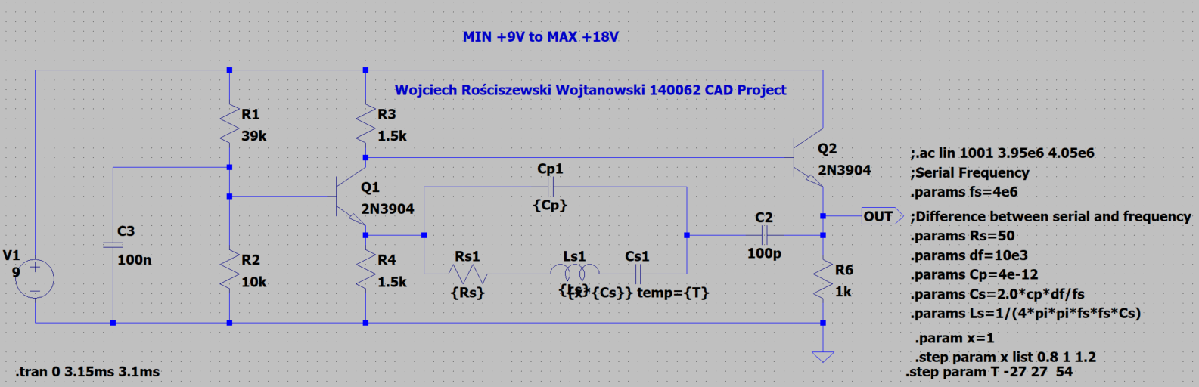

Figure LTSPICE Wide range oscillator with CS Temperature Change.

In the below please see the results, from the perspective of amplitude the waveform is similar however it is definitely shifted to the right, so please notice how the gaps between each time waveform dips for example between 1 – 1.7 micro seconds we see that the waveform is continuously shifting as the three waveforms are of course not in phase with each other but we see that they get very close to each other.

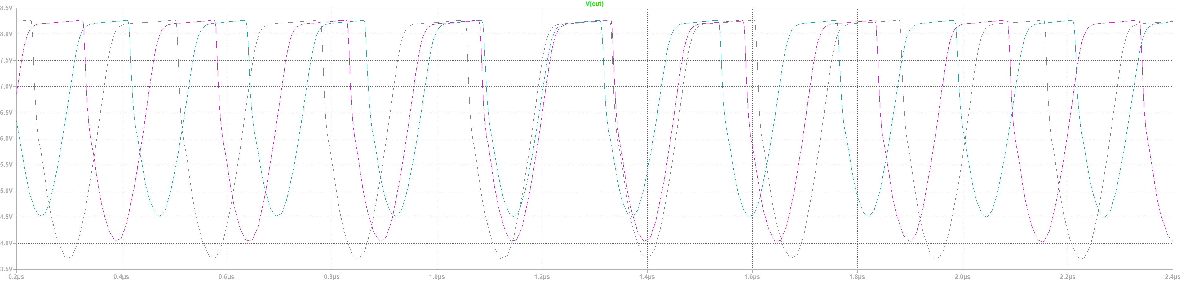

Figure Temperature Change Results – Interesting.

For the next part of our project I’ll complete the similar analysis and will manipulate the resistive element R3 for example and see how to circuit is affected. I have found that the resistor R3 is very sensitive to our generator. Firstly, please see the small modifications made to our circuit similarly as to before however it is best practice to document every step.

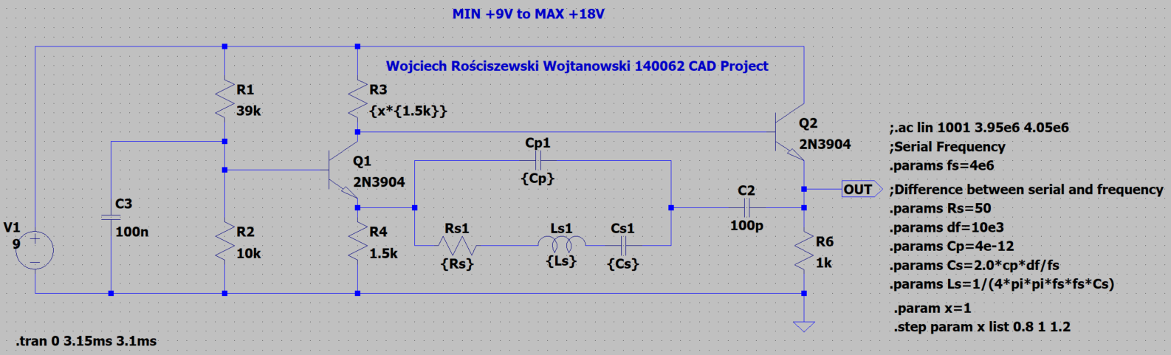

Figure LTSPICE Wide range oscillator with R3 parameter change (20%).

In the below please see the output waveform, as we see the resistor influences the circuit greatly as it is going straight into the collector of our main transistor. We can experiment on that transistor later for example change its beta and see how the circuit behaves under those changes and how vital that part of the circuit is. Below the waveform cannot be really used but I have presented that we cannot use the difference of +/- 20% like before as our results are not very clear for example for -20% we see that the green line is almost straight, chaining but we can only assume that here the values are so small that might seem that the generator is in fact not generating our oscillations. Whilst if the value is +20% the generator has errors in its oscillations so values in this resistive element are very vital for the correct performance of our circuit.

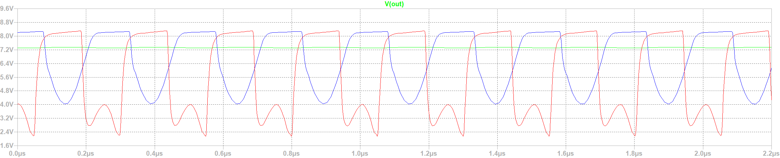

Figure Output characteristic of +/- 20% change.

In the circuit below I have modified the previous circuit but only changed the parameter that affects the resistor by 15% less, so 5% change of original value is conducted in our simulations since even 10% is too large before we can actually take some significant results/outcomes of our simulation.

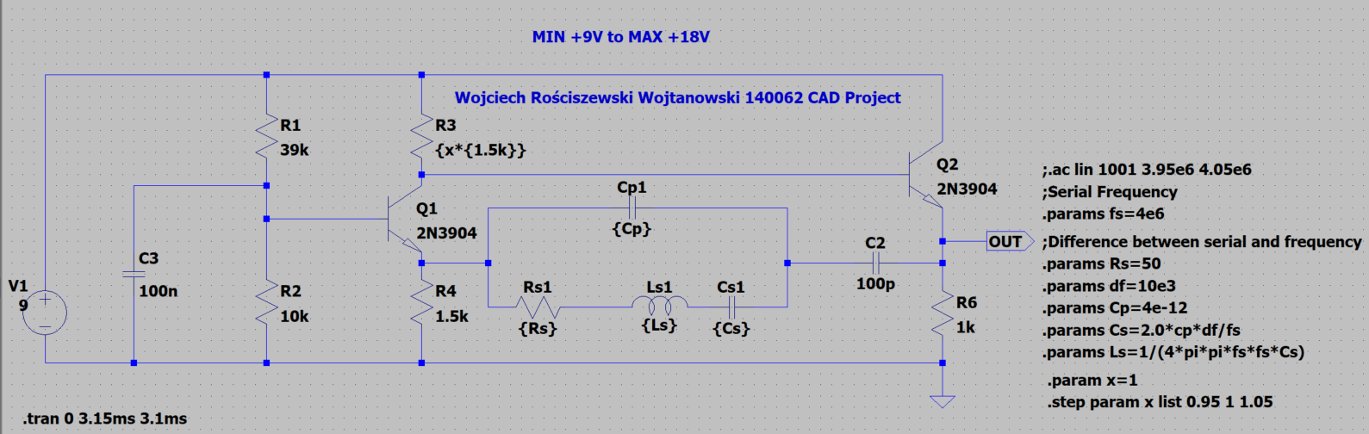

Figure LTSPICE Wide range oscillator with R3 parameter change (5%).

Below please see the resulting waveform characteristic of our circuit we see that the waveform is also shifted and is dependent on the resistance of our R3 component.

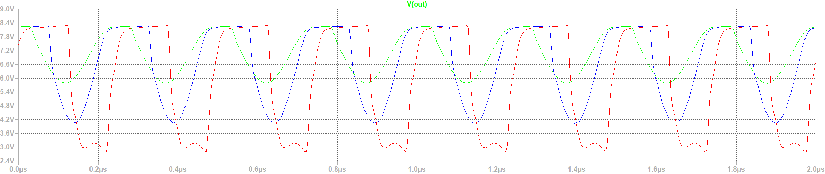

Figure Output characteristic of +/- 5% change.

Below please see my circuit with the temperature change on our resistor R3.

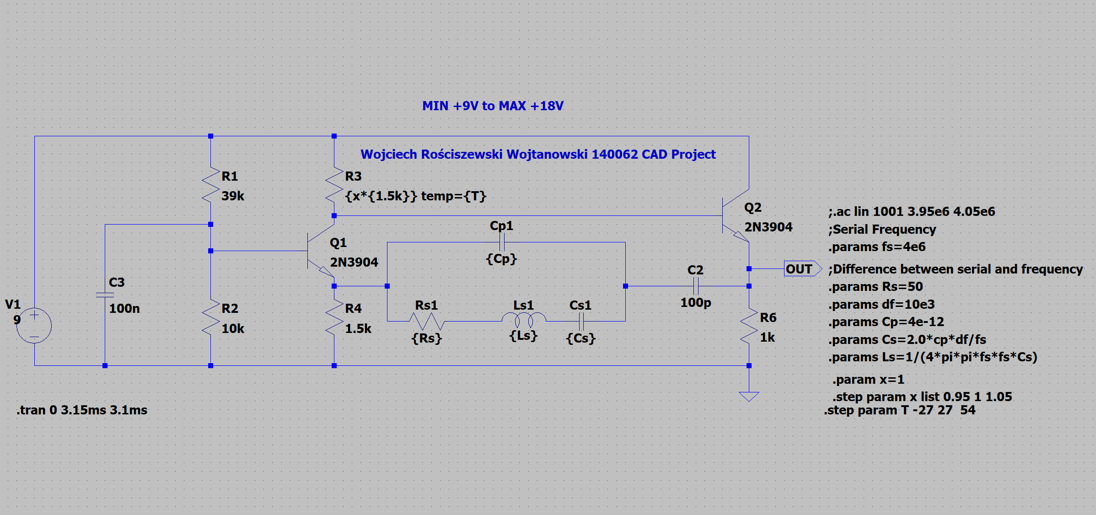

Figure LTSPICE Wide range oscillator with R3 parameter change (5%) with TEMP.

Below please see the similar effect that we have noticed with the capacitor temp change, the amplitude doesn’t change however the waveform is shifted therefore we can say that the periods of our waveforms or i.e. our oscillations change and by doing so I suspect that we can replace that resistor with a potentiometer so we can calibrate our oscillations to our desired state, however this is just my theory and might vary from reality. But in our simulation, we really see that the temperature brings out minimal effects to this particular component.

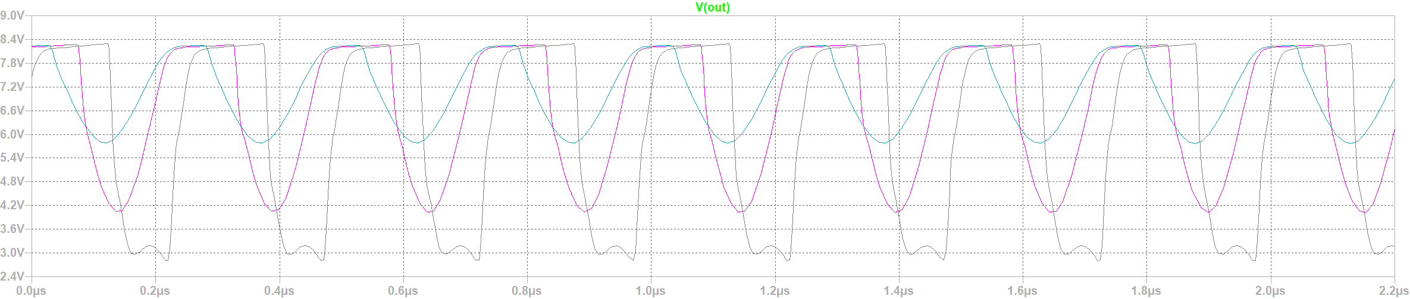

Figure Output characteristic of parameter change with temp change.

For the last but not least stage of our R3 component I would like to perform worse case analysis so we can see how the resistor behaves. Below please see my circuit with the WC application.

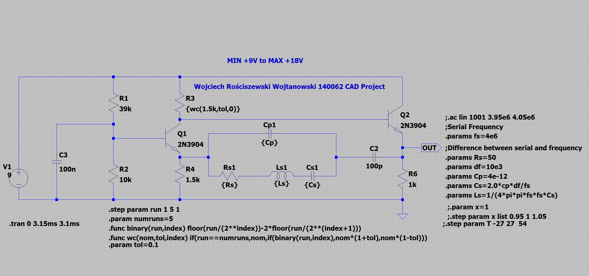

Figure WC Analysis.

Below please see the output characteristic of our WC analysis. Through this analysis we have actually successfully identified a very critical component in our circuit that effects the performance of our generator. For some it barely generates oscillations whilst for other it generates oscillations with an error! Therefore, we see that the component value is literally pushed to the limits of the assigned tolerance 0.1 and we see that the worst limits are visible in the characteristic. So we almost have this visible boundary of what we really want in fact, we either have the minimum, the maximum or the threshold differences and as a result tells us a lot about how sensitive this generator really is.

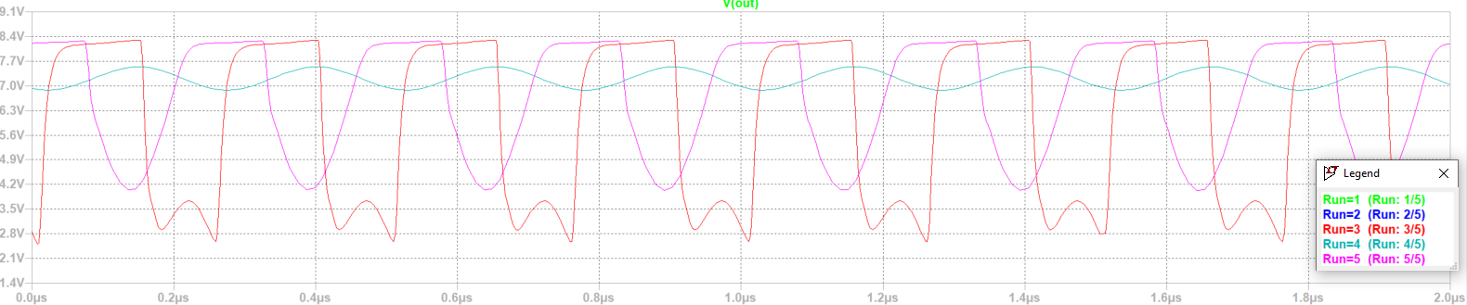

Figure Output Waveform.

Finally, we’ve reached the final stage of our project in LTSPICE. Now I intend to change the beta value of our transistor Q1 as I’ve promised previously.

Before I make any changes below please see the reference characteristic of our standard transistor on the output.

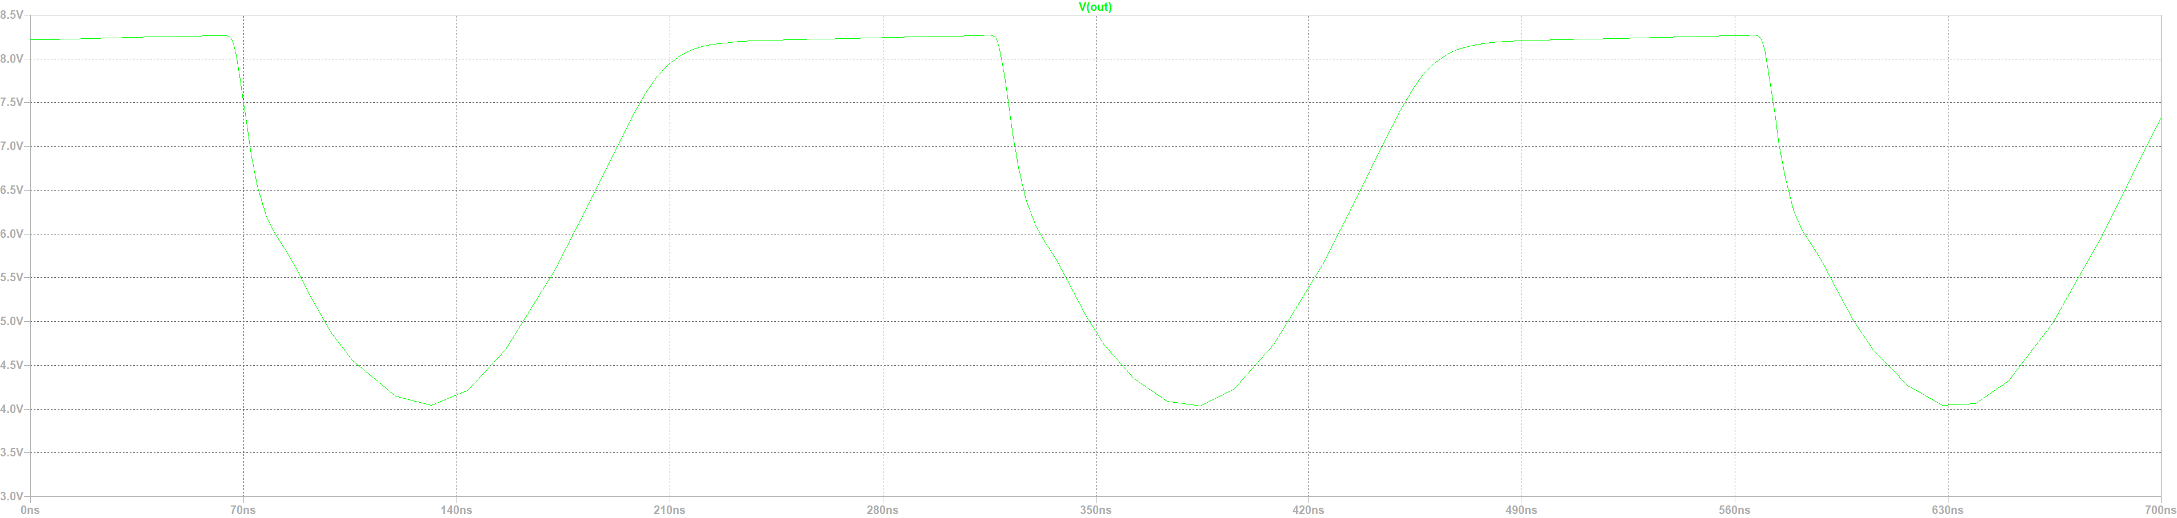

Figure Original waveform of our generator at minimal values.

Notice that in the characteristic the sinusoid isn’t really straight this is because the generator overshoots and we have an over steer of our signal. This was visible in the first demonstration with this equivalent circuit however not as much zoomed in up close.

In the below please find the modified circuit with the .model setting where I will step through different beta values and gather results from that.

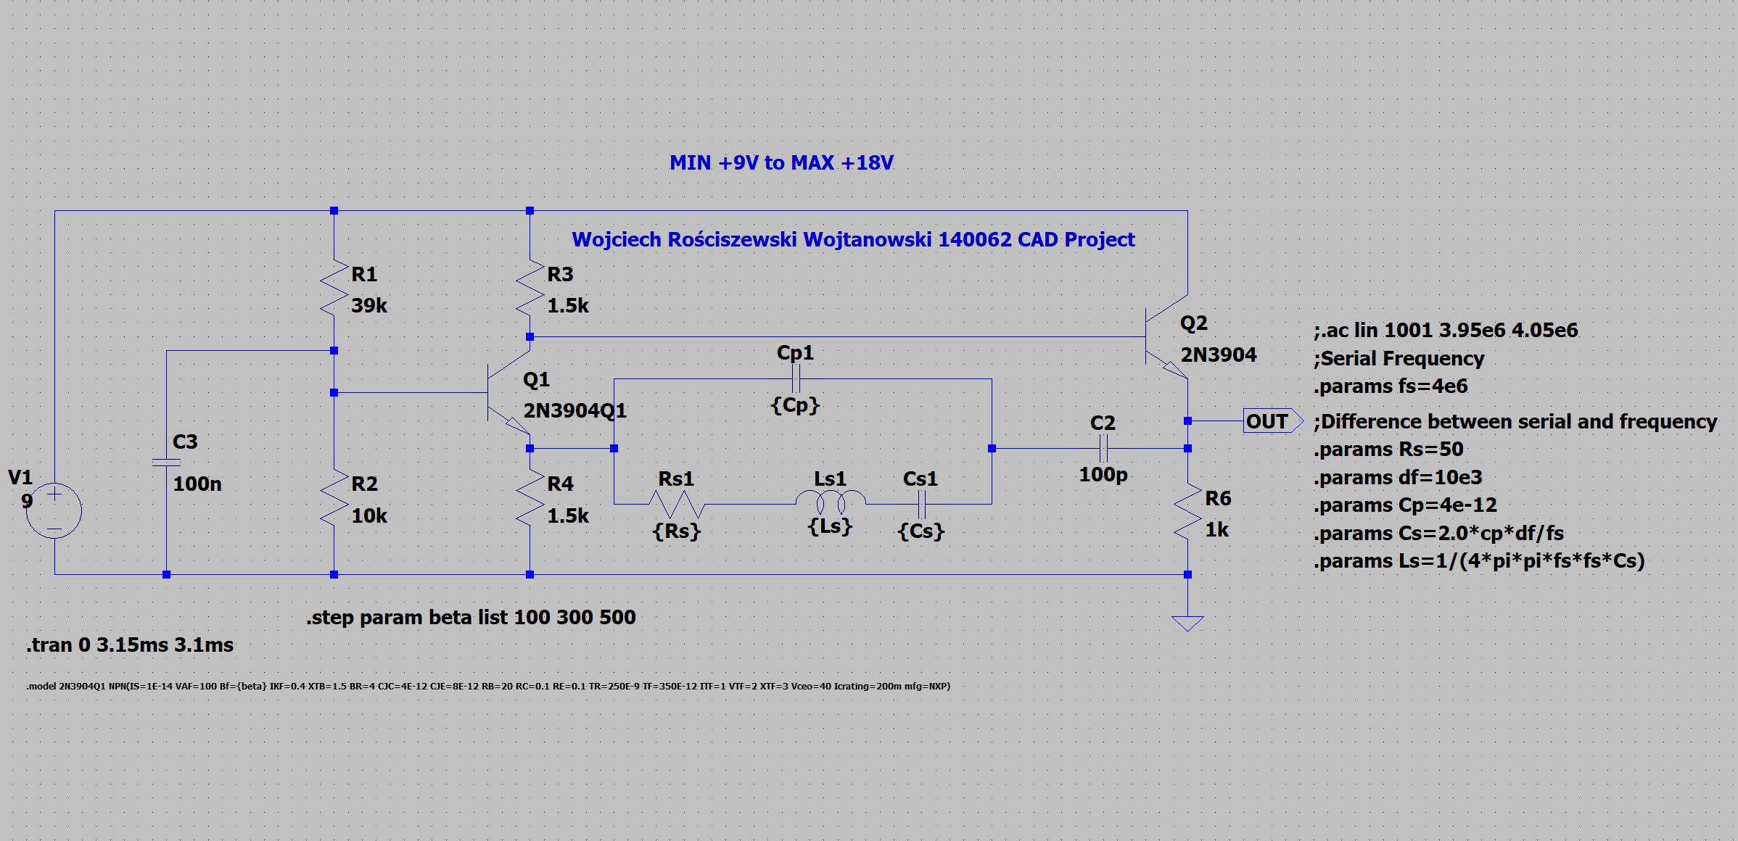

Figure Beta value parameter step.

In the below please see the output of this change and we can see how the change of our transistor beta value will affect our output characteristic. Please notice that the blue waveform represents the original value of our beta of that transistor being in fact 300. However, if we manipulate the circuit, we can see that the oscillations shift accordingly to the beta change of our transistor. What we will see in fact is that the collector current will be changed accordingly to Ib*beta where Ib is the base current. Therefore this is our result, so if the ratio is decreased in value we see that the waveform oscillation shifts to the right however the output is still the same as before so we see only shift, the order just changes whilst magnitude is the same.

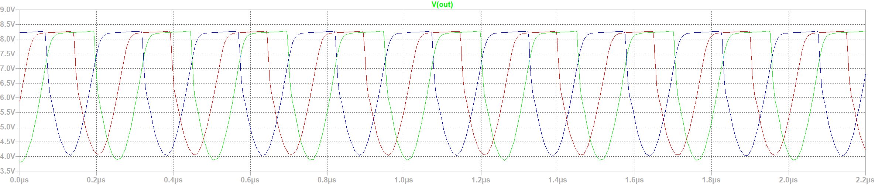

Figure Transistor Value Change.

In conclusion we see some differences, we see that the BJT behavior really does influence the entire system operation, and simply the oscillator oscillates at different times. If we look closely, we can even see that some parts of our waveforms are not identical, they’ve become somewhat distorted.

**MULTISIM Simulation**

For this part of the project we’ll conduct similar test just as in LTSPICE program above. We will analyze the same circuit system of our wide-band oscillator circuit.

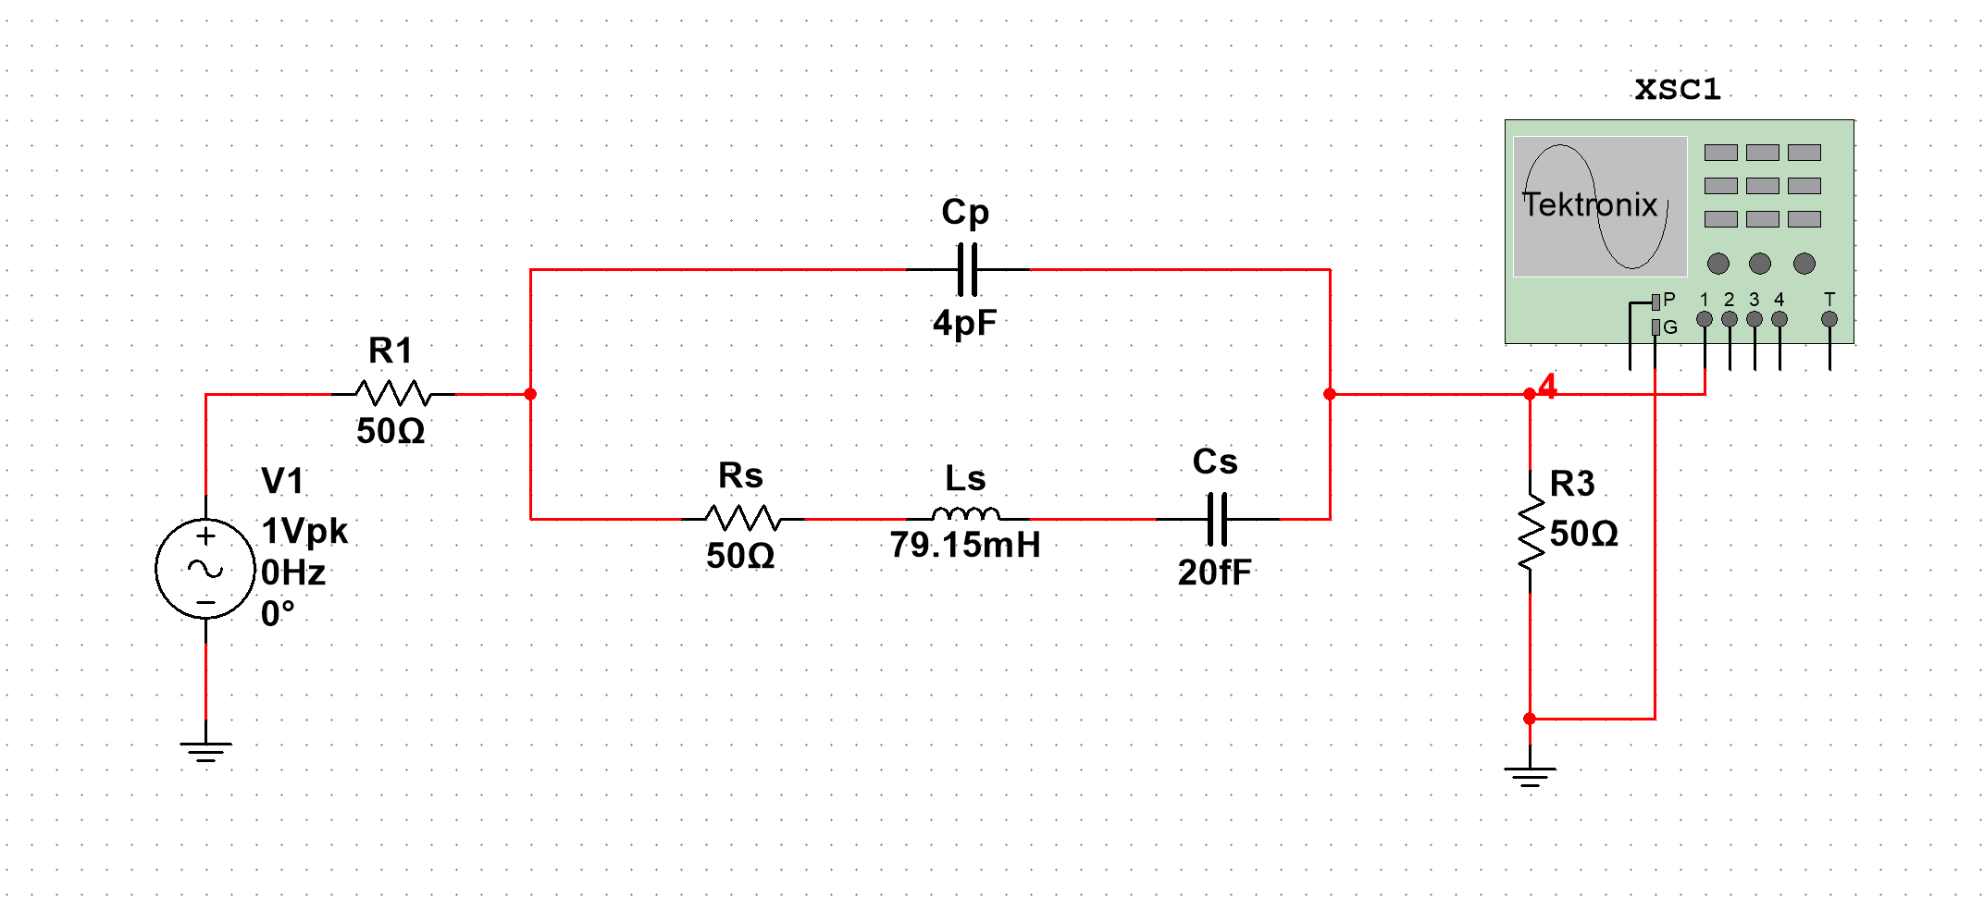

Figure MULTISIM equivalent circuit.

I will avoid describing everything in vast amounts of detail as we in fact did this in SPICE simulations and since MULTISIM and MICROCAP are using LTSPICE engine then we do not have to worry about anything, so to show this I will be comparing step by step the results and see if we in fact have any differences. The goal is to have the same.

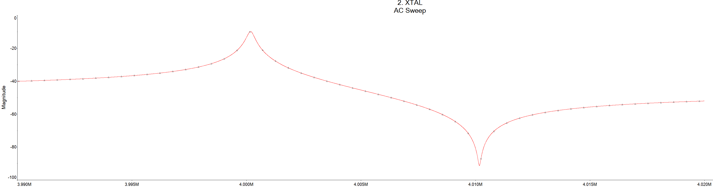

Figure Measured Amplitude Response of a Quartz Crystal Equivalent Circuit.

In the above please see that we have the same characteristic as in LTSPICE, I will reference this as “same as before”. Since we have the same as before we can only assume that our equivalent circuit is working correctly in the Multisim environment and we can transfer it onto our main circuit. Below please see the transient analysis of our circuit, we see that a sinusoidal shape is correctly generated in our analysis. However, this isn’t from our generator yet!

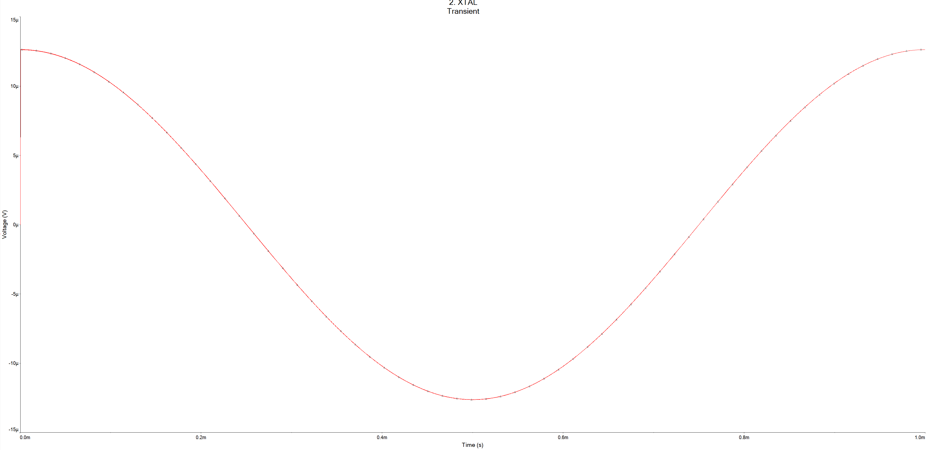

Figure LTSPICE Result of XTAL Analysis Zoomed In.

In the below please see the equivalent circuit, we see I have connected an oscilloscope and the oscillator works but the waveform is too compressed however it does work similarly as on LTSPICE.

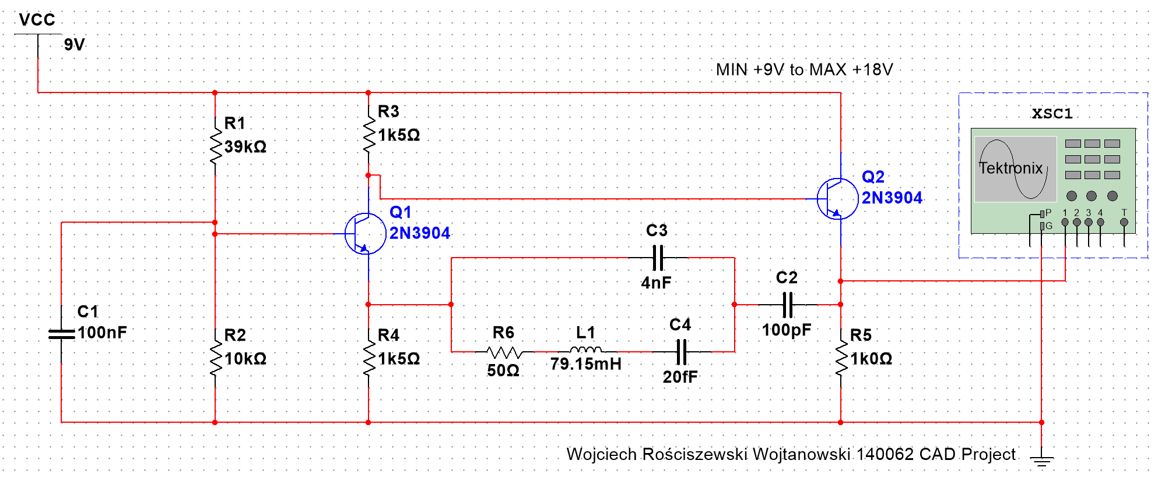

Figure Circuit design.

Therefore, since we cannot really tell much from the figure above, I have prepared a closer copy of the same waveforms of our circuit. Below please see that we have the same waveform as in LTSPICE. Below please see the waveforms from oscilloscope and transient analysis.

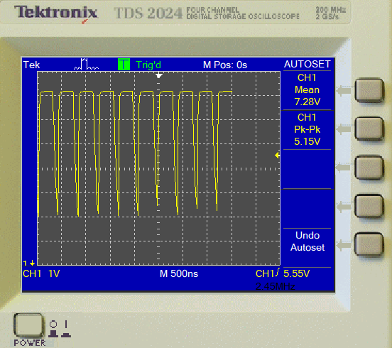

Figure Oscilloscope Window.

Figure More accurate waveform from oscilloscope.

In the below please see a +/-5% parameter sweep of our CS capacitor, in this case C4. The characteristic is very similar to the one from LTSPICE, we see the same unique parts where the signal shifts and the amplitude does not change.

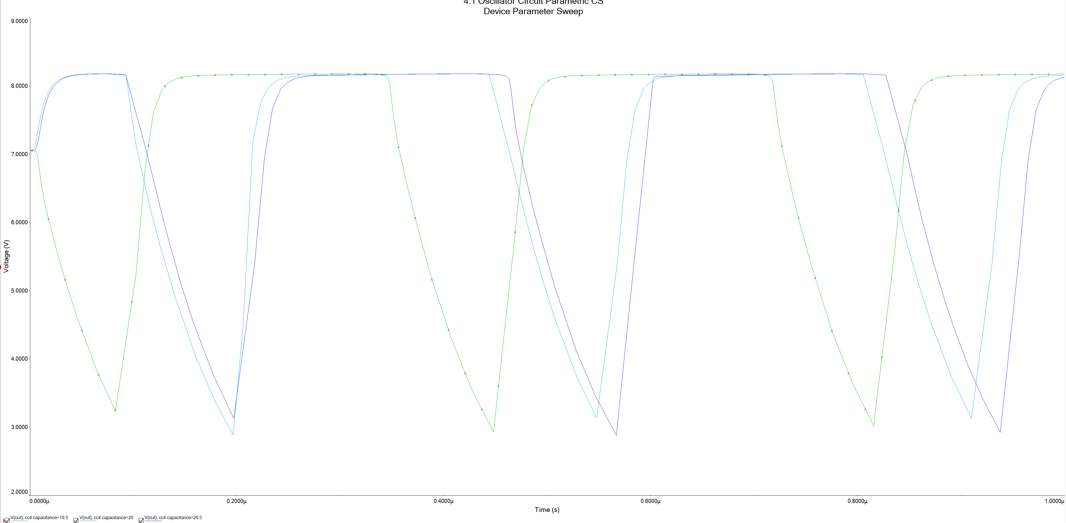

Figure CS Parametric.

For the next part we will conduct the temperature analysis, of our CS capacitor. I suspect that the values must also be the same as for LTSPICE. Below please see the results of this analysis.

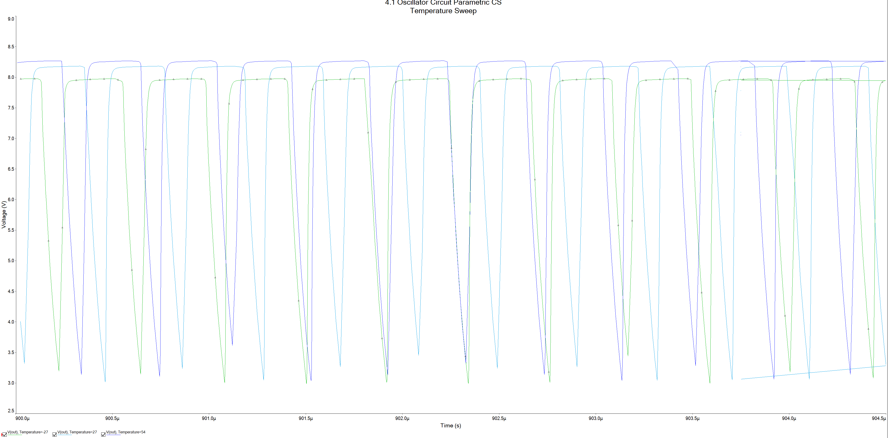

Figure Capacitor CS results.

The capacitor temperature sweep isn’t the same as Multisim exactly, however this could have been caused with me selecting the incorrect sweep settings. Anyhow for the next step in our project I will conduct analysis on the R3 resistor below please find the results of the analysis where we have changed the values of the resistor by ONLY +/- 5%.

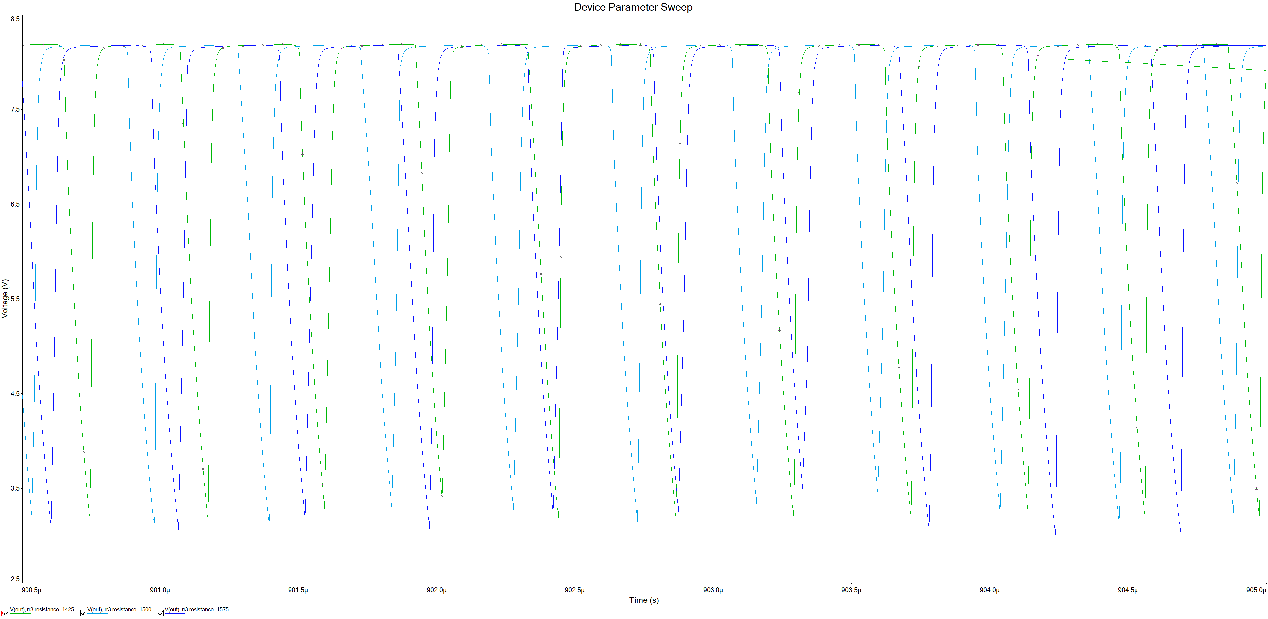

Figure R3 Parametric (+/- 5%).

In the above please see the results of the R3 resistor change of +/- 5% in resistive value, we see that this output is correct and matches what we have in LTSPICE. We can move forward and perform similarly as before the parametric test but on the R3 resistor and see how temperature affects the performance of our resistor.

In the below please see the next phase of our analysis where I test the effects of temperature on our circuit output. The below characteristic clearly demonstrates this.

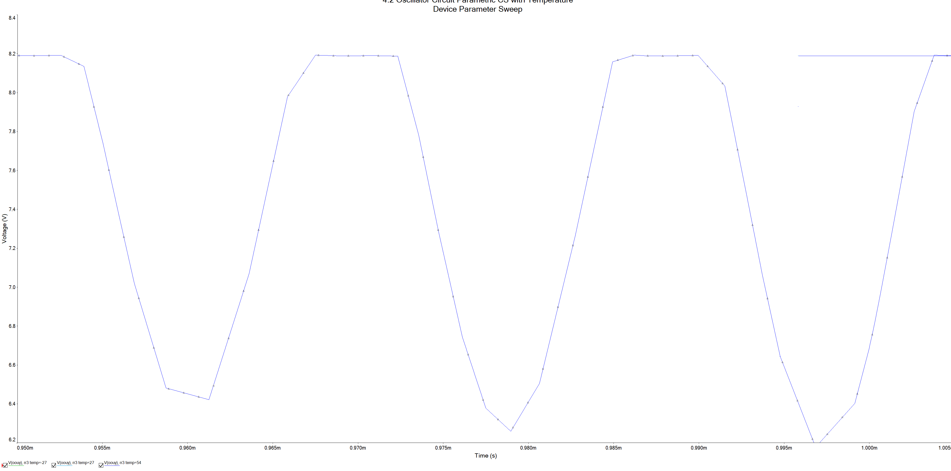

Figure Output waveform issue.

We can see that the three waveforms overlap each other meaning that the step command did not work as planned. However, I have modified the simulation analysis to almost force the temperature sweep to be done however it did not go as planned and predicted as the shift is occurring but also the amplitude changes, we did not have this before! Therefore, this is my remark that we have a small difference in the simulation methods or it is simply my mistake however I hope with the attached files it is possible to correct this simulation method of analysis in a parametric temperature sweep.

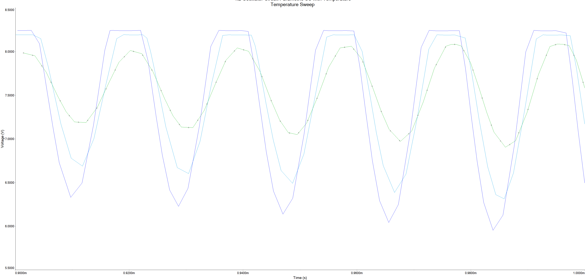

Figure Slight Correction for Temperature Sweep on Resistor R3.

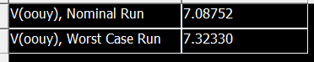

Figure WC Output.

This is my output of the worst case run. As we can see, it is different as the simulation method is different as I only has a DC setting which didn’t enable much in terms of options and AC analysis which of course isn’t what we need as we want to see the circuits behavior. Other than that, we have had no other waveforms in terms of magnitude spectrum, and I cannot really deliver it since Multisim is not providing this for me.

For the next part of our analysis I will conduct our final test of changing our beta value of our Q1 transistor in our generator circuit. Below please find the aftermath results of this and we can compare if it is the same as in LTSPICE.

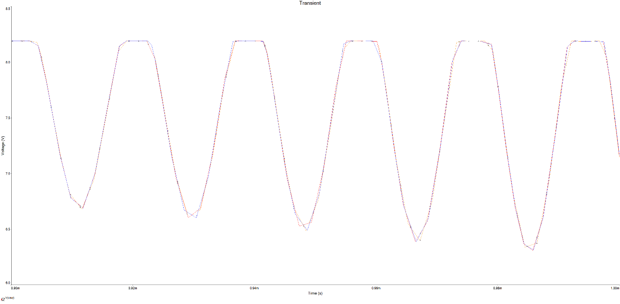

Figure Beta value change, 316, 416 (original), 516.

Since it isn’t very clear I have decided to zoom in on the waveform therefore below please see another figure. The red waveform represents the beta ratio value of 316, the blue represents 416 which is the original beta value of our transistor and last is our orange color which represents the 516 beta value.

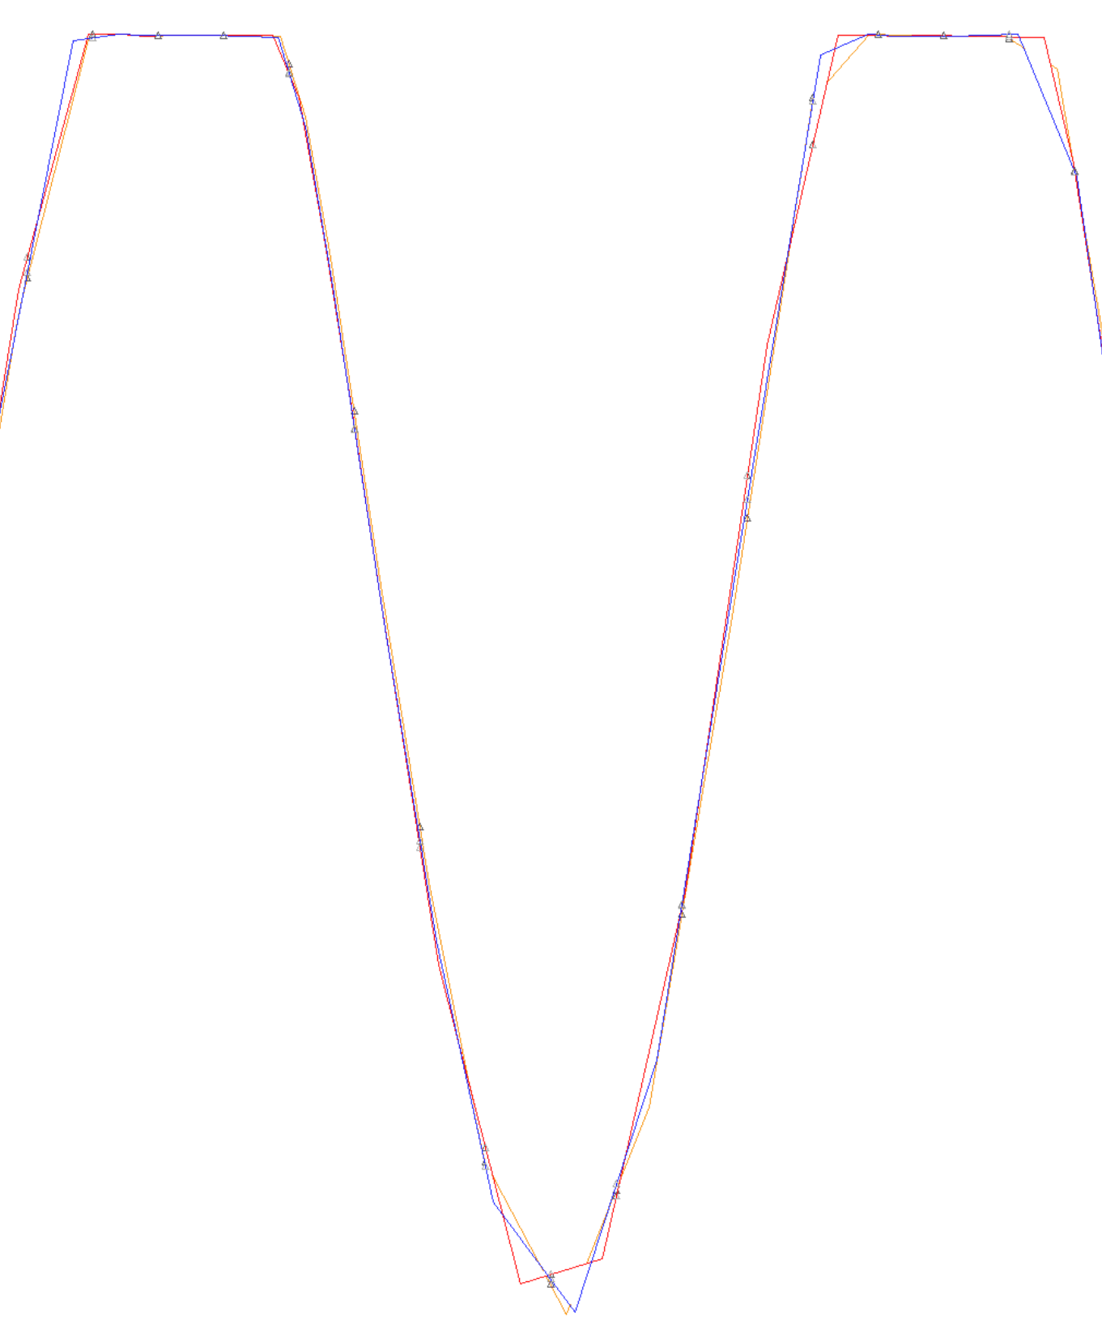

Figure Zoomed in version.

As we can quite clearly see the values of our signal shape change, the waveform seems to be transformed and in fact this is the same result that we have seen in LTSPICE, the peaks and dips are slightly deformed.

# **Conclusion**

In conclusion of all of our simulations we see that in fact the simulation results are very similar to LTSPICE and Multisim this is because the two are almost identical, because Multisim uses the same engine as LTSPICE for its calculations. However, we do see that Multisim has some issues, errors, and maybe even more differences than LTSPICE that affect the performance of our results. Ideally, I heavily rely on the results produced by LTSPICE however that is my personal opinion, Multisim is by far handier for me for designing digital systems such as logic gates etc. I strongly hope that I have clearly indicated that we have the difference of simulation analysis, different options, even different parameters of certain circuit models!