**stunning, breathtaking, sites, spectacular**

With its………………… beaches, fascinating history and ………………………..nature, Israel offers its visitors a great variety of different………………... Here’s our guide to 10 must see places in Israel that will give you an idea of some of what the ……………………………….country has to offer.

**Acre (Akko)**

**inhabited, landmarks, stroll**

A variety of different cultures have……………… [Acre](https://theculturetrip.com/middle-east/israel/articles/living-ancient-history-israel-s-top-10-unesco-world-heritage-sites/%0A) throughout history, including the Crusaders and the Ottomans, leaving their mark on this region. With interesting, culturally molded buildings, ruins and …………………around every corner, Acre is a must visit location in the north of Israel. Enjoy a romantic evening walk along the port, have a good meal at one of the local restaurants or take a relaxed……………….. through Akko’s markets.

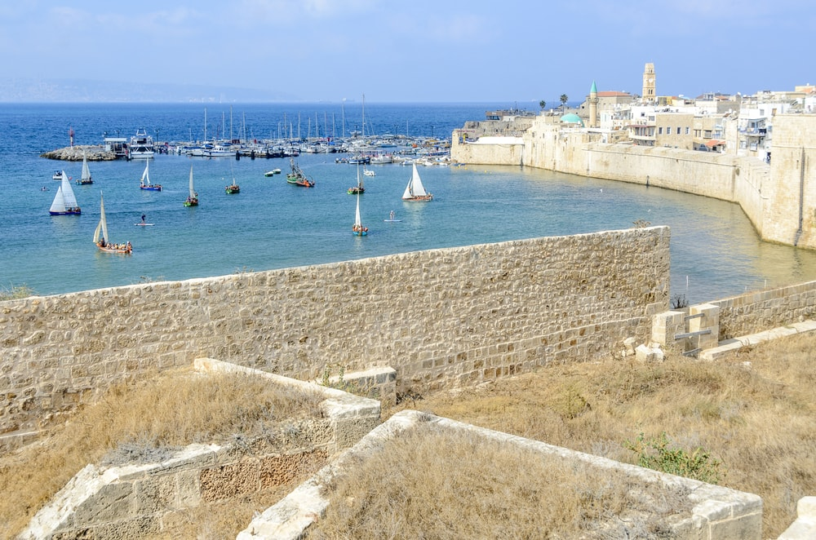

Old City of Acre, Israel | © Alex Lerner/Shutterstock

**Nazareth (Natsrat)**

**holy, brought up**

Located in the lower Galilee, you can find one of the Christian centers, Nazareth. It is said that here, Jesus was ………………….and Mary was told by the angel Gabriel that she was carrying the child of God. This, and a scattering of other very important Christian sites, makes the city of Nazareth a ………………….destination. In addition to its great religious value, Nazareth is also a city rich in culture and history, not to mention interesting archaeology, that will show visitors a different side to the [Middle Eastern charm](http://theculturetrip.com/middle-east/).

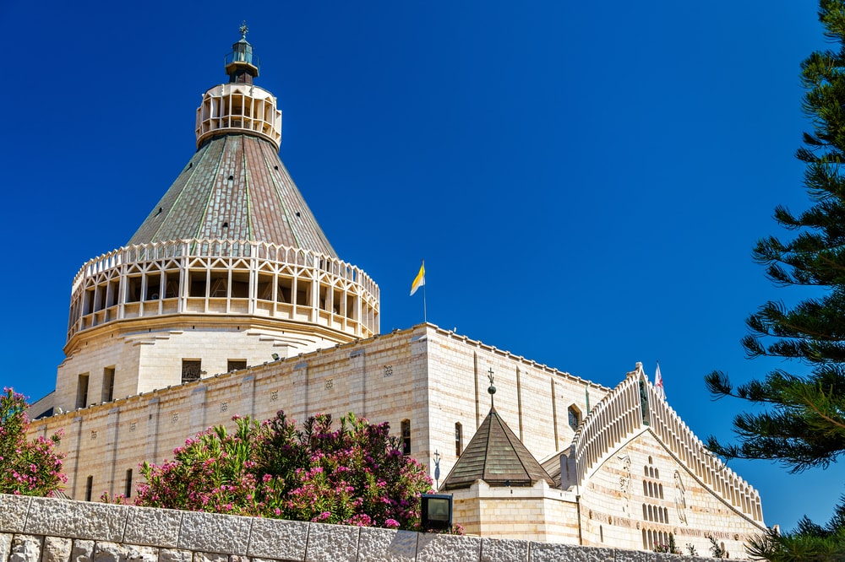

Basilica of the Annunciation, Nazareth, Israel | © Leonid Andronov/Shutterstock

**Sea of Galilee (Kinneret)**

**various, freshwater , miracles**

The [Sea of Galilee](https://theculturetrip.com/middle-east/israel/articles/5-books-that-will-make-you-fall-in-love-with-israel/%0A), or as Israelis call it the Kinneret, is the main water source, as well as the largest ………………….lake in Israel. The history of the lake goes way back. According to the New Testament, many of Jesus’ ……………….occurred here, including his walk on the water. Today, tourists visit The Sea of Galilee to enjoy the relaxing lake, have fun building rafts, or to practice ………………….. water activities.

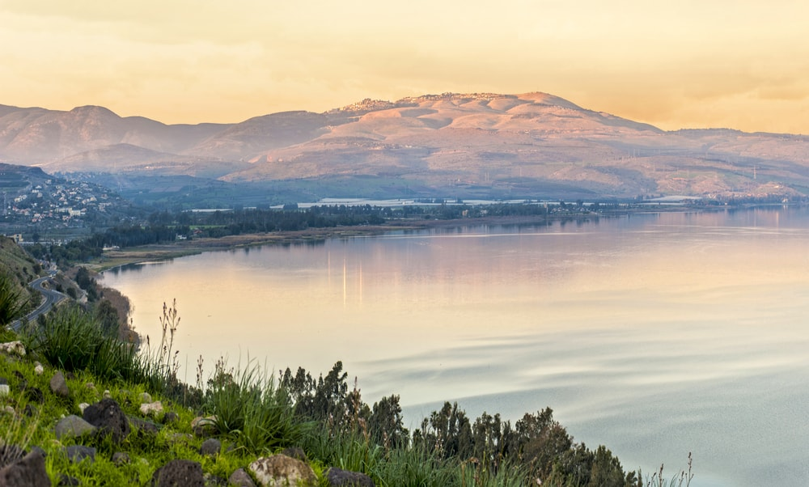

Sunset of the Sea of Galilee | © Max Shamota/Shutterstock

**Golan Heights**

**mountainous, impressive, shaped**

In the north of the country you can find [Golan Heights](http://www.goisrael.com/tourism_eng/wheretogo/north/pages/the%20golan%20heights.aspx), a ……………………region with breathtaking landscapes, wonderful nature reserves and historically ………………attractions for the whole family. As a perfect destination for hikers, the [Golan region](https://theculturetrip.com/middle-east/israel/articles/top-5-romantic-destinations-in-israel/%0A) offers a variety of different paths with different difficulty levels dependent on the time of year. It is especially …………………..during spring, when flowers are blooming and fields are green. In wintertime, the Herman Mountain, located in the Golan Heights, is the ideal destination for skiers.

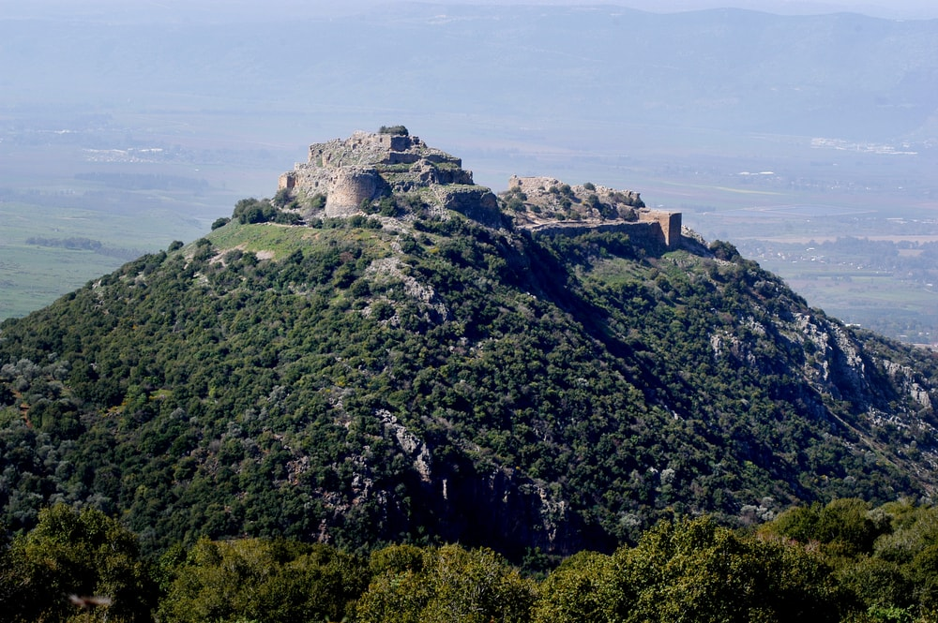

Nimrod Fortress at the Golan Heights, Israel | © ChameleonsEye/Shutterstock

**Haifa**

**lively, diverse, background**

Haifa has a variety of different neighborhoods and a mix of cultures, making it a very …………………. place. Visitors can enjoy the beautiful port and the vibrant beach, perfect for surfers. They can experience a greatly [………………… society](https://theculturetrip.com/middle-east/israel/articles/breaking-down-barriers-i-coexistence-hubs-in-israel-/%0A), with its ……………………….and history in the city, and last but not least, they can take in the beautiful nature Haifa has to offer with its unique Bahai Garden.

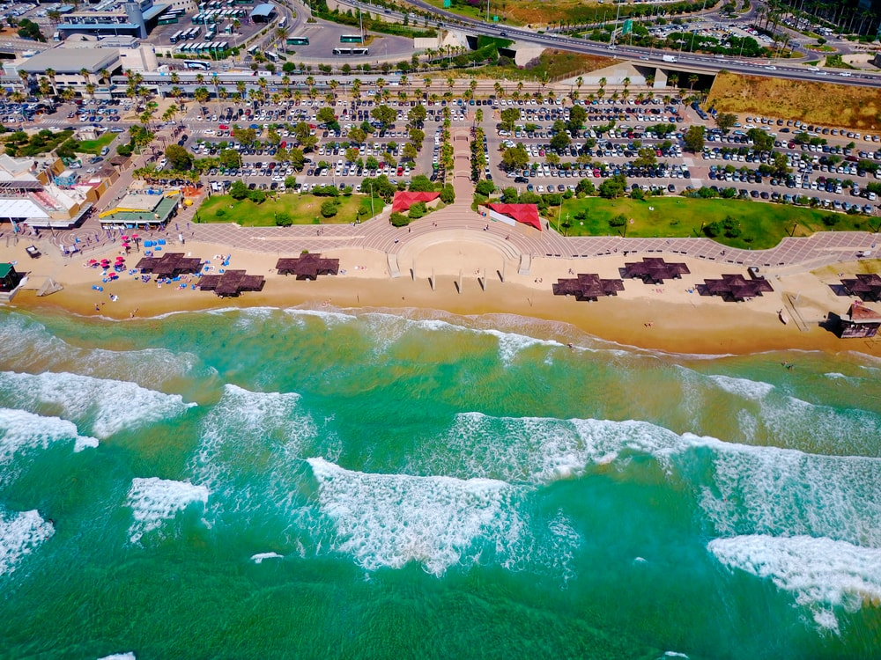

Haifa Beach, Israel | © sembler/Shutterstock

**Tel Aviv**

**vibrant, explore, throughout**

Tel Aviv combines relaxing beaches, [a ………………….nightlife](https://theculturetrip.com/middle-east/israel/articles/top-5-underground-bars-in-tel-aviv/), authentic markets, [culinary highlights](https://theculturetrip.com/middle-east/israel/articles/the-top-10-restaurants-in-tel-aviv/) and much more. The diverse society is very open-minded, so that everyone finds their place and learns to love it. With it’s different neighborhoods and sites, there is plenty to see and many places to ……………….in Tel Aviv: the city is exciting for beach lovers, street art admirers, foodies, photographers and [museum visitors](https://theculturetrip.com/middle-east/israel/articles/inside-look-at-the-tel-aviv-museum-of-art/%0A). As Israel’s center of entertainment, Tel Aviv offers its visitors many attractions………………….. the year. These include a water fight, the Gay Pride Parade, the Purim Street Party, the Tel Aviv Fashion Week and more.

**flea, preserved, restored, genuine**

**Jaffa** with its……………………… **acropolis** remains and well-………………….. stone architecture. Much of the original **bazaar area** is now home to restaurants and artisan boutiques. It's particularly lively in the evening when the old town throngs with diners. The **……………………. market** here is the major attraction for visitors, full of the hubbub of a …………………..souk, while **St. Peter's Monastery** and the **Old Port** area itself are also not to be missed.

**exhibits, ultra-modern, highlights**

**Tel Aviv Museum of Art.** contains works by Degas, Monet, Van Gogh, Henry Moore, Picasso, Jackson Pollock and the world's largest collection of work by Israeli artists. The …………………..building with its sophisticated architecture houses and ……………………the artworks perfectly. As well as the permanent collection, the museum hosts regular temporary……………………. and other events.

**displays, exhibits, population, illustrates**

**Beit Hatefutsoth** (the Diaspora Museum) ……………………..the life and culture of the Jewish people throughout history. The museum …………………….a wide variety of …………………….including film, recordings, and models, to document the world's Jewish ……………………………across the centuries.

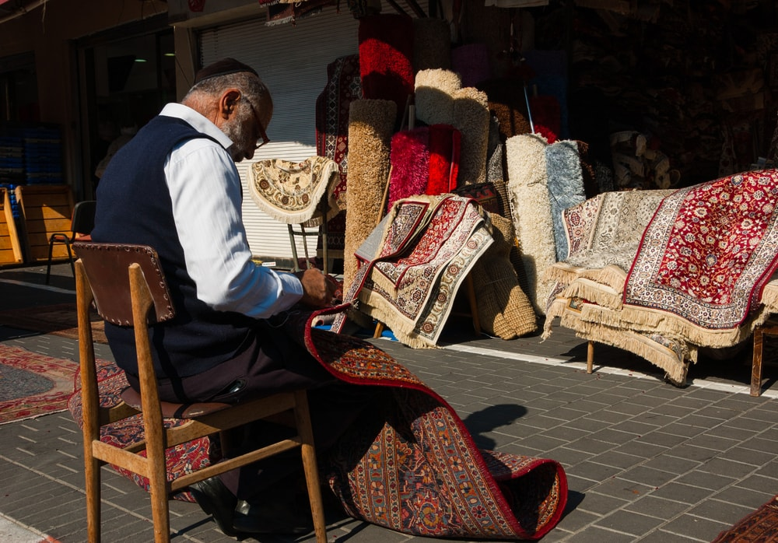

Carpet vendor in Tel Aviv, Israel | © Elena Dijour/Shutterstock

**Jerusalem (Yerushalaim)**

**holiest, grand, quarter, unites**

Jerusalem is the ……………………… city in the world, the city that …………………….the three biggest religions. Visiting Jerusalem is like travelling back in time. At the center you’ll find the Old City surrounded by a …………………….. wall. Here, visitors can learn a lot about Jerusalem’s religious history by visiting the sites of the three major religions, the Al Aqsa Mosque, the Church of Holy Sepulcher, and the Western Wall. The Old City of Jerusalem is divided into four…………………..: the Muslim quarter, the Armenian quarter, the Christian quarter and the Jewish quarter. When visiting Jerusalem visitors should visit one of the museums outside the Old City, such as [Yad VaShem](http://www.yadvashem.org/" \t "_blank), the World Center of Holocaust Research.

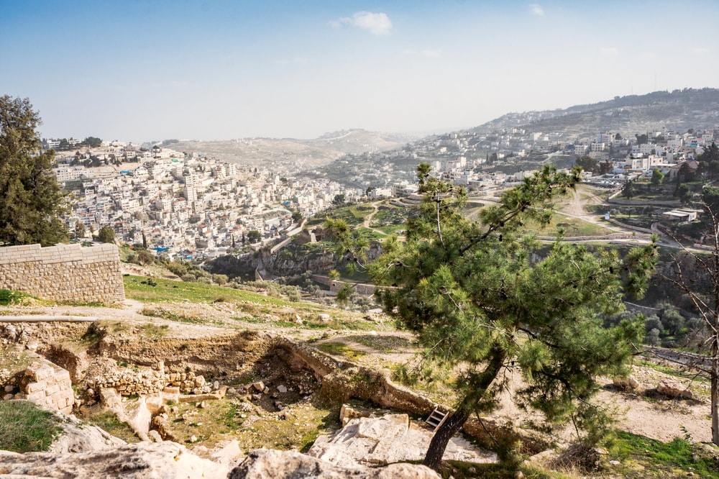

Mount of Olives on Old Jerusalem city, Israel | © Dmitry Polonskiy/Shutterstock

**Ramon Crater (Mahtesh Ramon)**

**crater, desert**

Located in Mitzpe Ramon, a town in the Negev ……………………., is the Ramon Crater, or as it is called in Hebrew – [Mahtesh Ramon](https://theculturetrip.com/middle-east/israel/articles/the-top-5-nature-parks-and-nature-reserves-in-israel/%0A). The…………………. is the biggest crater in Israel, 40 km in length and 10 km at its widest point. Try activities such as Jeep tours, Segway tours, or even helicopter tours: hot air balloon flights offer particularly spectacular views of the crater from above.

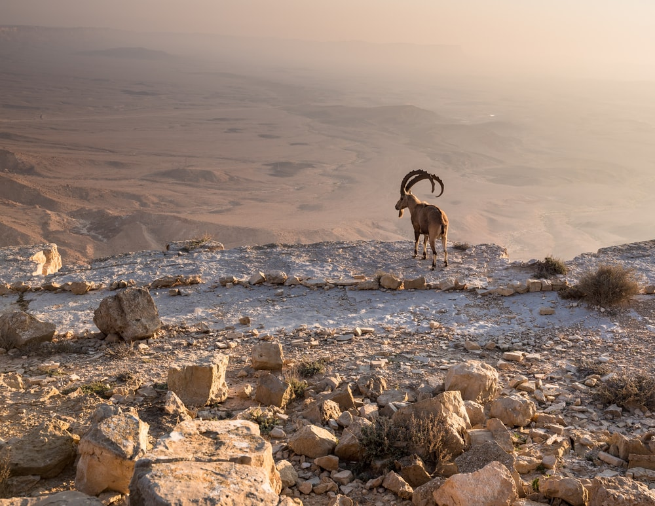

Mountain Goat overlooks the Ramon crater, Israel | © MoLarjung/Shutterstock

**float in, evaporates, pure**

**Dead Sea (Yam HaMelach)**

The lowest point on earth, 417 meters below the sea level, the Dead Sea is not only fun to ………………..in, it is also healthy, historic and surrounded by breathtaking beauty. It is the saltiest water on earth due to the fact that more water ……………………..than flows in. Float in the sea and cover your body in the healthy Dead Sea mud to find………………, inner relaxation. Once in the Dead Sea area, there are two other sites that should not be missed: [Masada](https://theculturetrip.com/middle-east/israel/articles/living-ancient-history-israel-s-top-10-unesco-world-heritage-sites/%0A) with its cruel history and amazing view, as well as [Ein Gedi](https://theculturetrip.com/middle-east/israel/articles/the-top-5-nature-parks-and-nature-reserves-in-israel/%0A), a water oasis in the desert.

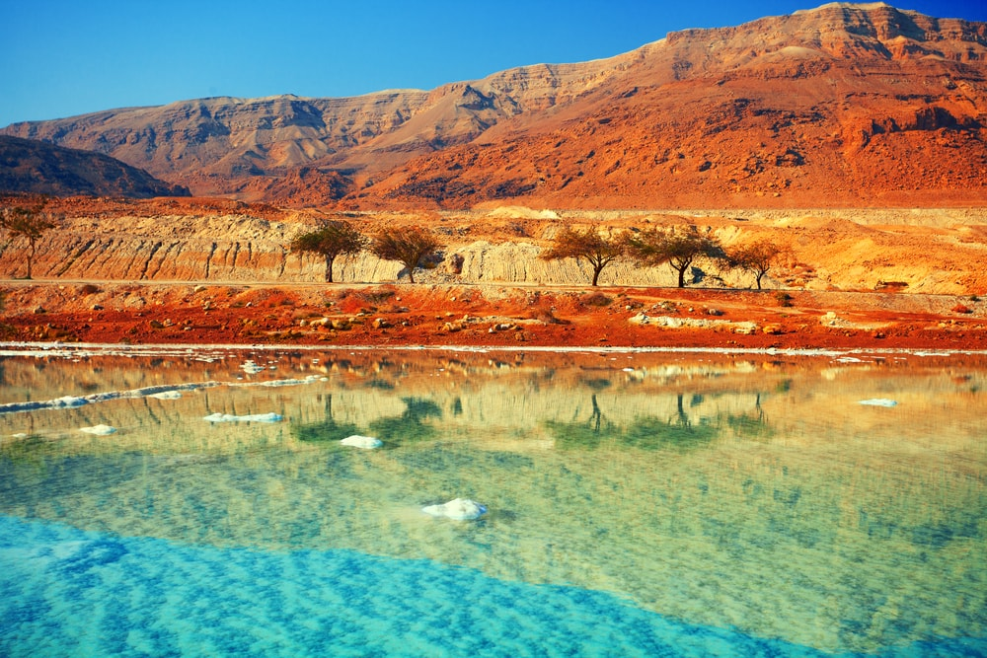

Dead Sea, Israel | © vvvita/Shutterstock

**Eilat**

**kick back, reefs, paradise**

After travelling around Israel, taking in history, nature and culture, Eilat is the perfect destination in which to ………………. Equipped with a great variety of beautiful hotels and resorts, this ……………………..at the very south of Israel offers many different activities. Visitors can take diving lessons along coral ………………….and enjoy the stunning under water world of the red sea. Other activities include swimming with dolphins, enjoying good food, or having a calmer day at the pool or the beach. During summertime, temperatures can reach highs of over 40 degrees Celsius (104 degrees Fahrenheit), and average lows of 20 degrees Celsius (68 degrees