**surrounding, bleak, rocky, familiar, gentle,**

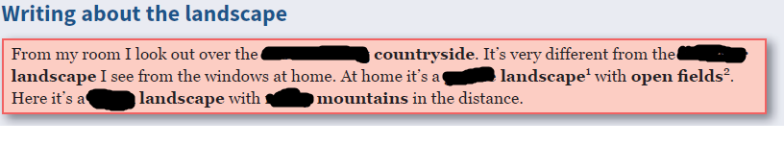

**follow, glimpse, caught, round, come, steep, flowing, worth, ruin, corner, setting**

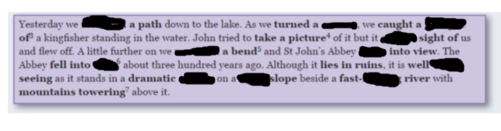

**unspoilt, dense, block, safeguard, wind, capped, destroy**

