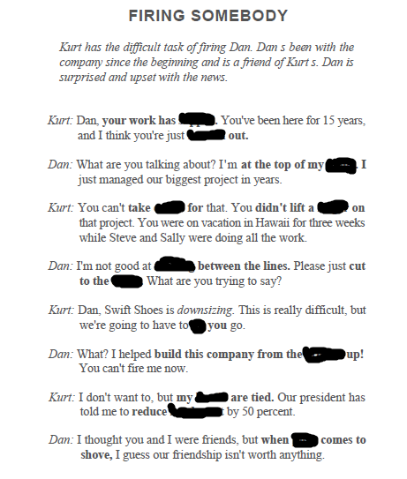

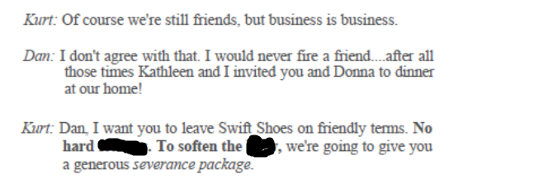

hands, blow, feelings, ground, let, chase, reading, game, credit, slipped, burned, finger, push, headcount