**, scattered, diverse, multicultural , proximity, picturesque, cutting-edge, thought-provoking,**

Malmö, Sweden's third largest city, is a …………………………portal to [Europe](https://www.planetware.com/europe-travel.htm). Indeed, a short drive from the city will take you to the iconic **Oresund Bridge** that links [Sweden](https://www.planetware.com/sweden-tourism-vacations-s.htm) to [Denmark](https://www.planetware.com/denmark-tourism-vacations-dk.htm).The city's ……………………….to the continent is reflected in its highly ……………………..testament to this fact - especially around **Möllevångstorget**, a public square in the melting pot neighborhood of Möllevången south of the city. A settlement has existed where Malmö lies since the 13th century, and despite offering a modern exterior to the world, it is a city filled with history. Popular things to do include admiring Malmo's mix of architectural styles, wandering through ……………………….city parks, dining at diverse restaurants and cafes, and exploring …………………………art and other fascinating exhibits at the city's ……………………..museums.

1. **Oresund Bridge**

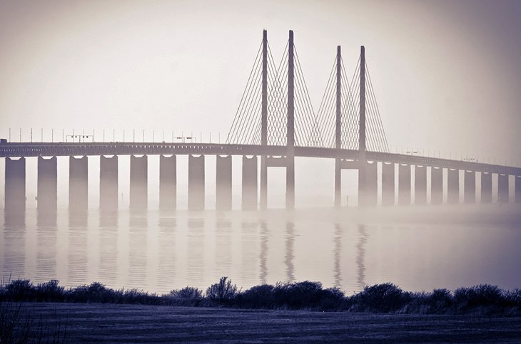

**throughout, multi-faceted, instantly,**

The magnificent Oresund Bridge lies a 15-minute drive from Malmö city center. Decades in the planning, and famous ……………………..the world since opening in 1999, the bridge has gained further infamy as the central focus of the smash hit Danish/Swedish TV drama *The Bridge*. Those familiar with the series will ………………………recognise the magnificent structure that now links Sweden to Denmark, and in turn, the entire European continent. The bridge is ……………………….- a road, a railway, and a tunnel. The initial stretch is some eight kilometers in length to the man-made island of **Peberholm**. From there, it connects to a tunnel of four kilometers, constructed so as not to impact the incoming aircraft to nearby Copenhagen airport. If you get the chance, take a trip across the bridge and through the tunnel to Sweden's neighbour, Denmark. After all, a day or even an hour in [Copenhagen](https://www.planetware.com/tourist-attractions-/copenhagen-dk-z-cop.htm) is never wasted

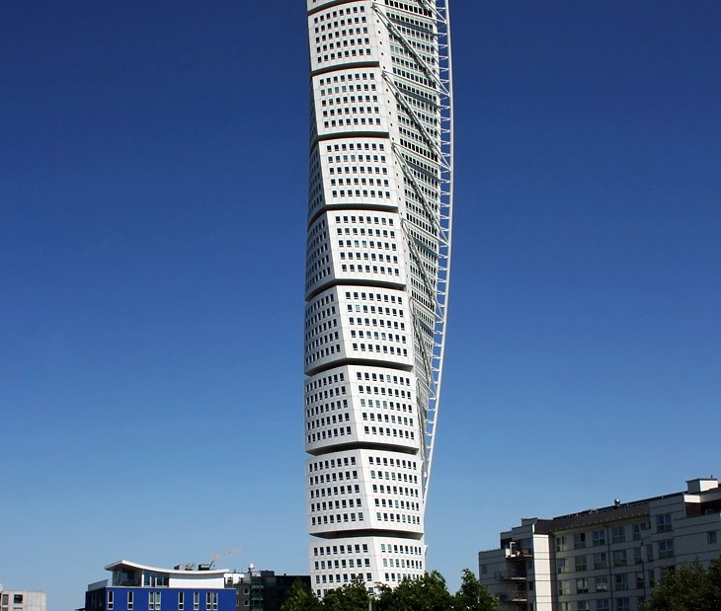

**residential, cutting-edge, eye-catching**

About 2.7 kilometers from **Malmö Central Station** and easily reached by bus or car is the most talked about building in southern Sweden. The striking Turning Torso is 190 meters high and combines………………………, office, and conference space. The skyscraper is based on a sculpture by designer, artist, and architect Santiago Calatrava, the Twisting Torso, which featured in the competition brochure for the design and construction of **Oresund Bridge**. The …………………..building took four years to complete, opened in 2005, and is supplied with locally-produced renewable energy. This …………………..and iconic structure has put Malmö firmly on the architectural map.

Address: Lilla Varvsgatan 14, 211 15 Malmo

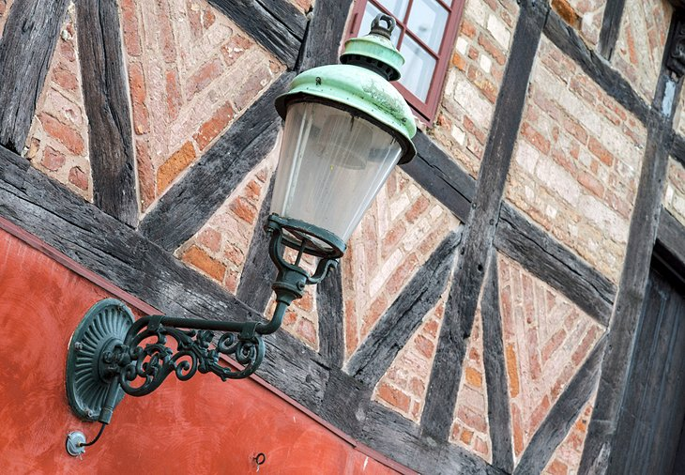

**overlooking, merchant’s hustle, terraced,**

Lilla Torg (Little Square) is one of Malmö's busiest spots, no matter the season. Enjoy a coffee, relax, and people watch. Numerous …………………… cafés……………………. the town square jostle alongside one another. All serve a range of food, from traditional Swedish to sushi. If the ………………….. and bustle gets too much, the **Rosen** restaurant at the [Renaissance Malmö Hotel](http://www.jdoqocy.com/click-2339553-10842362?URL=http%3A%2F%2Fwww.tripadvisor.com%2FHotel_Review-s1-g189839-d1580844-Reviews-a_cja.10842362-a_cjp.2339553-m13092-Renaissance_Malmo_Hotel-Malmo_Skane_County.html" \t "_blank) offers sedate fine dining. Lilla Torg is also famous, for its picturesque merchant's or **burgher's houses** dating from the 16th, 17th, and 18th centuries.

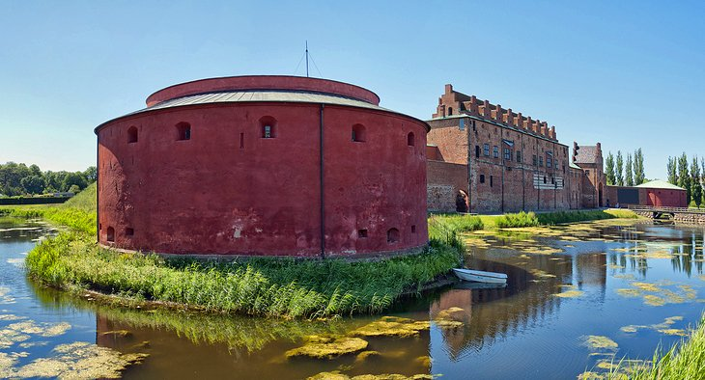

**must, citadel, restored, exhibitions,**

A must-see for any visitor, Malmöhus Castle houses several of Malmö's major museums within its historic walls, including **Malmö Museum of Art**, the **City Museum**, the **Natural History Museum,**a small **aquarium,**and the **Science and Maritime House**. Permanent exhibitions here feature topics such as natural history, ocean voyages, and technology, and the museum hosts several temporary ……………………each year. The castle itself was originally a minor…………………… dating from 1434. Denmark's currency was coined here in the Middle Ages, and during the 19th century, the castle served as a prison. Today, the ……………………Malmöhus Castle transports visitors back to the 16th century.

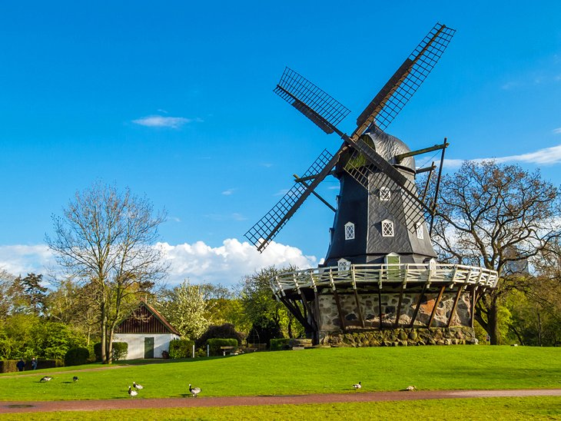

**heart, punctuate, peaceful, seasonal, windmill,**

Malmö is well-known for its beautiful city parks. In the……………….. of the city, right by Malmöhus Castle, the 8.4-acre Kungsparken (The King's Park) is Malmö's oldest park. It was originally called King Oscar's Park after it was opened in 1872 by the Swedish monarch and is inspired by English gardens. Ponds and exotic, old trees…………………. This………………………. oasis in the city, and you can relax on the lush lawns, feed the ducks, and explore a vaulted cave. The beautiful cast iron fountain at the center of the park dates from 1882, and was the city's first piece of public artwork.

Across a little bridge from Kungsparken is another beautiful park, Slottsträdgården. Highlights are the castle ………………….and ………………………plantings, including vegetables and colorful flowers like tulips, primroses, and sweet peas. Don't miss the sculpture *Pegasus* by Carl Milles, one of Sweden's most famous sculptors. To see these parks from a different perspective, a [Sightseeing canal cruise](https://www.viator.com/tours/Malmoe/Rundan-Canal-Tour-of-Malmoe/d680-3904P37?eap=planetware-tours-14254&aid=vba14254en" \t "_blank) takes you past these picturesque green spaces as well as **Malmöhus Castle** to the harbor.

About a 20-minute walk away from Kungsparken, **Pildammsparken** is another city park, with more than 10,000 flowers planted in its "flower alley" and plenty of ducks to feed. It's particularly beautiful in Autumn when the leaves are changing colors.

**6 Malmö Konsthall (Malmo Art Gallery)**

**hosting, incorporates, concrete, brunch,**

…………………….rotating exhibitions of national and international contemporary art, Malmö Konsthall (Malmö Art Gallery) opened in 1975 and has one of Europe's largest exhibition halls. The construction materials are light and simple - concrete, glass, wood, and aluminum. Constructed of 550 domes, the ceiling in the gallery varies in height and ………………………. plenty of natural light. The result is a structure that is almost as interesting as the thought-provoking exhibits it hosts. If visiting on a Sunday, you can enjoy a great ………………………………(a particular favorite with trendy locals) at **Restaurant Smak,** which also serves lunch daily. Entry to the museum is free.

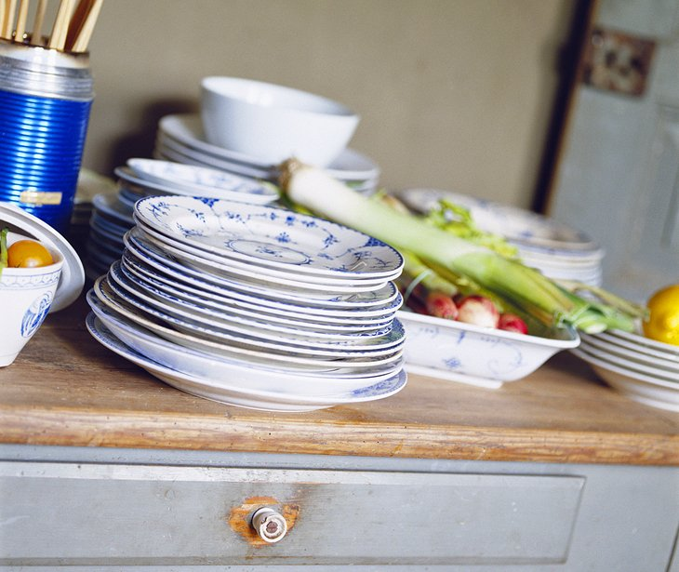

Meet the Malmö locals with a Slice of Swedish Hospitality. This is your chance to mix with Swedes behind the scenes. Locals share their homes and advise visitors how to enjoy the sights, make the most of shopping, experience authentic Swedish food, and discover the hidden treasures Malmö and the region have to offer. All are welcome, including single travelers, families, or friends, with a maximum of five people per group. A meal with a local family includes two courses, generally a main followed by dessert, and afterwards a chat or possibly a stroll, weather permitting. A word to the wise: be on time, Swedes are extremely punctual, particularly at meal times.

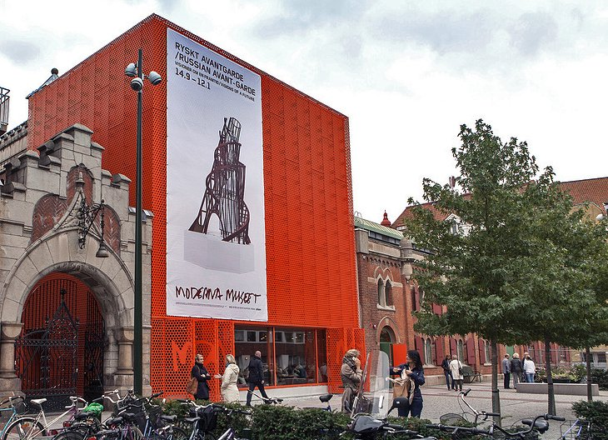

**striking, contemporary, state,**

An easy eight-minute walk from **St. Peter's Cathedral** (St. Petri Kyrka), the Museum of Modernism (Moderna Museet) is known as a little piece of [Stockholm](https://www.planetware.com/tourist-attractions-/stockholm-s-upp-stock.htm) in Malmö. The museum opened in 2009 as a branch of …………………-owned Moderna Museet (Stockholm), and it also runs courses and seminars. Formerly an electricity plant with a ………………….new orange-red annex, the building houses modern and …………………works of art. Installations include film, photography, design, and paintings. Entry is free. After touring the exhibits, you can enjoy coffee or lunch in the café.

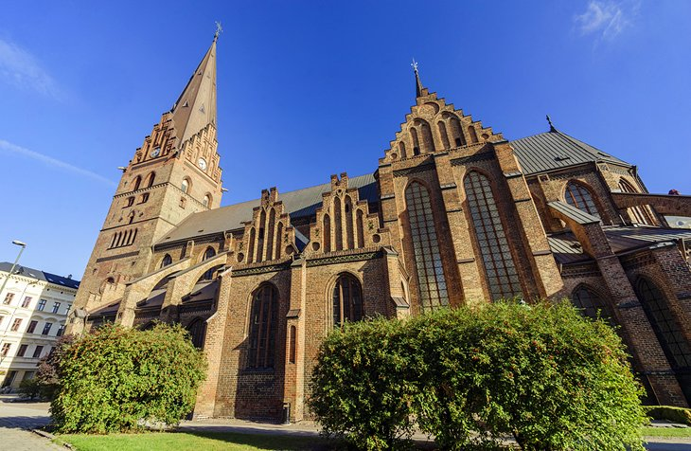

**imposing, murals, ambiance, glimpse, intricate, adorned,**

Near Central Station, Sankt Petri Kyrka (St. Peter's Church) dates from the 14th century and is Malmo's oldest church. This…………………… brick Gothic building is known for its impressive wooden retable, the largest such piece in Northern Europe, and its 17th- and 18th-century grave stones. In the early 20th century, ceiling ………………in the Krämare Chapel were restored, providing a ……………………….of the………………….. art that once ………………………the walls and ceilings elsewhere in the church before it was whitewashed in later years. It's worth wandering through this distinctive landmark to soak up some of its rich medieval ……………………..

**10 Katrinetorp Country House**

**Idyllic, playground, pipe, converted**

Katrinetorp, on the outskirts of Malmö, (about a 15-minute easy drive) is one of the best-preserved Empire-style manor houses (Herrgård**)** in Sweden. Originally built in an ………………….location for one of southern Sweden's richest families, the 19th-century home is surrounded by magnificent landscaped gardens. Also on-site is a garden café, restaurant, and antique store. During the year, Katrinetorp hosts a harvest fair, a Christmas market, various exhibitions, and evening concerts. Guided tours are available during the summer on select days

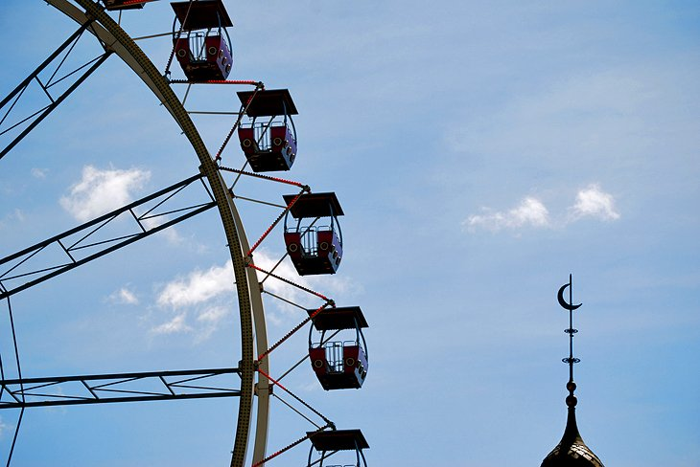

Malmö's Folkets Park (People's Park) is a favorite destination for locals and visitors - especially families with young children. For more than a century, people have come here to unwind. Among other tourist attractions, you'll find a green area with ponds, a popular children's………………………., miniature golf, and a half-………………….. for skateboarding. Ice-cream stands and cafés are on hand if you need a snack, and in winter, the wading pool is ……………………….into a small ice rink for skating. The park also serves as a venue for festivals and events.