**turquoise, fertile ,pebble, hinterland, devastating,**

Zákynthos (Zante) island truly offers something for everyone when it comes to things to do. Easy to access at just 16 kilometers off Peloponnese's west coast in the Ionian Sea, the geography here is stunning and varied. Steep cliffs plummet down to rocky shores with white ……………….. beaches and crystal-clear………………………… seas on the northwest coast, while to the south, you'll find golden-sand beaches and less rock formations. The island's central ……………………..is also not lacking; it is a ……………………… plain overflowing with woodlands and olive groves.

This mix of beautiful scenery; good beaches; and access to an equally stunning underwater world, filled with hidden caves and colorful fish, which is perfect for snorkeling and scuba diving, has made Zákynthos one of the top tourist destinations in Greece.

Beyond the scenery, the island is also historically interesting. It was under Venice from 1484 to 1797, and Venetian influence can still be felt in the architecture, cuisine, and dialect. Unfortunately, few of its old buildings have remained, due to two ……………………… earthquakes, in 1515 and 1953.

**1. Shipwreck Beach (Navagio Beach)**

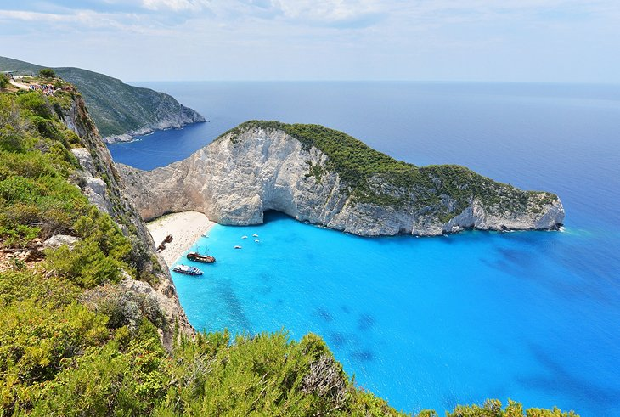

**arguably, departing, smuggling**

Probably the most photographed and, …………………., beautiful beach in all of Greece, Shipwreck Beach lies in the so-called Smuggler's Cove on Zakynthos' west coast. Made up of fine white pebbles backed by cliffs, the beach takes its name from the wreck of a contraband cigarette ………………… ship that washed up here in 1980.

The most special aspect of this beach is that it can only be accessed from the sea — grab a taxi-boat from the harbor at **Agios Nikolaos**, which is on the island's northeast coast, 32 kilometers from Zakynthos Town. You can also visit as part of an organized tour like this [Shipwreck Beach day-trip excursion](https://www.viator.com/tours/Zakynthos/Zakynthos-Shipwreck-Beach-Excursion/d23524-26587P1?eap=planetware-tours-14254&aid=vba14254en" \t "_blank)……………………… from Zakynthos Town

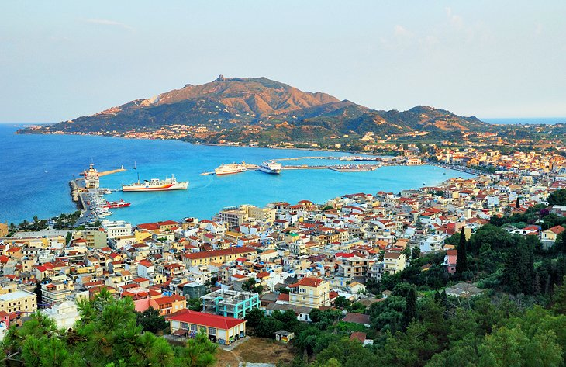

**sloping, battlements, reconstructed,**

On the island's east coast, extending in a wide arc along the gently ……………………….shores of a bay, Zákynthos Town is the capital of Zákynthos. Many of its Neoclassical buildings were demolished by the 1953 earthquake, but its paved streets and squares, filled with bakeries, cafés, boutiques, and jewelry stores, are still a joy to explore on foot.

The town's main church, **Agios Dionysios**, which houses the relics of the town's patron saint, dates from 1708 and was ……………………. in 1954. For spectacular views over town and the port, go up to the village of **Bohali**(2.5 kilometers) to the ruined **Venetian castle**, set in a park with pine trees. This attraction was also largely destroyed by the earthquake, but you can still see the main gate (bearing the Lion of St. Mark, the symbol of Venice), the outer walls, and………………………...

**3. Byzantine Museum**

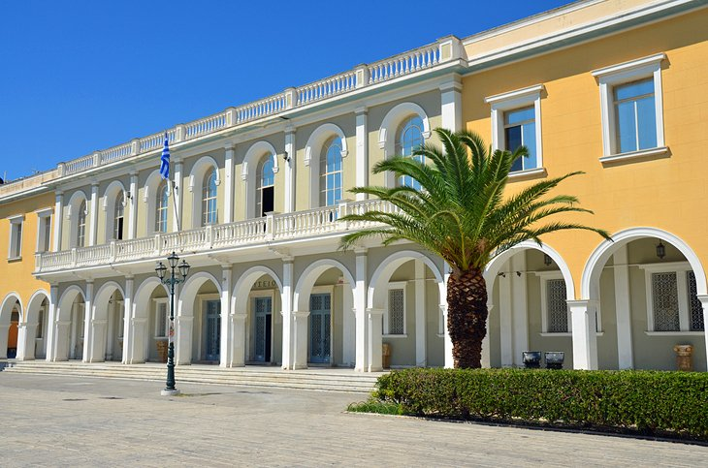

**displays, sculptures, carved,**

On the main square in **Zakynthos Town**, this purpose-built museum ……………………..religious icons, frescoes, and ……………………….. from the island's churches and monasteries, dating from the 12th century onwards. You'll see Byzantine icons ………………….. into wood and there are two rooms dedicated to 18th-century oil paintings. There's also a scale model of the town from around 1950, giving you some idea of how it looked before the devastating 1953 earthquake.

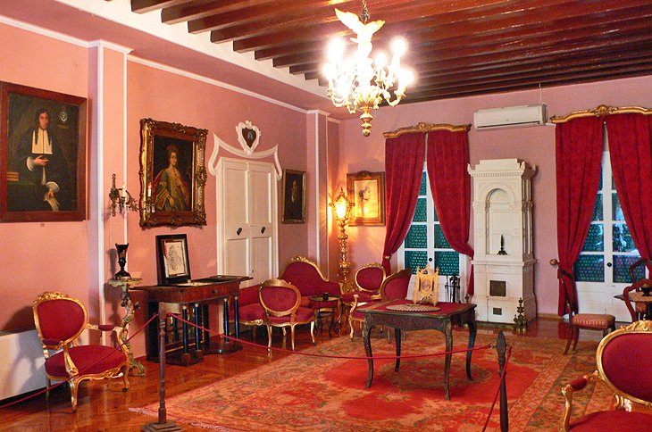

Built in the 1660s, this proud mansion is one of the few old buildings to have survived the 1953 earthquake, which wiped out most of Zakynthos Town. It is owned by the Roma family, who decided to renovate it and opened it to the public in 2007. Inside, you can see period furniture, paintings, and books, giving you some idea of how local aristocrats lived in the centuries prior.

**5. Blue Caves**

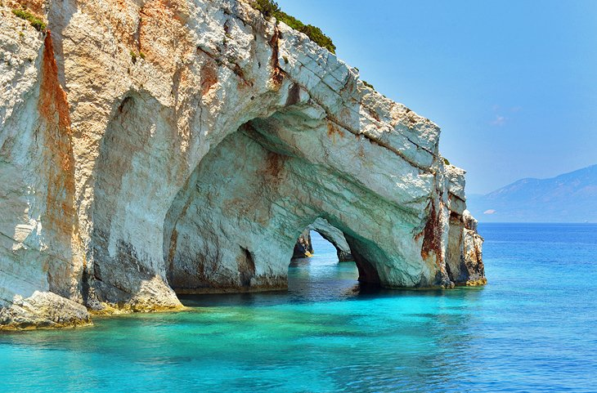

**spectacular, cruise, azure,**

On the northern tip of the island, at Cape Skinari, you'll find the most ………………………. so-called Blue Caves. Inside, the bright blue sea reflects the color of the sky, which is mirrored off the walls of the caves and creates an absolutely magical ………………………. and sapphire light scheme. You can visit the Blue Caves in a small glass-bottom boat, which departs from **Agios Nikolaos**(on the northeast coast, 32 kilometers from Zakynthos Town), or as part of the longer round-the-island …………………… from Zakynthos Town

**6. Keri Caves**

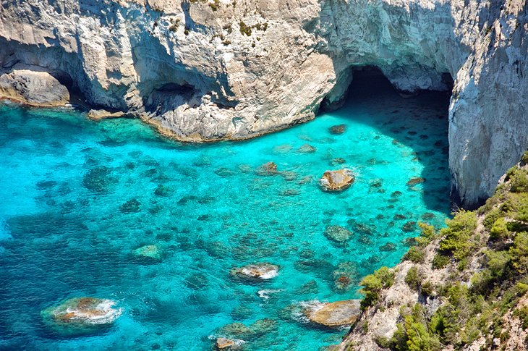

**crystal, reflecting, excursion,**

On the southwest coast, 14 kilometers from Zákynthos Town, close to the village of **Kerí**, a row of dramatic caves opens directly onto a ………………….-clear turquoise sea, and exploring them with a mask and snorkel or scuba dive tank is one of the top things to do on the island — the lighting effects of the sun ………………………… through the water and onto the cave walls makes for some amazing photos and video. It's possible to visit the caves as part of an organized …………………….., or rent a boat and go independently.

**7. Porto Limnionas**

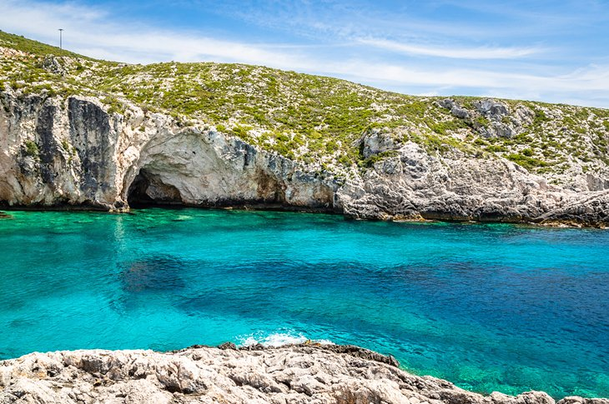

**backdrop, height, fronting, secluded,**

With crystal-clear, blue-green water set against a ………………….. of cliffs and caves, Porto Limnionas is one of the top …………………………… swimming spots on the island. In a wild location down an only recently paved road, not far from the small village of **Agios Leon,** it is gaining in popularity each year, and in the …………………….. of summer can get crowded. Sun-loungers can be rented from two local restaurants with terraces …………………. the sea, and once in the water there is good snorkeling, along with caves and even an underwater bridge

**8. Zakynthos National Marine Park in Laganás Bay**

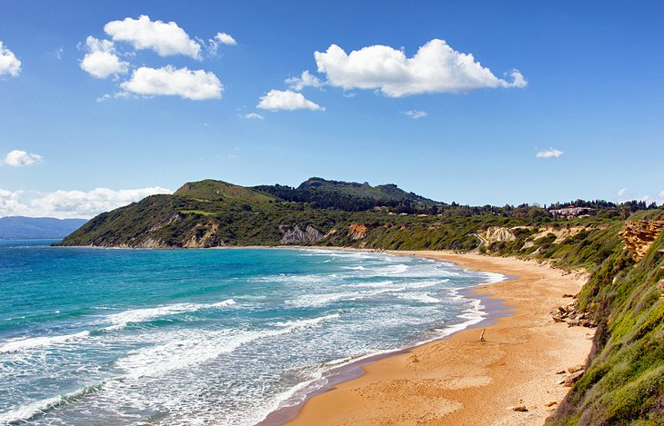

**blissful, loggerhead, nesting, endangered**

On the southeast coast, eight kilometers south of **Zákynthos town**, the wide bay of Laganás is home to several ……………………….. stretches of sandy beach. Since the 1980s, it has been the island's top resort, with budget accommodation attracting young visitors in search of sea, sun, and fun.

This area is also the breeding ground for the……………………. sea turtle, which is an ………………………. species, known for being very timid. An estimated 1,300 loggerhead turtles live around Laganas Bay and are protected in the Zakynthos National Marine Park, which was founded in 1999 to limit access to certain parts of the beach during the …………………..season. To learn more, visit the park's exhibition center in Dafni, at the east end of Laganas Bay.