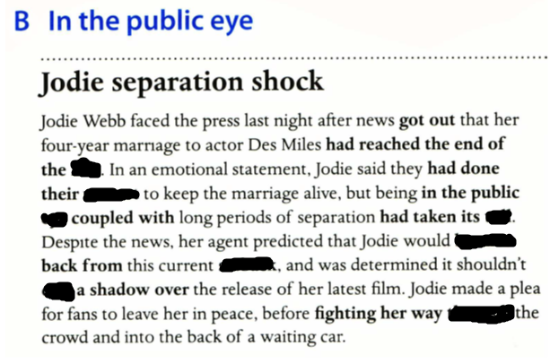

**line , cast , through, bounce, utmost, setback**

**line, utmost, eye, toll, bounce, setback, cast, through**

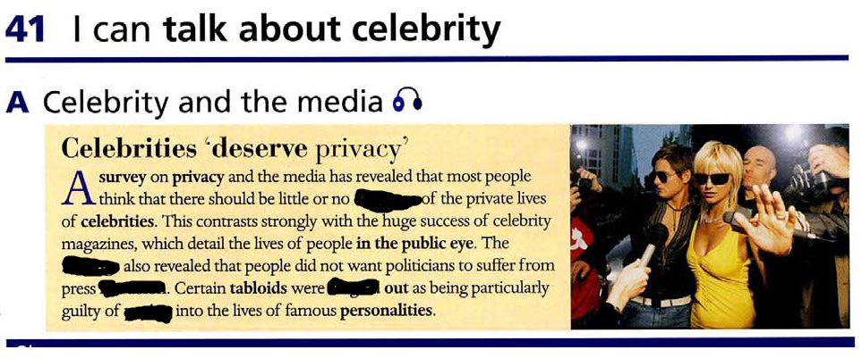

coverage, single out , intrusion , prying, findings

coverage, findings, intrusion, single, prying

- one-hit wonder , wear many different hats ,

- rise to fame ( unprecedented talent , stroke of luck , concurrence of events)

- encroach on/ interfere with/denied the right to privacy ( deprived of privacy)

- connotations

- under surveillance

- poke your nose into

- exemplary - look up to /emulate

- prenuptial agreement/ take him to the cleaners

- edge you on

harass/stalk ,fabricate, unrivalled, resounding , lavish , glowing ,hounded , debunk , frivolous , buzz , hit

- glowing reviews

- fabricate/debunk untrue story

- hounded by press

- hit the headlines

- frivolous actress

- create buzz around yourself

- lavish lifestyle

- harass/stalk celebrity

- debunk falsehood

- resounding success

- unrivalled talent





1. intrusion

2. tabloid

3. alleged

4. deserve

5. allegation

6. privacy

7. exclusive

8. coverage

9. scandal