Norway

spectacular, stunning, northern, wonders, cosmopolitan, snow-capped, prosperous, rich, glaciers

Norway offers visitors an incredible mix of cultural and natural…wonders……………... From…cosmopolitan…………………….. **Oslo** to its endless …snow-capped……………………….mountain peaks and deep fjords, there's no end of choices for travelers in the land of the midnight sun and stunning …northern………………….lights. Getting around the country is easy, and the country's top-notch transit systems offer some of the best sightseeing opportunities, too, whether by rail or the fantastic coastal steamers.

One of the world's most …prosperous…………………….nations, Norway seems to have a fascinating museum for just about every important aspect of its …rich……………….cultural and social history, covering everything from the Vikings to seafaring and fishing, as well as art and entertainment. Norway is also rich in ……spectacular………………….scenery, from its …stunning…………………….fjords to its spectacular mountains and…glaciers………………., many of which are easily accessible to tourists.

**1 Scenic Rail Routes**

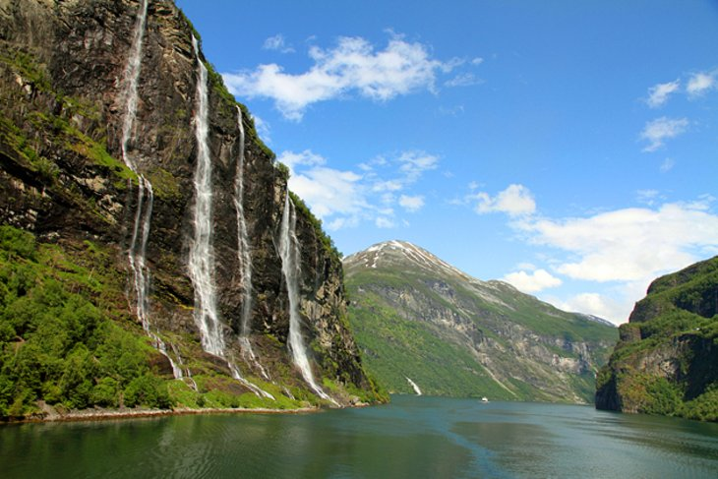

**winding, finest, boast about, breathtaking**

Part of the spectacular **Fjord Norway** network - and regularly topping the **UNESCO World Heritage Sites** list - the Geirangerfjord region north of **Ålesund** offers some of the…finest…………………. scenery anywhere in Norway. The eastward continuation of the **Sunnylvsfjord**, the Geirangerfjord …boasts about………………… some of the country's most spectacular views. One of the best is from the summit of **Dalsnibba**: at 4,905ft, the views of the surrounding mountains and the Geirangerfjord far below are simply …breathtaking……………….Numerous cruises and tours are available, but if you're driving, be sure to take the…winding……………………. **Eagles' Road** with its 11 hairpin bends and great views.

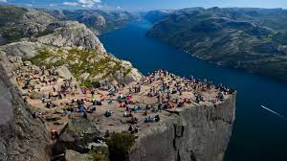

massive, gaze, plateau, edge,

The Pulpit Rock is a …massive………………………..cliff 604 meters above the Lysefjord and is the most famous attraction in the county of Rogaland.

The flat …plateau………………………of the Pulpit Rock, also known as the Preacher's Pulpit, is approximately 25 by 25 metres, and from the top you can see all the way to Lysebotn at the end of the Lysefjord. If you dare you can lie on your stomach at the …edge……………….. and …gaze……………….. hundreds of feet down to the fjord below!

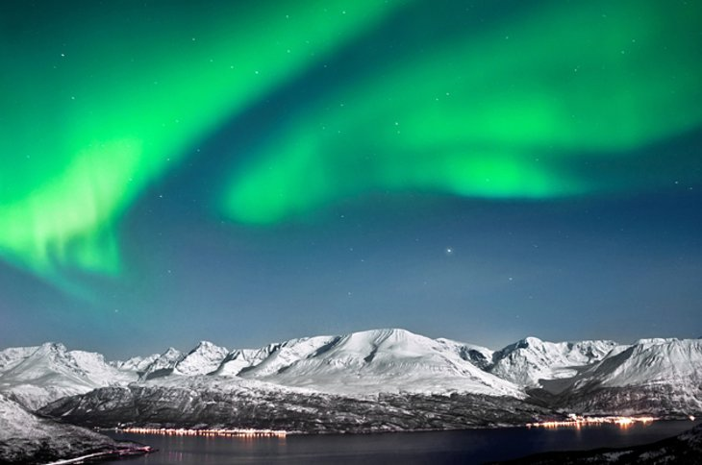

**impressive , solstice, endless, striking, flairing**

A sizable section of northern Norway is located within the Arctic Circle, a fact that provides the country with two of its most popular tourist attractions. The first, the **Midnight Sun**, is an …impressive…………………… sight and experience. During the summer months, surrounding the summer …solstice………………….., these latitudes see …endless………………..days when the sun doesn't set. However, it's the spectacular  Northern Lights, that really steal the show in winter. Caused when electrically charged particles emitted by the sun are caught up in the earth's magnetic field and producing …flairing…………………..light effects in the thin ionized upper atmosphere at heights of between 40 and 620 miles, the sky comes alive with spectacular bluish arcs of light, glowing coronas and shimmering curtains of radiance …striking…………………… over the sky in constant movement.

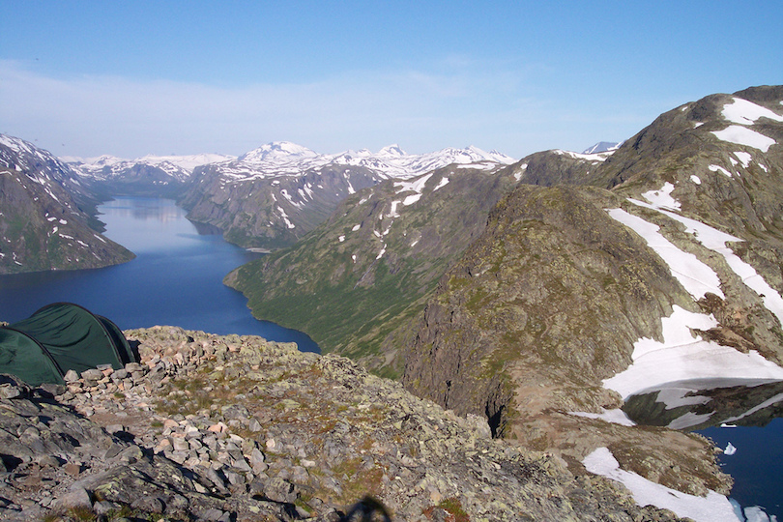

**stroll, renowned, surroundings**

The largest city in Northern Norway, Tromso is…renowned……………………. both for its large number of 18th-century wooden houses and for the beauty of its natural…surroundings………………….. Most of the city is situated on the island of Tromsoya where visitors can explore several fine museums and ……stroll…………………….through stunning birch tree forests. Trips up Storsteinen Mountain in the Fjellheisen Cable Car offer visitors amazing views of the surrounding fjords and mountains. The arctic aquarium Polaria and the Polar Museum are popular attractions in this city located 350 km (217 miles) north of the Arctic Circle. Tromso is one of the best places in the world to view the Northern Lights

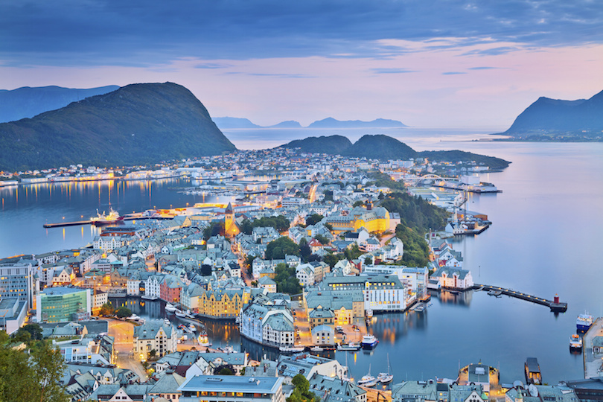

**gateaway, picturesque, viewpoint,**

Located on Norway’s west coast, Ålesund is the …gateaway……………………to the iconic northwestern fjords and surrounding alpine mountains. The city of Alesund owes its present-day …picturesque………………….appearance to a city-wide reconstruction after a fire in 1904 destroyed most of the town. The city was rebuilt with stone and brick in the architectural style of the time, and stands today as a perfect example of Jugendstil design, Northern Europe’s version of Art Nouveau. Visitors can learn more about the style at the Jugendstilsenteret, or Art Nouveau Center. A hike up the 400 steps to the …viewpoint…………………………..Fjellstua is worthwhile as well. The mountain peak offers stunning views of Alesund and the surrounding islands.

8. Trondheim

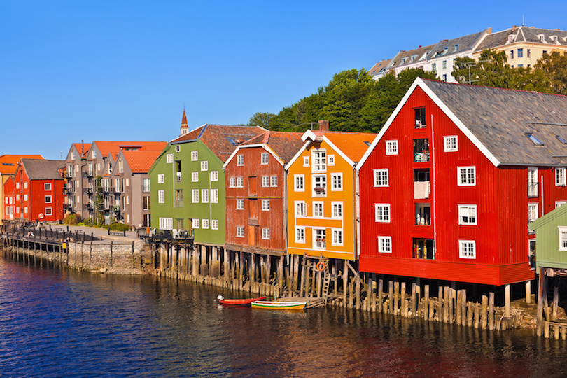

**abounds, destination, restore,**

There’s something for everyone in the northern city of Trondheim. Founded in 997, Norway’s third largest city was the country’s capital during the Viking Age and the nation’s religious center during the Middle Ages, making it the ideal …destination……………………………. for those who want to …restore………………………..Norway’s history. From Sverresborg, a restored 12th century castle, to the Nidaros Cathedral, the northernmost Medieval cathedral in the world, the city …abounds…………………………….. with remnants of the past.

7. Jotunheimen National Park[http://cdn.touropia.com/gfx/showmap.png](http://www.touropia.com/map/?list=best-places-to-visit-in-norway&open=7)

flickr/[jneilson23](http://www.flickr.com/photos/69461230@N00)

**premier, encompasses, well-marked, adventures**

Jotunheimen, or Home of the Giants, is Norway’s …premier…………………….national park. Located in the nation’s south central region, the park …encompasses…………………several mountain ranges, including Norway’s 29 highest peaks. The park is also home to Vettisfossen, which at 275 meters (900 feet) is the highest waterfall in Norway. Mountain lodges and …well-marked……………………. trails in the area offer visitors easy access to glacier hikes, summit tours, mountain climbing and skiing. Tour companies and trekking associations offer outdoor …adventures…………………………..for visitors of every age and skill level.

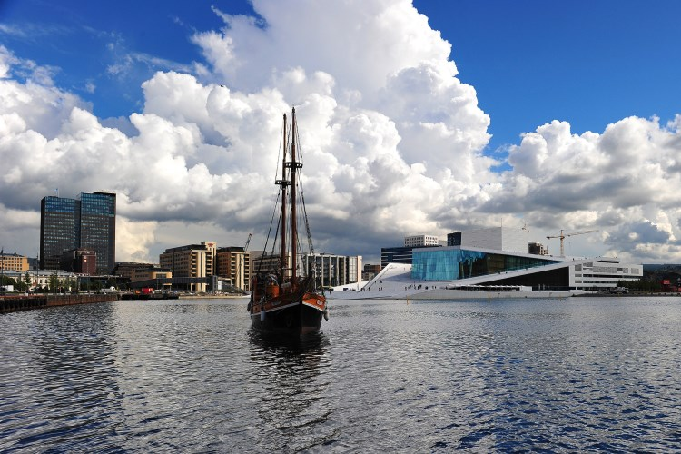

populated, vibrant, lively, laid-back, pastimes, culturally,

Norway’s capital and most…populated…………………….. city, Oslo is a …vibrant…………………….. modern city with a confident attitude and ……lively………………… atmosphere. Hugging the horseshoe-shaped shores of the Oslofjord, [Oslo](http://www.touropia.com/attractions-in-oslo/) is one-third city and two-thirds forests, parks and green spaces, making outdoor activities like hiking and biking popular…pastimes…………………….. From its 19th-century city center with its museums, …laid-back……………………. bars and restaurants to the Nobel Peace Center located in the city’s former railway station, Oslo is …culturally………………….. rich as well. The city’s 50 museums range from the Munch Museum, which features “The Scream” and other works by Edvard Munch, to the Folkemuseet, an outdoor museum that includes more than 150 historic buildings from all over Norway, including a Stave Church