**surrounding, bleak, rocky, familiar, gentle,**

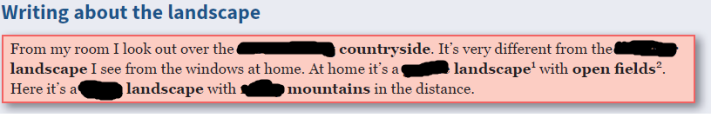

Surrounding, familiar, gentle, bleak, rocky

**follow, glimpse, caught, round, come, steep, flowing, worth, ruin, corner, setting**

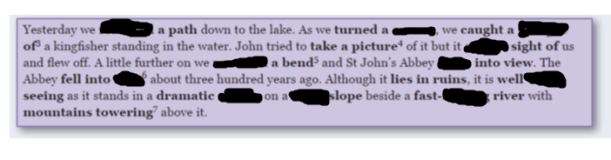

Followed, corner, glimpse, caught, round, came, ruin, worth, setting, steep, flowing

**unspoilt, dense, block, safeguard, wind, capped, destroy**

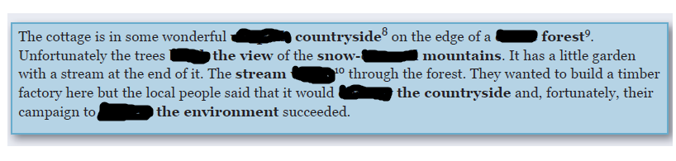

Unspoilt, dense, block, capped, winds, destroy, safeguard

