**haphazardly, ,steeply, monumental, lanes, funicular,**

The first thing a traveler arriving in Bergamo notices is its topography, a perfectly flat lower town that rises …steeply…………………….and suddenly to the 16th-century bastions of the old town on the crest of its hill. The contrast is even sharper because the straight lower streets are lined with Neoclassical and modern buildings, while the old town's narrow …lanes………………. wind …haphazardly…………………among Romanesque and Renaissance structures. The old upper city - Citta Alta - is where most of the tourist attractions are found.

The two parts of Bergamo are connected by a …funicular……………….., a much easier approach to the old citadel than the steep, winding roads at either end. But the …monumental……………………….. gates through which these roads enter the old city are worth a look. Two of them show the Lion of St. Mark, a reminder that Bergamo, like much of northern Italy, was once part of the Venetian Republic

**Citta Alta**

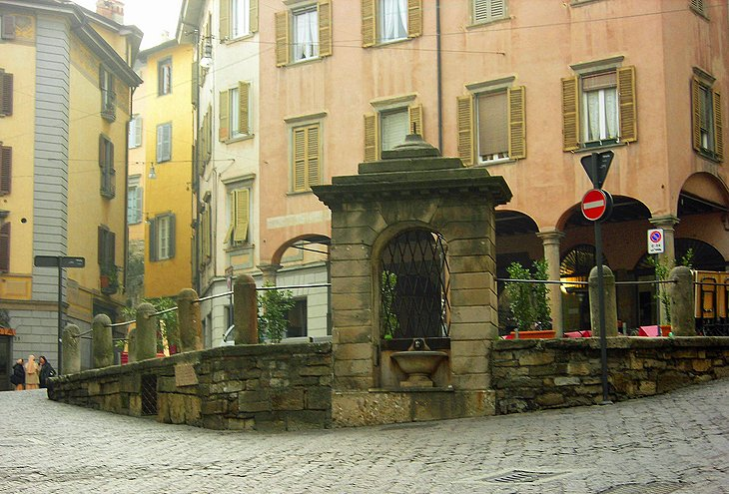

**medival , clustered, paved,**

Most of the top things to do in Bergamo are in the Citta Alta, the old town, with its …medival…………………. and Renaissance buildings tightly …clustered………………..at the top of a rock outcrop. The best way to get there is on the funicular, which brings you to **Piazza Mercato delle Scarpe**. This small square leads into the narrow stone-paved………………. **Via Gombito**, in which lies a patrician tower-house, the **Torre di Gombito**, built around 1100. Below, on Via di Porta Dipinta, stand the beautiful churches of **San Michele al Pozzo Bianco** and **Sant'Andrea** (inside the latter is a *Madonna Enthroned with Saints* by Moretto). Lined by patrician buildings with small shops on their street level, Via Gombito leads on to the beautiful Piazza Vecchia

**2 Piazza Vecchia**

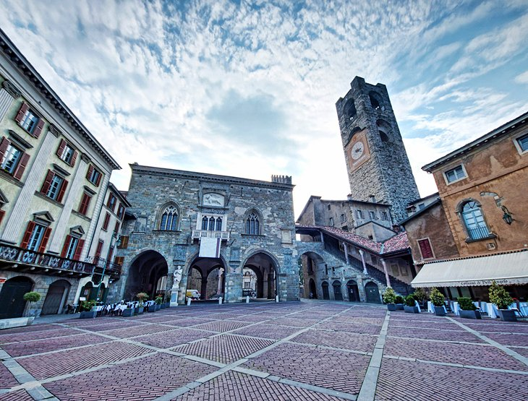

**assembly, bounded, municipal, adjoining**

A remarkable and beautiful ………………..of patrician houses and the **Palazzo della Ragione**(city hall) frame this square at the heart of the old town. The 12th-century Palazzo della Ragione's stone staircase and loggia of three Gothic arches (largely rebuilt in the mid-1500s) forms the piazza's upper side, …………………….. the tall tower, **Torre del Comune**. The lower side is ………………. by the late-Renaissance **Palazzo Nuovo**, housing the municipal library. In the center stands the **Contarini Fountain**, decorated by lions, and another Lion of St. Mark looks down from above. A café in the upper corner makes a good spot for appreciating the scene.

**3 Santa Maria Maggiore (Basilica of St. Mary Major)**

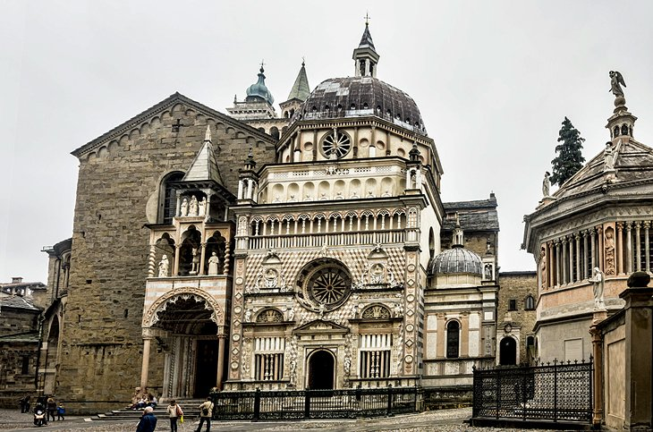

**stepped, tapestries, choir,**

Through the archway at the top of Piazza Vecchia is **Piazza del Duomo** (cathedral square), and together they contain some of Bergamo's most impressive architectural treasures. The church of Santa Maria Maggiore, begun in 1137 as a Romanesque basilica, has a … …stepped…………….-back tower over the crossing and an ornate … choir …………………. Doorways at either side of the church are guarded by lions under beautiful Gothic canopies (1353 and 1360). Inside are fine Renaissance choir stalls, Baroque stucco work, and 16th-century …tapestry……………………… on the walls of the side-aisles and choir. Local admirers still leave fresh flowers on the tomb of the composer Donizetti, a Bergamo native buried here.

**4 Cappella Colleoni (Colleoni Chapel)**

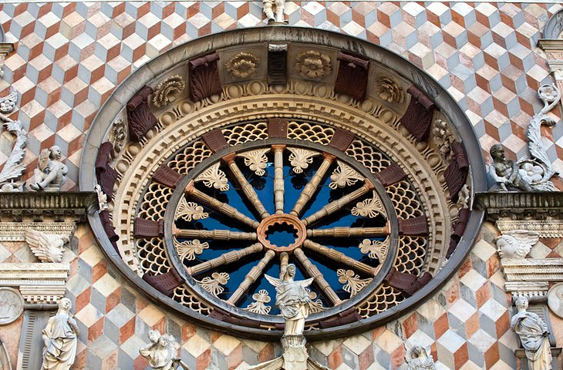

**inlaid, tombs, lavishly,**

Adjoining Santa Maria Maggiore is the Cappella Colleoni, in early Lombard Renaissance style with a …lavishly……………….. decorated façade of multicolored …inlaid……………… marble. Built 1470-76 to house the tomb of the condottiere Bartolomeo Colleoni and his daughter Medea, the chapel was designed by Giovanni Amadeo, who also designed the …tombs…………inside. The ceiling paintings by Giambattista Tiepolo were added in 1732.

**5 Art Gallery of the Accademia Carrara**

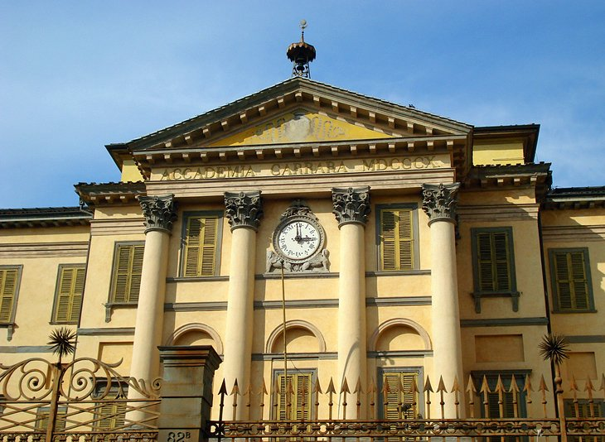

Reached by a stepped lane leading down from **Porta Sant'Agostino** is a palace housing the Accademia Carrara, an art museum with works by Italian artists Lorenzo Lotto, Palma il Vecchio, Giovanni Battista Moroni, Vittore Carpaccio, Jacopo and Giovanni Bellini, Andrea Mantegna, Girolamo Romani Romanino, Giovanni Battista Tiepolo, Titian, Paolo Veronese, Raffael Santi, Sandro Botticelli, Luca Signorelli, and Carlo Crivelli, as well as works by Albrecht Dürer and Anton van Dyck.

**6 Cinta Muraria and the City Gates**

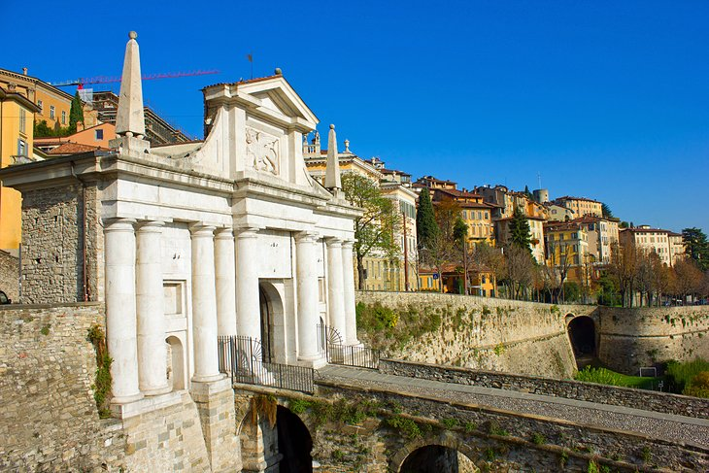

**marvellous, descends, funicular**

More than four kilometers of walls built by the Venetians surround the old city, known as the Cinta Muraria. Viale delle Mura follows them from **Porta Sant'Alessandro**, near the Donizetti Museum, past **Porta San Giacomo**, the most …marvellous……………………. of the town gates, and on past the church of Sant'Agostino to **Porta Sant'Agostino**. From this gate, Viale Vittorio Emanuele II ,…descends………………. past the lower station of the …funicular……………………. and into the center of the lower town

**7 Cathedral of Sant'Alessandro**

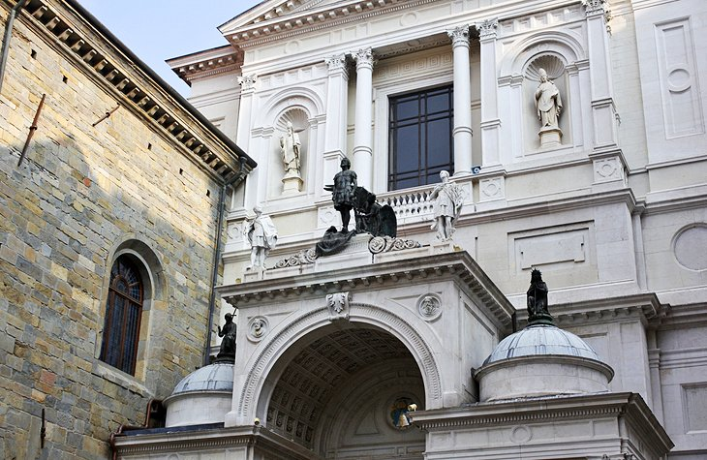

**stalls, adorned, displayed, reliquaries**

At one end of **Piazza del Duomo**, at right angles to **Santa Maria Maggiore**, is the cathedral of Sant'Alessandro, built in 1459, and with a Neoclassical façade and dome added in 1889. Inside are paintings by Tiepolo, Previtali, and Moroni and beautiful Baroque choir-…stalls…………... Along with several silver …reliquaries…………………., the church treasury displays the Tiara of the beatified Pope John XXIII, …adorned……………… with pearls, diamonds, rubies, and emeralds. The tiara, a chalice, and several other objects belonging to him are …displayed……………..in the Chapel of St. Vincent and St. John XXIII.

**8 Baptistery**

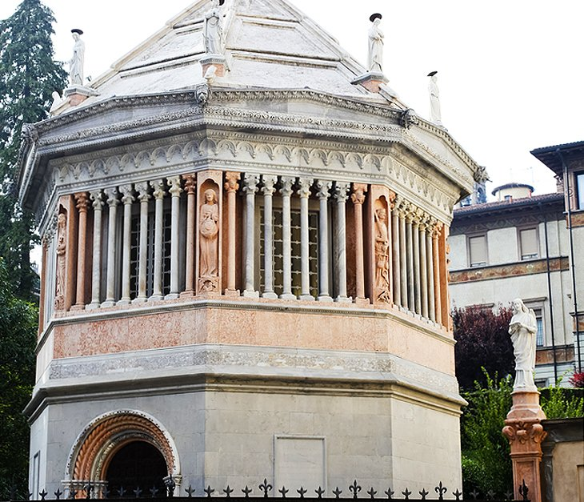

**reassembled, marble, erected,**

To the right of the Cappella Colleoni is the Baptistery, an unusual octagonal building dating from 1340. It was originally inside **Santa Maria Maggiore**, then taken down in 1661 and stored, …reassembled……………….. in 1856, and again torn down and re-erected………………… here in 1898. The statues surrounding it, representing the Virtues of Faith, Hope, Charity, Fortitude, Justice, Prudence, Temperance, and Patience, date to the 14th century. An altar behind the Baptistery has a …marble…………….. statue of St. John the Baptist.

**9 Museo Civico di Scienze Naturali (Natural Science Museum)**

**exhibits, remains, impaired, curiosities,**

From the Piazza Vecchia, the narrow Via Colleoni runs northwest to the Citadel, which houses an excellent museum with…………………. on natural science, ethnography, paleontology, and archeology. As you enter, you'll see a large reconstructed mammoth, introducing exhibits relating to the early 20th-century discovery of a large cache of mammoth and other…………………. in the nearby Petosino plain. The museum's Hall of Mammals displays finds from this region, which is very rich in fossils. In addition to the natural sciences and archaeology, the museum has more than 1,000 ethnographic artifacts, most from collections of early travelers to Africa and the Americas, interpreted for artistic and cultural qualities, not just as curiosities. Sensory features throughout the museum make it especially well adapted for visitors with …………………… sight. Audio guides are available in English.

**10 Piazza Matteotti**

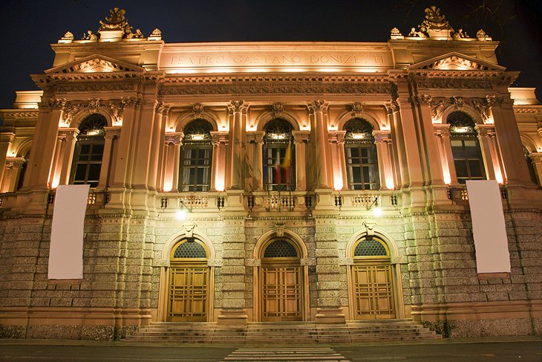

**adjoining, imposing, principal,**

The center of Bergamo's Lower Town (Città Bassa) is the Piazza Matteotti, with beautiful gardens, parks, and monuments, …………………. which is the ……………………… **Piazza Vittorio Veneto**, with the **Torre dei Caduti**, a war memorial. Opposite are the twin neo-classical gatehouses of the **Porta Nuova**, from which the wide Viale Papa Giovanni XXIII runs south to the train station. This street and the Viale Vittoria Emanuele II, which leads from the Piazza Vittorio Veneto to the upper town, form Bergamo's …………………. traffic artery. East of Piazza Matteotti, in the busy avenue called the **Sentierone**, stands the **Teatro Donizetti**, and in the east side of the Piazza Cavour is a monument to **Gaetano Donizetti**.

**11 Rocca Museum**

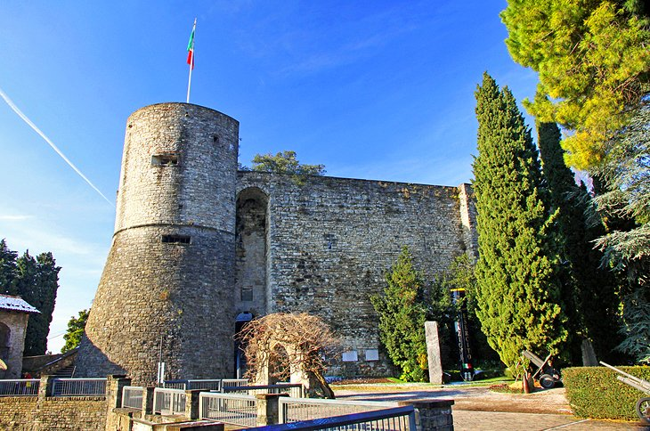

**ascends, struggle,**

From the Piazza Mercato delle Scarpe, Via alla Rocca, to the right, …ascends……………………… to the Rocca, a 14th-century bastion that contains the Museo del Risorgimento e della Resistenza. This museum contains documents and exhibits about the …struggle………….. for independence in [Italy](https://www.planetware.com/italy-tourism-vacations-i.htm), when the city of Bergamo was freed from Austrian rule by the army of Giuseppe Garibaldi. Views from the castle keep and the adjoining Parco della Rimembranza (Remembrance Park) cover a full 360-degrees.