With fashionable Milan as its capital, celebrated vineyards and grand lakeside villas, Lombardy is definitely northern Italy’s most glamorous region. But it is also an amazing place for outdoor sports enthusiasts and offers endless destinations for culture vultures. Here is a short list of top attractions across the province.

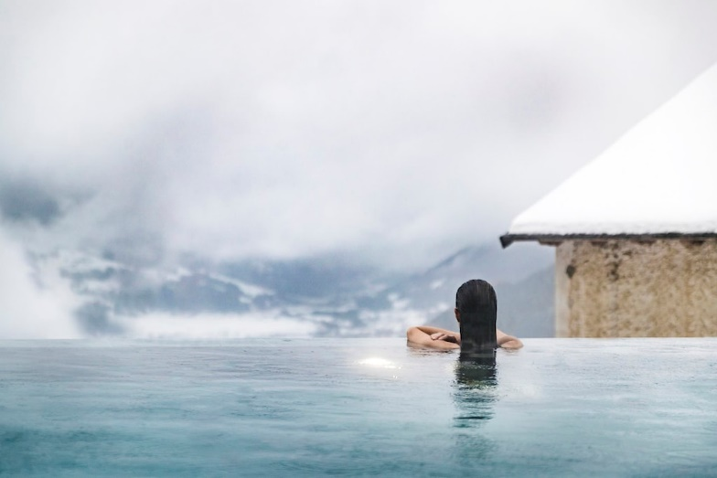

**wellness, panorama, springs, capped, banks,**

Bormio is a small commune in the Valtellina area of the Alps close to Switzerland, which is built around ancient hot ………………... For centuries people have travelled to Bormio in search of ……………………….. from the thermal spa and fresh mountain air. There are three main points to the resort: Bagni Vecchi (the old baths), [Bagni Nuovi](http://www.awin1.com/cread.php?awinaffid=306915&awinmid=7038&p=https%3A%2F%2Fwww.viator.com%2Fen-GB%2Ftours%2FLivigno-and-Bormio%2FOld-Terme-Bagni-Bormio-spa-entrance%2Fd25873-17024P272) (the new baths), and Terme di Bormio (the spa). The charming 1,000-year-old Bagni Vecchi features a pool in an ancient Roman tunnel and provides a spectacular ………………………….. of the snow-…………………… western Dolomites. The wild spring is situated on the …………………… of the nearby stream and waters reach around 40°C

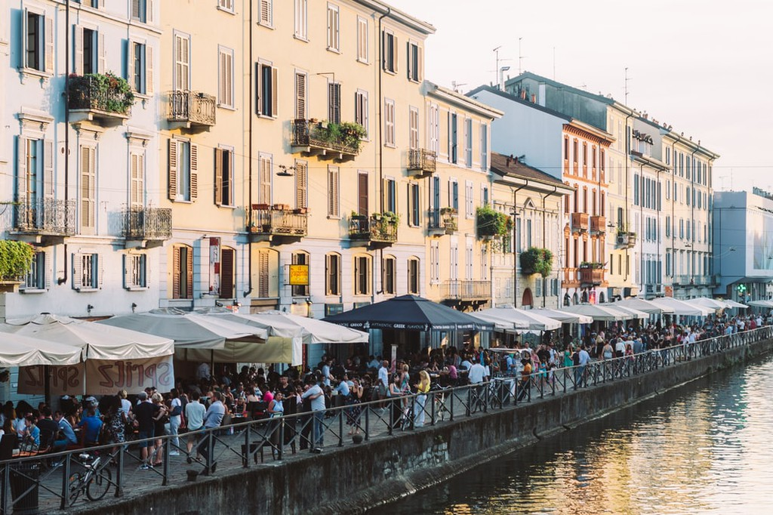

**thriving, stalls, vendors, embroidery, glassware**

On the first Sunday of each month, Navigli Grande is transformed into a …………………………. antiques market. Amble (or hustle) along the canal side, which is crowded with ……………………….. selling everything from traditional white linen tablecloths with lace …………………………. and antique …………………………., to mid-century lamps and vintage designer Italian skirt-suits. The level of quality of what is on offer is mostly very high. The canals are also lined with bars and [restaurants](https://theculturetrip.com/europe/italy/articles/the-10-best-restaurants-in-brera-milan/) so you can stop for lunch or coffee at any time. It is open roughly between 8am and 6pm, but some …………………. start packing away at about 4pm.

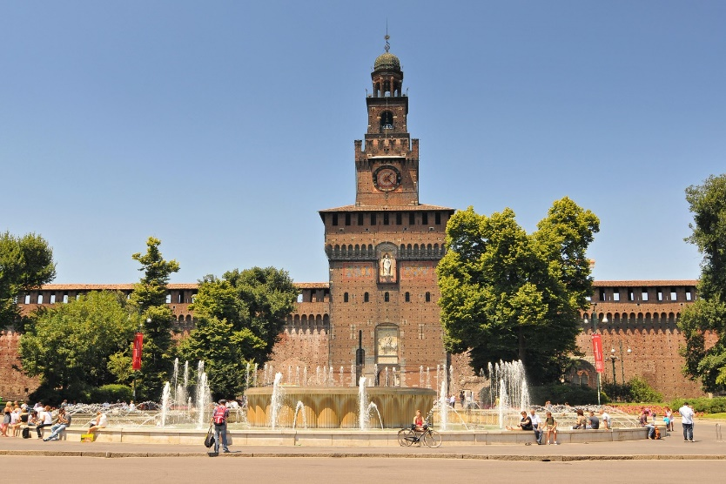

**medieval, fortress, allotting, comprises,**

After the Duomo, [Castello Sforzesco](http://www.awin1.com/cread.php?awinaffid=306915&awinmid=7038&p=https%3A%2F%2Fwww.viator.com%2Fen-GB%2FMilan-attractions%2FCastello-Sforzesco%2Fd512-a725) is the next major ‘symbol of Milan’ and is the best place to learn about the city’s …………………. and early modern history (the castle bore witness to Spanish, Habsburg and Napoleonic rule). The imposing …………………..was built by Francesco Sforza (the first Duke of Milan) in the 15th century, but underwent several modifications in the following decades. It is worth …………………. a large amount of time to visit the castle because it ……………………. multiple museums and galleries, including the Pinacoteca which is home to paintings by the likes of Bronzino, Tintoretto and Titian.

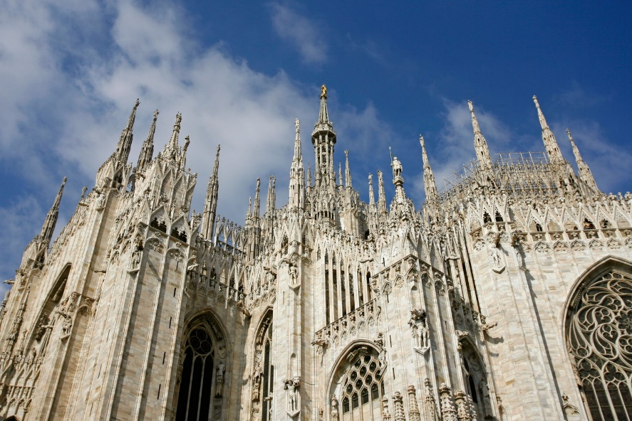

**site, elaborate, intricacies, hued, rooftop,**

Every major European city has an iconic architectural ………………, the Eiffel Tower in Paris, Big Ben in London… in Milan it is the majestic [Duomo](https://www.getyourguide.co.uk/milan-cathedral-l3580/?partner_id=NXU0022&utm_medium=online_publisher&placement=other), situated at the very centre of the city in Piazza del Duomo. Built with pink-…………………………… white marble from the quarries of Lake Maggiore, the cathedral is the biggest and arguably the most ……………………. Gothic building in Italy. Construction began in 1386 but took over six centuries to complete. Make sure you climb to the ……………………… where you can take-in a panoramic view of the city and admire the …………………………… of the architecture. To learn about the cathedral’s history visit the adjacent museum, Museo del Duomo.

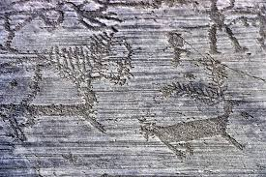

Valcamonica

**valleys, engravings, enticing, habitation,**

[Valcamonica](http://www.turismovallecamonica.it/en) is one of the most famous valleys in Lombardy, known for its cultural significance and …………………….. regional foods. It measures 90 kilometers in length, from Passo del Tonale down to Lake Iseo. This valley is very ancient and there is evidence of human …………………….. from pre-historic times. A proof of this is the series of rock ……………………….that are dotted across the valley and which can be visited for free during a trek in the hills – culture and nature in one.