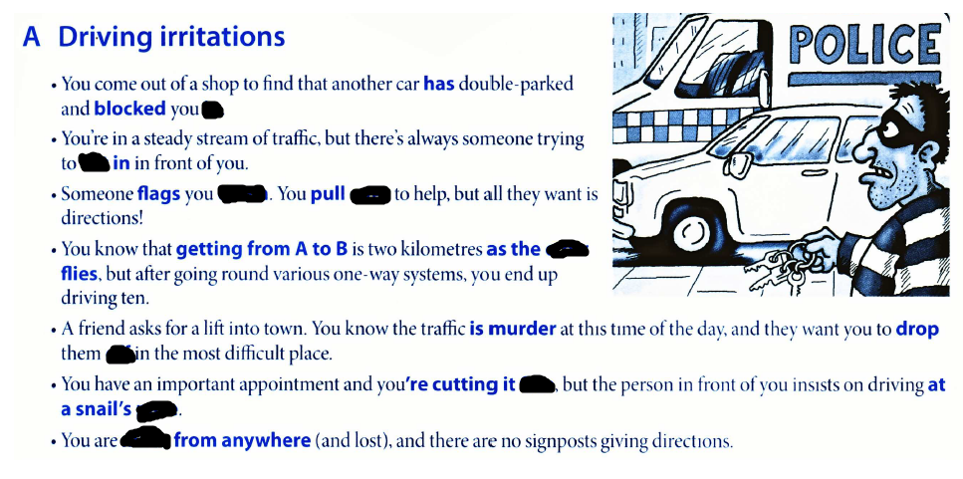

over, In, cut, down , crow, off, pace, miles, fine