Requirements Report for The People’s Bao

Project background
The People’s Bao (TPB) is intended to be an open source replacement for the Chairman’s Bao web application. The product’s core purpose is to help people’s Chinese learning journey – providing the tools to make the learning process a little easier and more intuitive.
The project is intended to be a practice project of u/thewooniverse and u/wokebison, to practice the use of OOAD, git, bash, scripting, APIs, python and its many frameworks (Django, Beautiful Soup etc…)
Which, if successful – will serve the above function for himself and many others!

Product Functions
The core functionality of the People’s Bao will be allowing users to enter an URL with an article, or simply copy and paste the Chinese text from the article itself (if the web scraping module is not yet built or is faulty) – or alternatively to view existing translated articles on in the app’s library.
The application then plugs the body text of the article (scraped or entered manually) via google translate API to get the translated version of the body text, and presents the returned article with a nice UI with view different view options and interactivity.
View options include enable / show pinyin, or hide pinyin over the body text, along with a translated body text for full sentence translations below the Chinese article (see diagram 1. For prototype)
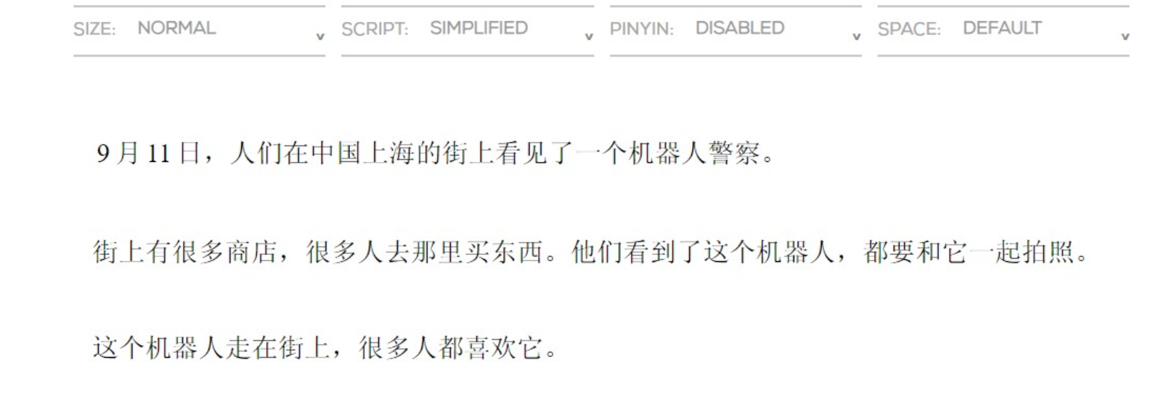
Diagram 1 – prototype scrapped from TCB
The users are then able to interact with the translated body text by highlighting individual characters and words, to see their individual meanings, their HSK level and to add them into their personal lists.
The app is also able to roughly determine the level of a provided article by the % of different characters of different difficulty that are in the body text.
The users have their own lists of articles and words which they can manage and edit (for example, viewed, book marked article lists – viewed, reviewed, mastered words).
The app will also provide support for flash cards with user words and spaced repetition based testing on later versions of the app.

The homepage will have a central field to enter the URL with an option to change the field into a larger field to paste Chinese text into.

Features
V1

V2

V3

