Adhesion factors of S. aureus on the skin of AD (AdheSaur)

W. Francuzik

# Background

1. The reason for an increased colonization of atopic skin with *S. aureus* in unknown.
2. Microbial Surface components recognizing adhesive matrix molecules (MSCRAMMs) of S. aureus are recognizing FIBRONECTIN/FIBRINOGEN and bind to it.
3. The Fibronectin is incresed in the AD skin!!!! Healthy and diseased.
4. The reason for the increase in fibronectin in AD is unknown
5. Fibronectin might depend on the increased Th2 response in AD.
6. IL-4 can induce fibronectin production in skin.
7. Blocking of the FnbpA MSCRAMM of S. aureus can be a selective therapeutic target for the treatment of S. aureus.
8. Binding of S. aureus depends also on other factors!!! so this needs further examination.

# Proposed mechanisms

## Skin scratching

The skin barrier is mechanically destroyed by scratching and extracellular matrix molecules (e.g. fibronectin, fibrinogen or collagen) which act as binding partners for the microbial surface components recognizing adhesive matrix molecules (MSCRAMMs) of *S.aureus* are enriched at the lesional skin sites. As a result despite the antimicrobial activity mediated by the immune system, *S. aureus* might be more prone to adhere to lesional skin sites of AD patients than other bacteria.

Possibly TSLP is making the Th2 respons more important and therefore the increasing FN production.

## The problem with IL-4 action on the FN production.

Two papers have totally different approach and understanding of IL-4 roles on producing the FN in skin.

Pstlethwaite et al. (Postlethwaite et al. 1992) suggest that IL4 may be a “fi- brogenic cytokine” that could be important in promoting biogenesis of extracellular matrix proteins in normal wound healing and in pathological fibrosis in which mast cells and T lymphocytes play a central role.

Authors found out that collagen in fibroblast culture as well as fibronectin production were upregulated in a dose dependent fashion under IL4 influence. It does not stimulate FIBROBLST growth. It increased the FN production fourfold.

On the other hand Serezani et al. (2017) state that IL-4 impairs wound healing potential in the skin by repressing fibronectin expression.

The question is now who understood it better.

Both studies used cells from foreskin cell cultures, but the latter paper used actually ~100 cell lines. and the first paper analyzed GENE expression not PROTEIN expression as in the latter.

## Importance of adhesion:

Unknown (2019) : One important mechanism promoting colonisation is adherence of S. aureus to surface components of the nasal epithelium or epidermal keratinocytes, such as fibrinogen, fibronectin, and cytokeratins. S. aureus utilises microbial surface components, such as fibrinogen-binding proteins A and B, iron- regulated surface determinant, and wall teichoic acid, to bind adhesive matrix molecules. 24,25 Interestingly, pH values between 7 and 8, which are usually found in AD after the disruption of the skin barrier (compared with the pH values of 4.2–5.6 found in normal skin), are more likely to support this adhesion process. 26 Furthermore, the expression of fibronectin is regulated by IL-4, the crucial Th2-promoting cytokine that is present in higher concentrations in AD patients. 27

# Background information

## What are the MSCRAMMs on S. aureus



Major MSCRAMMs

## What ligands are present in epidermis/dermis ?

I could not find anything about bone sialoprotein in epidermis and dermis.

### Fibrinogen

It is present in the dermis and epidermis

F3879-100MG 65.70

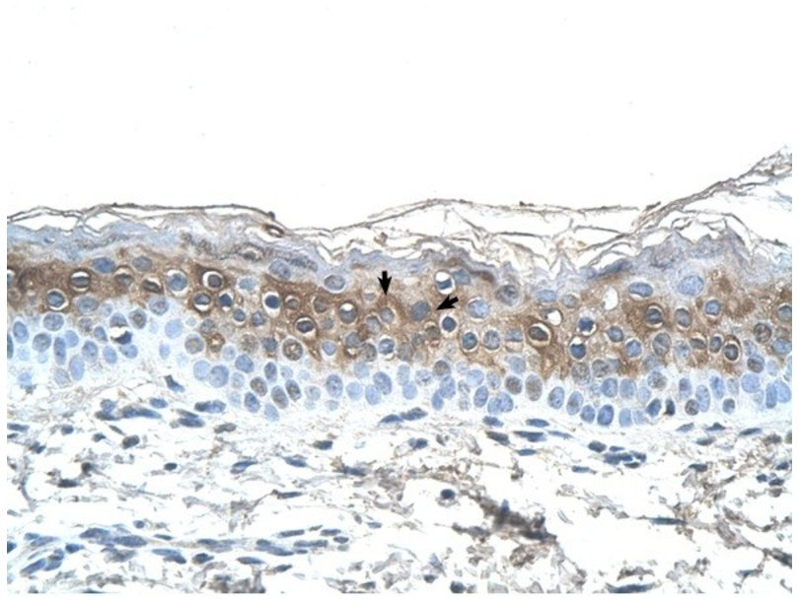

Fibrinogen staining for the alpha chain

### Fibrin

It is present in the dermis and epidermis F5386-1G 308.50

### Fibronectin

It is present in the dermis and epidermis

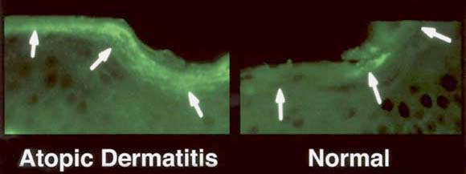

Fibronectin

Sigma aldrich prod#: F2518-.5MG 574.00

### Elastin

Elastin from human skin E7402 insoluble powder (Sigma) E7402-2MG  
324.50

### Collagen

C7624 Collagen human, Bornstein and Traub Type I, recombinant, expressed in Nicotiana tabacum (tobacco),  
C7624-5ML  
231.00

VCarriel et al. (2011)

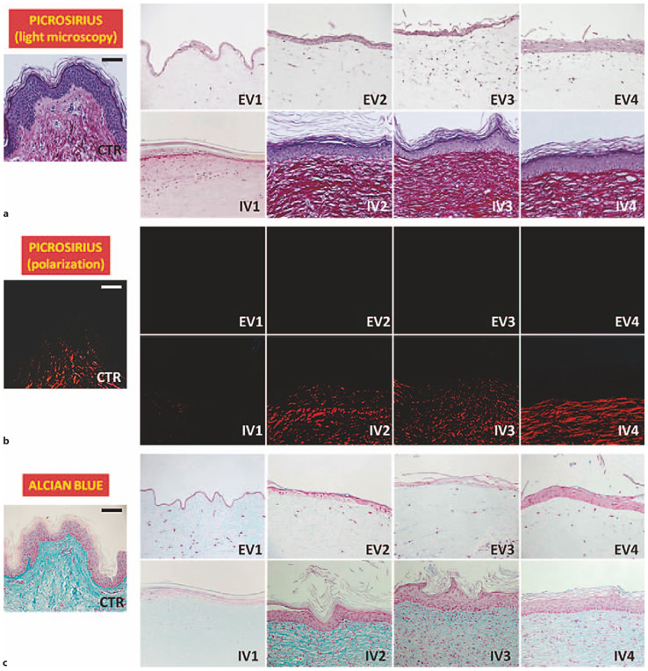

CTR colagens!

### Cytokeratin 10

How the keratin look like in normal skin (the CTR ahe human skin sections)

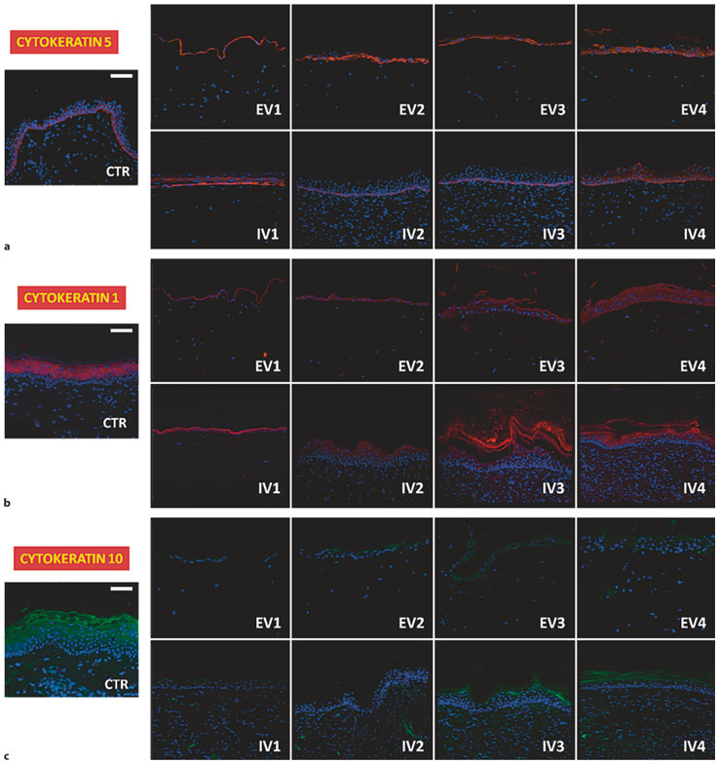

CTR are important

HE staining revealed that FLG knock-down resulted in obvious and strong alterations in the morphology of the viable epidermis and stratum corneum. In the normal skin model, all the epidermal layers were clearly structured, and the typical flattening of the keratinocytes that occurs during epidermal differentiation could be seen (Figure 1b). By contrast, transfected (FLG knock-down) skin constructs exhibited an obviously disturbed development of the stratum corneum (Figure 1c), with intercellular and intracellular spongiosis as a permanent feature. The typical flattening of the keratinocytes and the loss of nuclei during keratinocyte differentiation were less pronounced in the skin disease model. Furthermore, the staining clearly revealed typically erected cells and their compact organisation in the basal epidermal layer of the normal tissue (Figure 1b). This was not observed in the FLG knock-down model (Figure 1c). The epidermal differentiation markers, involucrin, keratin 10, keratin 14 and collagen IV, were expressed in the skin constructs, both normal and diseased, but with varying levels of intensity (data not shown):

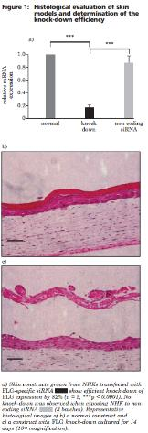

equiv

### Involucrin

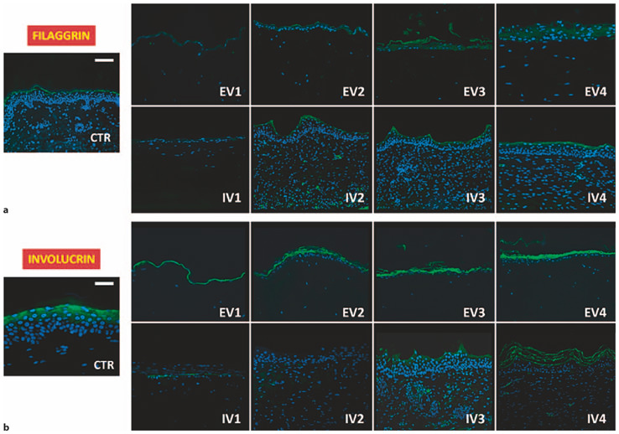

Involucrin CTR!

Wholle human keratin… K0253-1MG 242.50

## Diffecences in immuno histology of AD lesions

### CKFL1

Yang et al. (2013) show dfferent expression of this molecule in AD lesions.

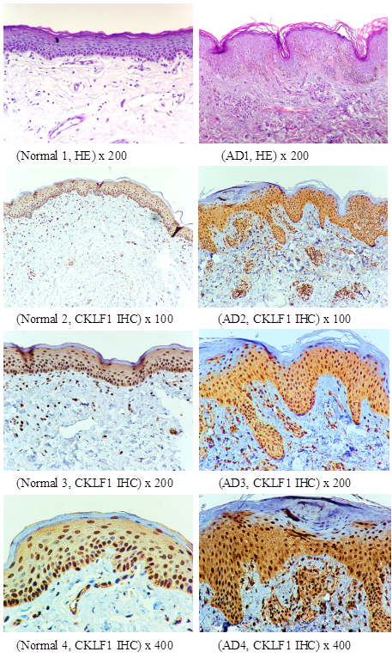

skin lesions CKFL1

### NGF and NPY

### Cathepsin L

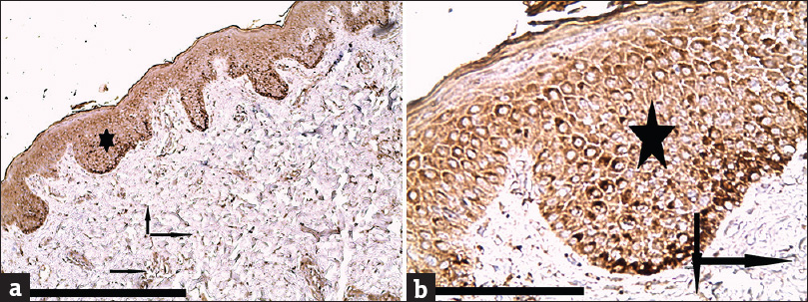

cathepsinL

### E selectin.

### ICAM 1

### SSTR 1-5

### List:

1. Fibronectin
2. Fibrinogen
3. Fibrin
4. Elastin
5. Cytokeratin 10
6. Vitronectin
7. Involucrin
8. Collagen
9. ICAM-1
10. Beta-Neurexin
11. Cathepsin L
12. E-selectin
13. Nerve growth factor
14. Neuropeptide Y
15. Chemokine-like factor

# Proposed experiments

## Staining of skin sections

First we need to decide which CANDIDATE Proteins to include in our study

1. Establish the staining.
2. Start with Sabine’s samples (stored AD skin samples),
3. Perform stainings on healthy skin
4. Primers for ligand genes. (UCSC)
5. We want to include proteins that are MSCRAMMS ligands and are present on hman skin.
6. They must also be elevated in AD !!

So first step is to conduct a literature search to describe such proteins.

This search will be as follows:

1. Search for the proteins that are MSCRAMMS ligands for aureus.
2. Search for proteins that are known to allow binding to aureus to skin
3. Search for differently expressed proteins in AD skin.

### Genes that are upregulated in IL-4 treated HK cells:

RELN - Entrez Gene Summary for RELN Gene This gene encodes a large secreted extracellular matrix protein thought to control cell-cell interactions critical for cell positioning and neuronal migration during brain development. This protein may be involved in schizophrenia, autism, bipolar disorder, major depression and in migration defects associated with temporal lobe epilepsy. Mutations of this gene are associated with autosomal recessive lissencephaly with cerebellar hypoplasia. Two transcript variants encoding distinct isoforms have been identified for this gene. Other transcript variants have been described but their full length nature has not been determined. [provided by RefSeq, Jul 2008]

This would be a potential new candidate…

GPNMB: The protein encoded by this gene is a type I transmembrane glycoprotein which shows homology to the pMEL17 precursor, a melanocyte-specific protein. GPNMB shows expression in the lowly metastatic human melanoma cell lines and xenografts but does not show expression in the highly metastatic cell lines. GPNMB may be involved in growth delay and reduction of metastatic potential. Two transcript variants encoding different isoforms have been found for this gene. [provided by RefSeq, Jul 2008]

This is expressed on the keratinocytes according to the work of Tomihari et al. (2009)

## What is the expression pattern of fibronectin during the course of AD (considering the acute and chronic phase)?

Using the skin biopsies from AD patients and healthy controls we will determine and compare the distribution patterns of fibronectin using immunohistochemistry (for the protein quantification) and qPCR (for the mRNA quantification).

### Ex. 1.1 Get the probes of AD skin from Sabine and their description

Sabine has the probes from her thesis described. Dennis knows where they are.

## 2. Which mechanisms (e.g. which cytokines) affect the expression of fibronectin in the skin?

Using either ex vivo skin or skin equivalents in cultures we will investigate which cytokines stimulate the expression of fibronectin using the above-mentioned methods.

## 3. Does increased fibronectin expression promote *S. aureus* colonization?

Using fibronectin cell adhesion assay we will determine the adhesion of various bacteria to fibronectin. This will help to investigate which of skin commensals are predisposed to colonize skin during an increased fibronectin expression. This step will be repeated for other discovered MSCRAMMs ligands.

Afterward, using skin equivalents or ex vivo skin we will recreate the conditions resembling healthy human skin surface and subsequently introduce the cytokine milieu similar to AD (Th2 type of response). The observed changes in potential ligands for MSCRAMMs will lead to the subsequent phase - evaluation if *S. aureus* introduced in these cultures will show an increased adherence to the treated skin.

## 4. Which other compounds may be plausible *S. aureus* MSCRAMMs ligands in AD?

To identify further potential MSCRAMMs ligands we will perform in silico experiments based on the literature search. After identification of plausible candidates, we will perform binding assays to prove their interaction. We will repeat steps 1-3 to verify their clinical significance.

The results of these experiments will subsequently be used in further studies to evaluate the changes in the composition of the skin microbiome after challenge with topical application of MSCRAMMs ligands by performing our already established protocol for the quantification of selected bacterial species in skin samples (qPCR).

# Methods used in the studies

## Binding assays

### Cover slip fibronecting binding.

The GREEN eta l 1995 have used cover slips to bind aureus to fibronectin.

# References:

Postlethwaite, A E, M A Holness, H Katai, and R Raghow. 1992. “Human Fibroblasts Synthesize Elevated Levels of Extracellular Matrix Proteins in Response to Interleukin 4.” *Journal of Clinical Investigation* 90 (4). American Society for Clinical Investigation: 1479–85. doi:[10.1172/jci116015](https://doi.org/10.1172/jci116015).

Serezani, Ana P.M., Gunseli Bozdogan, Sarita Sehra, Daniel Walsh, Purna Krishnamurthy, Elizabeth A. Sierra Potchanant, Grzegorz Nalepa, et al. 2017. “IL-4 Impairs Wound Healing Potential in the Skin by Repressing Fibronectin Expression.” *Journal of Allergy and Clinical Immunology* 139 (1). Elsevier BV: 142–151.e5. doi:[10.1016/j.jaci.2016.07.012](https://doi.org/10.1016/j.jaci.2016.07.012).

Tomihari, Mizuki, Sun-Hee Hwang, Jin-Sung Chung, Ponciano D. Cruz Jr., and Kiyoshi Ariizumi. 2009. “Gpnmb Is a Melanosome-Associated Glycoprotein That Contributes to Melanocyte/Keratinocyte Adhesion in a RGD-Dependent Fashion.” *Experimental Dermatology* 18 (7). Wiley: 586–95. doi:[10.1111/j.1600-0625.2008.00830.x](https://doi.org/10.1111/j.1600-0625.2008.00830.x).

Unknown. 2019. “Unknown.” <http://emjreviews.com/therapeutic-area/dermatology/staphylococcus-aureus-and-atopic-dermatitis-which-came-first-the-chicken-or-the-egg/>. <http://emjreviews.com/therapeutic-area/dermatology/staphylococcus-aureus-and-atopic-dermatitis-which-came-first-the-chicken-or-the-egg/>.

VCarriel, Ingrid Garz’on, Jose-MarJim’enez, Celeste-Ximenes Oliveira, Salvador Arias-Santiago, Antonio Campos, Maria-Carmen S’anchez-Quevedo, and Miguel Alaminos. 2011. “Epithelial and Stromal Developmental Patterns in a Novel Substitute of the Human Skin Generated with Fibrin-Agarose Biomaterials.” *Cells Tissues Organs*. S. Karger AG. doi:[10.1159/000330682](https://doi.org/10.1159/000330682).

Yang, Gao-yun, Xue Chen, Ya-chun Sun, Chen-li Ma, and Ge Qian. 2013. “Chemokine-Like Factor 1 (CLFK1) Is over-Expressed in Patients with Atopic Dermatitis.” *International Journal of Biological Sciences* 9 (8). Ivyspring International Publisher: 759–65. doi:[10.7150/ijbs.6291](https://doi.org/10.7150/ijbs.6291).