Elderly Paper - data analysis

W. Francuzik

21.08.2018

# Loading the data

Registered cases 10212

Cases after getting rid of some low-reporting countries 10203

Cases with severity of >= II 9415

Children 2524, adults 6891,

Adults 18-40 = 2262 Adults 41-64 = 3506 Elderly >=65 = 1123

##   
## elderly middle young  
## female 606 1974 1400  
## male 517 1532 862

##   
## Pairwise comparisons using Pearson's Chi-squared tests   
##   
## data: d.rm$b_sex and d.rm$ages   
##   
## elderly middle young  
## elderly - - -   
## middle 0.18 - -   
## young 0.000035 0.000059 -   
##   
## P value adjustment method: holm

# Atopic dermatitis

##   
## elderly middle young  
## atopic 190 836 792  
## non-atopic 933 2670 1470

##   
## Pairwise comparisons using Pearson's Chi-squared tests   
##   
## data: d.rm$d_410_atopic and d.rm$ages   
##   
## elderly middle young  
## elderly - - -   
## middle 0.0000043 - -   
## young < 0.0000000000000002 < 0.0000000000000002 -   
##   
## P value adjustment method: bonferroni

# Cardiovascular disease

##   
## Pairwise comparisons using Pearson's Chi-squared tests   
##   
## data: d.rm$q_410_cardio_cur[d.rm$q_410_cardio_cur %in% c("no", "yes")] %>% and d.rm$ages[d.rm$q_410_cardio_cur %in% c("no", "yes")] { and d.rm$ages[d.rm$q_410_cardio_cur %in% c("no", "yes")] as.character(.) and d.rm$ages[d.rm$q_410_cardio_cur %in% c("no", "yes")] } and d.rm$ages[d.rm$q_410_cardio_cur %in% c("no", "yes")]   
##   
## elderly middle young  
## elderly - - -   
## middle <0.0000000000000002 - -   
## young <0.0000000000000002 <0.0000000000000002 -   
##   
## P value adjustment method: holm

# Urticaria

##   
## elderly middle young  
## no 1067 3266 2069  
## yes 14 52 52  
## unknown 42 188 141

##   
## Pairwise comparisons using Pearson's Chi-squared tests   
##   
## data: val[which(val %in% c("no", "yes"))] %>% as.character() and d.rm$ages[which(val %in% c("no", "yes"))]   
##   
## elderly middle young  
## elderly - - -   
## middle 0.621 - -   
## young 0.081 0.079 -   
##   
## P value adjustment method: holm

# Mastocytosis

##   
## elderly middle young  
## no 1042 3211 2092  
## yes 39 107 29  
## unknown 42 188 141

##   
## Pairwise comparisons using Pearson's Chi-squared tests   
##   
## data: val[which(val %in% c("no", "yes"))] %>% as.character() and d.rm$ages[which(val %in% c("no", "yes"))]   
##   
## elderly middle young  
## elderly - - -   
## middle 0.60818 - -   
## young 0.00011 0.000084 -   
##   
## P value adjustment method: holm

# Thyroid disease

##   
## elderly middle young  
## no 919 2962 2001  
## yes 162 356 120  
## unknown 42 188 141

##   
## Pairwise comparisons using Pearson's Chi-squared tests   
##   
## data: val[which(val %in% c("no", "yes"))] %>% as.character() and d.rm$ages[which(val %in% c("no", "yes"))]   
##   
## elderly middle young  
## elderly - - -   
## middle 0.0002 - -   
## young < 0.0000000000000002 0.0000000003 -   
##   
## P value adjustment method: holm

# Physical exercise

##   
## elderly  
## no 737  
## mild eg. walking 111  
## moderate eg. vigorous housework or gardening 79  
## vigorous eg. running, heavy manual work, competitive sport 77  
## unknown 119  
##   
## middle young  
## no 2177 1355  
## mild eg. walking 370 249  
## moderate eg. vigorous housework or gardening 306 174  
## vigorous eg. running, heavy manual work, competitive sport 285 225  
## unknown 367 259

##   
## Pairwise comparisons using Pearson's Chi-squared tests   
##   
## data: d.rm$q_421_exercise and d.rm$ages   
##   
## elderly middle young  
## elderly - - -   
## middle 0.149 - -   
## young 0.024 0.100 -   
##   
## P value adjustment method: holm

# Psychological stress

##   
## elderly middle young  
## no(unlikely) 1039 3266 2083  
## yes(likely) 84 239 179

##   
## Pairwise comparisons using Pearson's Chi-squared tests   
##   
## data: d.rm$q_422_stress and d.rm$ages   
##   
## elderly middle young  
## elderly - - -   
## middle 0.98 - -   
## young 0.98 0.39 -   
##   
## P value adjustment method: holm

# Alcohol

##   
## elderly middle young  
## no 868 2597 1683  
## yes 48 178 148  
## unknown 207 731 430

##   
## Pairwise comparisons using Pearson's Chi-squared tests   
##   
## data: val[which(val %in% c("no", "yes"))] %>% as.character() and d.rm$ages[which(val %in% c("no", "yes"))]   
##   
## elderly middle young  
## elderly - - -   
## middle 0.228 - -   
## young 0.024 0.071 -   
##   
## P value adjustment method: holm

# Menstruation

##   
## elderly middle young  
## no 529 1114 591  
## yes 0 27 57  
## unknown 77 833 752

##   
## Pairwise comparisons using Pearson's Chi-squared tests   
##   
## data: val[which(val %in% c("no", "yes"))] %>% as.character() and d.rm$ages[which(val %in% c("no", "yes"))]   
##   
## elderly middle young  
## elderly - - -   
## middle 0.00078 - -   
## young 0.000000000021 0.000000002671 -   
##   
## P value adjustment method: holm

This variable should not be taken into account I think. The elderly group does not have any menstrruation…

# infection

##   
## elderly middle young  
## no 1048 3223 2039  
## yes 33 95 82  
## unknown 42 188 141

##   
## Pairwise comparisons using Pearson's Chi-squared tests   
##   
## data: val[which(val %in% c("no", "yes"))] %>% as.character() and d.rm$ages[which(val %in% c("no", "yes"))]   
##   
## elderly middle young  
## elderly - - -   
## middle 0.83 - -   
## young 0.57 0.15 -   
##   
## P value adjustment method: holm

# repeated reaction

##   
## elderly middle young  
## no 694 2117 1337  
## yes 314 1043 675  
## unknown 115 346 249

##   
## Pairwise comparisons using Pearson's Chi-squared tests   
##   
## data: val[which(val %in% c("no", "yes"))] %>% as.character() and d.rm$ages[which(val %in% c("no", "yes"))]   
##   
## elderly middle young  
## elderly - - -   
## middle 0.60 - -   
## young 0.60 0.71 -   
##   
## P value adjustment method: holm

# Elicitors

## Total

## [[1]]  
## [1] "q_310_trigger"  
##   
## [[2]]  
##   
## elderly middle young  
## no 51 180 192  
## yes 883 2685 1557  
## reasonable suspicion 189 641 513  
##   
## [[3]]  
##   
## Pairwise comparisons using Pearson's Chi-squared tests   
##   
## data: d.rm[selector, x] %>% as.character and d.rm$ages[selector] %>% as.character   
##   
## elderly middle young  
## elderly - - -   
## middle 0.36 - -   
## young 0.000000008087 0.000000000089 -   
##   
## P value adjustment method: holm

## Elicitor known

## [[1]]  
## [1] "elicitor_known"  
##   
## [[2]]  
##   
## elderly middle young  
## no 240 821 705  
## yes 883 2685 1557  
##   
## [[3]]  
##   
## Pairwise comparisons using Pearson's Chi-squared tests   
##   
## data: d.rm[selector, x] %>% as.character and d.rm$ages[selector] %>% as.character   
##   
## elderly middle young  
## elderly - - -   
## middle 0.17 - -   
## young 0.00000000566 0.00000000027 -   
##   
## P value adjustment method: holm

## Elicitor suspected

## [[1]]  
## [1] "elicitor_suspected"  
##   
## [[2]]  
##   
## elderly middle young  
## no 934 2865 1749  
## yes 189 641 513  
##   
## [[3]]  
##   
## Pairwise comparisons using Pearson's Chi-squared tests   
##   
## data: d.rm[selector, x] %>% as.character and d.rm$ages[selector] %>% as.character   
##   
## elderly middle young  
## elderly - - -   
## middle 0.28915 - -   
## young 0.00019 0.00016 -   
##   
## P value adjustment method: holm

## Drugs

## [[1]]  
## [1] "elicitor_drug"  
##   
## [[2]]  
##   
## elderly middle young  
## no 838 2708 1803  
## yes 285 798 459  
##   
## [[3]]  
##   
## Pairwise comparisons using Pearson's Chi-squared tests   
##   
## data: d.rm[selector, x] %>% as.character and d.rm$ages[selector] %>% as.character   
##   
## elderly middle young  
## elderly - - -   
## middle 0.0780 - -   
## young 0.0027 0.0578 -   
##   
## P value adjustment method: holm

### analgesics

## [[1]]  
## [1] "elicitor_analg"  
##   
## [[2]]  
##   
## elderly middle young  
## no 1012 3199 2087  
## yes 111 307 175  
##   
## [[3]]  
##   
## Pairwise comparisons using Pearson's Chi-squared tests   
##   
## data: d.rm[selector, x] %>% as.character and d.rm$ages[selector] %>% as.character   
##   
## elderly middle young  
## elderly - - -   
## middle 0.38 - -   
## young 0.12 0.38 -   
##   
## P value adjustment method: holm

### antibiotics

## [[1]]  
## [1] "elicitor_anty"  
##   
## [[2]]  
##   
## elderly middle young  
## no 1044 3277 2118  
## yes 79 229 144  
##   
## [[3]]  
##   
## Pairwise comparisons using Pearson's Chi-squared tests   
##   
## data: d.rm[selector, x] %>% as.character and d.rm$ages[selector] %>% as.character   
##   
## elderly middle young  
## elderly - - -   
## middle 1 - -   
## young 1 1 -   
##   
## P value adjustment method: holm

### Local anesthetics

## [[1]]  
## [1] "elicitor_LA"  
##   
## [[2]]  
##   
## elderly middle young  
## no 1100 3431 2218  
## yes 23 75 44  
##   
## [[3]]  
##   
## Pairwise comparisons using Pearson's Chi-squared tests   
##   
## data: d.rm[selector, x] %>% as.character and d.rm$ages[selector] %>% as.character   
##   
## elderly middle young  
## elderly - - -   
## middle 1 - -   
## young 1 1 -   
##   
## P value adjustment method: holm

### x-ray (contrast agent)

## [[1]]  
## [1] "elicitor_contrast"  
##   
## [[2]]  
##   
## elderly middle young  
## no 1101 3460 2250  
## yes 22 46 12  
##   
## [[3]]  
##   
## Pairwise comparisons using Pearson's Chi-squared tests   
##   
## data: d.rm[selector, x] %>% as.character and d.rm$ages[selector] %>% as.character   
##   
## elderly middle young  
## elderly - - -   
## middle 0.15389 - -   
## young 0.00055 0.01123 -   
##   
## P value adjustment method: holm

### PPI

## [[1]]  
## [1] "elicitor_ppi"  
##   
## [[2]]  
##   
## elderly middle young  
## no 1114 3490 2245  
## yes 9 16 17  
##   
## [[3]]  
##   
## Pairwise comparisons using Pearson's Chi-squared tests   
##   
## data: d.rm[selector, x] %>% as.character and d.rm$ages[selector] %>% as.character   
##   
## elderly middle young  
## elderly - - -   
## middle 0.61 - -   
## young 1.00 0.61 -   
##   
## P value adjustment method: holm

### Cardiovascular drugs

Here Only 1 patient in the youg adults group was positive for the cardio drugs.

## [[1]]  
## [1] "elicitor_cvd"  
##   
## [[2]]  
##   
## elderly middle young  
## no 1118 3498 2261  
## yes 5 8 1  
##   
## [[3]]  
##   
## Pairwise comparisons using Pearson's Chi-squared tests   
##   
## data: d.rm[selector, x] %>% as.character and d.rm$ages[selector] %>% as.character   
##   
## elderly middle young  
## elderly - - -   
## middle 0.383 - -   
## young 0.088 0.331 -   
##   
## P value adjustment method: holm

## Insects

## [[1]]  
## [1] "elicitor_insects"  
##   
## [[2]]  
##   
## elderly middle young  
## no 490 1618 1441  
## yes 633 1888 821  
##   
## [[3]]  
##   
## Pairwise comparisons using Pearson's Chi-squared tests   
##   
## data: d.rm[selector, x] %>% as.character and d.rm$ages[selector] %>% as.character   
##   
## elderly middle young  
## elderly - - -   
## middle 0.15 - -   
## young <0.0000000000000002 <0.0000000000000002 -   
##   
## P value adjustment method: holm

### Yellow jacket

## [[1]]  
## [1] "elicitor_yj"  
##   
## [[2]]  
##   
## elderly middle young  
## no 672 2128 1703  
## yes 451 1378 559  
##   
## [[3]]  
##   
## Pairwise comparisons using Pearson's Chi-squared tests   
##   
## data: d.rm[selector, x] %>% as.character and d.rm$ages[selector] %>% as.character   
##   
## elderly middle young  
## elderly - - -   
## middle 0.63 - -   
## young <0.0000000000000002 <0.0000000000000002 -   
##   
## P value adjustment method: holm

### Bee

## [[1]]  
## [1] "elicitor_bee"  
##   
## [[2]]  
##   
## elderly middle young  
## no 1026 3196 2060  
## yes 97 310 202  
##   
## [[3]]  
##   
## Pairwise comparisons using Pearson's Chi-squared tests   
##   
## data: d.rm[selector, x] %>% as.character and d.rm$ages[selector] %>% as.character   
##   
## elderly middle young  
## elderly - - -   
## middle 1 - -   
## young 1 1 -   
##   
## P value adjustment method: holm

### Hornet

## [[1]]  
## [1] "elicitor_hornet"  
##   
## [[2]]  
##   
## elderly middle young  
## no 1067 3387 2228  
## yes 56 119 34  
##   
## [[3]]  
##   
## Pairwise comparisons using Pearson's Chi-squared tests   
##   
## data: d.rm[selector, x] %>% as.character and d.rm$ages[selector] %>% as.character   
##   
## elderly middle young  
## elderly - - -   
## middle 0.019 - -   
## young 0.000000018 0.000037413 -   
##   
## P value adjustment method: holm

## Food

## [[1]]  
## [1] "elicitor_food"  
##   
## [[2]]  
##   
## elderly middle young  
## no 1001 2959 1555  
## yes 122 547 707  
##   
## [[3]]  
##   
## Pairwise comparisons using Pearson's Chi-squared tests   
##   
## data: d.rm[selector, x] %>% as.character and d.rm$ages[selector] %>% as.character   
##   
## elderly middle young  
## elderly - - -   
## middle 0.0001 - -   
## young <0.0000000000000002 <0.0000000000000002 -   
##   
## P value adjustment method: holm

### wheat

## [[1]]  
## [1] "elicitor_wheat"  
##   
## [[2]]  
##   
## elderly middle young  
## no 105 463 614  
## yes 17 84 93  
##   
## [[3]]  
##   
## Pairwise comparisons using Pearson's Chi-squared tests   
##   
## data: d.rm.f[selector, x] and d.rm.f$ages[selector]   
##   
## elderly middle young  
## elderly - - -   
## middle 1.00 - -   
## young 1.00 0.91 -   
##   
## P value adjustment method: holm

### hazelnut

## [[1]]  
## [1] "elicitor_HN"  
##   
## [[2]]  
##   
## elderly middle young  
## no 106 509 661  
## yes 16 38 46  
##   
## [[3]]  
##   
## Pairwise comparisons using Pearson's Chi-squared tests   
##   
## data: d.rm.f[selector, x] and d.rm.f$ages[selector]   
##   
## elderly middle young  
## elderly - - -   
## middle 0.075 - -   
## young 0.052 0.845 -   
##   
## P value adjustment method: holm

### soy

## [[1]]  
## [1] "elicitor_soy"  
##   
## [[2]]  
##   
## elderly middle young  
## no 116 500 676  
## yes 6 47 31  
##   
## [[3]]  
##   
## Pairwise comparisons using Pearson's Chi-squared tests   
##   
## data: d.rm.f[selector, x] and d.rm.f$ages[selector]   
##   
## elderly middle young  
## elderly - - -   
## middle 0.4813 - -   
## young 0.9792 0.0098 -   
##   
## P value adjustment method: holm

### celery

## [[1]]  
## [1] "elicitor_celery"  
##   
## [[2]]  
##   
## elderly middle young  
## no 115 510 670  
## yes 7 37 37  
##   
## [[3]]  
##   
## Pairwise comparisons using Pearson's Chi-squared tests   
##   
## data: d.rm.f[selector, x] and d.rm.f$ages[selector]   
##   
## elderly middle young  
## elderly - - -   
## middle 1.00 - -   
## young 1.00 0.92 -   
##   
## P value adjustment method: holm

### shellfish

## [[1]]  
## [1] "elicitor_shellfish"  
##   
## [[2]]  
##   
## elderly middle young  
## no 107 494 637  
## yes 15 53 70  
##   
## [[3]]  
##   
## Pairwise comparisons using Pearson's Chi-squared tests   
##   
## data: d.rm.f[selector, x] and d.rm.f$ages[selector]   
##   
## elderly middle young  
## elderly - - -   
## middle 1 - -   
## young 1 1 -   
##   
## P value adjustment method: holm

### peanut

## [[1]]  
## [1] "elicitor_peanut"  
##   
## [[2]]  
##   
## elderly middle young  
## no 121 528 658  
## yes 1 19 49  
##   
## [[3]]  
##   
## Pairwise comparisons using Pearson's Chi-squared tests   
##   
## data: d.rm.f[selector, x] and d.rm.f$ages[selector]   
##   
## elderly middle young  
## elderly - - -   
## middle 0.207 - -   
## young 0.032 0.032 -   
##   
## P value adjustment method: holm

## Immunotherapy (SIT)

## [[1]]  
## [1] "elicitor_SIT"  
##   
## [[2]]  
##   
## elderly middle young  
## no 1118 3476 2229  
## yes 5 30 33  
##   
## [[3]]  
##   
## Pairwise comparisons using Pearson's Chi-squared tests   
##   
## data: d.rm[selector, x] %>% as.character and d.rm$ages[selector] %>% as.character   
##   
## elderly middle young  
## elderly - - -   
## middle 0.236 - -   
## young 0.041 0.086 -   
##   
## P value adjustment method: holm

# Plots

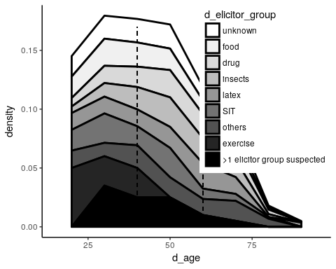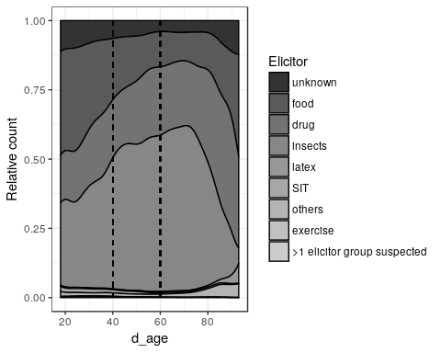

So we can do it - the question now is what do we want to display? Food? or any other variables here that may be of interest?

Second plot - symptoms

## Gastrointestinal

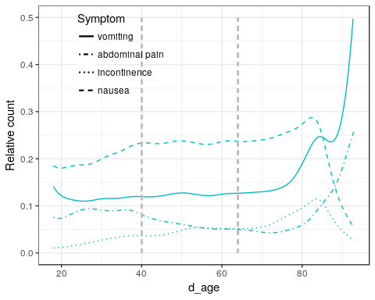

## Skin

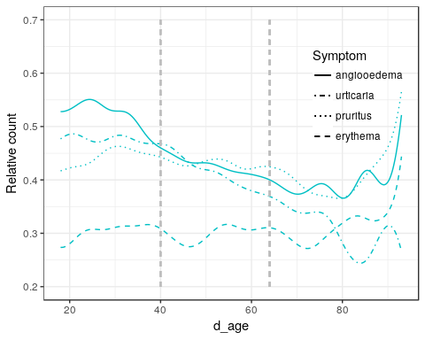

## Respiratory

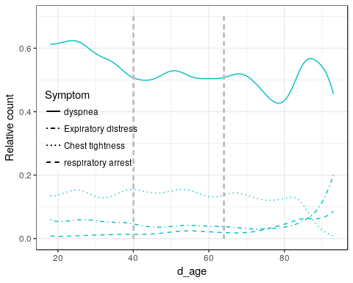

## Cardiac

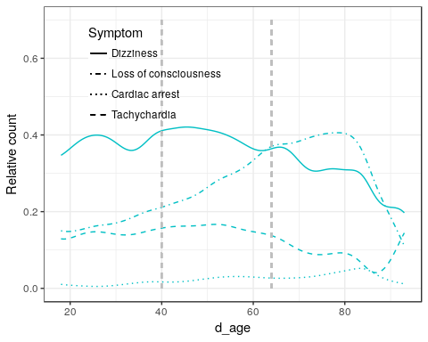

# Risk of developing a biphasic reaction

## with concomitant hypotension

left Biphasic, top - Hypotension as a symptom. Alle cases, no age differentiation:

## Number of cases in table: 4940   
## Number of factors: 2   
## Test for independence of all factors:  
## Chisq = 1.738, df = 1, p-value = 0.1874

## with unknown trigger as an elicitor

Unknown elicitor showed relevant meanig that unknown trigger-cases were more often connected with biphasic reactions

##   
## no yes  
## no 292 3588  
## yes 25 148

## Trigger  
## Biphasic unknown known  
## not biphasic 0.92113565 0.96038544  
## biphasic 0.07886435 0.03961456

## Number of cases in table: 4053   
## Number of factors: 2   
## Test for independence of all factors:  
## Chisq = 11.016, df = 1, p-value = 0.0009031

## Biphasic reaction depending on the trigger group

##   
## -9 no yes unknown  
## food 206 1067 42 61  
## drugs 240 1150 44 108  
## insects 818 2166 96 261  
## other 38 149 11 10  
## unkown 73 292 25 34

##   
## Pairwise comparisons using Pearson's Chi-squared tests   
##   
## data: tab   
##   
## food drugs insects other unkown  
## food - - - - -   
## drugs 1.000 - - - -   
## insects 1.000 1.000 - - -   
## other 0.639 0.616 0.860 - -   
## unkown 0.035 0.024 0.051 1.000 -   
##   
## P value adjustment method: holm

##   
## Pearson's Chi-squared test with Yates' continuity correction  
##   
## data: t[c(1, 5), 2:3]  
## X-squared = 8.3589, df = 1, p-value = 0.003838

# e_420_CoF_incl_infect

##   
## elderly middle young  
## no 1123 3506 2262

##   
## Pairwise comparisons using Pearson's Chi-squared tests   
##   
## data: val[which(val %in% c("no", "yes"))] %>% as.character() and d.rm$ages[which(val %in% c("no", "yes"))]   
##   
## elderly middle young  
## elderly - - -   
## middle <0.0000000000000002 - -   
## young <0.0000000000000002 <0.0000000000000002 -   
##   
## P value adjustment method: holm

# e_423_five

##   
## elderly middle young  
## no 509 2634 2143  
## yes 614 872 119

##   
## Pairwise comparisons using Pearson's Chi-squared tests   
##   
## data: val[which(val %in% c("no", "yes"))] %>% as.character() and d.rm$ages[which(val %in% c("no", "yes"))]   
##   
## elderly middle young  
## elderly - - -   
## middle <0.0000000000000002 - -   
## young <0.0000000000000002 <0.0000000000000002 -   
##   
## P value adjustment method: holm

# Differences between Age groups and time to reaction

##   
## 00 – 10 Minutes 11 - 30 Minutes 31 - 60 Minutes 61 - 120 Minutes  
## elderly 436 199 57 41  
## middle 1364 682 188 116  
## young 782 425 183 77  
##   
## 121 – 240 Minutes (2 – 4 hours) more than 240 Minutes  
## elderly 29 21  
## middle 71 61  
## young 61 69

##   
## Pairwise comparisons using Pearson's Chi-squared tests   
##   
## data: tab   
##   
## elderly middle young  
## elderly - - -   
## middle 0.707 - -   
## young 0.006 0.0000024 -   
##   
## P value adjustment method: holm