The area of focus a case report

Firstname Lastname1

Firstnamea Lastnamea2

1 Division of X, Department of Y, University of Z, Address 1, 10117 City,

2 Division of X2, Department of Y2, University of Z2, Address 1, 10117 City,

**Corresponding author:** Prof. Dr. med. X. Why Zet ([xyz@uni.edu](mailto:xyz@uni.edu)) Phone: ; Fax:

**Disclosures:** This work was supported by… Authors disclose no potential conflicts of interest.

**Author contributions:** XY wrote the original manuscript, revised it critically and analyzed the data. ZY YX both analyzed the data and revised the manuscript critically.

**Running head:** Shorter title.

**Abstract:**

*Introduction*: Sed leo ante, dictum quis tellus nec, imperdiet egestas ex. Proin non lacinia erat, nec bibendum augue. Quisque malesuada ante elementum, tempor felis et, faucibus orci.

*Case report*: Mauris dictum justo sit amet sem rhoncus pulvinar. Sed eros dolor, auctor non ante ut, facilisis accumsan nulla. Integer consectetur eget risus nec accumsan.

*Conclusion*: Integer tellus tellus, semper dictum turpis quis, mollis dictum mauris. Phasellus in lectus a nibh dapibus vehicula a eu elit. Pellentesque habitant morbi tristique senectus et netus et malesuada fames ac turpis egestas.

**Keywords:**

# Introduction

# Patient Information

This is how to cite a table (table 1).

This is how to cite a figure (Fig. 1).

# Clinical Findings

# Timeline

# Diagnostic Assessment

# Therapeutic Intervention

# Follow-up and Outcomes

# Discussion

# Patient Perspective

# Informed Consent

# Acknowledgements

We acknowledge and thank the X.

# References

##### 

# Tables

Table 1 The Title of a table comes here.

|  |  |  |  |  |  |  |  |  |  |  |  |
| --- | --- | --- | --- | --- | --- | --- | --- | --- | --- | --- | --- |
|  | mpg | cyl | disp | hp | drat | wt | qsec | vs | am | gear | carb |
| Mazda RX4 | 21 | 6 | 160 | 110 | 4 | 3 | 16 | 0 | 1 | 4 | 4 |
| Mazda RX4 Wag | 21 | 6 | 160 | 110 | 4 | 3 | 17 | 0 | 1 | 4 | 4 |
| Datsun 710 | 23 | 4 | 108 | 93 | 4 | 2 | 19 | 1 | 1 | 4 | 1 |
| Hornet 4 Drive | 21 | 6 | 258 | 110 | 3 | 3 | 19 | 1 | 0 | 3 | 1 |
| Hornet Sportabout | 19 | 8 | 360 | 175 | 3 | 3 | 17 | 0 | 0 | 3 | 2 |
| Valiant | 18 | 6 | 225 | 105 | 3 | 4 | 20 | 1 | 0 | 3 | 1 |

##### 

# Figures

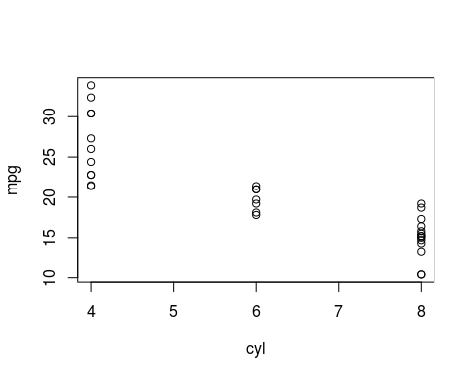

Figure 1 This is the description of a figure. Note that it has to be written here

##### 

# Online supplemental material