MWD

# Results

This text refers to Fig. 1. We also want to refere here to Fig. 2.

In some cases we also need supplementary data. Please see Suppl. Fig. S3.

Please note that the ‘S’ before the reference should optimally NOT be there and ideally one should write:

Fig. \@ref(fig:fig1supp)

what would evaluate to Fig. S1.

# Figures

plot(1)

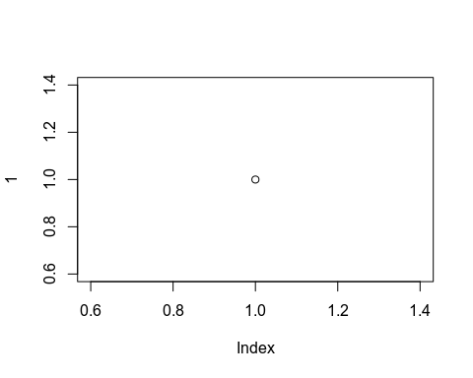

Figure 1: First Main Figure

plot(1)



Figure 2: Second Main Figure

# Supplementary data

plot(1)



Figure 3: This is a supplementary figure and it should be called Fig. S1 and not Fig 3.