Insect venom anaphylaxis: a case - control study of the European Anaphylaxis Registry

Wojciech Francuzik1

Sabine Dölle-Bierke1

Franziska Ruëff2

Claudia Pföhler3

Kathrin Scherer Hofmeier4

Margitta Worm1

24 Juli, 2019

1 Department of Dermatology, Venerology, and Allergology, Charité – Universitätsmedizin Berlin, corporate member of Freie Universität Berlin, Humboldt-Universität zu Berlin, and Berlin Institute of Health, Charitéplatz 1, 10117 Berlin,

2 Department of Dermatology and Allergology, Klinikum der Universität München, Germany

3 Department of Dermatology, Saarland University Hospital, Homburg/Saar, Germany

4 Department of Dermatology, University Hospital Basel, Switzerland

**Corresponding author:**  Prof. Dr. med. M. Worm [margitta.worm@charite.de](mailto:margitta.worm@charite.de) Phone: +49 30 450 529 005; Fax: +49 30 450 529 902

**Keywords:** anaphylaxis, adrenaline (epinephrine), beta-blockers, insect venom allergy, yellow-jacket

**Document statistics:** Word count, figures, tables, references

# Abstract

Insect-venom elicited anaphylaxis is a common hypersensitivity reaction which may be life-threatening. Using the data from the European Anaphylaxis Registry (12874 cases in total) we identified insect-venom elicited anaphylaxis cases (n = 4953) and analyzed these in comparison to anaphylaxis elicited by other elicitors (n = 7921).

The data showed that 68.2% of all insect elicited cases were elicited by yellow jackets, followed by bees (20.5%). The insect venom elicited cases occurred mostly in outdoor places (46%) patients’ homes (13.2%) or urban places (9.4%).

Skin, gastrointestinal and respiratory symptoms occurred less frequently in insect elicited cases of anaphylaxis, whereas cardiologic symptoms (with hypotension, collapse, and loss of consciousness) were more frequent. Intramuscular adrenaline (as a first-line therapy) was administered significantly less often in insect venom elicited cases (36.8% vs 52.6, p < 0.0001). The mortality rate in insect anaphylaxis was comparable to other cases (0.295%, p = 0.174).

Patients who experienced insect-venom anaphylaxis were older (p < 0.0001), more often had concomitant mastocytosis (p < 0.0001) and cardiologic conditions (p < 0.0001) and females more often had concomitant thyroid diseases and less often suffered from a food allergy or atopic dermatitis.

Symptoms of insect venom anaphylaxis are distinctively different from other anaphylactic reactions. What made us consider the therapy of insect elicited cases of anaphylaxis separately. Indeed we observed different therapeutic patterns in insect elicited cases of anaphylaxis (more antihistaminics but fewer corticosteroids, bronchodilators, and surprisingly - adrenaline). The presented evidence indicates that the management of insect-venom anaphylaxis may be improved. Patients with concomitant cardiologic conditions and these with hyperreactive mast cells require intensified prophylactic measures.

# Introduction

Hypersensitivity to insect venom may manifest as a systemic reaction (anaphylaxis) in up to 0.3-7.5% of the adult population [1]. Insect venom anaphylaxis (IVA) can be fatal, and patients sometimes require lifelong systemic immunotherapy [2].

Recent expert position on the future of anaphylaxis research indicates the need for a more precise description of diagnosis, biomarkers, and phenotypes of anaphylaxis [3]. Nevertheless, in order to facilitate precision-medicine approach [4] in the treatment of anaphylaxis - we first need to investigate its subtypes and pathomechanisms better.

Clinical controlled trials in anaphylaxis are hardly possible due to the acuteness of this life-threatening condition. Therefore large registries, gathering clinical data as well as biological samples from patients with a well documented (recent) history of anaphylaxis are a crucial tool in investigating this entity.

This study aimed to identify current patterns of insect venom anaphylaxis (IVA) in regard to symptoms, cofactors, and management and compare them to other types of anaphylaxis (non-IVA) in a case-control manner.

# Methods

We searched the European Anaphylaxis Registry [5] database from March 2019 for anaphylaxis cases elicited by insect’s venom. The flowchart in figure 1 represents the detailed case-selection process.

The final database consisted of 3612 cases of insect elicited anaphylaxis from 11 countries. Severe reactions were identified based on the definition by NIAID/FAAN [6] or as Ring and Messmer Scale - grades III and IV) and presented with significant hypoxia, hypotension, confusion, collapse and loss of consciousness, or incontinence.

The cases were either assigned to IVA group (if the triggering factor was an insect sting) or non-IVA group (other elicitors of anaphylaxis). We compared the frequency of various symptoms, cofactors — known to increase the risk of severe anaphylaxis, [7] and management in both groups.

Due to a large number of documented reactions in the European Anaphylaxis registry - we were able to match the IVA cases to selected non-IVA cases according to sex and age to reduce the comparison bias. Subsequently, we compared the management in both groups and matched the control group according to the severity of a reaction. Propensity score matching has been performed using the “MatchIt” package for R [8]. The results of the propensity score matching are in Fig. 1B-D.

We trained a random forest classifier (using the “randomForest” package for R [9]) in order to find therapy approaches that varied the most between IVA / non-IVA group and presented the results Gini importance [10]. We also performed an association study of therapeutic interventions and symptoms. The resulting phi values are presented in a heatmap with automatic clustering using Ward’s Agglomerative Hierarchical Clustering Method with Euclidean distance [11].

The statistical analysis was performed in the R Statistical Package [12]. A simple comparison of categorical variables was performed using either Chi2 test or Fisher’s exact test (where the number of observation in a bin was less than 10), continuous variables were analyzed using Mann-Whitney U test. We defined statistical significance as α = 0.05. Data, along with the analysis script, can be accessed online at <https://github.com/wolass/venomanaphylaxiscompendium>.

# Results

## Perennial distribution of anaphylaxis cases by elicitor.

Insect venom elicited anaphylaxis in contrast to other elicitors showed a significant seasonal fluctuation and was frequently reported from May till October. Their proportion of IVA to anaphylaxis cases elicited by other triggers during the summer seasons reached 60% and was as under 1% of cases during winter. Nevertheless, 116 cases of IVA (bee – *Apis mellifera* in spring; yellow jacket – *Vespula spp.* in autumn) were also reported in March, April, and November. Yellow-jacket was the most prominent IVA-causing insect followed by bees. The IVA-causing insects differed in European countries with hornets (*Vespa crabro*) being more prominent in the south of Europe.

IVA was more frequent in adults and seniors when compared to children and young adults. (Fig 2B). When we looked at the density plot of IVA cases according to age - we saw a bimodal distribution forming two subsets of patients with a cutoff age of 22 (Fig 1B.

## Symptoms

IVA showed a specific symptom pattern. Patients, who underwent IVA, more often experienced cardiologic symptoms (dizziness, reduced alertness, unconsciousness) than in other elicitors of anaphylaxis and less often showed skin or gastrointestinal symptoms (Fig 3A). The difference in severe hypotension frequency was especially prominent in the younger group under 22 (Fig. S6).

The pattern of organ involvement showed similarities in gastrologic, skin, and respiratory symptoms, and did not differ in the proportion of elevated baseline serum tryptase (> 8 ng/ml). Although, patients undergoing IVA less often had concomitant atopic diseases (Fig 3B).

Severe reactions were more prevalent in older patients in comparison to patients under 22, and in IVA cases vs. other elicitors (Fig. S7D). There were no differences in severity of reactions elicited by yellow-jackets and other insect species.

## Repeated reactions

In general 28.6% of patients with insect allergy had experienced anaphylaxis in the past. If the reaction was elicited by other elcitors previous reactions were more frequently seen (35.7%, p < 0.001). We observed 227 patients with two documented reactions in our registry. Out of these 59 (26%) had Insect elicited anaphylaxis and in 6 (10.2%) the following reaction was more severe than before. In 43 (72.9%) cases the reaction was graded exactly as before.

## Co-factors

The factor most prominently associated with an increased risk of severe anaphylaxis was mastocytosis, and there were no differences in elicitor groups (Fig. 4). Mastocytosis was increasing the risk of cardiac arrest in patients undergoing IVA significantly more than in patients undergoing anaphylaxis due to other triggers (Fig. S6).

Concomitant cardiovascular diseases were associated with a higher risk of severe anaphylaxis when elicited by insects. They played an insignificant role in non-IVA cases (Fig. 4).

Risk of severe anaphylaxis in patients concomitantly using ACE-I (as well as beta-blockers) could not be independently measured due to coexisting cardiovascular pathologies. ACE-I use was, however, more often associated with cardiac arrests in both IVA and anaphylaxis by other triggers (Fig. 4C) whereas beta-blockers use was associated with higher severity of anaphylaxis and with cardiovascular symptoms (cardiac arrest, chest pain). Surprisingly, arrhythmia was more frequently reported in patients undergoing IVA with concomitant beta-blockers (Fig. 4D).

Baseline serum tryptase correlated with the severity of reactions in the Ring and Messmer scale and was more prominently increasing risk of severe anaphylaxis in IVA patients than in other cases (Fig. 4B). Cases with cardiac arrest were associated with increased tryptase over eight ng/ml, and this proportion was higher in IVA when compared to other elicitors. Loss of consciousness was also associated with increased tryptase levels but only in patients with IVA (Fig. 4C). Based on the severity and symptom profile, we decided to use a tryptase cut off value of 8 ng/ml (Fig. S4B) rather than the currently used 11.5 ng/ml.

We compared the Hymenoptera species responsible for triggering IVA according to the severity of the reaction and found no differences. Patients matched according to sex and age had similar severity of a reaction to known eliciting insects (p = 0.4128).

Physical exercise in the fresh air (e.g., jogging in the park) predisposed to anaphylaxis due to insect stings (p < 0.001). However, even though the physical exercise was more often associated with IVA than other triggers of anaphylaxis - it was not predictive of the severity of a reaction in these patients, as there were no differences in severity concerning accompanying exercise (p = 0.436).

## Management

Patients who underwent IVA significantly less often received adrenaline treatment than in other anaphylaxis cases (26.9% vs 34.6%, p < 0.001). After adjusting both groups for similar age, sex and severity distribution - the difference in adrenaline use was still significant irrespective of the administration route (p < 0.001, Fig 5). Patients with IVA received corticosteroids and antihistamines significantly more frequently than in other anaphylaxis cases. On the other hand, adrenaline, beta-2 mimetics, and oxygen were given more often in non-IVA.

We discovered clusters of associated symptoms and therapy modes in IVA patients (association measured using phi). Cardiologic symptoms (cardiac arrest, hypotension, loss of consciousness) and urticaria, were treated more similarly than respiratory or gastrointestinal symptoms (Fig. 5B). Therapy of these symptoms consisted of adrenaline autoinjector (AAI), i.v. adrenaline in multiple doses, 100% oxygen inhalation, an initial dose of antihistamines, and inhaled β-2 agonists. Corticosteroids, i.v. volume replacement and i.v. β-2 agonists formed another therapy mode.

The most differences in the therapy of IVA vs. other forms of anaphylaxis was observed in the frequency of inhaled beta2-agonists and antihistamines (Fig. 5B).

Interestingly, adrenaline as a first emergency therapy was given less often in IVA cases when compared to other cases **if patients did not report the previous history of anaphylaxis** (p < 0.001), but in patients who reported previous reactions, there was no difference in adrenaline therapy (p = 0.874).

Similarly, there were no differences in adrenaline use between IVA and non-IVA when severe reactions were taken into consideration (p = 0.073). However, when we restricted the analysis to mild anaphylaxis cases - non-IVA patients received adrenaline more frequently than IVA (p < 0.001).

# Discussion

Surprisingly, detailed information on the seasonality of insect-elicited hypersensitivity reactions is scarce [13]. The activity of *Vespula germanica* depends on the climate, and in invaded regions (e.i. Australia) it can even extend throughout the whole year [14]. The changing climate in Europe may influence the activity of Hymenoptera in this region in the upcoming years, but in the period from 2007 - 2019 the perennial distribution of IVA has remained stable (data not shown).

We saw differences in IVA frequency in age groups. Especially at the age extremes, IVA was less frequent, and the density distribution showed two modes (for ages of 10 and 54). Although frequency of insect stings hypersensitivity reactions in children is comparable to food hypersensitivity reactions (12-15% of cases of hypersensitivity reactions admitted to the ER), anaphylaxis is triggered significantly more often by food elicitors in childhood (56% of food hypersensitivity cases vs 5.3% of sting cases seen in the ER) [15]. Senior patients, on the other hand, suffer from drug-related hypersensitivity more often than insect sting hypersensitivity [16].

IVA was more associated with cardiologic symptoms than other anaphylaxis types. Additionally, cardiologic diseases were vital cofactor increasing the risk of a severe reaction in IVA only. The body of evidence suggests [7,17,18] that there is an essential link between the cardiovascular system and insect stings as they have been associated with cardiac arrhythmias usually occurring in patients with preexisting heart disease [19].

Kounis syndrome (coronary arterial spasm induced by the release of mast cell mediators) could be another explanation for the increased concomitance of cardiovascular symptoms with IVA ([20,21]). As the severity of cardiologic reactions was positively associated with the elevated BST (> 8 ng/ml), we theorize that insect venom is unspecifically activating more mast cells at once than food or drug elicitors (potentially due to its composition and subcutaneous route of administration). Such rapid activation leads to a more evident cardiovascular spasm (especially if the concomitant cardiovascular disease is present) and in result to more severe anaphylaxis.

We propose to review the currently used reference values of serum tryptase levels. In our opinion, we should consider a cut-off value of 8 ng/ml as elevated, when evaluating patients in the context of IVA. Baseline serum tryptase levels (BST) of > 8 ng/ml were better predicting the risk of severe anaphylaxis and corresponded with cardiovascular symptom frequency.

Cases of IVA had been treated with adrenaline less often than the age-and-sex-matched cases of anaphylaxis due to other elicitors. Moreover, administration of adrenaline did not depend on the trigger if the patient experienced anaphylaxis previously, but was significantly less often used if the patient experienced their first episode of IVA. One explanation for this fact may be that although symptoms of IVA are more severe (cardiologic symptoms are considered life-threatening), they tend to be more transient. In case of food allergy, patients could develop symptoms for an extended time and will eventually be treated with adrenaline, whereas patients with IVA will often be recovering from hypotension or collapse when the emergency medical team arrive at the site (with AAI).

We saw less IVA in patients with concomitant atopic diseases, as these patients more often present with food anaphylaxis [22].

# Conclusion

Based on our results, IVA is a distinctive subtype of anaphylaxis, with specific symptom profile and risk factors. Although therapy of IVA should be performed according to the guidelines and should not differ from other types of anaphylaxis, it is unclear why patients with IVA tend to receive adrenaline less often.

When evaluating the risk of future severe episodes - baseline serum tryptase levels over eight ng/ml should be considered.

# Acknowledgements

We thank all patients, parents, and their children for their support in providing data on the occurrence of anaphylaxis for this study. We thank the study personnel for patients counseling and data entry, and we thank the members of The European Anaphylaxis Registry in detail: J. Grünhagen (Berlin, Germany), K. Beyer (Berlin, Germany), A. Möser (Jena, Germany), T. Fuchs (Göttingen, Germany), F. Ruëff (Munich, Germany), B. Wedi (Hanover, Germany), F. Friedrichs (Aachen, Germany), H. Dickel (Bochum, Germany), H. Merk (Aachen, Germany), U. Hillen (Essen, Germany), A. Bauer (Dresden, Germany), N. Wagner (Erlangen, Germany), E. Rietschel (Cologne, Germany), R. Treudler, S. Aurich (Leipzig, Germany), L. Klimek, O. Pfaar (Wiesbaden, Germany), N. Reider (Innsbruck, Germany), W. Aberer (Graz, Austria), A. Köhli (Zurich, Switzerland), F. Riffelmann (Schmallenberg, Germany), B. Kreft (Halle, Germany), K. Nemat (Dresden, Germany), T. Kinaciyan (Vienna, Austria), R. Brehler (Münster, Germany), J. Witte (Hamburg, Germany), N. Hunzelmann und I. Huseynow (Cologne, Germany), T. Bieber (Bonn, Germany), U. Rabe (Treuenbritzen, Germany), P. Schmid-Grendelmeier (Zurich, Switzerland), W. Brosi (Würzburg, Germany), S. Nestoris (Lippe-Lemgo, Germany), T. Hawranek (Salzburg, Austria), R. Bruns (Greifswald, Germany), S. Lehmann (Aachen, Germany), L. Lange (Bonn, Germany), G. Hansen (Hanover, Germany), C. Pföhler (Homburg, Germany), E. Varga (Graz, Austria), Z. Szepfalusi (Vienna, Austria), P. Eng (Aarau, Switzerland), P. Eng (Lucerne, Switzerland), T. Reese (Rheine, Germany), M. Polz (Rüsselsheim, Germany), S. Schweitzer-Krantz (Düsseldorf, Germany), H. Rebmann (Tübingen, Germany), G. Stichtenoth (Lübeck, Germany), S. Theis (Schwedt, Germany), I. Yildiz (Neumünster, Germany), M. Gerstlauer (Augsburg, Germany), A. Nordwig (Dresden, Germany), R. Schlags (Wangen im Allgäu, Germany), I. Neustädter (Fürth, Germany), C. Stadlin (Zurich, Switzerland), M. Bücheler (Bonn, Germany), S. Volkmuth (Velbert, Germany), J. Fischer (Tübingen, Germany), A. Henschel (Berlin, Germany), S. Plank-Habibi (Alzenau, Germany), B. Schilling (Passau, Germany), A. Kleinheinz (Buxtehude, Germany), K. Schäkel (Heidelberg, Germany), N. Papadopoulos (Athen, Greece), M. Kowalski (Lodz, Poland), M. Fernandez-Rivas (Madrid, Spain), K. Solarewicz-Madajek (Wroclaw, Poland), C. Körner-Rettberg (Bochum, Germany), T. Mustakov (Sofia, Bulgaria), K. Hartmann (Lübeck, Germany), C. Kemen (Hamburg, Germany), U. Miehe (Leipzig, Germany), C. Ebner (Vienna, Austria), S. Haak (Oldenburg, Deutschland), V. Cardona (Barcelona, Spain), S. Hämmerling (Heidelberg, Germany), E. Arroabarren (Pamplona, Spain), M. Bilo (Ancona, Italy), N. Cabañes Higuero (Toledo, Spain), A. Vega Castro (Guadalajara, Spain), I. Poziomkowska-Gęsicka (Szczecin, Poland), S. Büsing (Osnabrück, Germany), U. Klettke (Berlin, Germany), C. Virchow (Rostock, Germany), G. Christoff (Sofia, Bulgaria), U. Jappe (Borstel, Germany), K. Breuer (Hamburg, Germany), S. Müller and T. Jakob (Freiburg, Germany), H. Straube (Darmstadt, Germany), C. Vogelberg (Dresden, Germany), F. Knöpfel (Norderney, Germany), J. Hourihane (Cork, Ireland), B. Rogala (Silesia, Poland), A. Montoro (Madrid, Spain), A. Brandes (Frankfurt/Oder, Germany), A. Muraro (Padua, Italy), T. Buck und J. Büsselberg (Hanover-Misburg, Germany), N. Zimmermann (Potsdam, Germany), D. Hernandez (Valencia, Spain), P. Minale (Genua, Italy), J. Niederwimmer und B. Zahel (Linz, Austria), A. Fiocchi (Rome, Italy), A. Reissig (Gera, Germany), F. Horak (Vienna, Austria), N. Klossowiski (Düsseldorf, Germany), F. Eitelberger (Wels, Austria), H. Ott (Hanover, Germany), R. Asero (Milan, Italy), S. Pistauer (Sylt/Westerland, Germany), M. Geißler (Ribnitz-Damgarten, Germany), L. Ensina (Sao Paulo, Brazil), A. Plaza Martin (Barcelona, Spain), J. Meister (Aue, Germany), S. Hompes (Hamburg, Germany), S. Stieglitz (Wuppertal, Germany).

##### 

# References

[1] Bilò BM, Bonifazi F. Epidemiology of insect-venom anaphylaxis. Current Opinion in Allergy and Clinical Immunology [Internet]. 2008;8:330–337. Available from: <https://doi.org/10.1097/aci.0b013e32830638c5>.

[2] Sturm GJ, Varga E-M, Roberts G, et al. EAACI guidelines on allergen immunotherapy: Hymenoptera venom allergy. Allergy [Internet]. 2017;73:744–764. Available from: <https://doi.org/10.1111/all.13262>.

[3] Jimenez-Rodriguez T, Garcia-Neuer M, Alenazy LA, et al. Anaphylaxis in the 21st century: Phenotypes, endotypes, and biomarkers. Journal of Asthma and Allergy [Internet]. 2018;Volume 11:121–142. Available from: <https://doi.org/10.2147/jaa.s159411>.

[4] Muraro A, Lemanske RF, Castells M, et al. Precision medicine in allergic disease-food allergy, drug allergy, and anaphylaxis-PRACTALL document of the european academy of allergy and clinical immunology and the american academy of allergy, asthma and immunology. Allergy [Internet]. 2017;72:1006–1021. Available from: <https://doi.org/10.1111/all.13132>.

[5] Grabenhenrich LB, Dölle S, Moneret-Vautrin A, et al. Anaphylaxis in children and adolescents: The european anaphylaxis registry. Journal of Allergy and Clinical Immunology. 2016;137:1128–1137.e1.

[6] Sampson HA, Muñoz-Furlong A, Campbell RL, et al. Second symposium on the definition and management of anaphylaxis: Summary report - Second National Institute of Allergy and Infectious Disease/Food Allergy and Anaphylaxis Network Symposium. Annals of Emergency Medicine. 2006;47:373–380.

[7] Worm M, Francuzik W, Renaudin J-M, et al. Factors increasing the risk for a severe reaction in anaphylaxis: An analysis of data from the european anaphylaxis registry. Allergy. 2018;

[8] Ho DE, Imai K, King G, et al. MatchIt: Nonparametric preprocessing for parametric causal inference. Journal of Statistical Software [Internet]. 2011;42:1–28. Available from: <http://www.jstatsoft.org/v42/i08/>.

[9] Liaw A, Wiener M. Classification and regression by randomForest. R News [Internet]. 2002;2:18–22. Available from: <https://CRAN.R-project.org/doc/Rnews/>.

[10] Strobl C, Boulesteix A-L, Zeileis A, et al. Bias in random forest variable importance measures: Illustrations, sources and a solution. BMC Bioinformatics [Internet]. 2007;8. Available from: <https://doi.org/10.1186/1471-2105-8-25>.

[11] Galili, Tal, O’Callaghan, et al. Heatmaply: An r package for creating interactive cluster heatmaps for online publishing. Bioinformatics [Internet]. 2017; Available from: <http://dx.doi.org/10.1093/bioinformatics/btx657>.

[12] R Core Team. R: A language and environment for statistical computing. Vienna, Austria: R Foundation for Statistical Computing; 2017.

[13] Bischof RO. Seasonal incidence of insect stings: Autumn ’yellow jacket delirium’. Journal of Family Practice. 1996;271.

[14] Spradbery J, Maywald G. The distribution of the european or german wasp, vespula-germanica (f) (hymenoptera, vespidae), in australia - past, present and future. Australian Journal of Zoology [Internet]. 1992;40:495. Available from: <https://doi.org/10.1071%2Fzo9920495>.

[15] Braganza SC. Paediatric emergency department anaphylaxis: Different patterns from adults. Archives of Disease in Childhood [Internet]. 2005;91:159–163. Available from: <https://doi.org/10.1136/adc.2004.069914>.

[16] Aurich S, Dölle-Bierke S, Francuzik W, et al. Anaphylaxis in elderly patientsData from the european anaphylaxis registry. Frontiers in Immunology [Internet]. 2019;10. Available from: <https://doi.org/10.3389/fimmu.2019.00750>.

[17] Nittner-Marszalska M, Cichocka-Jarosz E. Insect sting allergy in adults: Key messages for clinicians. Pol Arch Med Wewn. 2015;125:929–937.

[18] Ruëff F, Przybilla B, Biló MB, et al. Predictors of severe systemic anaphylactic reactions in patients with hymenoptera venom allergy: Importance of baseline serum tryptasea study of the european academy of allergology and clinical immunology interest group on insect venom hypersensitivity. Journal of Allergy and Clinical Immunology. 2009;124:1047–1054.

[19] Sharma A, Sharma T, Bhatnagar M. An unusual case of sustained ventricular tachycardia following a wasp bite. Journal of Family Medicine and Primary Care [Internet]. 2016;5:879. Available from: <https://doi.org/10.4103/2249-4863.201165>.

[20] Gangadharan V, Bhatheja S, Balbissi KA. Kounis syndrome - an atopic monster for the heart. Cardiovascular Diagnosis and Therapy [Internet]. 2013;3. Available from: <http://cdt.amegroups.com/article/view/1609>.

[21] Sinkiewicz W, Sobański P, Bartuzi Z. Allergic myocardial infarction. Cardiology Journal. 2008;15:220–225.

[22] Tham EH, Leung DY. Mechanisms by which atopic dermatitis predisposes to food allergy and the atopic march. Allergy, Asthma & Immunology Research [Internet]. 2019;11:4. Available from: <https://doi.org/10.4168/aair.2019.11.1.4>.

##### 

# Figures

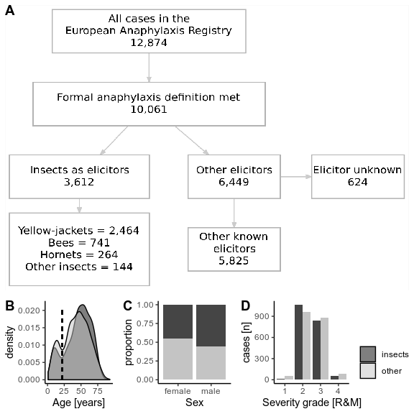

Figure 1: A) Flow-diagram illustrating the rationale for including registry cases in the final analysis. B, C, D: Age, sex, and severity distribution was matched in cases in both groups to allow for comparable results between IVA and non-IVA cases. Two age-subsets of patients could be recognized based on the density plot of age (B).

##### 

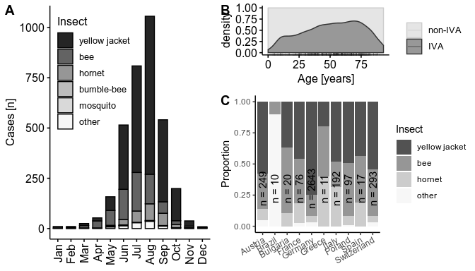

Figure 2: A: Proportion of anaphylaxis cases elicited by specific insects according to the month in which the reaction occurred. Less common insect species grouped as ‘other’. B: The density distribution of IVA cases to cases elicited by other triggers considering the patient’s age. C: Geographical differences in the most common elicitors of IVA. Countries which reported less than 10 IVA cases were not illustrated in this figure.

##### 

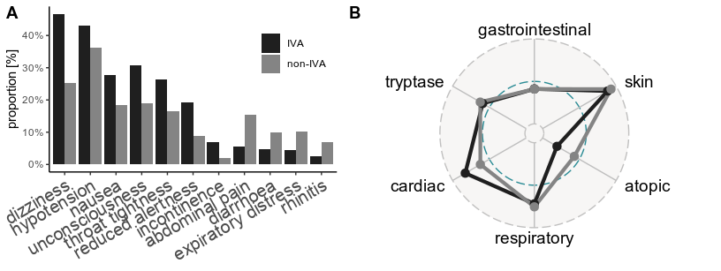

Figure 3: Symptoms of insect venom anaphylaxis (IVA) compared to other elicitors. A: Proportional presentation of specific reaction symptoms. B: High-level overview of involved organ systems and selected cofactors in the form of a radar plot.

##### 

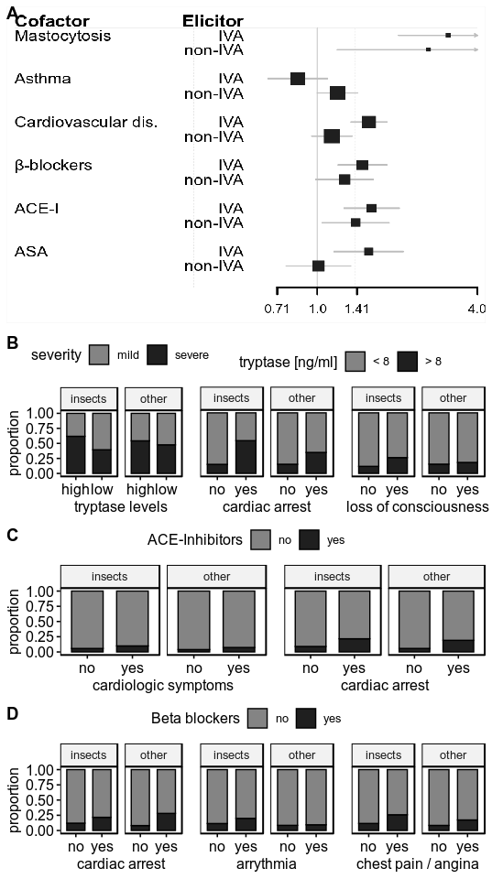

Figure 4: Cofactors of insect venom anaphylaxis. A: Odds ratios of eliciting severe anaphylaxis. B: Proportion of cases elicited by insects or other elicitors (upper panels) according to tryptase levels and cardiologic symptoms.

##### 

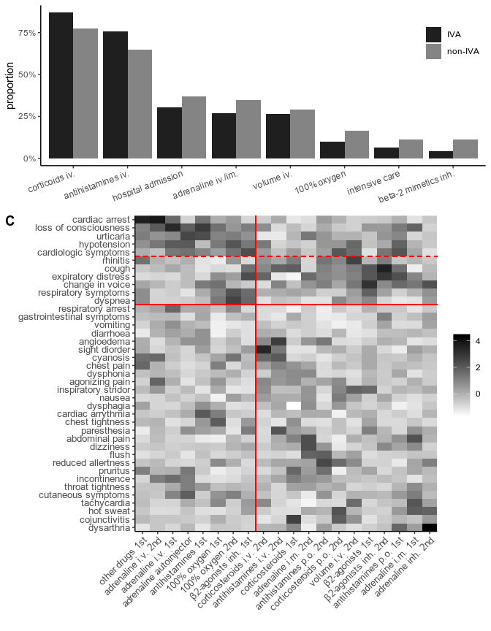

Figure 5: Therapy in patients with IVA compared to other elicitors, cases matched according to sex, age, and severity of a reaction. A: Proportional use of therapy measures in both anaphylaxis groups. B: Heatmap visualizing the association of symptoms and corresponding treatment - presented as a scaled correlation coefficient (phi).

# Supplementary Figures

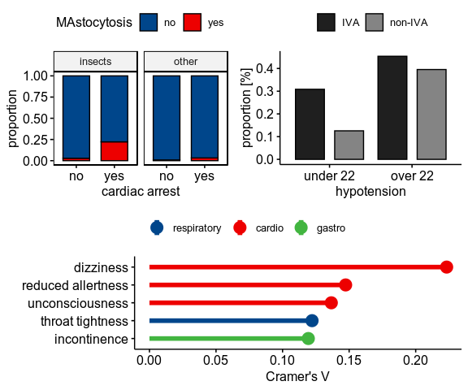

Figure 6: Symptoms of anaphylaxis

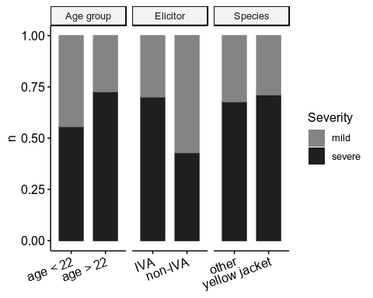

Figure 7: Severity of anaphylaxis in subgroups. The severity of patients with IVA in two age groups (left), according to elicitor type (center) and according to the responsible insect species (right)

