**Volodymyr Holomb,**

job seeker for business data analyst

+38 (067)612-78-24

wldmrgml@gmail.com

**Task 1.1.**

**A prioritized list of user stories for the project:**

*M – must have:*

M1. I have an allergy, so I need to know whether a food contains allergic components.

M2. As I can be on the go at lunchtime I need a flexible tool to adjust or cancel preordered food delivery (in terms of time and/or place).

M3. I usually have a lot of things to do for a limited lunch-breaks, so it is crucial for me to get notified immediately about any delay in food delivery.

M4. For me, as for an administrator, it is important to have clients contact to provide specific information in case of unexpected changes in the menu.

*S – should have*

S1. Being a practical person I want to keep track of my previous orders to repeat them later.

S2. I’m a vegetarian, so I need to order meals without meat.

S3. As a very busy person, I want to order prechosen combo-menu.

*C – could have*

С1. As a low-paid employee, I have a limited budget for lunches, so I expect that system will help me to make the best order for a given sum of money.

C2. I’m on diet so I expect appropriate suggestions for the menu.

C3. I’m keen on my health. How I can be sure that a catering agency has all necessary sanitary certificates and licenses? I need to see them all.

C4. I’m an office manager and sometimes I’ve been asked to order lunch for my busy colleagues, so I’ll appreciate simple interface to make a grouped order.

C5. As a director of catering agency for convenience of my customers, I may decide to collect payments not on one-off bases, but rather on a monthly basis (admittedly only for dully authorized users).

*W – won’t have*

W1. As a director of a catering agency, I can provide a discount for clients, who order from the same location, so that potential customers should know that their colleagues have already ordered from us.

W2. I really enjoy delicious food and I want to know about special offers from the chef, or even suggest my own ingredients for meals.

W3. Sometimes I need to make an order from my car by phone, but I used to keep all my accounts, so I need this information in my user account.

**Task 1.2.**

**Functional requirements of the ordering process:**

1.   User can start ordering meals only after a proper authorization in a system (log or sign in).

2.   An authorized user has to select a menu section first.

3.   According to a menu, section user can select respective meals by their common names.

4.   For each selected meal user get information about its availability and price for a current week per each authorized catering agency.

5.   For a selected meal user choose exactly one supplier and add his choice to cart.

6.   After adding to cart the user is asked whether he or she wants to continue choosing meals or is willing to place an order.

7.   In the latter case, the user is redirected to site section with the list of preselected meals.

8.   At this stage, the user should have an option to set his or her order as a one-off (for the current day or another day of the current week) or regular (for a certain provided dates).

9.   Then the user explicitly confirms his/her order and its total amount provided any specific information to the supplier if needed.

10.   After confirming an order the system should ask for any contact details, explicitly specified by the selected supplier as preferable, if they are missed in the user profile.

11.   The payment is conducted through the online banking system.

**Task 1.3.**

**Interface prototype (mobile-first version):**

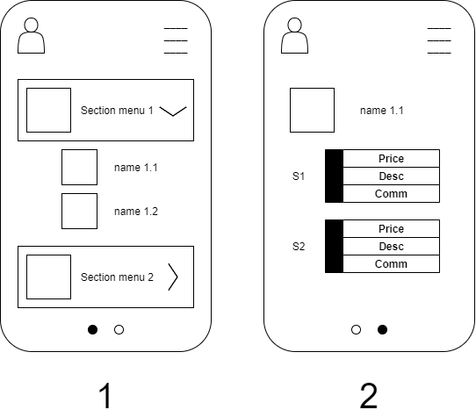

**Task 1.4.**

**File structure for downloading:**

* section_name
* meal_name
* meal_description
* serving_days
* allergic_agents
* serving_output
* is_vegan
* is_healthy_diet
* price_per_serving_output
* max_item_for_serving_per_day
* combo_menu_id