Dear Volodymyr,

Thank you for your message and your interest in Eurostat’s data.

We regret to inform you that unfortunately, at Eurostat database there is no specific dataset on the percentage of population (households) **assessed itself** in terms of ‘rich / middle class / poor'

However, you can find numerous indicators on “income distributions and monetary poverty” and “people at risk of poverty or social exclusion” under the “[Income and Living conditions](http://ec.europa.eu/eurostat/web/income-and-living-conditions/data/database)” section that might interest you.

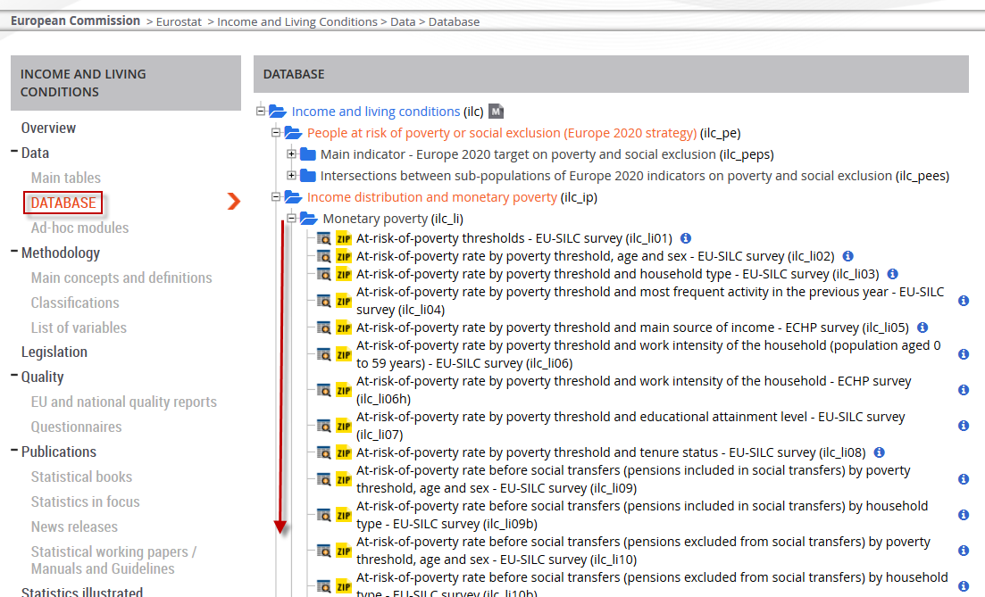

The collection "Income distribution and monetary poverty" houses collections of indicators relating to poverty risk, poverty risk of working individuals as well as the distribution of income.

The collection "People at risk of poverty or social exclusion" houses main indicator on risk of poverty or social inclusion included in the Europe 2020 strategy as well as the intersections between sub-populations of all Europe 2020 indicators on poverty and social exclusion.

Here is a tutorial for data extraction: <http://ec.europa.eu/eurostat/help/demo-tours>

Please note that our service can only provide support on data available at Eurostat database. For requests on data from other sources you need to contact them directly.

Here is the contact from Europe Direct: <https://europa.eu/european-union/contact_en>

European Social Survey contact center: <http://www.europeansocialsurvey.org/about/contact_information.html>

We regret not being able to help you entirely and we remain at your disposal should you require further guidance.

Please note that it is not necessary to send the same request by e-mail and by the on-line form in order to avoid double work.

Best regards,

**Laia Guinovart**

**Eurostat User Support – English Language**Web site: <http://ec.europa.eu/eurostat>     
Email: [eurostat.helpdesk_EN@sogeti.lu](mailto:eurostat.helpdesk_EN@sogeti.lu)

Phone:           Ireland: +353 151 33080

                        Malta: +356 277 803 07

                        United Kingdom: +44 20 300 63103

You can reach us from Mo-Fr, 09:30-12:00 and 13:00-17:00 (CET).

Legal Notice/Disclaimer: <http://europa.eu/geninfo/legal_notices_en.htm>

Copyright notice and free re-use of data: <http://ec.europa.eu/eurostat/web/main/about/our-partners/copyright>

[cid:image001.jpg@01D1D38F.C57B47F0](https://twitter.com/eu_eurostat)  [cid:image002.jpg@01D1D38F.C57B47F0](http://ec.europa.eu/eurostat/web/rss/about-rss)   [](https://www.facebook.com/EurostatStatistics/)

Description: estat RGB

[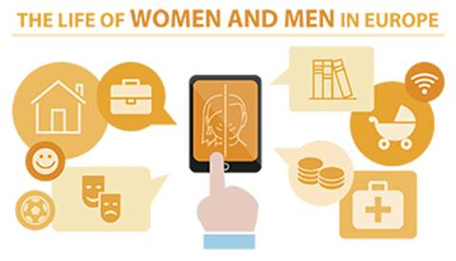](https://na01.safelinks.protection.outlook.com/?url=http%3A%2F%2Fec.europa.eu%2Feurostat%2Fproduct%3Fcode%3DKS-02-17-602&data=02%7C01%7Cdpapapostolou%40staffingindustry.com%7C98377f2c2abc4ebfea7508d522a7ab37%7C2c6dce2dd43a4e78905e80e15b0a4b44%7C0%7C0%7C636453026206422693&sdata=xFrCiojhbw3AiYSl6bTHsLAFZf0fRvZxRenXnN%2BFzps%3D&reserved=0)