Tomas Woldemichael

February 21th 2020

IT FDN 100

Assignment 05

**Task & Priorities**

**Introduction**

In this assignment we learned about writing and appending data from a user and store the data in table using dictionaries as rows. This program was a little bit more difficult than the last assignments since we had to use a lot of different logic to get the scenario we would like to perform such as showing data in table, adding to the table, deleting from a table and writing back to a file.

**Reading Data from a file**

I first began this program by reading data from a text file and placing the data into a dictionary row of task and priorities. Once I put the data into a dictionary row I place the row in a table that was a list. See figure 1 to see h. w I load the table with rows of dictionaries

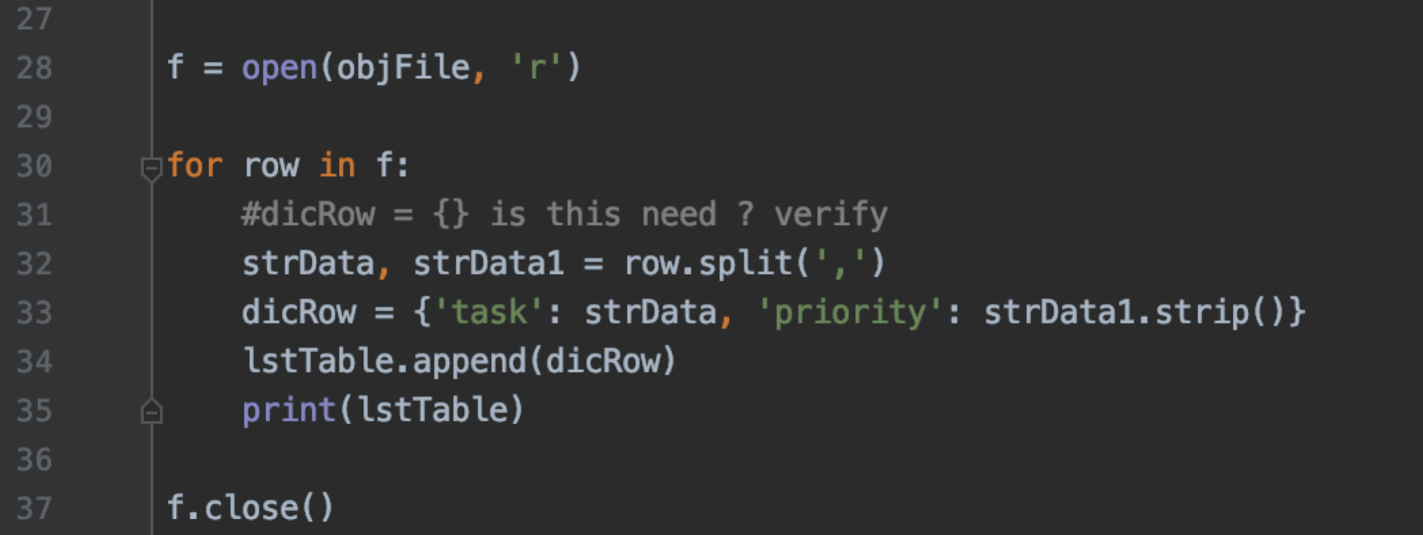

***Figure 1: Read from text file and load table with dictionaries rows***

**Display and Input From User**

I first began this program by displaying a menu with the various options of the program. The five options were to show the current data, add a new item, remove, save data to file, and exit the program. Keep in mind this program continually display the menu options. This was simply handle with a while loop and a if/else break statement. See Figure 2 to view how I displayed the menu and the prompt the user to select an option. Once the user selects and option I was able to organize different sections of my code by using a if/else statement with logic that would identify which branch of the statement the user should be in to perform the option they have selected. This is where the real processing happens.

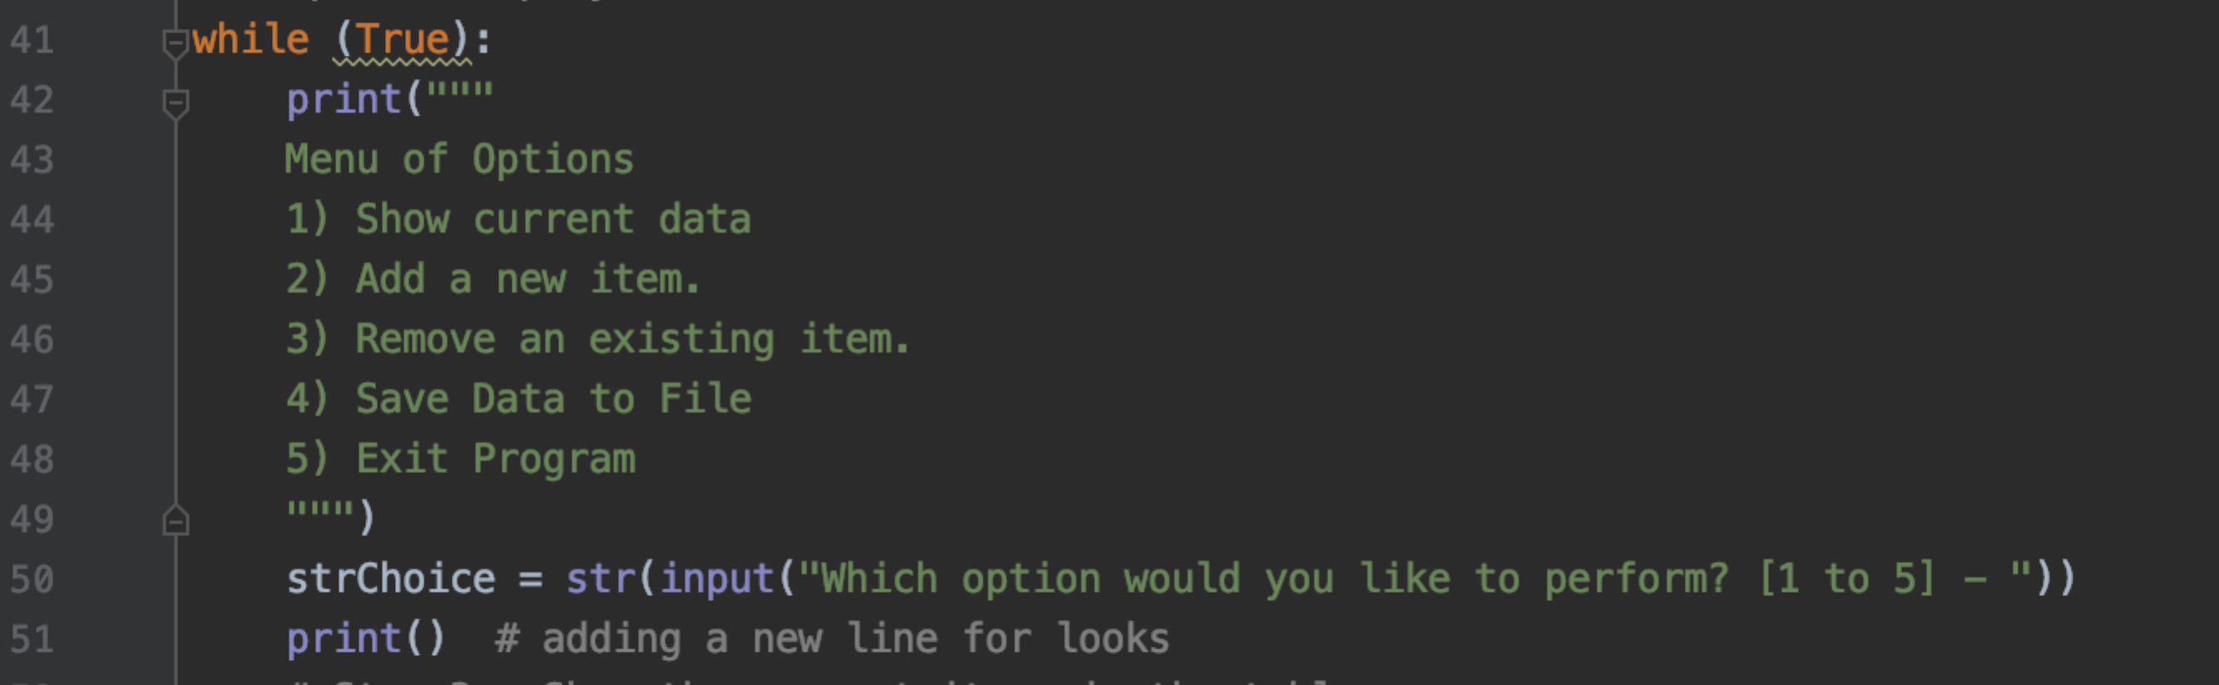

***Figure 2: Display menu and prompts user***

**Show Current Data**

If the user selects the first option I could show the current data in the table that was quite simple. All I had to do was use a for look to iterate through the table. Once I had an element in the table I could call the key name and use the print statement to simply print it out to the user.

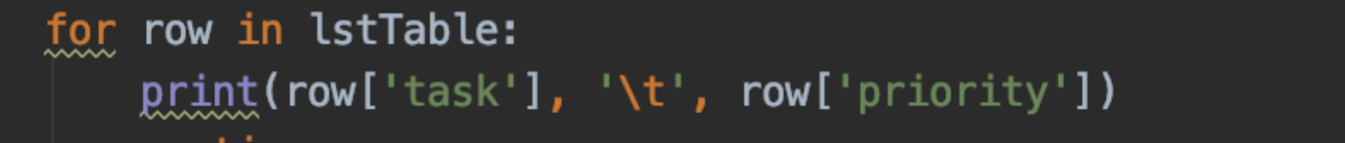

***Figure 3: Showing data in table***

**Adding a New Item**

In order to add data to the table we must use input functions to prompt the users with the correct questions then take that data and store it into a dictionary row with two keys. One of task and the other for priority. Once we have our new dictionary row I simply appended the dictionary row to the table. See figure 4 for the code.   
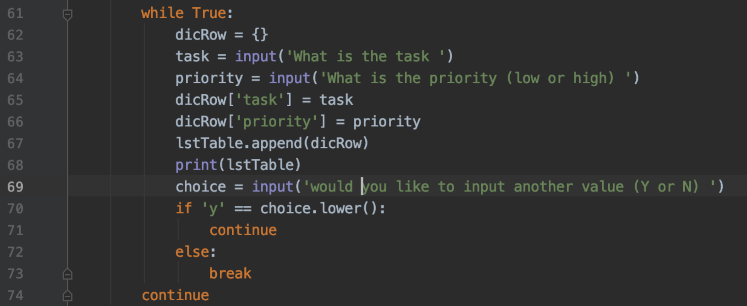

***Figure 4: Adding new data to the table***

**Removing Data From Table**

To remove data from the table when the user selects the third option I ask the user what task they would like to remove and save that string to a variable. I then iterate through the table and take each dictironary and comparing the inputted data to the dictionaries task key. If the data matches I then use the list remove function to remove the whole dictionary. See figure 5 for removal code.

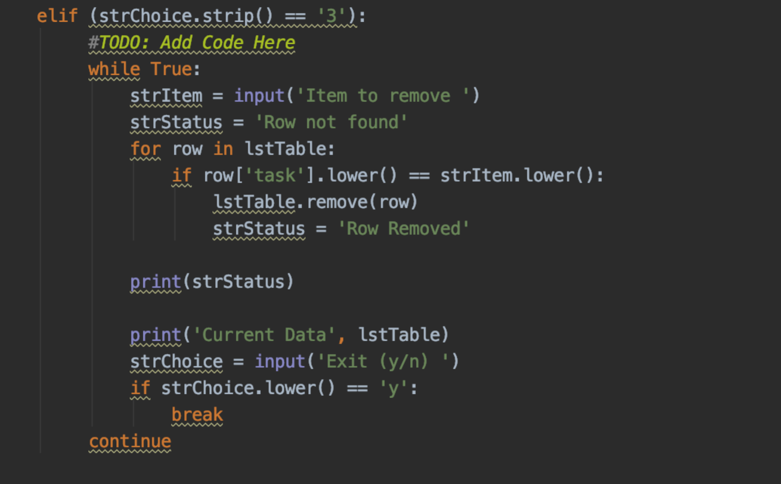

***Figure 4: Removing data from table***

**Saving The Data and Exiting**

Saving data to the text file is quite similar to how we print the data but instead we using the following code for the last lab. If the user then chooses to exit the program I just prompt with with a goodbye and let it enter the break statement.  
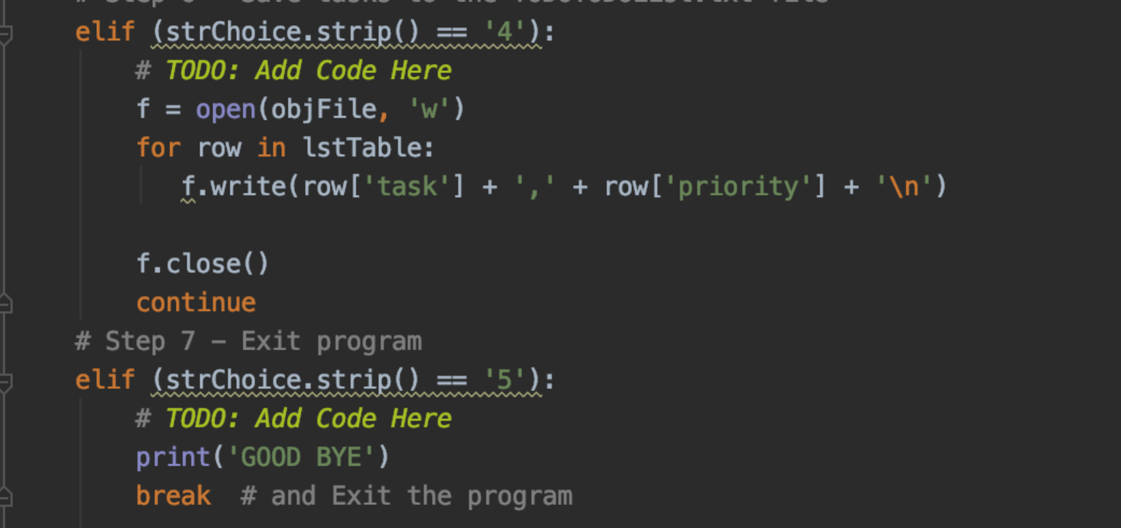

***Figure 5: Saving data to the text file and exit***

**Running the program**

Once I completed the program I was able to run the program both on my terminal. To run the program on py charm I hit the run button in the toolbar I will show how to run it on the terminal. See **figure 6** for user input.

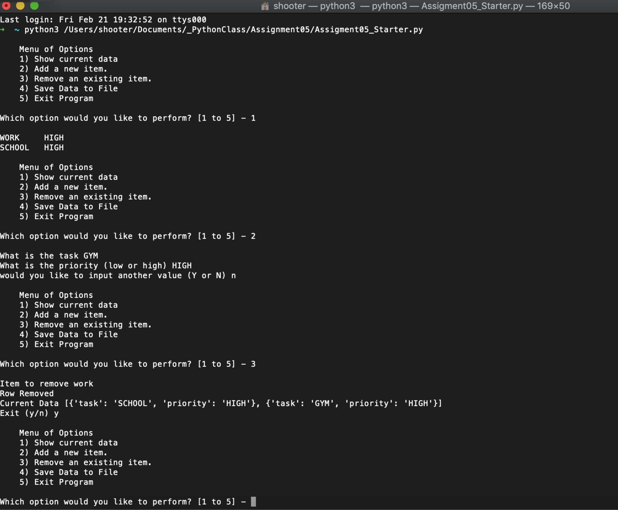

**Conclusion**

Overall, through this assignment I was able to create a program that took in two values continuously from the user and saved them to at table using a dictionary. The user was able to select multiple options in which we would display or save the data and even delete data they have already inputted.