Installation Guide

- Install the SQLSERVER by
Click MSDESetup.bat in D:\MSDE2000
- Run the setup.exe in D:
- Run the main program using the shortcut

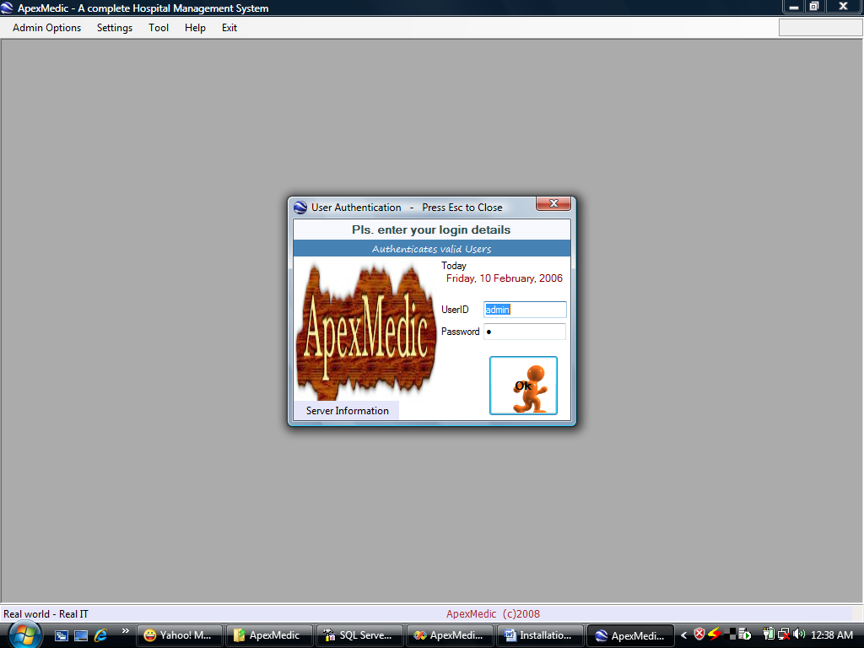
Click

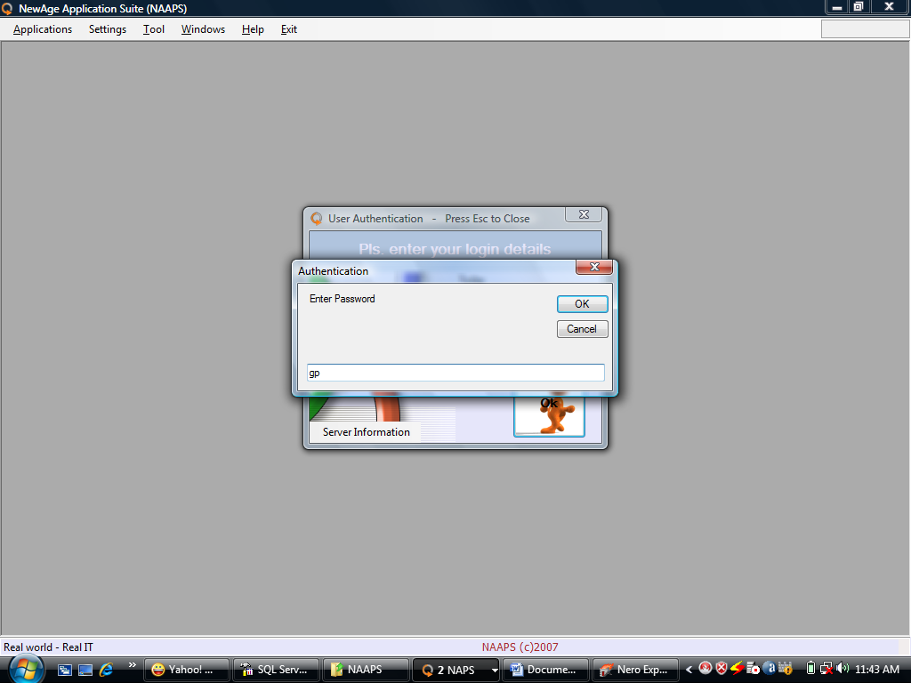

type ap

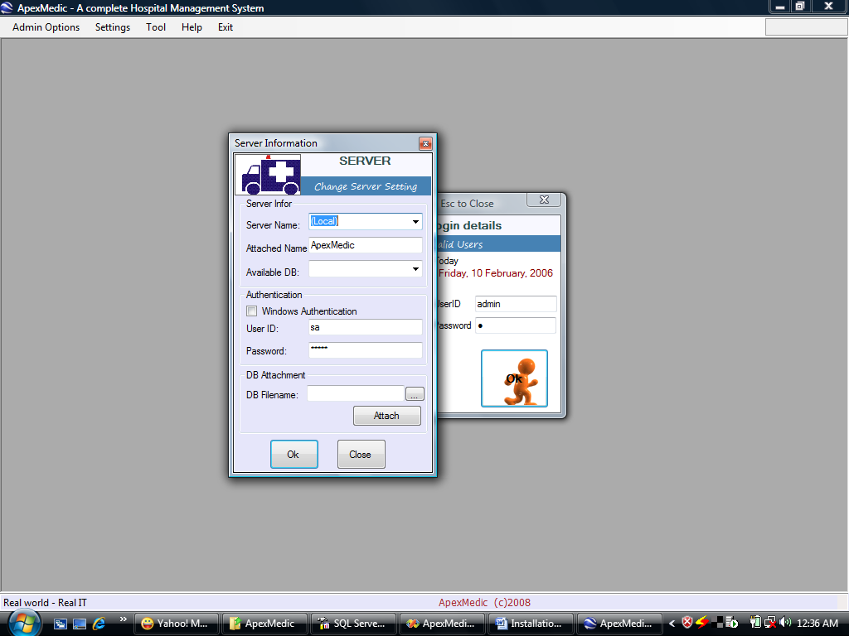
Click to
Select file ApexMedic.nas
In Configdir folder

Click
Then Click Attach

Close the program and restart it.

