# 破解步骤

1. 去官网下载正版的，专业版本的（版本：2018.1）
2. 安装完成之后把涉及的文件目录里的JetbrainsCrack-2.8-release-enc.jar放到安装目录的bin目录下
3. 在bin目录下，找到pycharm.exe.vmoptions 和 pycharm64.exe.vmoptions ，用记事本打开之后在末尾加上jar文件的全路径：

-javaagent:D:\Develop\pycharm\bin\JetbrainsCrack-2.8-release-enc.jar（目录根据实际更换）

1. 重启pycharm，点击help->register->选择activation code,把激活代码复制进去点击ok
2. 结束

PS：激活代码：

ThisCrackLicenseId-{

"licenseId":"11011",

"licenseeName":"woleto",

"assigneeName":"天天鱼术",

"assigneeEmail":"1113449881@qq.com",

"licenseRestriction":"",

"checkConcurrentUse":false,

"products":[

{"code":"II","paidUpTo":"2099-12-31"},

{"code":"DM","paidUpTo":"2099-12-31"},

{"code":"AC","paidUpTo":"2099-12-31"},

{"code":"RS0","paidUpTo":"2099-12-31"},

{"code":"WS","paidUpTo":"2099-12-31"},

{"code":"DPN","paidUpTo":"2099-12-31"},

{"code":"RC","paidUpTo":"2099-12-31"},

{"code":"PS","paidUpTo":"2099-12-31"},

{"code":"DC","paidUpTo":"2099-12-31"},

{"code":"RM","paidUpTo":"2099-12-31"},

{"code":"CL","paidUpTo":"2099-12-31"},

{"code":"PC","paidUpTo":"2099-12-31"}

],

"hash":"2911276/0",

"gracePeriodDays":7,

"autoProlongated":false}

# 快捷键

**编辑**

****Ctrl + /    行注释/取消行注释  
Ctrl + Shift + /    块注释****

****Alt + Enter    快速修正  
Ctrl + Alt + L     代码格式化****

****Ctrl + Numpad+/-   展开/折叠代码块****（当前位置的：函数，注释等）  
****Ctrl + shift + Numpad+/-   展开/折叠所有代码块****

**运行(Running)**

****Shift + F10    运行****  
Shift + F9   调试

调试(Debugging)  
F8   跳过  
F7   进入  
Shift + F8   退出  
Alt + F9    运行游标  
Alt + F8    验证表达式  
Ctrl + Alt + F8   快速验证表达式  
F9    恢复程序  
Ctrl + F8   断点开关  
Ctrl + Shift + F8   查看断点

# 配置

1. 设置Python自动引入包，要先在file -> Setting ->Editor>general > autoimport -> python :show popup

     快捷键：Alt + Enter: 自动添加包

1. 设置缩进符为制表符“Tab” File -> Default Settings -> Code Style-> General -> 勾选“Use tab character”-> Python -> 勾选“Use tab character”-> 其他的语言代码同理设置

3.>file and code template>python scripts

#!/usr/bin/env python  
 # -*- coding: utf-8 -*-  
 """  
 __title__ = '$Package_name'  
 __author__ = '$USER'  
 __mtime__ = '$DATE'  
 # code is far away from bugs with the god animal protecting  
    I love animals. They taste delicious.  
              ┏┓      ┏┓  
            ┏┛┻━━━┛┻┓  
            ┃      ☃      ┃  
            ┃  ┳┛  ┗┳  ┃  
            ┃      ┻      ┃  
            ┗━┓      ┏━┛  
                ┃      ┗━━━┓  
                ┃  神兽保佑    ┣┓  
                ┃　永无BUG！   ┏┛  
                ┗┓┓┏━┳┓┏┛  
                  ┃┫┫  ┃┫┫  
                  ┗┻┛  ┗┻┛  
 """

1. python文件默认编码 File Encodings> IDE Encoding: UTF-8;Project Encoding: UTF-8;
2. 代码自动整理设置

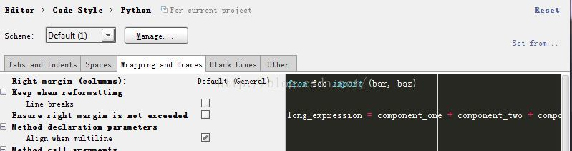

这里line breaks去掉√，否则bar, 和baz会分开在不同行，不好看。