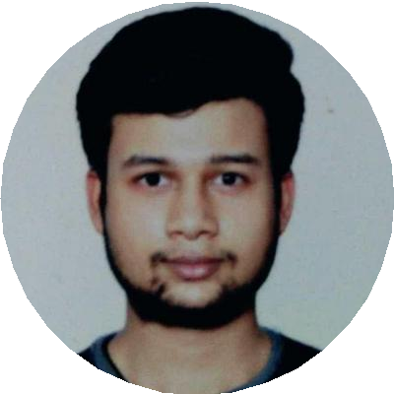

**PRASHANT**

**SHARMA**

S O F T WA R E D E V E L O P E R

**Details**

H.No. 27-B, Air Force Station, Mullanpur Garibdass,

Mohali, Punjab, 140901 INDIA

+91-9923988650

[prashantp5sharma.1998@gmail.c](mailto:prashantp5sharma.1998@gmail.com)om

D AT E O F B I R T H

15/10/1998

**Links**

GitHub: https://github.com/wolf-dagger

**Skills**

PeopleSoft MySQL HTML CSS3

JavaScript

**Hobbies**

Learning New Things Playing FPS Games Cooking

**Languages**

Hindi English

Panjabi

# Profile

Proactive and result-driven Software Engineer capable of building a high-energy team. Looking to switch technology to WEB DEVELOPMENT field like MERN. Highly Adaptive and I am a fast learner.

# Employment History

## ASSOCIATE SOFTWARE ENGINEER, MPHASIS Pvt. Ltd., Bangalore

J U N E 2 0 2 1 — J U LY 2 0 2 2

Worked as an Associate Software Engineer on People Soft Technology where I built Processes and handled them in the deployment phase. Also worked on MySQL and managed the Tables in the database. Also worked on GitHub.

**React Js Intern, Omninos Solutions Pvt. Ltd., Mohali**

OCT 2 0 2 1 — Present

Learned the key concepts of React Js, and have written some reusable components. Also working on personal project to enhance my level of skills

# Education

## B.E./B.Tech., CHANDIGARH UNIVERSITY, Mohali

J U N E 2 0 1 7 — M AY 2 0 2 1

Stream: Computer Science Engineering Specialization: Internet Of Things CGPA: 7.07

# PROJECTS

## Smart Irrigation System

Technology: IOT

Created an IoT project using Arduino Board and Programmed the Arduino Board To use the Peripheral sensors to work accordingly.

## Obstacle Avoiding Robot

Technology: IOT

Created a Project which avoids obstacles in its way using an ultrasonic sensor and decides which way is clear to move ahead.

## Smart Side-Mirror for Cars

Technology: IOT, Python

Created a Project to remove Blind Spots in Cars while driving which will help in reducing the number of accidents on the road.

# ACADEMIC ACHIEVEMENTS

## Workshop, Delhi

Participated in IOT Workshop held in IIT-Delhi.

# Extra-curricular activities

## Inter-School Badminton Player

**3rd prize in Treasure Hunt competition**