PROJECT mC
OPENBRAILLE
SEMESTER ARCHITECTURE
AND FUTURE RESEARCH REFERENCE DOSSIER
Frozen Macro Six-Dot Build Plan, Validation Programme and Post-Semester VPD-C7 Research Path
Control item | Value
Course | PBCST504 - Microcontrollers Micro Project
Programme | B.Tech Computer Science and Engineering (Cyber Security)
Group | Group 8
Document status | Complete retained-reference and fallback implementation dossier
Current portfolio status | VibeGuard switch requested; OpenBraille remains the fully documented alternative
Frozen architecture | One macro six-dot cell; six SG90-class servos; eccentric cams; guided pins; ESP32 direct PWM
Expected semester budget | Approximately ₹2,984; conservative envelope approximately ₹4,909
Future mechanism | VPD-C7 research hypothesis - unbuilt, confidential and evidence-gated
Controlling decision
This dossier does not override the current request to adopt VibeGuard. It provides the complete OpenBraille plan if the teacher retains the zeroth-review concept, and preserves OpenBraille as a future accessibility/mechatronics research route.
Patent boundary
The macro six-servo semester prototype is conventional and is not represented as patent-ready. VPD-C7 is a separate post-semester hypothesis that must be redesigned, built, compared and professionally reviewed before any filing decision.
Prepared from the controlled Project mC authority set and the Master Evidence, Costing and Decision Basis. This document is an engineering reference plan, not a patent opinion, standards-compliance declaration or promise of grant.

Document control and approval use
Control item | Value
Architecture baseline | Frozen OpenBraille Phase 3C macro six-servo/cam architecture
Return-motion rule | Active servo-driven cam retraction unless a usable passive return is physically proved
Power baseline | External regulated 5 V servo supply; 5 V/3 A procurement target; measured droop controls acceptance
USB role | Serial command input and logs; not six-servo power
Semester boundary | No moving roller, encoder, RAMPS/Mega, continuous paper or electromagnetic substitution
Future boundary | VPD-C7 only on a separate post-MVP coupon; current never certifies pin height alone
Approval checkpoints required before an OpenBraille procurement freeze
1. Teacher confirmation that OpenBraille, rather than the requested VibeGuard alternative, remains the semester implementation.
2. Confirmation of the effective build window and dependable institutional FDM-printer access.
3. Approval of the one-dot-first mechanical validation plan before six servos and full-cell materials are committed.
4. Approval of the external 5 V power arrangement, pinch-point controls and tactile-participant protocol.
5. Approval of quantitative repeatability, cycle-life and pattern-test criteria before the locked validation run.
Executive reference decision
Complete alternative semester plan
OpenBraille is technically buildable within the ₹5,000 ceiling and offers a strong accessibility demonstration. Its execution risk is concentrated in FDM tolerances, cam/follower friction, active retraction, six-servo power behavior and trustworthy tactile-state validation. This dossier is therefore retained as the complete fallback/reference plan while VibeGuard remains the recommended semester choice.
The correct semester claim is narrow: one macro-scale six-dot cell accepts a character or dot pattern over USB/serial, commands six independent servo/cam channels, produces repeatable raised/lowered tactile states, and reports measured limitations. The project must not be presented as a standards-compliant commercial Braille display or as a patented actuator mechanism.
Success definition at a glance
Layer | Required semester result | Evidence
Mechanical | Six independently moving macro dots with active raise/retract and safe rounded pin tips | CAD/build IDs, caliper measurements, photographs, cycle logs
Electrical | Stable ESP32 control and external servo rail without brownouts or unsafe heating | Voltage/current observations, reset log, power checklist
Firmware | Correct character-to-six-dot mapping, per-dot calibration and USB commands/logs | Unit tests, configuration record, pattern test report
Validation | Repeatability, lifecycle, pattern-transition and approved tactile evidence | Locked test sheet, raw records, failed-run register
Scope honesty | Macro educational prototype; no physical-state claim from command timing alone | Explicit limitations in report and live demonstration
Future separation | VPD-C7 kept outside the semester architecture | Separate research folder and disclosure controls
1. Purpose, audience and scope
1.1 Purpose
This dossier converts the frozen OpenBraille Phase 3C architecture into a procurement-aware and execution-ready semester plan. It defines the hardware, mechanical build order, electrical integration, firmware, calibration, validation, team ownership, semester schedule and future-research boundary.
1.2 Audience
• Project coordinator and teacher: concept-retention decision, scope, budget, safety and review gates.
• Five-member student team: CAD, fabrication, firmware, assembly, testing, evidence and demonstration responsibilities.
• Department laboratories: FDM access, tools, metrology and safety support.
• Accessibility or tactile-test reviewers: honest macro-prototype scope and participant protocol.
• Institutional innovation/IPR reviewers: separation between the public semester cell and confidential VPD-C7 work.
1.3 Scope hierarchy
Scope tier | Included | Not included
Semester OpenBraille | One macro six-dot cell; six servos/cams/pins; direct PWM; active retraction; USB; measurements | Standards-compliant product, multi-cell line, production design, patent claim
Semester instrumentation | Calipers/camera, voltage/current checks and test scripts used as development evidence | Permanent endpoint contacts or current-only state inference
Post-semester VPD-C7 | Separate coupon studying a datum that sets and directly evidences pin endpoints | Assumed performance, filing-ready claims or automatic inclusion in the semester cell
2. Engineering identity and problem definition
2.1 Engineering identity
OpenBraille is an assistive embedded-system experiment focused on lowering the cost of refreshable tactile output. Its semester purpose is not to compete with commercial displays, but to test whether a simple low-cost actuation channel can create one repeatable six-dot cell suitable for education and engineering study.
2.2 Semester engineering hypothesis
Hypothesis to test
A macro-scaled servo-and-cam mechanism can produce repeatable raised and lowered tactile states for one six-dot Braille cell within the student budget and schedule, while accepting that the prototype is not commercial-scale or standards-compliant.
2.3 What the hypothesis does not claim
• It does not claim that servo + cam + Braille pin actuation is novel.
• It does not claim commercial Braille pitch, force, refresh speed, noise or lifetime.
• It does not assume a passive servo spring retracts the pin.
• It does not treat a PWM command, elapsed time or servo current as direct proof of tactile-pin height.
• It does not establish a patent or freedom to operate.
3. Frozen system architecture
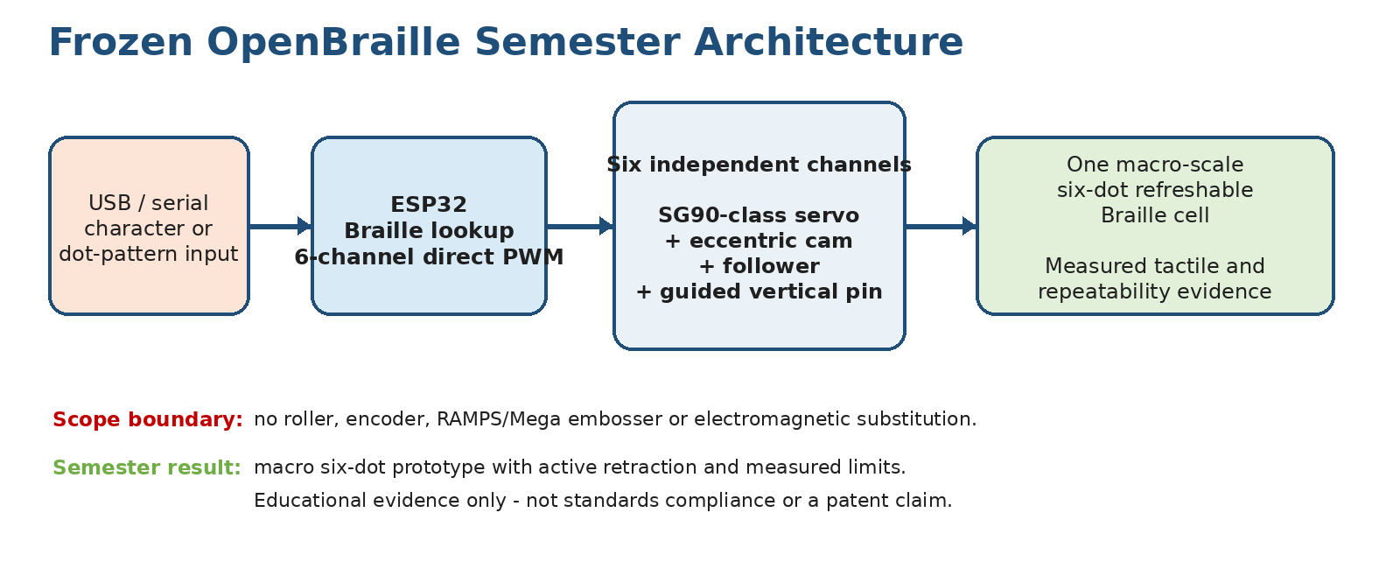
Figure 1. Frozen macro six-dot architecture and explicit semester scope boundary.
3.1 Subsystem boundaries
Subsystem | Inputs | Outputs | Owner acceptance
USB/serial interface | Character, pattern or test command | Parsed request, acknowledgement and log line | Commands are deterministic, versioned and unit-tested
ESP32 control | Pattern, per-dot calibration and fixed sequencing rules | Six PWM outputs and timestamped command records | No invalid GPIO use, unstable resets or hidden configuration
Six actuator channels | 5 V servo power and PWM | Cam rotation and follower displacement | Each channel accepted on a one-dot fixture before full-cell assembly
Mechanical cell | Six channel motions | Six guided raised/lowered tactile pins | No binding, unsafe tips or adjacent-channel interference
Power distribution | External regulated 5 V and common ground | Stable servo rail and logic operation | No USB servo power, brownout or unsafe heating
Development measurement | Pin position, cycle count, rail behavior and operator observations | Evidence package and limitations | External measurement remains the truth source for physical position
3.2 Frozen architecture controls
• One macro-scale six-dot cell only.
• Six SG90-class servos, one eccentric cam and one guided vertical pin per dot.
• ESP32 local direct-PWM control; no intermediate motor driver is required for the servo signal.
• FDM frame/guides/cams and external regulated servo power.
• Active servo-driven retraction unless a procured mechanism proves a reliable passive return under load.
• No moving roller, encoder wheel, RAMPS/Mega embosser, continuous-paper system or electromagnetic substitution.

4. Detailed hardware architecture and BOM
4.1 Required purchased and fabricated items
Item | Qty | Exact semester role | Expected | Conservative | Acceptance/procurement rule
ESP32 development board | 1 | Six PWM channels, USB/serial commands and logging | ₹400 | ₹899 | Verified WROOM-32 DevKit baseline; ESP32-S3 authorized fallback. Record pinout and regulator.
SG90-class servo | 6 | One independent eccentric-cam actuator per dot | ₹120 each / ₹720 | ₹142 each / ₹852 | Buy one consistent batch where possible; inspect every unit; no passive-return assumption.
5 V / 3 A regulated adapter | 1 | External servo supply with test headroom | ₹289 | ₹408 | Connector and regulation verified; adequacy controlled by measured droop and stall tests.
1,000 µF electrolytic capacitor | 1-2 | Servo-rail transient buffering | ₹25 | ₹50 | Install near distribution; voltage rating above 5 V; not a substitute for an adequate supply.
FDM frame, guides, cams and followers | 1 cell | Macro mechanical structure | ₹450 | ₹900 | Expected case assumes institutional printer access; print a single-dot coupon first.
Stainless pins/rod with rounded tips | 6 + spare | Guided tactile dots | ₹250 | ₹400 | Local quote; polished/rounded, safe for repeated touch, dimensions recorded.
Fasteners, servo mounts and cable management | 1 lot | Alignment, assembly, strain relief and guards | ₹300 | ₹500 | Final quantity follows CAD and physical servo dimensions.
Perfboard, wires, headers and connectors | 1 lot | Power distribution and stable PWM wiring | ₹200 | ₹350 | Servo current never routed through ESP32 3.3 V rail or thin USB wiring.
USB data cable | 1 | Serial input and logs | ₹100 | ₹150 | Reusable cable acceptable after connection reliability check.
Budget layer | Low | Expected | Conservative
Required hardware/material subtotal | ₹1,866 | ₹2,734 | ₹4,509
Delivery/local variability/replacement allowance | ₹100 | ₹250 | ₹400
Semester planning total | ₹1,966 | ₹2,984 | ₹4,909
Budget decision
Use approximately ₹3,000 as the expected teacher-facing budget. The conservative case remains below ₹5,000 only when institutional printing is available and full-cell reprints are limited. One or two spare servos are useful but should be approved separately.
4.2 Reusable or institutional equipment
Equipment | Use | Required status
Laptop with Arduino IDE and Python | Firmware, serial commands, analysis and reporting | Assumed available
FDM printer and slicing software | Frame, guides, cams, followers and coupons | Material dependency; access must be confirmed
Digital calipers | Pin travel, spacing, clearances, repeatability and wear | Required
Multimeter | Power, continuity and servo-rail checks | Required
Bench supply with current limit | One-servo bring-up and fault-safe testing | Strongly recommended / borrowed
Oscilloscope or logic analyzer | PWM and rail-transient checks | Useful but not essential
Camera / fixed measurement jig | External visual ground truth and configuration record | Required for credible evidence
Basic hand tools and soldering station | Assembly, finishing and final wiring | Institutional/reusable
Tactile participant access and approved protocol | Raised/lowered and pattern distinguishability | Not confirmed; teacher/ethics decision
5. Mechanical architecture and one-dot-first build
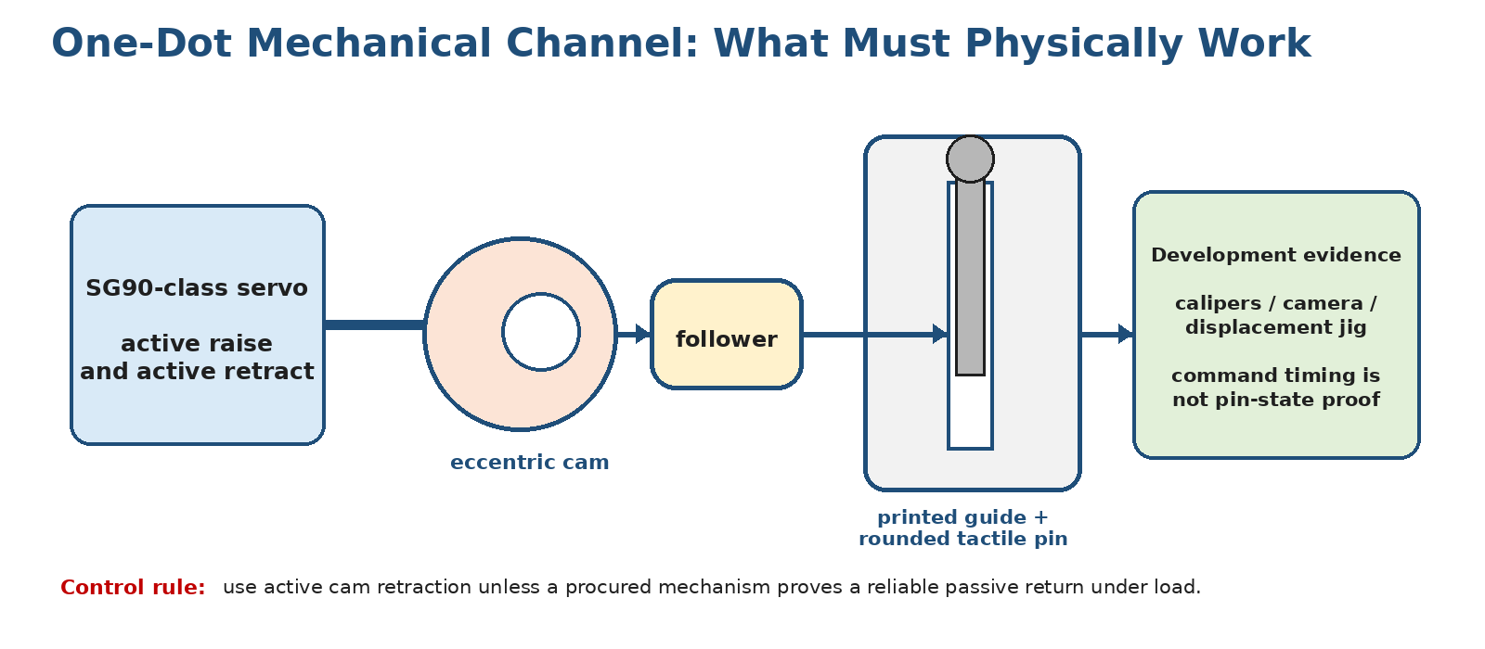
Figure 2. One-dot channel and the separation between command, physical motion and development ground truth.
5.1 Mechanical design rules
1. Start with one independently testable servo + cam + follower + pin coupon. Do not print the full cell before the coupon moves freely.
2. Use macro spacing and travel as a documented educational design choice. A starting target near 300% of standard sign-Braille geometry may guide CAD, but the prototype must not be labelled standards-compliant.
3. Use rounded, smooth tactile tips and guard all pinch points around cams and servo horns.
4. Set pin-guide clearance through printed tolerance coupons and measured finishing; nominal CAD dimensions do not prove physical clearance.
5. Use active cam-driven raise and retract positions. Do not rely on an unverified servo spring or gravity return.
6. Record each printed part revision, orientation, material, measured dimensions, sanding/finishing and assembly operator.
7. Treat each channel as replaceable for test purposes, but do not present modular replacement as a novel patent feature.
5.2 Provisional geometry and acceptance parameters
Parameter | Starting design basis | Acceptance rule
Cell scale | Macro single cell, approximately 3x commercial sign-Braille pitch as an engineering starting point | Final CAD and measured cell clearly labelled non-standard
Raised travel | Approximately 1.5 mm starting target | Teacher-approved tactile and repeatability test controls final value
Pin material | Approximately 2 mm stainless rod with rounded tip | No sharp edge, binding, corrosion or unsafe surface
Cam throw | Set through one-dot CAD/coupon to create required travel with margin | No stall, follower loss or adjacent interference
Guide clearance | Derived from printed tolerance coupon | Free motion under the selected load with repeatable alignment
Actuation sequence | Fixed sequential or bounded group of changed dots | No brownout, unsafe peak or excessive refresh delay
5.3 Mechanical stop conditions
• Pin binds, tilts, scrapes or fails to retract fully.
• Cam/follower loses contact, jumps, cracks or creates an exposed pinch hazard.
• Servo stalls or heats during the normal pattern sequence.
• Pin height varies beyond the approved repeatability band.
• A rounded tactile tip becomes loose or unsafe.
• Full-cell assembly changes the motion that passed on the single-dot coupon.
6. Electrical integration and provisional pin map
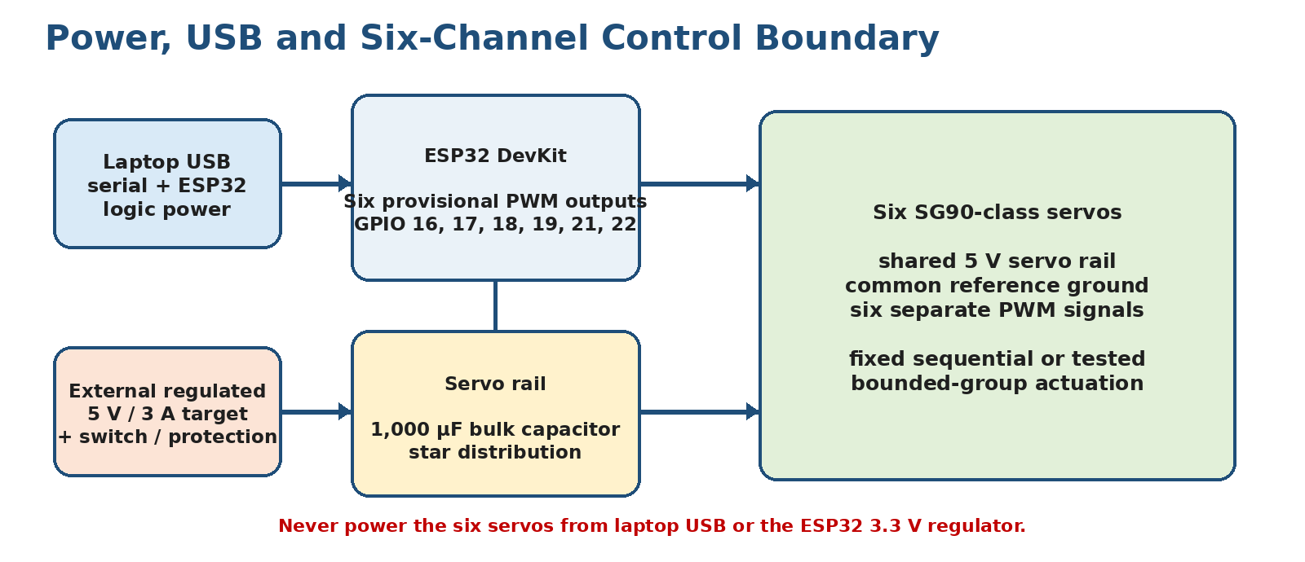
Figure 3. Recommended power and control boundary. Final wiring must be verified against the purchased board and supply.
6.1 Power domains
Domain | Source | Loads | Rule
Logic / USB | Laptop USB to ESP32 DevKit | ESP32 and serial interface | Do not back-feed a second 5 V source into an unverified board while USB is connected
Servo rail | External regulated 5 V / 3 A target | Six SG90-class servos | Separate branch and conductors sized for servo current; bulk capacitor near distribution
Signal reference | Common ground | ESP32 PWM and servo signal reference | Use star/controlled grounding; inspect for resets and noise
Measurement | Multimeter / optional scope | Servo rail and logic rail | Measurements must not create unsafe shorts or loose probes near moving cams
6.2 Provisional ESP32-WROOM-32 pin assignment
Function | Provisional GPIO | Notes
Dot 1 PWM | GPIO 16 | Output-capable; verify board label
Dot 2 PWM | GPIO 17 | Output-capable; verify board label
Dot 3 PWM | GPIO 18 | Output-capable; avoid conflict with other planned peripherals
Dot 4 PWM | GPIO 19 | Output-capable
Dot 5 PWM | GPIO 21 | Output-capable
Dot 6 PWM | GPIO 22 | Output-capable
USB serial | Onboard USB-UART | Primary command/log interface
Optional status LED | GPIO 23 or onboard LED where available | Not part of the six-dot mechanism; verify polarity/board mapping
Implementation note
This is a Phase 4 wiring proposal, not a source-file mandate. Revalidate every pin against the exact purchased DevKit and do not use boot-strapping or input-only pins without understanding their behavior.
6.3 Wiring acceptance checklist
• ESP32 boots and USB serial works with servo rail disconnected.
• External adapter polarity and no-load/loaded voltage are verified.
• Servo rail and logic share only the intended reference ground.
• Each servo is tested alone before joining the distribution rail.
• Bulk capacitor polarity and placement are correct.
• No servo current passes through the ESP32 3.3 V regulator or laptop USB cable.
• Combined pattern transitions produce no reset, cable heating or connector instability.
7. Firmware and software architecture
7.1 Firmware module breakdown
Module | Responsibility | Required outputs/tests
Configuration manager | Board variant, pin map, cell/build ID, PWM calibration and sequence policy | Startup banner and configuration record
USB command parser | Accept character, six-bit pattern, clear, test and calibration commands | Malformed-command tests and deterministic responses
Braille mapping table | Map supported characters to six-dot patterns | Unit test independent of hardware
PWM/channel manager | Apply per-dot up/down pulse widths and fixed sequencing | Logic-analyzer/servo acceptance and no illegal overlap
Calibration manager | Store per-dot command values established with external measurement | Versioned calibration table and reset procedure
Pattern transition engine | Move only changed dots, apply settle interval and update commanded state | Transition log and pattern suite
Fault/log manager | Record resets, invalid commands, manual faults and channel disable state | Human-readable USB log; no false physical-state claim
Test mode | Cycle one channel or selected patterns under operator control | Repeatability/lifecycle scripts
7.2 Repository and configuration structure
Folder/file | Purpose
firmware/ | ESP32 source, board configuration and release tags
firmware/config/ | Pin map, per-dot calibration and build identifiers
firmware/tests/ | Character mapping and command-parser unit tests
cad/ | Versioned frame, guide, cam, follower and coupon designs
fabrication/ | Slicer settings, material, orientation and post-processing record
protocols/ | Electrical, mechanical, cycle, tactile and demo procedures
data/ | Measurements, cycle logs, power observations and fault records
evidence/ | Photographs, videos, signed checklists and final locked results
7.3 Command and state semantics
The firmware should distinguish commanded state from verified physical state. Without a permanent pin sensor, the runtime may record that a PWM command and settle interval completed, but it must not label that event UPPER_CONFIRMED or LOWER_CONFIRMED. Physical confirmation belongs to external development measurement and the approved tactile protocol.
State | Meaning | Allowed evidence | Exit/exception
STARTUP | Board and configuration initialization | Firmware and board checks | FAULT on invalid configuration
READY | No active transition; accepts command | Commanded pattern record | RAISING / LOWERING / TEST
RAISING | One or more selected channels commanded toward up position | PWM command and timestamp | SETTLE_WAIT after command interval
LOWERING | Selected channels commanded toward down position | PWM command and timestamp | SETTLE_WAIT after command interval
SETTLE_WAIT | Fixed mechanical settling delay | Timer only | COMMAND_FINISHED; not physical confirmation
COMMAND_FINISHED | Requested command sequence ended | Command log | External tests decide physical correctness
FAULT/ISOLATED | Manual/operator or electrical/mechanical fault recorded | Fault input, reset, test observation | Operator-cleared after inspection
8. Calibration, sequencing and control logic
8.1 Per-dot calibration process
1. Assign a permanent channel and servo identity.
2. Use external calipers/camera or a fixed displacement jig to measure the lowered and raised pin positions.
3. Sweep the up command in small controlled increments to find the minimum repeatable raised position without stall or excessive load.
4. Repeat for active retraction and verify the pin returns to the approved lowered band.
5. Repeat across multiple cycles and store the selected command values with hardware/build IDs.
6. Invalidate or recheck calibration after servo replacement, cam/guide reprint or major reassembly.
8.2 Fixed sequencing policy
The semester system should use a simple fixed sequence: identify changed dots, lower dots that must clear, then raise dots that must set, with a bounded number of simultaneously moving channels chosen only after measured power testing. Dynamic current-aware sequencing belongs to future research and must not be backfilled into the frozen MVP.
8.3 Pattern transition rules
Rule | Purpose
Move only changed dots | Reduces unnecessary cycles, noise and power
Active retract before conflicting raise | Prevents ambiguous intermediate patterns
Fixed settle time per tested channel group | Makes behavior reproducible and loggable
Reject malformed/unsupported command | Protects mapping and state integrity
Manual stop on stall, heating or binding | No automatic recovery without evidence
Calibration version stored with every test | Prevents results from being separated from command values
8.4 Physical-truth boundary
Do not overclaim state
A servo angle, PWM pulse, elapsed time, current rise or visible cam movement does not automatically prove acceptable tactile-pin height. Semester physical truth comes from external measurement and an approved tactile evaluation. Current sensing may be used for power/safety observation, not endpoint certification.
9. Data and evidence management
9.1 Required build and session metadata
• Project, firmware, CAD, slicer and protocol version.
• Servo identity, seller/batch, channel assignment and replacement history.
• Cam, follower, guide and pin revision; material, print orientation and finishing.
• Per-dot up/down command values and calibration date.
• Supply identity, measured voltage, actuation grouping and reset/brownout observations.
• Pattern sequence, cycle count, operator, temperature/contamination/load note where relevant.
• Measured raised/lowered positions, failed transitions, binding, wear and manual interventions.
• Photographs/videos tied to the exact configuration ID.
9.2 Evidence hierarchy
Evidence type | What it supports | What it does not support
USB command log | Requested patterns, timestamps and firmware behavior | Actual tactile height
Calipers/camera/displacement jig | Development measurement of pin positions | Long-term tactile usability by itself
Power measurements | Supply adequacy, peaks, droop and resets | Endpoint correctness
Cycle log | Repeatability and mechanical failure history | Commercial lifetime
Tactile protocol | Participant distinguishability under the approved setup | Universal user performance or standards compliance
Photographs/video | Configuration and visible operation | Precise dimensions without measurement
9.3 Final evidence package
Evidence file | Minimum content
Configuration record | Board, pins, six servo IDs, CAD/slicer versions, power source and calibration table
Mechanical acceptance | One-dot and six-dot dimensions, travel, free-motion and safety checklist
Electrical acceptance | Supply voltage, resets, wiring, capacitor and combined-pattern observations
Pattern test | Supported character/pattern suite and exact pass/fail outputs
Repeatability/lifecycle | Per-channel measurements, cycle counts and failures
Tactile protocol report | Approved method, participants/ethics status, randomization, results and limitations
Failure register | Binding, wear, servo replacement, reprints, rejected runs and corrective action
Final demo package | Frozen firmware/CAD, demo script, backup evidence and limitations
10. Validation and acceptance programme
10.1 Validation stages
Stage | Question | Minimum evidence | Stop/fallback
OB-V0 Component acceptance | Are the ESP32, first servo, supply and tools usable? | Board/USB check, servo sweep, adapter polarity/voltage | Replace failed component before CAD freeze
OB-V1 One-dot mechanics | Can one printed channel raise and actively retract without binding? | Measured motion, photographs and repeated cycles | Redesign guide/cam before ordering full batch
OB-V2 Calibration | Can per-dot command windows produce repeatable positions? | External measurement across cycles | Change geometry or actuator; do not tune blindly
OB-V3 Six-dot integration | Do six channels coexist without interference and brownout? | Pattern commands, power observation and mechanical inspection | Use fixed sequencing, stronger supply or rebuild distribution
OB-V4 Pattern correctness | Does character mapping produce intended six-dot states? | Unit tests and physical pattern checks | Fix mapping/configuration before user testing
OB-V5 Repeatability/lifecycle | Does the mechanism retain position and motion over approved cycles? | 100-cycle precision set and at least 1,000 total actuations | Record failure; redesign or limit claim
OB-V6 Tactile evaluation | Are raised/lowered dots and selected patterns distinguishable? | Teacher-approved blinded protocol | Adjust geometry or report MDS not achieved
OB-V7 Locked demonstration | Can the frozen build reproduce the result safely? | Signed checklist, frozen configuration and final evidence | Use approved backup evidence; no late redesign
10.2 Proposed semester acceptance targets for teacher approval
Status of numbers
The project authority contains some architecture-level repeatability and lifecycle targets, but the tactile participant threshold is not frozen. The following set should be preregistered and approved before the locked run.
Metric | Proposed target | Why it matters
Channel function | All six channels independently raise and actively retract throughout the final pattern sequence | Minimum six-dot cell functionality
Repeatability | ≤0.1 mm position variation over 100 measured cycles under the approved setup | Source-derived architecture target; measures mechanical consistency
Lifecycle screen | At least 1,000 actuations without mechanical failure that invalidates the demo | Early engineering screen, not product lifetime
Pattern mapping | 100% correct output for the frozen supported character/test set | Separates firmware mapping from mechanical failure
Power integrity | No brownout/reset, connector heating or unsafe voltage collapse in the locked sequence | Electrical safety and reliability
Tactile distinguishability | Teacher-approved blinded threshold and trial count fixed before testing | Avoids inventing or post-hoc selecting a success rate
Failure honesty | Every incomplete/bound transition is logged; no command-complete event relabelled as physically verified | Evidence integrity
Budget | Final semester spend ≤₹5,000, with preferred target near ₹3,000 | Course requirement
10.3 Required performance reporting
• Per-dot raised and lowered position distributions, not only average travel.
• Pattern-level pass/fail counts and the exact supported character set.
• Power/reset observations for one, multiple and worst planned transitions.
• Cycle count, wear inspection and parts replaced.
• Tactile results with protocol, participant context and limitations.
• Negative evidence, binding, failed prints and calibration changes.
• Explicit statement that the macro prototype does not establish commercial-scale feasibility.
11. Twelve-week semester roadmap
Week | Primary work | Owner(s) | Measurable output | Exit criterion | Fallback
1 | Teacher decision, scope freeze, FDM/tool audit and first procurement | Nihad + team; Amith fabrication audit | Approved concept status; one-servo order; printer/tool booking; risk register | No full-cell purchase until one-dot gate and teacher direction are confirmed | Use available verified ESP32/servo variants without changing architecture
2 | ESP32/USB bring-up, one bare servo and power acceptance | Sreehari + Amith | Commanded servo sweep; adapter/polarity record; provisional pin map | Stable board/serial and safe one-servo motion | Replace failed board/servo/supply before CAD integration
3 | Print tolerance coupons and one-dot frame/cam/follower | Amith + Nihad | Measured coupon set; one-dot assembly; CAD/build ID | Pin moves freely and cam produces controllable travel | Adjust guide/cam dimensions; laser-cut guide fallback only if approved
4 | Active raise/retract calibration and single-dot repeatability | Amith + Sreehari; Sreeprada tests | Per-dot calibration procedure; 100-cycle single-dot dataset | Stable raised/lowered bands without binding or unsafe stall | Change geometry/servo before multiplying channels
5 | Procure/accept remaining servos and fabricate six-dot parts | Amith + Sreeprada inventory | Six accepted servo IDs; completed printed parts; assembly checklist | Each channel passes independent bench test | Use spares or pause channels; do not hide batch variation
6 | Six-dot mechanical and electrical integration | Nihad + Amith + Sreehari | Assembled cell; external rail; six PWM channels; command logs | All six move independently; no brownout/interference | Fixed sequential actuation, supply/distribution revision or rebuild
7 | Braille mapping, pattern transitions and per-dot calibration | Sreehari + Sreeprada | Supported character set; mapping unit tests; calibration table | Frozen test patterns produce correct commanded states | Reduce demo set while keeping mapping evidence honest
8 | Power, safety, repeatability and failure-mode testing | Amith + Nihad; Sreeprada runs | Worst planned transition record; fault/reprint log; safety review | No unsafe heating, reset, pinch or uncontrolled motion | Limit actuation group, strengthen guard/supply or redesign
9 | Lifecycle screen and tactile-protocol approval | Nihad + Archa; teacher/participant coordination | Cycle progress; approved blinded protocol or documented access limit | Mechanism survives and protocol is approved before use | Report tactile validation unavailable rather than improvising
10 | Locked pattern/repeatability/tactile validation | Full team; test led by Sreeprada | Frozen configuration and signed result sheets | Approved targets met without post-result calibration changes | Record failure; use honest partial-MDS conclusion
11 | Final report, source records and live-demo rehearsal | Archa + Nihad; technical review by Sreehari/Amith | Final BOM, CAD/firmware versions, results, limitations and demo script | Every technical claim traces to evidence | Remove unsupported claims and use backup video only if approved
12 | Contingency, repair-only window and final delivery | Full team | Stable final build and archived evidence package | No late VPD-C7 or architecture expansion | Submit the strongest verified semester result
Schedule rule
The minimum demonstrable cell should work by the end of Week 8. Weeks 9-12 are for lifecycle, tactile evidence, recovery and presentation. VPD-C7 hardware must not enter the semester critical path.
12. Team roles, actual members and accountability
Role status
The following map mirrors the established five-member structure. It is a proposed assignment for team approval; it deliberately gives mechanical work substantial ownership because that is OpenBraille’s critical risk.
Member | Proposed primary role | Specific OpenBraille ownership | Review/backup obligation
Nihad P C - JEC24CC044 | Technical integration lead / project manager | Architecture control, schedule, interface decisions, validation protocol, final integration and evidence integrity | Backs up firmware and hardware; approves configuration freezes
Sreehari K - JEC24CC055 | Firmware and embedded-control lead | USB command parser, Braille mapping, PWM/channel manager, calibration storage, test scripts and logs | Nihad reviews releases; Sreeprada executes scripted tests
Amith Krishna Das - JEC24CC016 | Mechanical, hardware and power lead | CAD/FDM, cam/follower/guide design, servo acceptance, power rail, assembly and safety inspection | Nihad reviews interfaces/safety; Sreehari checks control requirements
Sreeprada K S - JEC24CC056 | Learner, test and inventory assistant | Inventory, servo/build labels, cycle scripts, measurements, photos, test registry and repeated independent trials | Works from signed procedures; learns USB operation and calibration workflow
Archa Pramod - JEC24CC022 | Documentation, teacher communication and demonstration lead | Weekly records, teacher-safe explanations, tactile-test coordination, live-demo script, final presentation and source register | Technical statements reviewed by Nihad, Sreehari and Amith
12.1 Responsibility rules
• Every critical subsystem has one primary owner, one technical reviewer and one written checklist.
• No one changes CAD, PWM calibration, power wiring or test labels without a dated configuration update.
• The learner/test role is evidence-critical and must run independent repetitions, not only observe.
• The documentation lead does not publish VPD-C7 details without technical and IPR review.
• Nihad acts as integration failsafe, but CAD, firmware and validation must remain independently owned and reviewable.
13. Procurement, acceptance and configuration control
13.1 Procurement sequence
1. Confirm teacher decision and institutional FDM access.
2. Buy one verified ESP32 board, one SG90-class servo, the external supply and basic mechanical material first.
3. Pass the one-dot mechanical/active-retraction gate before buying or committing the remaining servo batch and full-cell prints.
4. Buy the remaining servos from one consistent seller/batch where practical and record every identity.
5. Fabricate the full frame only after the physical servo and pin dimensions are measured.
6. Purchase spares only when acceptance or delivery risk justifies them within the conservative envelope.
13.2 Component acceptance record
Component | Acceptance checks | Reject if
ESP32 | Reliable boot/USB, exact board identity and usable output GPIOs | Unknown pinout, repeated disconnect, overheating or unstable regulator
SG90 servo | Smooth sweep, no damaged gears, stable horn/shaft and repeatable response | Dead zone, severe jitter, gear damage, overheating or inconsistent return command
5 V adapter | Correct polarity, stable loaded output, adequate connector and no overheating | Unsafe voltage, instability, excessive droop or poor connector
FDM coupon | Measured clearance, free pin motion, no cracks or warped datum surfaces | Binding, unsafe roughness, large warp or non-repeatable fit
Cam/follower | Smooth engagement and required travel without losing contact | Stiction, follower jump, crack or unsafe pinch exposure
Pin/tip | Straight, smooth, rounded and securely retained | Sharp edge, looseness, corrosion or unsafe touch surface
13.3 Configuration ID format
Recommended format: OB-[cell/build]-[dot/servo]-[CAD]-[firmware]-[protocol]-[session]. Example: OB-C01-D3-SV05-CAD0.4-FW0.6-P03-R012. The exact format may change, but every measurement, image and result must identify the physical and software configuration.
14. Risk register and mitigation
Risk | Likelihood / impact | Early indicator | Mitigation | Decision consequence
FDM guide/cam tolerance and friction | High / High | Pin does not slide freely; variable travel; follower drag | One-dot coupons, measured clearance, material/print iteration, limited finishing | Do not proceed to six-dot assembly until passed
No usable passive return | High / Medium | Pin remains raised or servo does not return under load | Use active commanded retraction; remove passive-return language | Architecture remains valid with corrected control description
Servo batch variation/backlash | Medium / High | Different travel for common PWM; jitter or gear play | Consistent batch, per-dot calibration, spare/replace failed unit | May increase calibration and evidence burden
Six-servo brownout or rail droop | Medium / High | ESP32 reset, adapter sag, connector heating | Separate 5 V rail, bulk capacitor, fixed sequencing, measured load | Upgrade supply/distribution or reduce simultaneous motion
Pin tip unsafe or tactility poor | Medium / High | Sharp/loose tip or participant cannot distinguish states | Rounded tips, geometry iteration, approved tactile protocol | MDS may fail even when motion is visible
Cam/follower wear | Medium / Medium | Position drift, dust, roughness or increased noise | Material choice, inspection, lifecycle screen, replaceable coupon | Limit claims and redesign if systematic
CAD/print schedule slippage | High / Medium | Multiple full reprints or printer unavailable | Single-dot gate, modular prints, early lab booking, controlled fallback | May force reduced demo or switch to VibeGuard
Firmware mapping/calibration error | Low / Medium | Wrong pattern despite correct mechanics | Independent unit tests and configuration versioning | Fix before tactile validation
Tactile participant/protocol unavailable | Medium / Medium | No approved access or trial design | Secure approval early; document visual/mechanical evidence separately | Do not claim tactile success without the test
Macro prototype overstated as product | Medium / High | Slides imply standard compliance or commercial readiness | Teacher-safe wording, explicit dimensions/limits and review | Remove unsupported claim before presentation
Future patent concept leaks into MVP | Medium / Medium | VPD-C7 contact/current details added late | Separate folders, approval gate and confidentiality rule | Exclude from semester build and results
15. Required semester deliverables and live demonstration
15.1 Deliverables
• Working macro one-cell, six-dot servo/cam OpenBraille prototype if the concept is retained.
• Final BOM, procurement record, power diagram and provisional pin map.
• Versioned CAD, slicer settings, firmware and Braille mapping tests.
• One-dot and six-dot mechanical acceptance records.
• Per-dot calibration table and pattern-transition test suite.
• Repeatability, lifecycle, power and tactile-protocol results with limitations.
• Failure/reprint/replacement register and contributor chronology.
• Teacher-ready presentation and live-demo procedure.
• Separate confidential VPD-C7 research folder with no semester performance backfill.
15.2 Recommended five-minute live demonstration
1. Show the powered-off macro cell, six servos, rounded pins, guard/covering and separate servo power rail.
2. Connect USB, display the configuration banner and run a commanded one-dot test while explaining that command timing is not physical confirmation.
3. Display a small frozen sequence of characters or six-bit patterns and clear/refresh them.
4. Show per-dot calibration and one repeatability result table or measurement image.
5. Run the approved safe pattern transition while showing no reset/brownout and the USB log.
6. State the limitations: macro scale, educational prototype, active retraction, no standard-compliance or patent claim.
15.3 Demo failure fallback
If classroom operation is unsafe, unreliable or too noisy, use an approved guarded video of the locked physical setup plus a live USB/firmware demonstration and the signed measurement evidence. The fallback must not substitute a different actuator or conceal that the physical build failed the planned gate.
16. Post-semester VPD-C7 research hypothesis
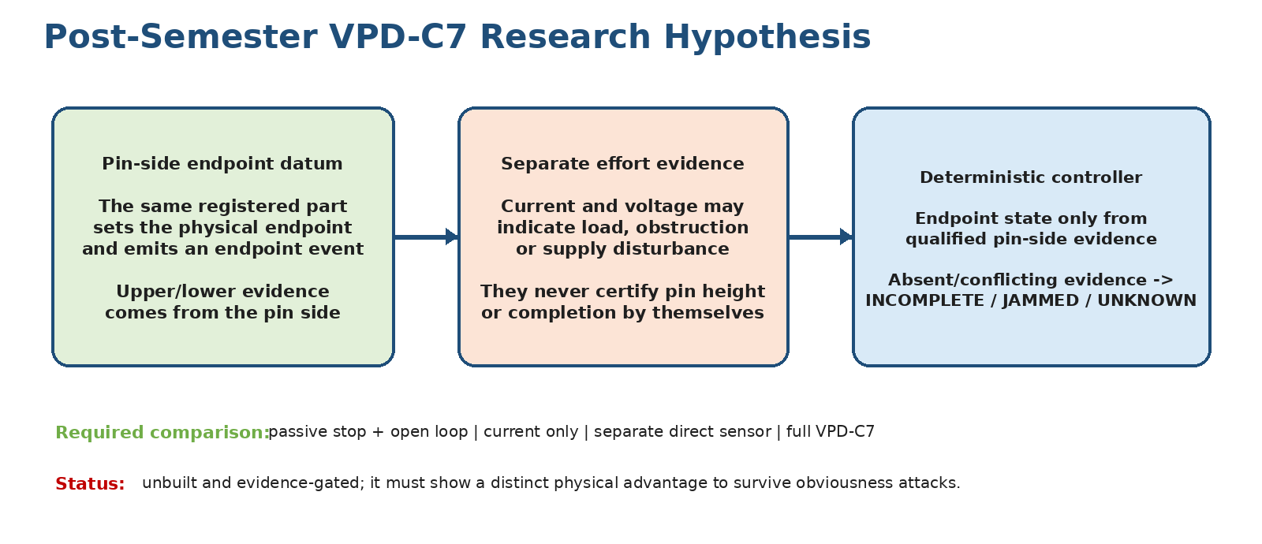
Figure 4. VPD-C7 research concept. It is not implemented or validated in the semester cell.
16.1 Technical question
Can a pin-side mechanical datum that sets the tactile endpoint also provide direct endpoint evidence with less registration error and fewer silent wrong states than a passive stop plus a separately mounted sensor, while keeping actuator current limited to independent effort/supply information?
16.2 Candidate mechanism in non-claim language
1. Redesign one post-MVP guide/pin coupon with mechanically registered upper and lower endpoint features.
2. Arrange the endpoint feature so reaching it can produce a low-energy pin-side event without carrying servo power through the contact.
3. Use external displacement and force measurement as the development oracle; do not let the candidate sensor label itself as truth.
4. Use a separate current/voltage channel only to characterize effort, obstruction-like behavior or supply disturbance.
5. Declare an endpoint state only from qualified pin-side evidence; absent or conflicting evidence becomes incomplete, jammed or Unknown.
6. Permit recovery/isolation only after the physical and safety behavior is experimentally qualified.
16.3 Why this is only a hypothesis
• A mechanical stop that also acts as a switch/contact is familiar engineering and may be obvious.
• The added contact may increase friction, force, bounce, contamination sensitivity or wear.
• Practical Braille pitch may not accommodate the contact and wiring.
• A separately mounted optical/magnetic sensor may perform just as well or better.
• Current may add no independent diagnostic value beyond command, time and voltage.
• The official Indian close-prior-art file and worldwide claims remain unresolved.
• No experiment currently shows a cooperative or non-additive physical effect.
17. Six-to-twelve-month future research roadmap
Month | Stage | Work | Pass evidence | Failure action
0-2 | Semester foundation and search boundary | Complete frozen macro MVP; preserve mechanical/power records; obtain official close-prior-art documents; build direct displacement oracle | Stable one-dot baseline and a defined professional search problem | Continue semester/publication only if close art anticipates the structural core
2-4 | Current observability and direct sensor baseline | Compare calibrated open loop, current-only observation and a separate direct pin sensor on one-dot fixtures | Held-out evidence showing what current can and cannot reveal | Remove current from the putative invention if it adds no independent value
4-6 | Dual-purpose datum coupon | Build passive-stop, separate-sensor and same-datum-contact coupons; measure force, bounce, registration and false endpoints | Distinct physical advantage fixed before confirmatory data | End VPD-C7 thesis if separate sensor performs equivalently
6-8 | Practical-scale and contamination tests | Develop smaller coupons; test wiring, force, dust/fiber, cleaning and assembly yield | Feasible packing and stable endpoint evidence | Hold Track D if only macro geometry works
8-10 | Replacement, reassembly and lifecycle | Blind servo/cam/pin/datum swaps; multiple operators; extended cycling and inspection | Transfer across builds with bounded drift and no systematic false endpoint | Redesign and restart after systematic wear/failure
10-11 | Locked held-out evidence | Run the preregistered 3,000-transition silent-error test on unseen units/builds/conditions | Zero silently accepted wrong states plus practical Unknown/false isolation rates | Kill the route after a silent wrong state unless a genuinely new mechanism restarts the gate
11-12 | Professional decision gate | Refresh worldwide search; claim/FTO chart; inventorship/disclosure review; management file/no-file decision | Useful narrow scope supported by reproducible physical evidence | Choose confidential know-how, defensive/academic publication or stop
17.1 Research baselines and ablations
Type | Required comparison
Strong conventional baselines | Fixed common PWM; calibrated per-dot open loop; passive datum only; direct separate sensor; fixed sequential refresh
Current tests | Current without endpoint contact; endpoint contact without current; current removed from full candidate
State logic | Unknown retained versus coerced binary decision; retry removed; isolation removed
Service robustness | Servo/pin/cam/datum replacement and independent reassembly
Scale and environment | Macro versus practical-scale coupons; clean versus contamination/wear conditions
17.2 Patent-development kill conditions
• A closer enabling reference or official Indian file discloses the defining combination.
• The same-datum contact has no measurable advantage over a passive stop plus separate sensor.
• The contact adds unacceptable force, friction, bounce, wear or debris sensitivity.
• Practical-scale packaging fails.
• Performance collapses after servo replacement, reprint, remount or reassembly.
• Current adds no independent diagnostic value or is required to certify endpoint completion.
• The locked 3,000-transition test contains a silently accepted wrong state.
• Useful scope collapses to exact hobby parts, macro dimensions or a trivial retry count.
• Institutional/professional review does not justify filing cost or disclosure risk.
18. Confidentiality, inventorship and disclosure control
18.1 Public-safe semester material
• Macro six-dot architecture, six SG90-class servos, eccentric cams, guided pins, ESP32 direct PWM and external servo power.
• Semester budget, team roles, CAD/fabrication learning, repeatability/lifecycle and approved tactile results.
• Honest limitations: macro educational prototype, active retraction, no current-only state verification and no patent claim.
18.2 Keep private until IPR review
• Exact VPD-C7 contact/datum geometry, materials, dimensions, circuits and thresholds.
• Unpublished comparative results against passive stops, separate sensors and current-only inference.
• Replacement/reassembly, wear, contamination and held-out silent-error datasets.
• Claim-to-experiment maps, filing strategies and contributor/inventorship analysis.
18.3 Inventorship/contribution record
Maintain dated records of who conceived each later mechanical/electrical interaction, who designed each experiment, who created CAD/firmware, and when the mechanism was first built and tested. AI/model assistance is not inventorship and must not replace human conception records.
18.4 Disclosure rule
Do not rely on an assumed grace period
Before publishing code, CAD, datasets, posters, videos, papers, competition entries or VPD-C7 details, obtain institutional IPR review. A patent filing or defensive publication does not create freedom to operate.
19. Decision gates and escalation rules
Gate | When | Pass | Fail response
OB-G0 Teacher concept decision | Before procurement | OpenBraille retained with scope/budget approved | Proceed with VibeGuard or revise the project request
OB-G1 Facility/procurement | Week 1 | Printer/tools and first components available | Do not commit full-cell schedule; use VibeGuard fallback if needed
OB-G2 One-dot mechanics | Weeks 3-4 | Active raise/retract and repeatability pass | Redesign coupon; stop six-dot expansion
OB-G3 Six-servo power | Weeks 6-8 | No unsafe droop, reset, heating or stall in planned sequence | Upgrade supply/distribution or reduce groups
OB-G4 Six-dot MDS | Week 8 | Correct pattern transitions and safe operation | Report partial prototype or switch according to teacher direction
OB-G5 Locked validation | Week 10 | Approved repeatability/lifecycle/tactile gates pass | No patent or performance overclaim; document failure
OB-G6 VPD-C7 research entry | Post-semester | Separate design, confidentiality and search approval | Keep OpenBraille as semester/publication record only
OB-G7 Counsel-led filing evaluation | Months 11-12 | Unexpected physical effect, enabling evidence and useful scope survive review | Do not file; choose publication/know-how/stop
20. Open questions and teacher decisions
ID | Question / decision | Owner | Required by
Q1 | Should OpenBraille remain the semester project or should the requested VibeGuard switch be approved? | Project coordinator | Before procurement
Q2 | Is the working build window approximately eight weeks or the full twelve-week plan? | Teacher/project coordinator | Week 1
Q3 | Is institutional FDM access dependable, and what material/print limits apply? | Amith + lab | Week 1
Q4 | Which exact ESP32 and SG90 seller/batch are approved? | Nihad/Sreehari/Amith | Before order
Q5 | What quantitative tactile-identification protocol and participant access are approved? | Teacher + Archa/Nihad | Before tactile test
Q6 | What is the approved raised/lowered position band for the macro cell? | Technical team + teacher | Before locked validation
Q7 | Is the 5 V / 3 A target supply adequate under the actual six-servo sequence? | Amith + Nihad | Before full integration
Q8 | What content may be disclosed publicly before institutional IPR review? | IPR cell / project owner | Before publication or competition
Q9 | Should VPD-C7 remain only a confidential future option after the semester? | Team + institution | After MVP evidence
21. Teacher approval and conditions
Decision item | Teacher response
Semester project | Retain OpenBraille / Approve VibeGuard switch / Revise and resubmit
Frozen OpenBraille scope | Approved / Approved with conditions / Not approved
Expected budget near ₹3,000 | Approved / Revise
External 5 V servo supply and safety controls | Approved / Lab review required
One-dot-first procurement gate | Approved / Revise
Tactile participant protocol | Approved / Separate ethics/access review required
Future VPD-C7 treatment | Confidential post-semester only / Not approved / Further review
Teacher conditions
Signature and date
22. Source basis
This dossier was prepared from the controlled Project mC master package. The main evidence layers are:
Evidence layer | Controlled source
Project authority | Engineering Design Review; Project mC Decision Register v1.2; approved Phase 3C Portfolio Closure Memo
Common evidence | Concept Evidence Matrix; Uncertainty and Test Register
OpenBraille technical authority | Final OpenBraille Architecture Report; Memory; SOP
Comparative decision context | Two final cross-concept adjudications - treated as context, not votes
Future research boundary | OpenBraille Pre-Build Future Patent-Case Simulation
Costing and teacher context | Project mC Teacher Documents - Master Evidence, Costing and Decision Basis
Previous presentation | Final OpenBraille zeroth-review presentation dated 30-07-2026
22.1 Current official specification and price references
• Espressif, ESP32-WROOM-32 data sheet: https://www.espressif.com/sites/default/files/documentation/esp32-wroom-32_datasheet_en.pdf
• Espressif, ESP32-S3 product page and DevKitC-1 guide: https://www.espressif.com/en/products/socs/esp32-s3
• TowerPro, SG90 analog servo specifications: https://towerpro.com.tw/product/sg90-analog/
• Indian price snapshots and procurement cautions are recorded in the Master Evidence, Costing and Decision Basis and must be refreshed on purchase day.
Prepared for academic project planning. The future research section is a management and experimental roadmap, not legal advice, patentability clearance, freedom-to-operate clearance, a filing recommendation or a promise of patent grant.

