Lets go screen by screen to be on the same page with you

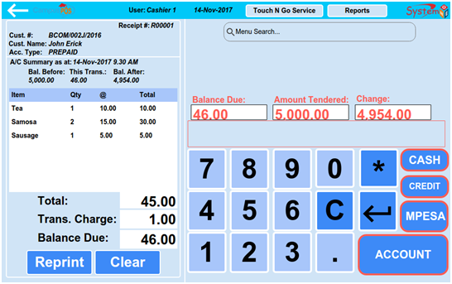

When student walk to the cafeteria/cateen, he can buy by CASH, OR CARD or MOBILE MONEY(MPESA) OR ACCOUNT

Let's start with a CASH student

He will tell the Cashier/Teller what he want, let us say Sausage and a Cup of Tea

Let's assume from the menu coding, Sausage is code 20 and a Cup of Tea is code 11

The Cashier/Teller will press keypad 2 and 0=code 20 and press enter then internally the system will search this item from the database and get it's description and the cost and display it on the left side screen

If the student wanted 2 sausages, the Cashier/Teller will press keypad 2 nad 0 then * and 2=code 20*2 then press enter

The default quontity is always 1

The cashier will repeat these steps for the other items like for tea press 11 then enter

Then click on CASH button, a prompt dialog box where the cashier will enter the amount of cash given by the student will be displayed

This value will be compared gainst the expected amount as displayed on the screen, if it is enough, it will be saved on the database then a reciept is printed. No detail about the student is required on this type of transaction

Incase it was a card which you dont need to code for now, there will be a dialog box promting for the card info and pin

Incase the student was to pay via MPESA which is simply mobile mpney in Kenya(very common), it will prompt for transaction code and phone number which it will save into the database and then print the receipt. ***The validity of the transaction will be done by us don't worry

No student data is required on above

Now on the Account is where the student record will be displayed on the screen suggested above.

When ACCOUNT is selected, the system will prompt the Cashier/Teller to provide the student account number which will be validated against the existing Accounts (Remember there is a screen for setting this already), if exist,the student will be prompted to put his pin or we will use a fingerprint(to be developed by us just do with the pin for now), if the pin is valid, depending on the account type, if PREPAID, the system will check the current available Prepaid balance and and display the detail as indicated on the screen then save the same on the database then send to the printer

IF POSTPAID account type, the system will check if the account holder have not reached the maximum allowed credit and continue with the same, save the data, display on the screen then sent to the printer

[11/21/2017 11:51:01 PM | Edited 11:51:04 PM] wolf: fingerprinter part is done by there, right?

[11/21/2017 11:51:08 PM] JOHN ERICK OKATCH: Yes

[11/21/2017 11:52:19 PM | Edited 11:52:38 PM] wolf: When ACCOUNT is selected, the system will prompt the Cashier/Teller to provide the student account number which will be validated against the existing Accountswill you provide design for prompt dialog to input student account number ?

[11/21/2017 11:52:56 PM] JOHN ERICK OKATCH: No problem I can.

But remember the actual accounts will be capture on

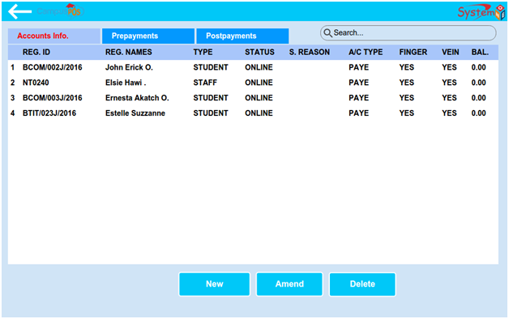

On the same screen, I can use the search box to search for an item either by title or by code and displayed on the space below the search box

Menu Search

Have you seen it?

yes.

The Reprint button is simply to help in resending the last transaction which is currently being displayed on the screen to the printer

Then the New button is to clear screen for new transaction

[11/22/2017 12:00:57 AM] JOHN ERICK OKATCH: Immediately above the keypad there is a display box for displaying the key pressed on the keypad before pressing the enter key

[11/22/2017 12:02:25 AM | Edited 12:02:31 AM] JOHN ERICK OKATCH: Are you comfortable with this screen now?

[11/22/2017 12:02:54 AM] wolf: reprint is also done by you, right?

[11/22/2017 12:03:41 AM] JOHN ERICK OKATCH: No problem

[11/22/2017 12:09:28 AM] wolf: Hi, John.

[11/22/2017 12:09:36 AM] JOHN ERICK OKATCH: Yes

[11/22/2017 12:09:38 AM] wolf: plz explain about others.

[11/22/2017 12:10:00 AM] JOHN ERICK OKATCH: Let's go to the second screen which you get when you press Toach N Go button on that sales screen

[11/22/2017 12:12:09 AM] wolf: I am on now.

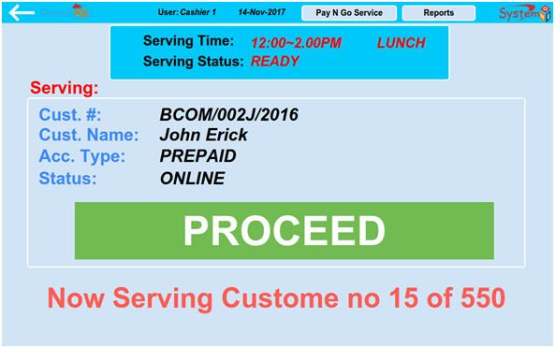

With this, just create that screen alone

The rest we will take care of

The next screen is menu

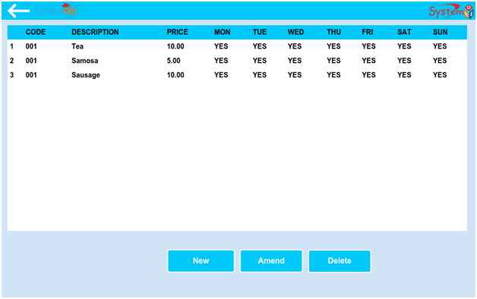

This should display existing menu of item. Sorry it should have a search box at the top like the rest of other screen

The screen is used for displaying menu from the database

When a user click on New button, a screen will prompt him to key in details as indicated on the above screen which will be saved on the database

If a user select a record and click on Amend button, the record will be displayed to enble the user change the record and save back

Ok



[11/23/2017 1:07:24 AM] wolf: tell me about "Cashier/Teller:" dropbox.

[11/23/2017 1:09:28 AM] JOHN ERICK OKATCH: The dropbox will list all the POS users coming from the database. Remember you will create the login details in the database right?

[11/23/2017 1:10:19 AM] JOHN ERICK OKATCH: Before a user user the system he must login into the system to serve the student right?

[11/23/2017 1:11:05 AM] JOHN ERICK OKATCH: So if we want to generate the report based on the users who logged in to serve the student

[11/23/2017 1:11:31 AM] wolf: you said that app will work on local right?

[11/23/2017 1:12:31 AM] JOHN ERICK OKATCH: Yes

[11/23/2017 1:13:50 AM] wolf: app will work with server?

[11/23/2017 1:13:54 AM] wolf: with api?

[11/23/2017 1:16:08 AM] JOHN ERICK OKATCH: Both local and server. But for you just do local, I will create a synchronization part

[11/23/2017 1:16:46 AM] wolf: so I don't implement login part?

[11/23/2017 1:18:11 AM] JOHN ERICK OKATCH: You have to implement. Please check through Settings, you will get the users screen

[11/23/2017 1:18:39 AM | Edited 1:18:50 AM] wolf: But for you just do local, I will create a synchronization partwhat is this mean?

[11/23/2017 1:21:19 AM] JOHN ERICK OKATCH: This app to run fully local, with a local database

[11/23/2017 1:21:29 AM] JOHN ERICK OKATCH: SQLite

[11/23/2017 1:21:55 AM] JOHN ERICK OKATCH: We will be able to create users locally

[11/23/2017 1:22:28 AM] wolf: login?

[11/23/2017 1:26:38 AM | Edited 1:26:45 AM] wolf: login will create user in local?

[11/23/2017 1:34:03 AM] JOHN ERICK OKATCH: Yes.

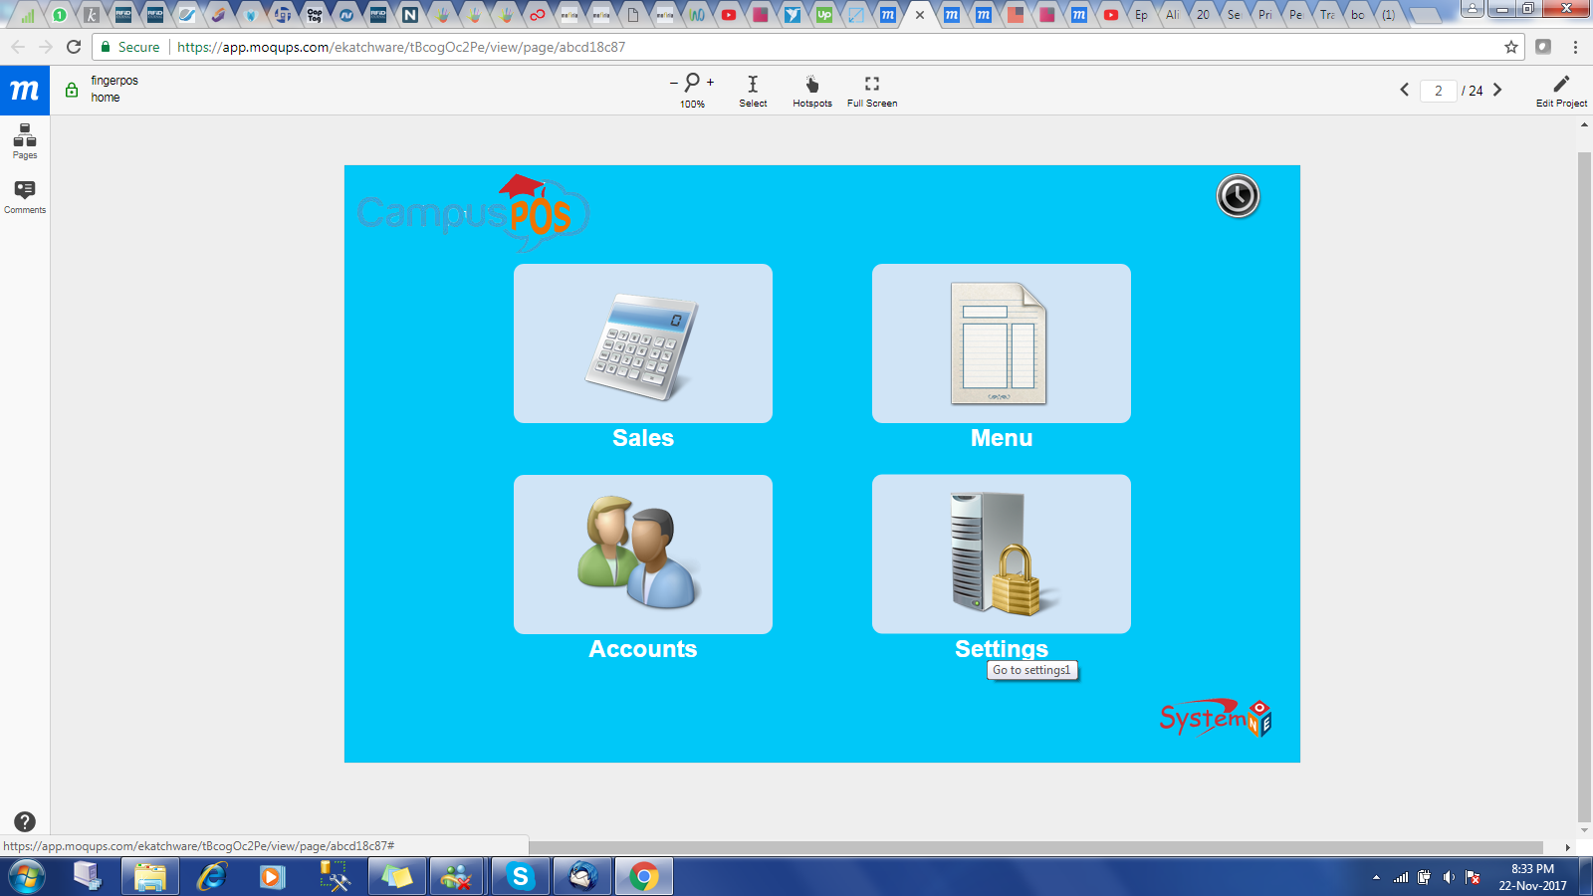

[11/23/2017 1:34:18 AM] wolf: don't work with api?

[11/23/2017 1:34:19 AM] JOHN ERICK OKATCH: Select Settings from that screen

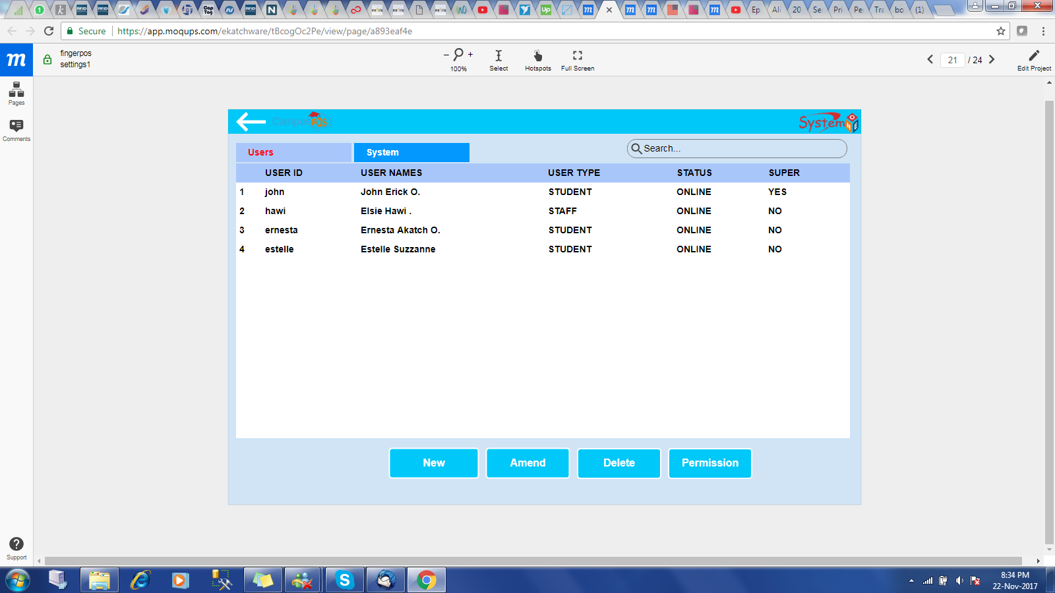

You get that screen

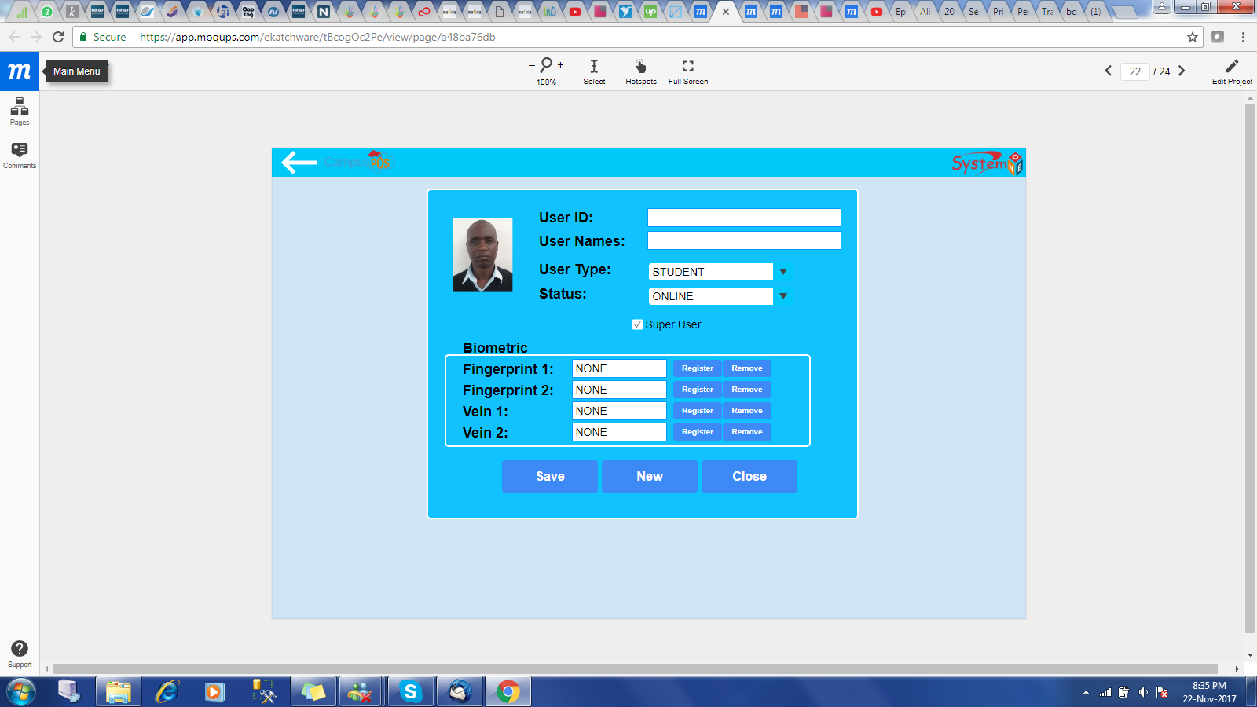

Click on New button you get that screen

It is used to save users(login) into local database

[11/23/2017 1:36:25 AM] wolf: first login?

[11/23/2017 1:36:37 AM] JOHN ERICK OKATCH: You only leave the biometric part

[11/23/2017 1:36:38 AM] wolf: first time there is no data in sql.

[11/23/2017 1:36:56 AM] JOHN ERICK OKATCH: Yes

[11/23/2017 1:37:08 AM] wolf: at this time, how to login?

[11/23/2017 1:37:19 AM | Edited 1:37:22 AM] wolf: how to check validate of user login.

[11/23/2017 1:37:22 AM] JOHN ERICK OKATCH: but you must create a default login credentials

[11/23/2017 1:37:43 AM] wolf: with server?

[11/23/2017 1:37:58 AM] JOHN ERICK OKATCH: Local db

[11/23/2017 1:38:20 AM] wolf: first time?

[11/23/2017 1:38:26 AM] wolf: also local db?

[11/23/2017 1:38:34 AM] wolf: there is no info at first time login.

[11/23/2017 1:38:39 AM] JOHN ERICK OKATCH: yes.

[11/23/2017 1:38:54 AM] wolf: how to check validate

[11/23/2017 1:39:00 AM] wolf: at the first time.

[11/23/2017 1:39:08 AM] wolf: there is no data to check in SQLite.

[11/23/2017 1:39:34 AM] JOHN ERICK OKATCH: You insert temporary data into the database via a code or hardcode the credentials

[11/23/2017 1:46:10 AM] wolf: at the first login? add data to local db, right?

[11/23/2017 1:46:23 AM] wolf: don't work with server?

[11/23/2017 1:51:20 AM] JOHN ERICK OKATCH: Yes

[11/23/2017 1:51:56 AM] wolf: ok, go on.

[11/23/2017 1:52:09 AM] wolf: plz explain about report.

[11/23/2017 1:53:29 AM] JOHN ERICK OKATCH: Have you ever used sql language?

[11/23/2017 1:53:45 AM] wolf: yes.

[11/23/2017 1:53:55 AM] wolf: don't worry about my experience .

[11/23/2017 1:54:11 AM] wolf: I have full experience on mobile app(android and ios) and web development.

[11/23/2017 1:54:28 AM] wolf: i only want to make all clear.

Now, when you select the server, and the the period date on the screen below during report generation

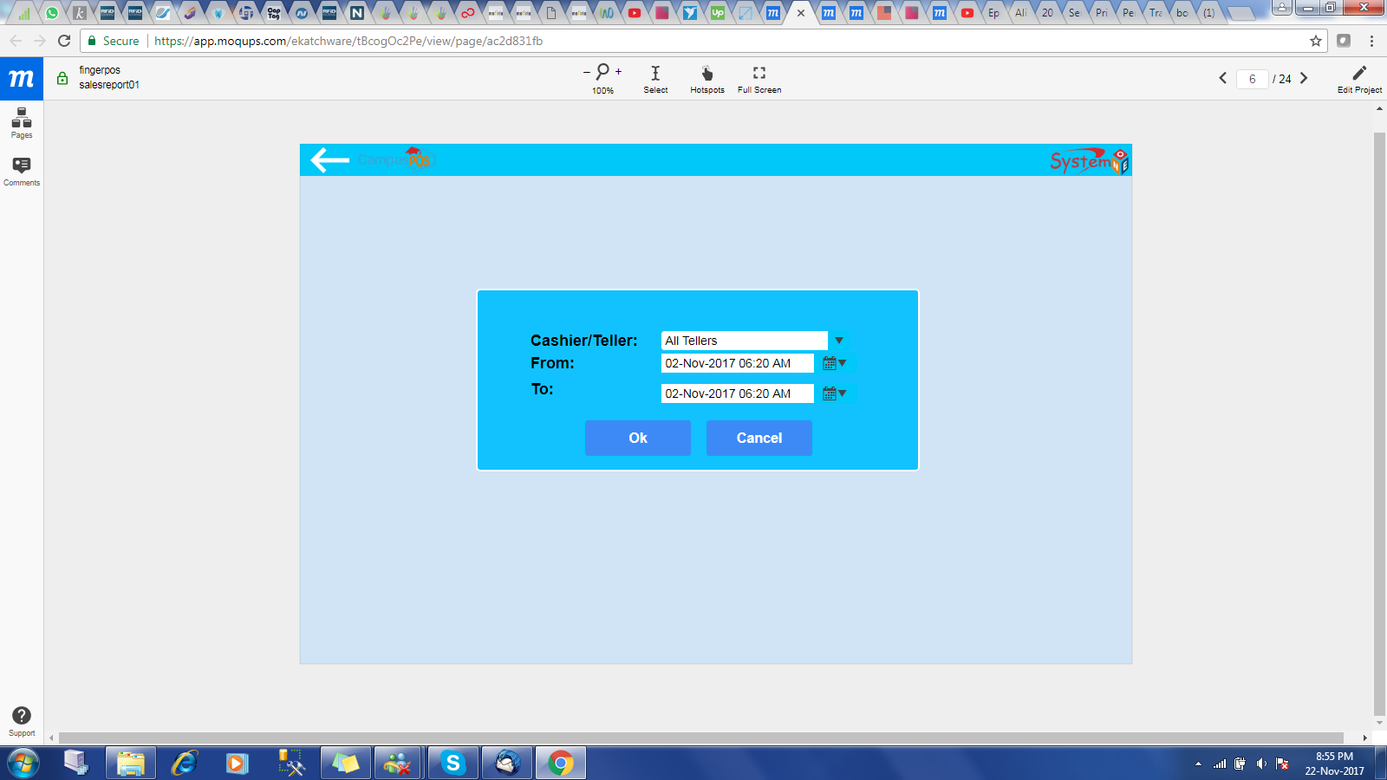

[11/23/2017 1:56:40 AM] JOHN ERICK OKATCH: You will use them as a parameter to query the database

[11/23/2017 1:56:52 AM] wolf: this data will from server? or local?

[11/23/2017 1:57:01 AM] JOHN ERICK OKATCH: Local.

[11/23/2017 1:57:10 AM] wolf: when you select the serverwhat do you mean server?

[11/23/2017 1:57:39 AM] wolf: Cashier/Teller?

[11/23/2017 1:57:51 AM] JOHN ERICK OKATCH: Exactly

[11/23/2017 1:57:57 AM] wolf: good.

[11/23/2017 1:58:00 AM] JOHN ERICK OKATCH: The person serving

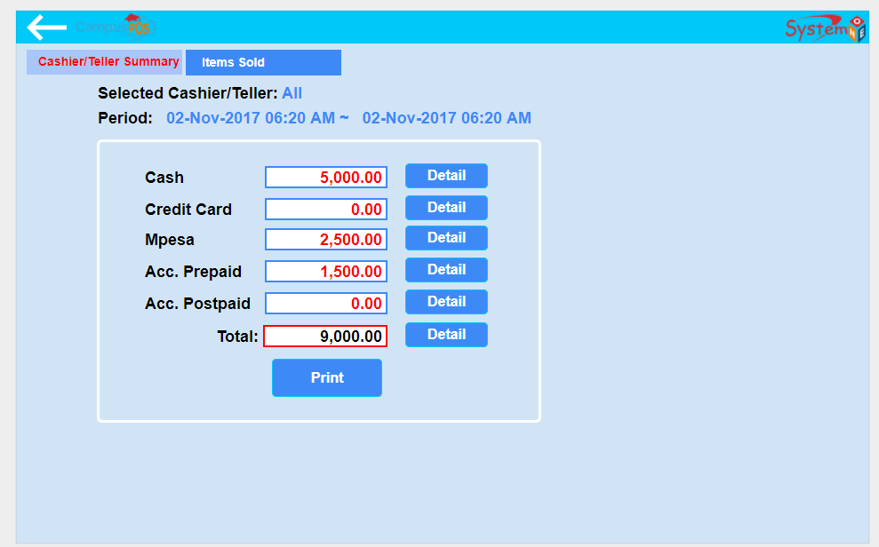

[11/23/2017 1:59:49 AM] wolf: difference between prepaid and postpaid.

[11/23/2017 2:02:34 AM | Edited 2:03:54 AM] JOHN ERICK OKATCH: All are of Account type but differ in terms of the Prepaid, the student deposit some money in advance and it is reduced as he buy the items from the canteen. While on Postpaid, the student buy on credit and pay later

[11/23/2017 2:04:38 AM] wolf: when pay using account, will be prepaid, right?

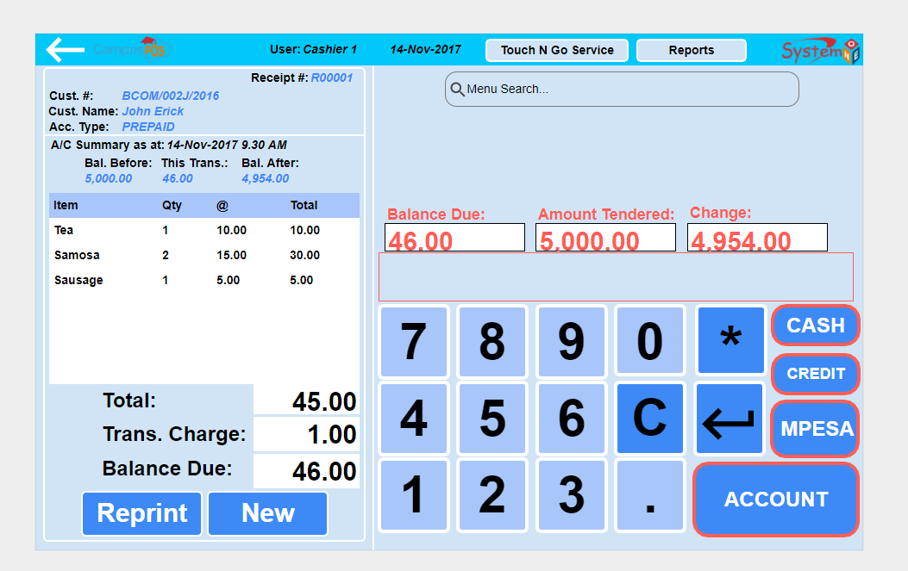

[11/23/2017 2:04:45 AM] wolf: and other is postpaid?

[11/23/2017 2:05:35 AM] JOHN ERICK OKATCH: It can either be Postpaid or Prepaid

[11/23/2017 2:06:09 AM] JOHN ERICK OKATCH: Depends on the Account type

[11/23/2017 2:06:14 AM] wolf: how can user set postpaid and prepaid?

[11/23/2017 2:06:38 AM] JOHN ERICK OKATCH: Can only be one but not both

[11/23/2017 2:07:16 AM] JOHN ERICK OKATCH: i.e. Staff like being Postpaid as they pay via their salary

[11/23/2017 2:07:41 AM] JOHN ERICK OKATCH: while Students are always Prepaid

[11/23/2017 2:08:52 AM] wolf: ok, go on.

[11/23/2017 2:11:08 AM] wolf: plz explain about other part.

[11/23/2017 2:14:09 AM] JOHN ERICK OKATCH: So when a user click on the Ok button the system query the data from the transaction table grouped as displayed on the screen

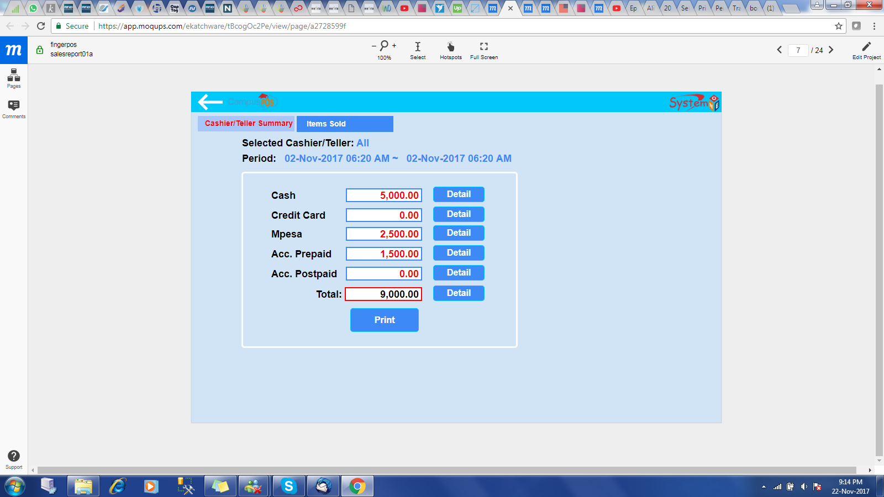

these are the shown on the screen

Wolf, or else you can do the UI only then I do the rest???

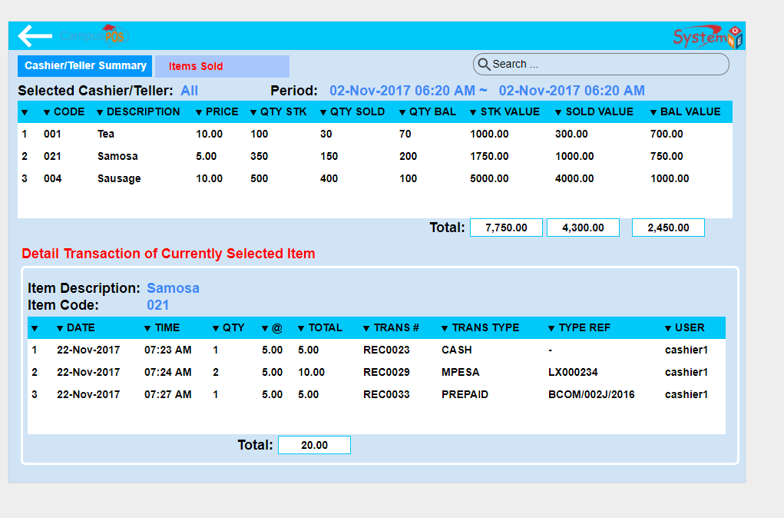

[11/23/2017 2:16:29 AM] wolf: this will be done by you?

[11/23/2017 2:18:32 AM] JOHN ERICK OKATCH: Still part of the report

[11/23/2017 2:19:55 AM] wolf: i don't understand of below

[11/23/2017 2:19:58 AM] wolf: red part.

[11/23/2017 2:21:56 AM] JOHN ERICK OKATCH: QTY STK means Quontity in Stock, ignore it

[11/23/2017 2:23:11 AM] JOHN ERICK OKATCH: But QTY SOLD is the quontity of the Item Sold within the specified period and you get this from sales table

[11/23/2017 2:24:05 AM | Edited 2:24:12 AM] JOHN ERICK OKATCH: QTY BAL is Quontity Balance or the difference between QTY STK and QTY SOLD

[11/23/2017 2:25:07 AM] JOHN ERICK OKATCH: STK VALUE means Stock Value, stock quontity * the unit price

[11/23/2017 2:25:32 AM] wolf: understand.

[11/23/2017 2:25:46 AM] JOHN ERICK OKATCH: Sold value is equal to QTY SOLD * Unit price

[11/23/2017 2:25:48 AM] JOHN ERICK OKATCH: Good

[11/23/2017 2:26:10 AM] wolf: below type_ref?

[11/23/2017 2:26:21 AM | Edited 2:26:28 AM] wolf: this is user info?

[11/23/2017 2:28:26 AM] JOHN ERICK OKATCH: Either Account number for transactions based on ACCOUNT such as Prepaid or Prepaid or Mobile Transaction number incase transaction is based on mobile phone money "MPESA"

[11/23/2017 2:28:41 AM] wolf: ok

[11/23/2017 2:28:46 AM] JOHN ERICK OKATCH: CASH has none

[11/23/2017 2:30:01 AM] wolf: go to account.

[11/23/2017 2:31:01 AM] JOHN ERICK OKATCH: This screen is used to display existing Account details

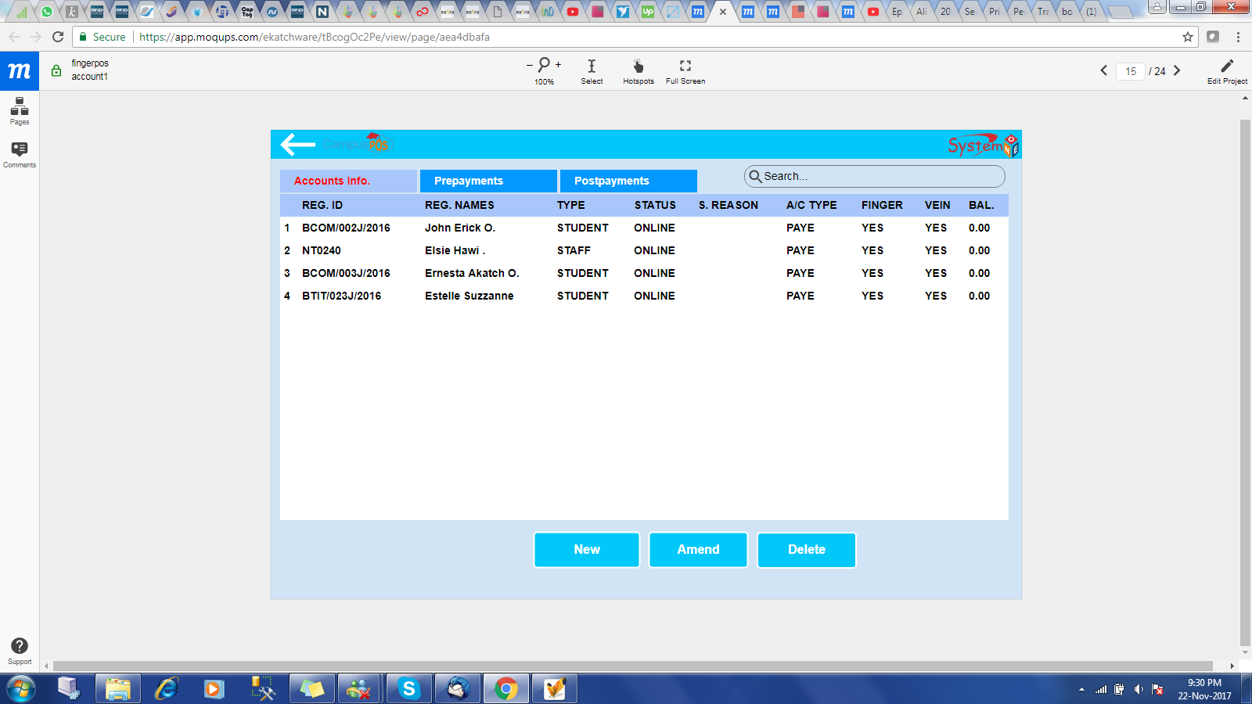

[11/23/2017 2:31:26 AM | Edited 2:31:32 AM] wolf: explain about new and amend.

[11/23/2017 2:31:53 AM] JOHN ERICK OKATCH: If you want to add a new Account, you click on New Button and you get the screen below

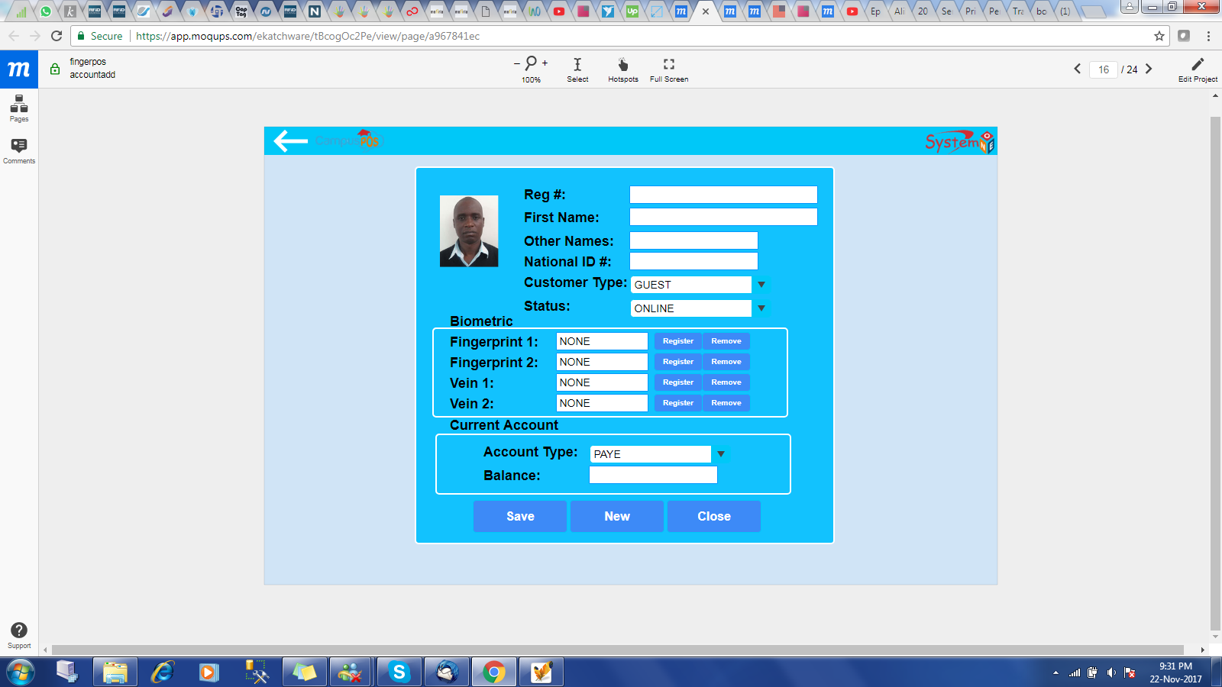

plz explain about this screen.

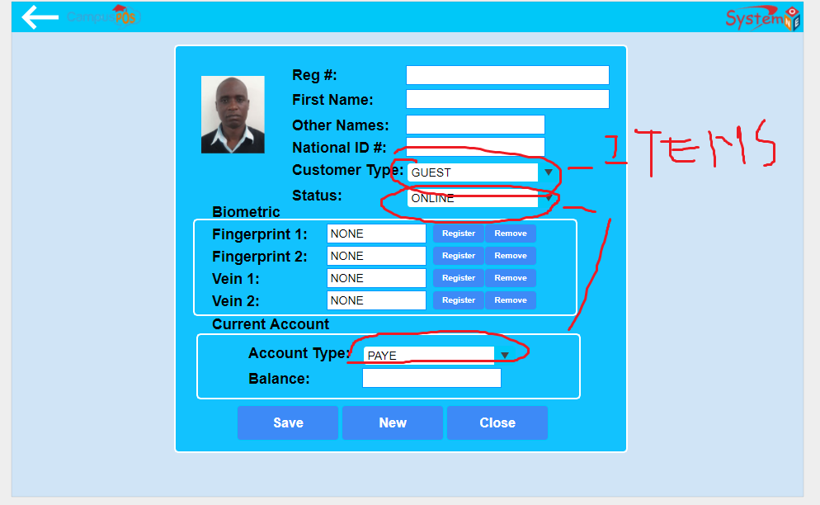

[11/23/2017 2:34:59 AM] JOHN ERICK OKATCH: There are four types of customer: 1. GUEST, 2. RESIDENT STUDENT, 3. NON RESIDENT STUDENT and 4. STAFF

[11/23/2017 2:35:24 AM] JOHN ERICK OKATCH: These should be listed on the combox

[11/23/2017 2:36:23 AM] JOHN ERICK OKATCH: Then the Status are only two: ONLINE or OFFLINE to help activate or deactivate account

[11/23/2017 2:37:19 AM] JOHN ERICK OKATCH: Then Account Types are also two only: PAYE or BORDER

[11/23/2017 2:38:48 AM] wolf: got.

[11/23/2017 2:38:56 AM] wolf: balance?

[11/23/2017 2:39:02 AM] JOHN ERICK OKATCH: Okay

[11/23/2017 2:39:49 AM] JOHN ERICK OKATCH: I will use it to display the current Prepaid Balance

[11/23/2017 2:40:12 AM] wolf: it will be concern with prepaid balance, right?

[11/23/2017 2:40:25 AM] JOHN ERICK OKATCH: Yes

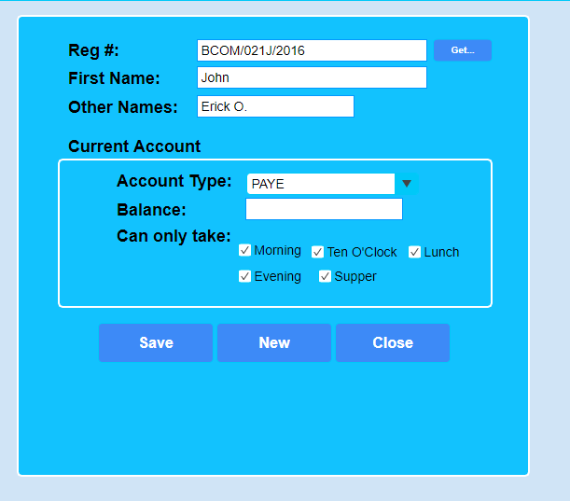

[11/23/2017 2:41:08 AM | Edited 2:41:14 AM] wolf: explain about "Can only take"

[11/23/2017 2:43:03 AM] wolf: and one user can have two account like prepayment and postpayment?

[11/23/2017 2:43:18 AM] JOHN ERICK OKATCH: No

[11/23/2017 2:43:48 AM] wolf: explain about "Can only take"

[11/23/2017 2:47:50 AM] JOHN ERICK OKATCH: This indicate which meal the student is allowed to take in a given day

[11/23/2017 2:48:36 AM] JOHN ERICK OKATCH: If not ticked, the student/account holder is not authorized to take that meal

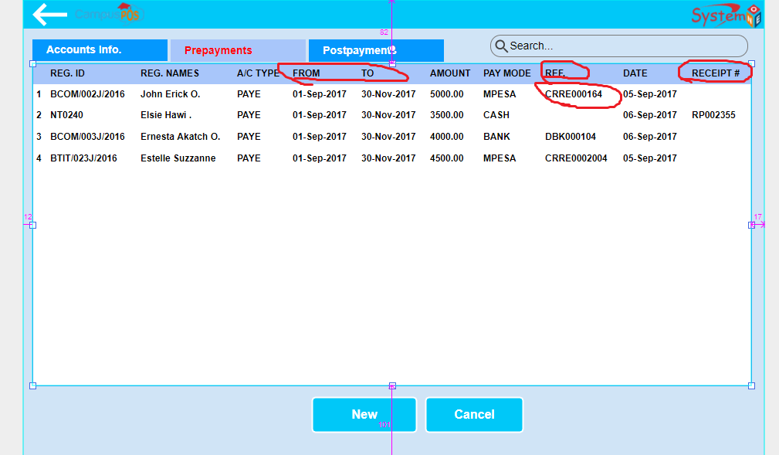

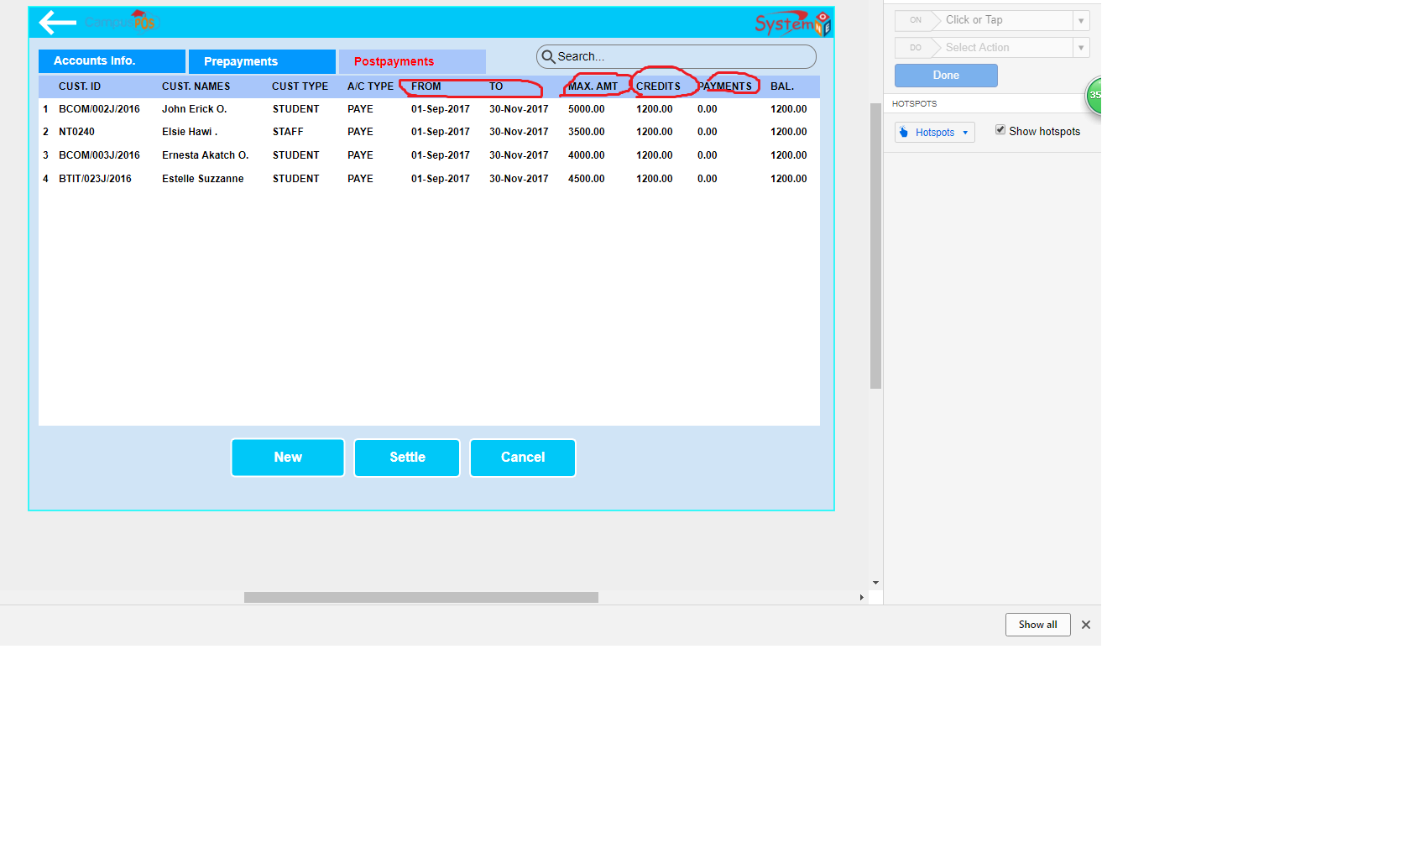

explain about red part.

and explain about difference between "account add" and "user add".

will save in difference table in sqlite?

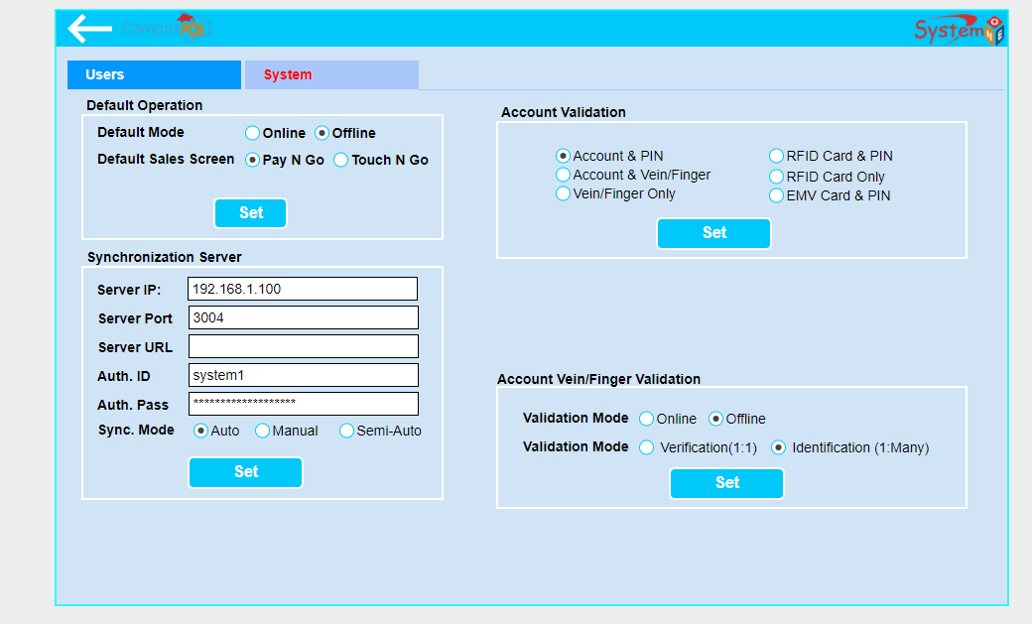

[11/23/2017 2:54:04 AM] wolf: and explain about that.

[11/23/2017 2:55:33 AM] JOHN ERICK OKATCH: Account is the Clients/Customers to be served with the system e.g a student while a User is the staff who will be operating the system, system users

[11/23/2017 2:55:50 AM] JOHN ERICK OKATCH: or the teller/cashier

[11/23/2017 2:58:18 AM] JOHN ERICK OKATCH: For system set up

[11/23/2017 2:58:58 AM] wolf: so will save difference table right?

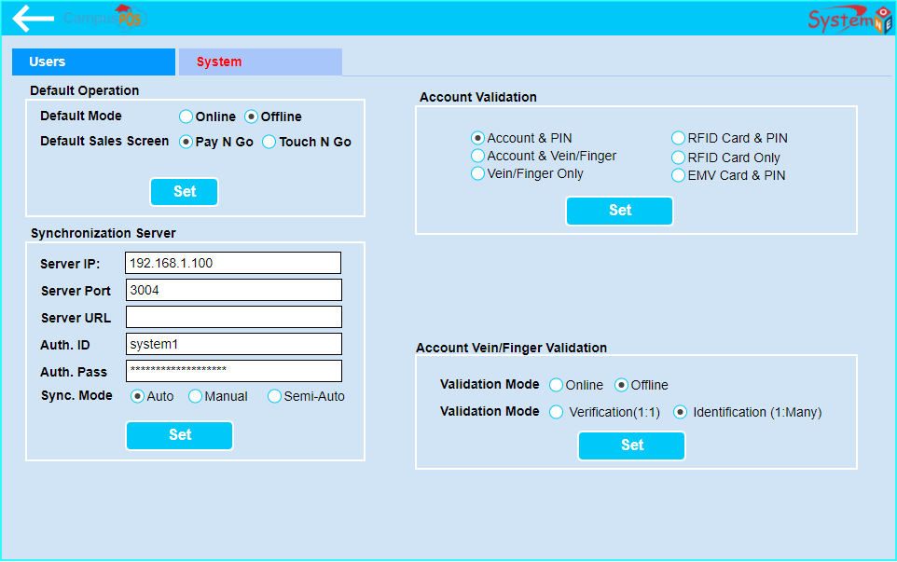

Yes

Like four tables

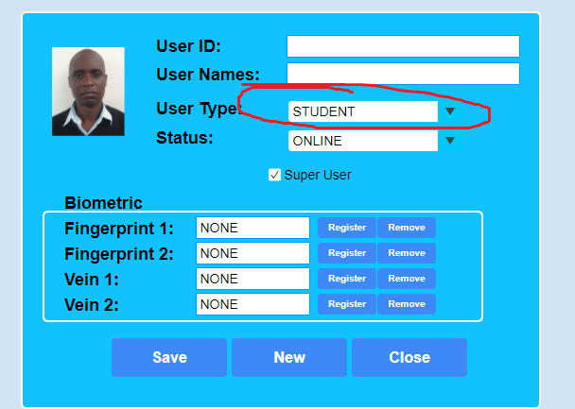

tell me about items for red part.

[11/23/2017 3:03:08 AM] JOHN ERICK OKATCH: Type of User, can only be MAIN ADMIN, LECTURE, STAFF

[11/23/2017 3:03:15 AM] JOHN ERICK OKATCH: No student there

[11/23/2017 3:05:07 AM] wolf: you put student so it makes me disconcernted

[11/23/2017 3:05:13 AM] wolf: ok.

[11/23/2017 3:05:30 AM] JOHN ERICK OKATCH: Sure. Sorry for that

[11/23/2017 3:05:31 AM] wolf: go on other part base on image that i sent.

[11/23/2017 3:05:39 AM] JOHN ERICK OKATCH: Copy paste

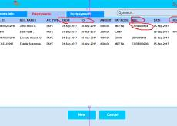

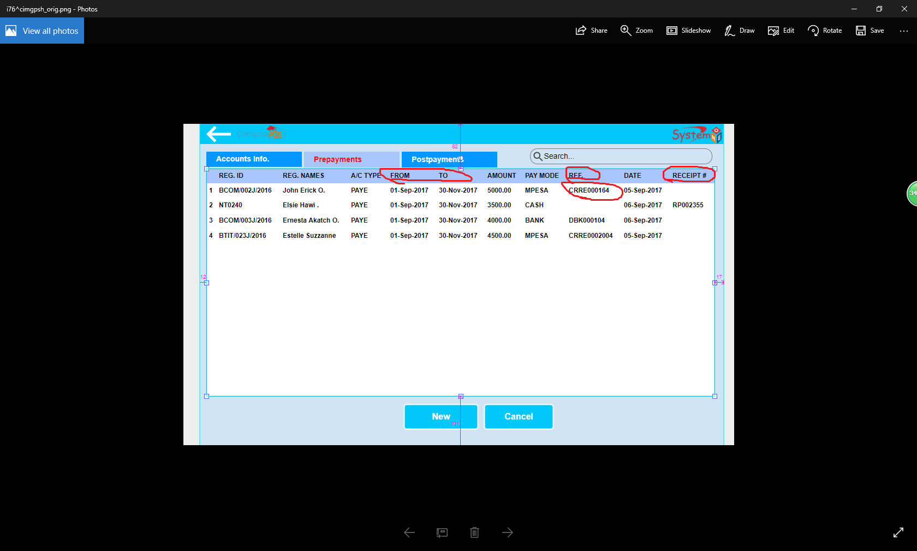

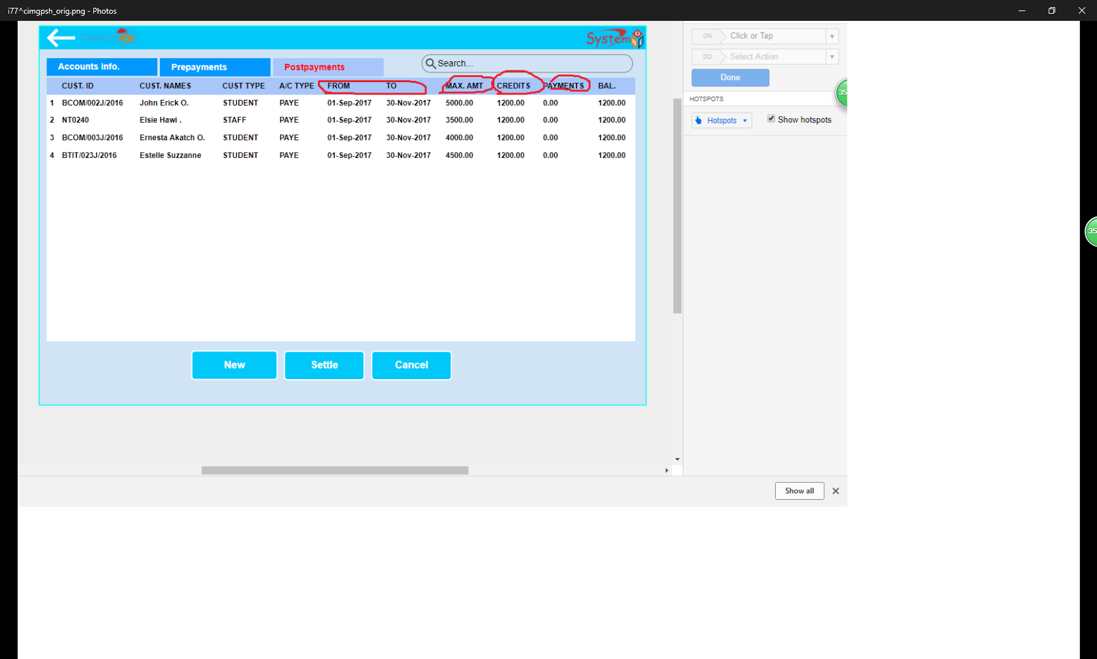

[11/23/2017 3:07:45 AM] JOHN ERICK OKATCH: At times when they make a Prepayment or a Postpayment, it should be only for a given period, that is why we have Date from and Date To

[11/23/2017 3:09:25 AM] JOHN ERICK OKATCH: Then REF is simply a transaction number such as Mobile Phone transactions though Cash does not

[11/23/2017 3:13:09 AM] wolf: REFis generated by app?

[11/23/2017 3:14:09 AM] JOHN ERICK OKATCH: No. Only Receipt Number is generated by app.

[11/23/2017 3:15:13 AM] wolf: ignore it, ok?

[11/23/2017 3:15:25 AM] JOHN ERICK OKATCH: Yes

[11/23/2017 3:16:25 AM] wolf: there is no info to input period.

[11/23/2017 3:19:38 AM] wolf: it's so later here.

[11/23/2017 3:19:55 AM] wolf: lets continue to discuss tomorrow.

[11/23/2017 3:19:56 AM] wolf: ok?

[11/23/2017 3:20:16 AM] JOHN ERICK OKATCH: Sure

[11/23/2017 3:20:36 AM] wolf: ping me when you are online tomorrow.

[11/23/2017 3:20:40 AM] wolf: see you tomorrow.

[11/23/2017 3:20:52 AM] JOHN ERICK OKATCH: Good night

[11/23/2017 3:21:01 AM] JOHN ERICK OKATCH: See you tomorrow too

[11/23/2017 2:54:23 PM] JOHN ERICK OKATCH: Hi Wolf

[11/23/2017 2:54:40 PM] JOHN ERICK OKATCH: I have been in a meeting is when I am done

[11/23/2017 2:55:25 PM] wolf: ping me when you have done meeting.

[11/23/2017 2:55:43 PM] JOHN ERICK OKATCH: I am done Wolf

[11/23/2017 2:58:01 PM] wolf: good

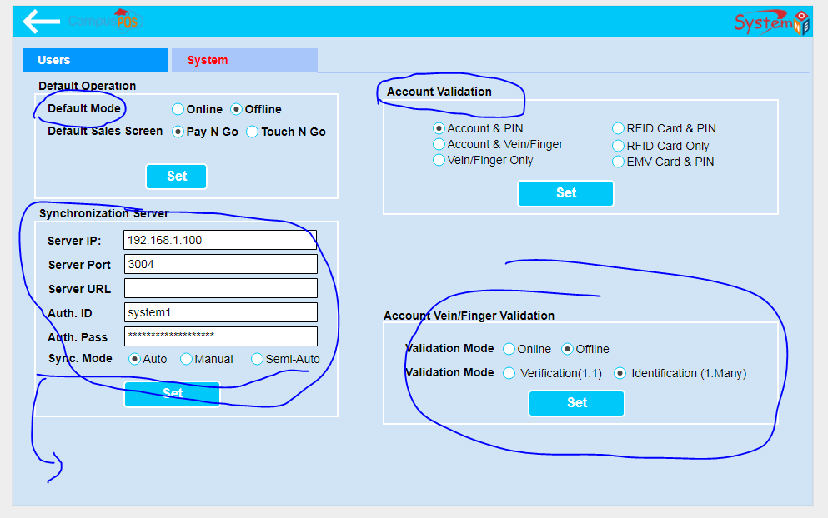

The default operation is a setting of how the system should work when first openned. i.e Should transact with the remote server "Online" via API or work with the local database "Offline"

And there are two sales screens

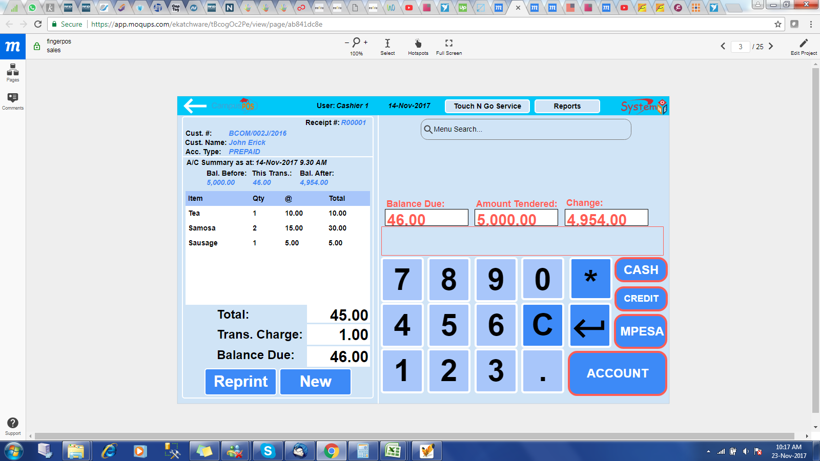

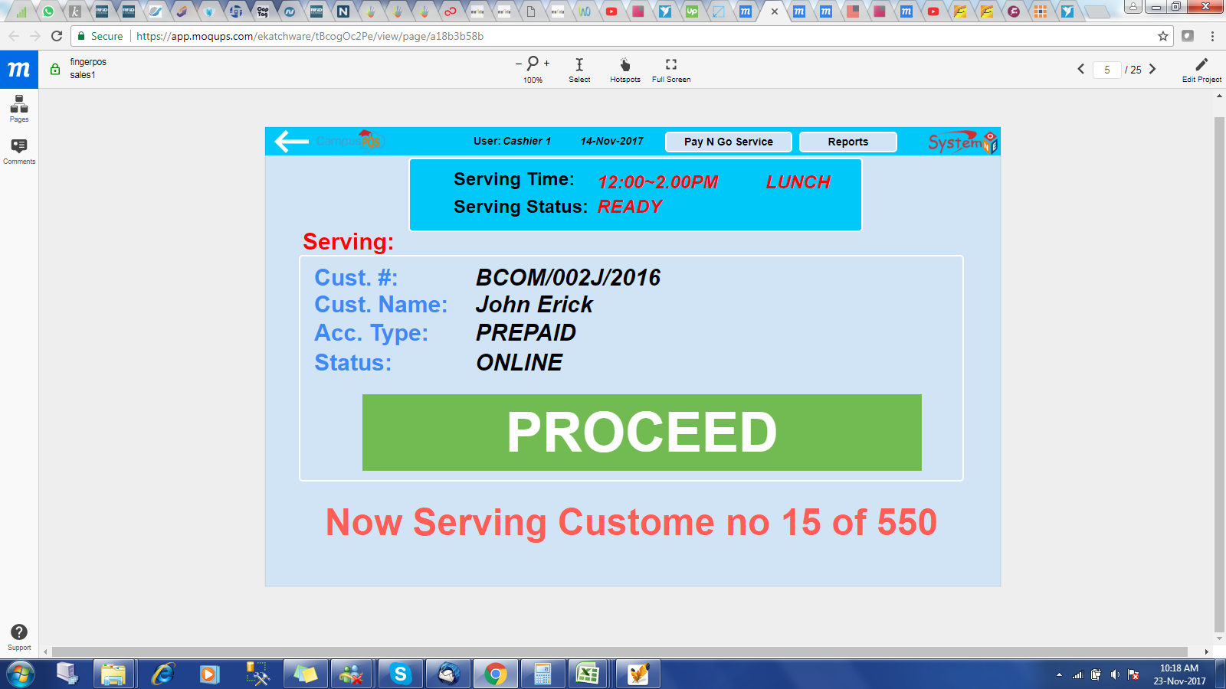

This one is called Touch N Go screen. The food cooked are fixed, i.e fixed menu hence everyone eat the same food, so the students will be just validated via card or fingerprint.

The other one "Pay N Go", there is verious items in the menu which the student can select to buy