Problem Link : <https://www.codingninjas.com/codestudio/problems/implement-trie_631356?topList=love-babbar-dsa-sheet-problems&leftPanelTab=0&utm_source=youtube&utm_medium=affiliate&utm_campaign=Lovebabbar>

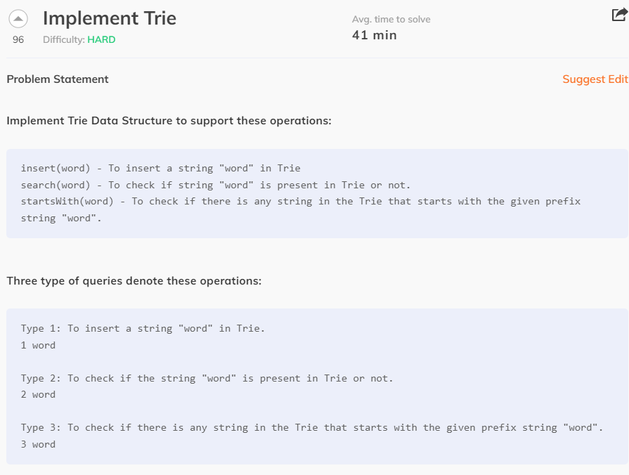

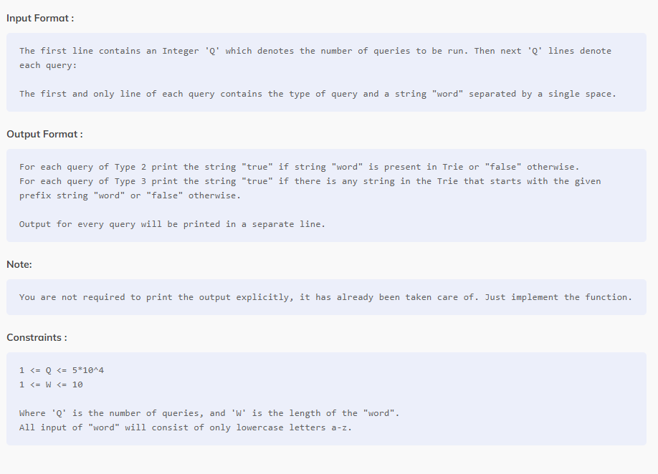

**Sample Input 1 :**

5

1 hello

1 help

2 help

3 hel

2 hel

**Sample Output 1 :**

true

true

false

**Explanation To Sample Input 1 :**

Query 1: "hello" is inserted

Query 2: "help" is inserted

Query 3: "true" is printed as "help" is present

Query 4: "true" is printed as "hello" and "help" is present having the prefix "hel"

Query 5: "false" is printed as "hel" is not present

**Sample Input 2 :**

10

1 aaaa

1 aaaaaa

1 bcd

2 aaaaa

3 aaaaa

3 bc

2 bc

1 bc

3 bcda

2 bc

**Sample Output 2 :**

false

true

true

false

false

true

**Explanation To Sample Input 2 :**

Query 1: "aaaa" is inserted

Query 2: "aaaaaa" is inserted

Query 3: "bcd" is inserted

Query 4: "false" is printed as "aaaaa" is not present

Query 5: "true" is printed as "aaaaaa" is present having the prefix "aaaaa"

Query 6: "true" is printed as "bcd" is present having the prefix "bc"

Query 7: "false" is printed as "bc" is not present

Query 8: "bc" is inserted

Query 9: "false" is printed as no word is present having the prefix "bcda"

Query 10: "true" is printed as "bc" is present