1. Prepare the project – Create a new project (Java with Ant, Java Application)  
   If a pop up asks you to install/or ready the Java interpreters then allow it.

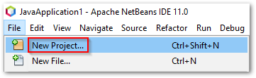

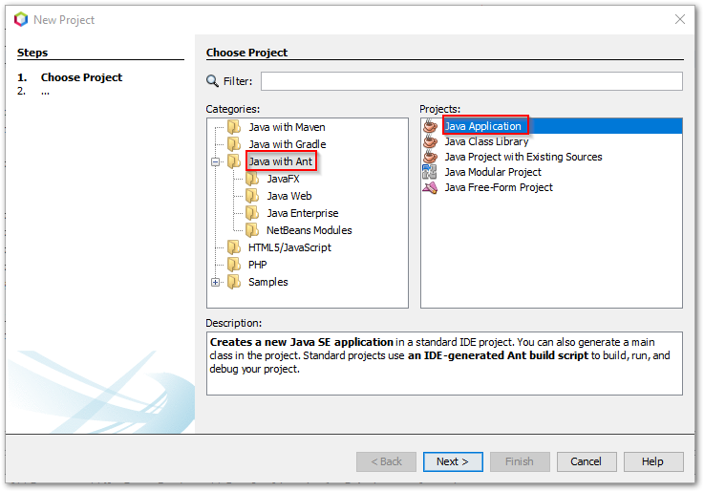

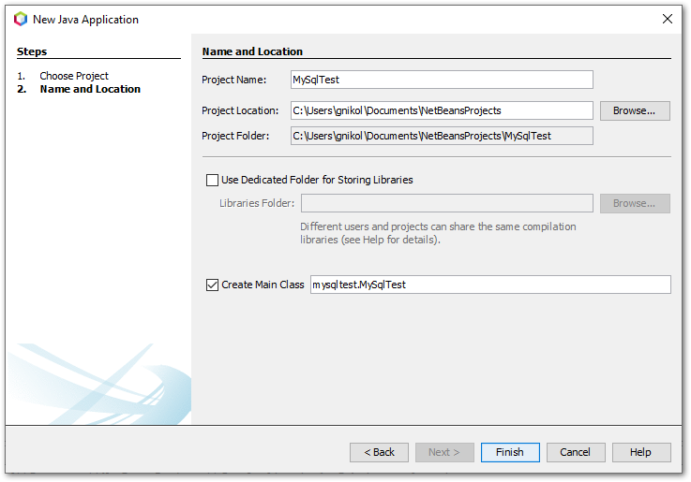

1. Specify the MySQL Driver Path – look to the left side of the window (Project Management)  
   Right-click on the **Libraries** path and then click **Add Library**

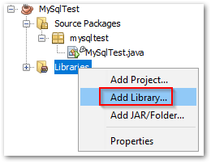

Chances are the MySQL JDBC driver will not appear in the list of libraries so we’ll have to add it manually. Click on **Create**, name the new library something meaningful then click **OK**. 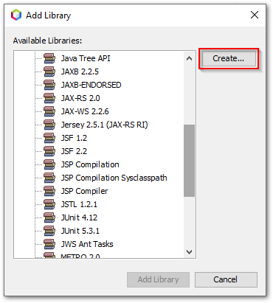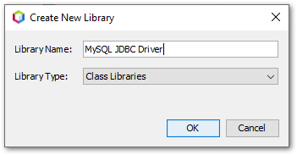

From this point click **Add JAR/Folder** and navigate to **C:\cs\MySQL8ce\mysql-connector-java-8.0.16** and double-click the mysql-connector-java-8.0.16.jar file

If you don’t find that .jar file, please download it from below address.

[Download mysql-connector-java-8.0.16.jar file (java2s.com)](http://www.java2s.com/ref/jar/download-mysqlconnectorjava8016jar-file.html)

1. Add the library to the project – now find your new library in the **Add Library** list and double-click

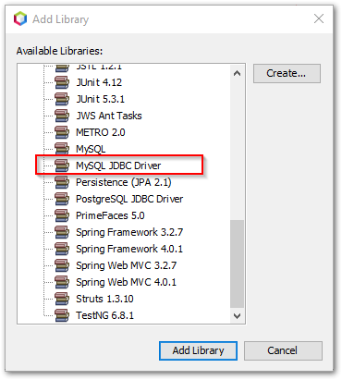

1. Test your connection

