CONTROL SYSTEMS

Telescope project

SOEN 385

Sean Marcoux 27511876

Georges Mathieu 26863477

Bruce Edouard Brazier 27419562

Daniel Privorotsky 40002150

Presented to

Dr. J. Sadri

2018/04/16

# ABSTRACT

# INTRODUCTION

We are tasked with having a telescope take two pictures of 100 stars with specific positions in the sky. Each star has a coordinate indicated by its r, and values, representing their position as two angles and a distance. The telescope can rotate its orientation to point at these stars using two DC motors, one controlling the angle, the other the angle. These motors require a control system for optimal functionality.

# ANALYSIS

a) Using the G(S) = 1/(S-1)(S-3), and H(S) to be equal = 1.

We get the following results for

**The P system**

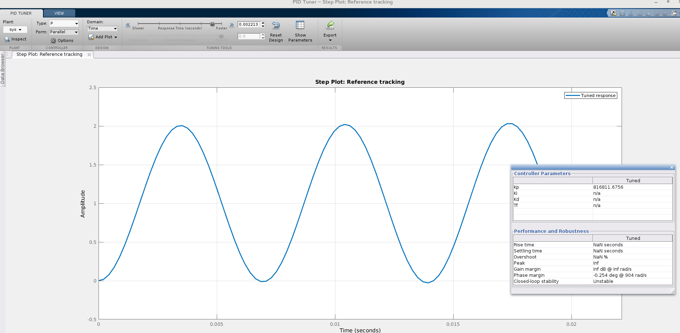

**The PI system**

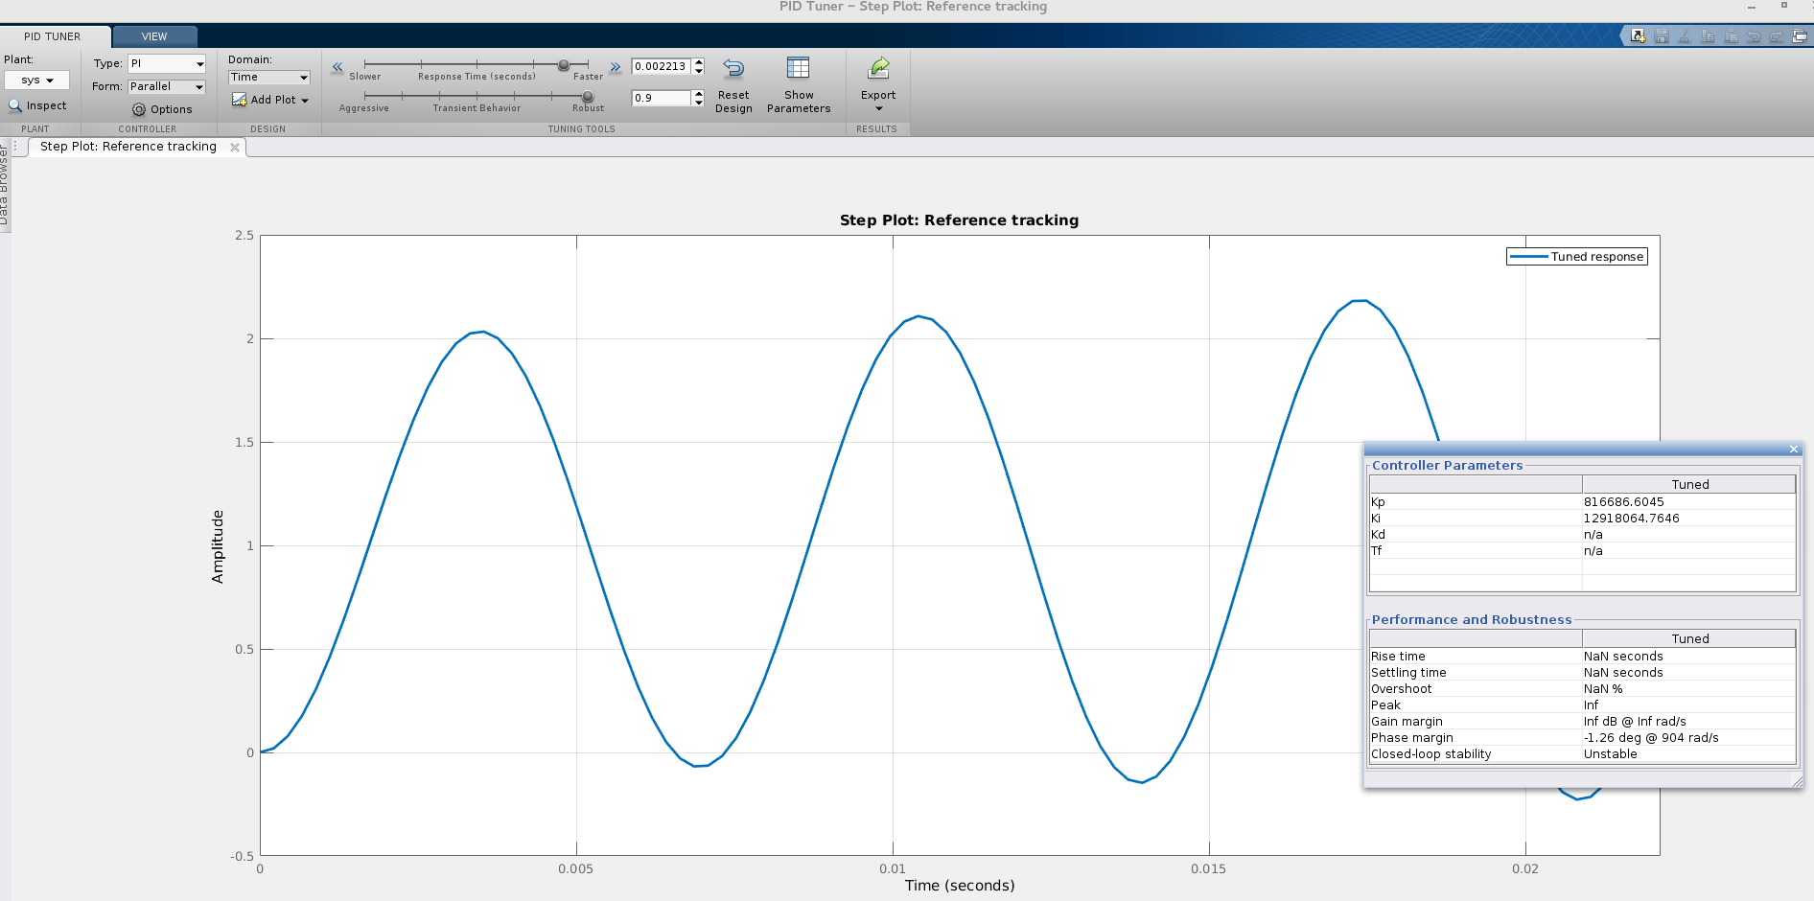

**The PD system**

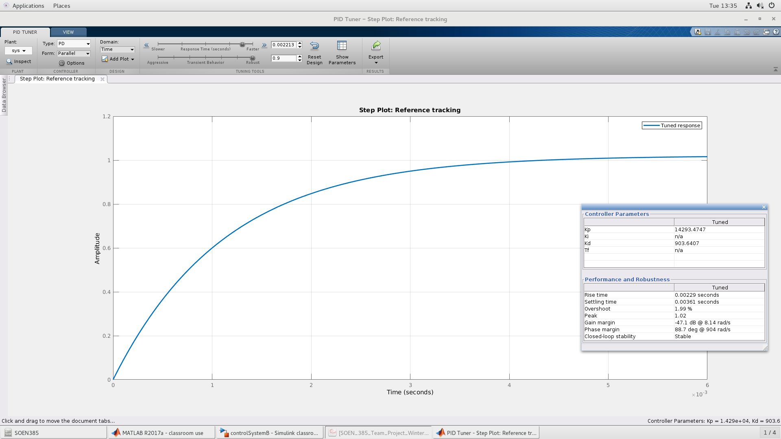

**The PID system**

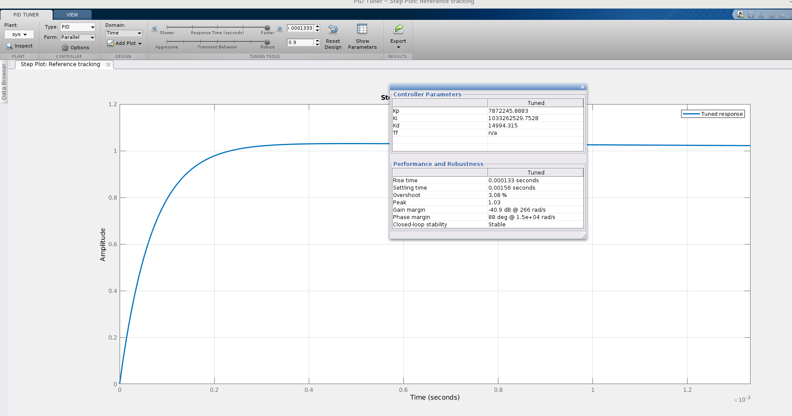

b) Using the G(S) = 1/(S+1)(S-3), and H(S) to be equal to = 0.1

We get the following results for

**The P system**

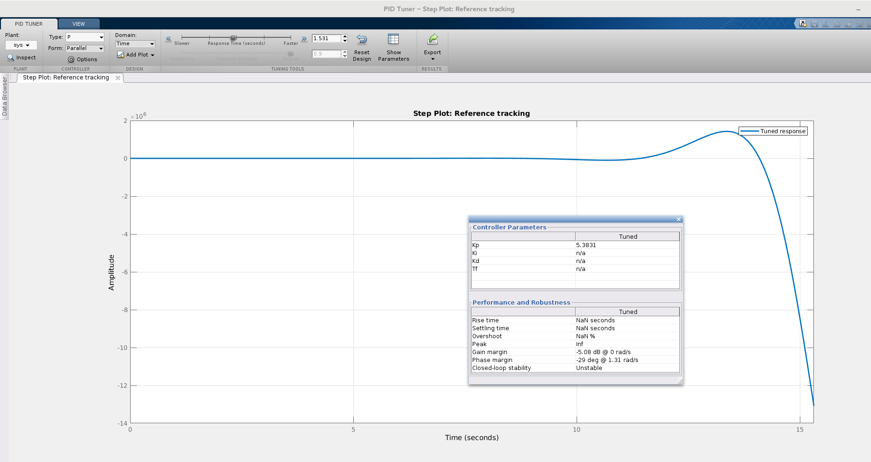

**The PI system**

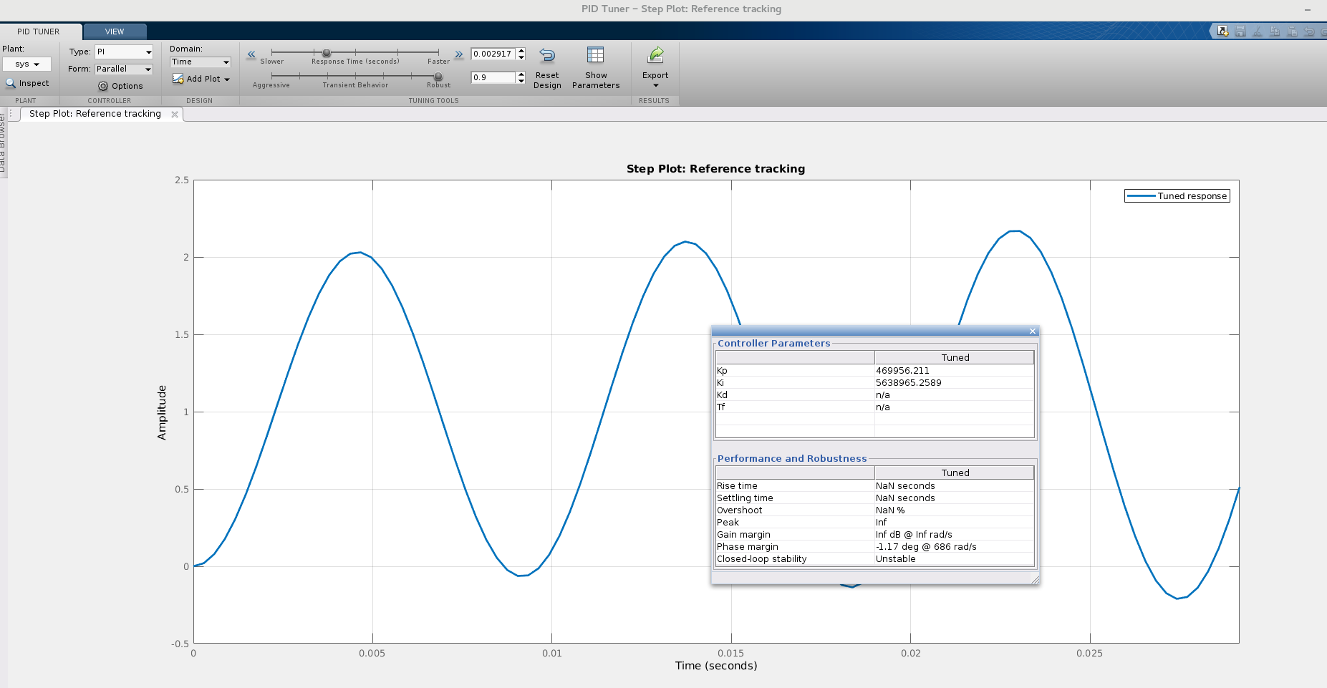

**The PD system**

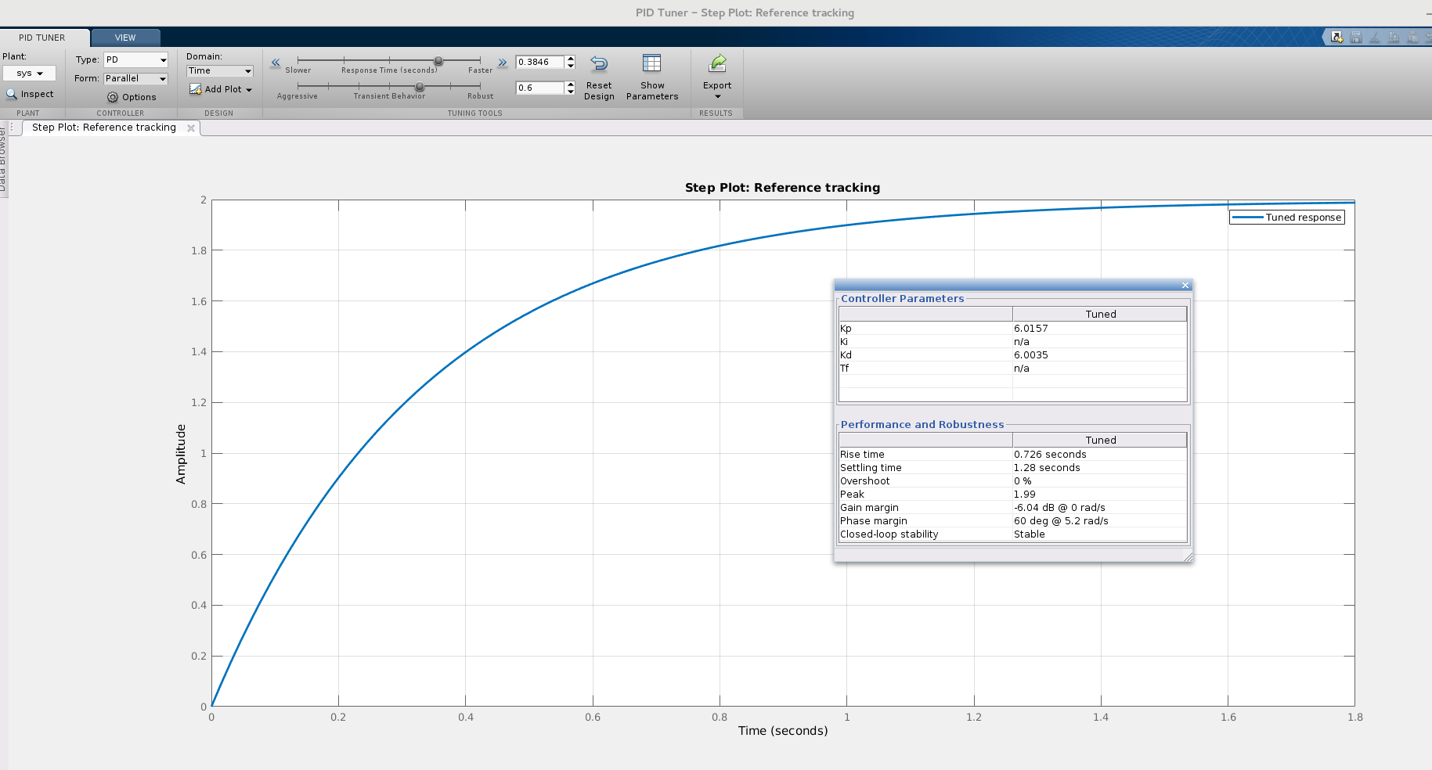

**The PID system**

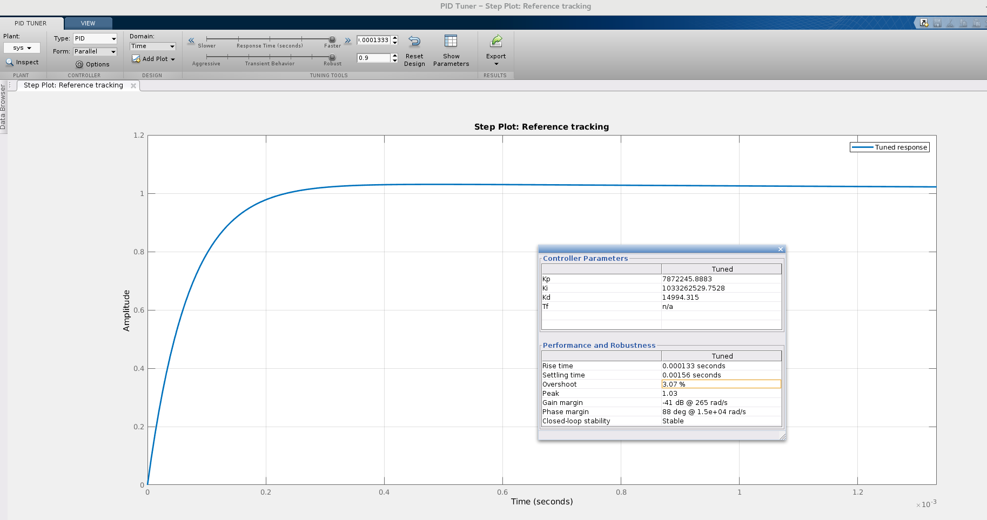

c) Using the G(S) = 1/(S-3) and H(S) to = 0.1/(S+1)

We get the following results for

**The P system**

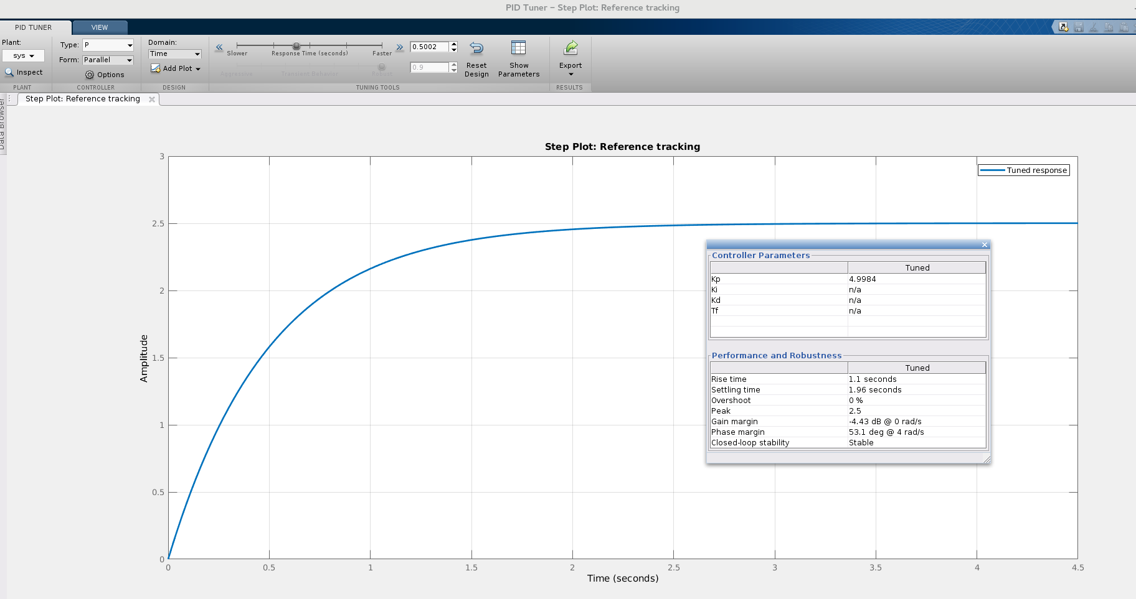

**The PI sytem**

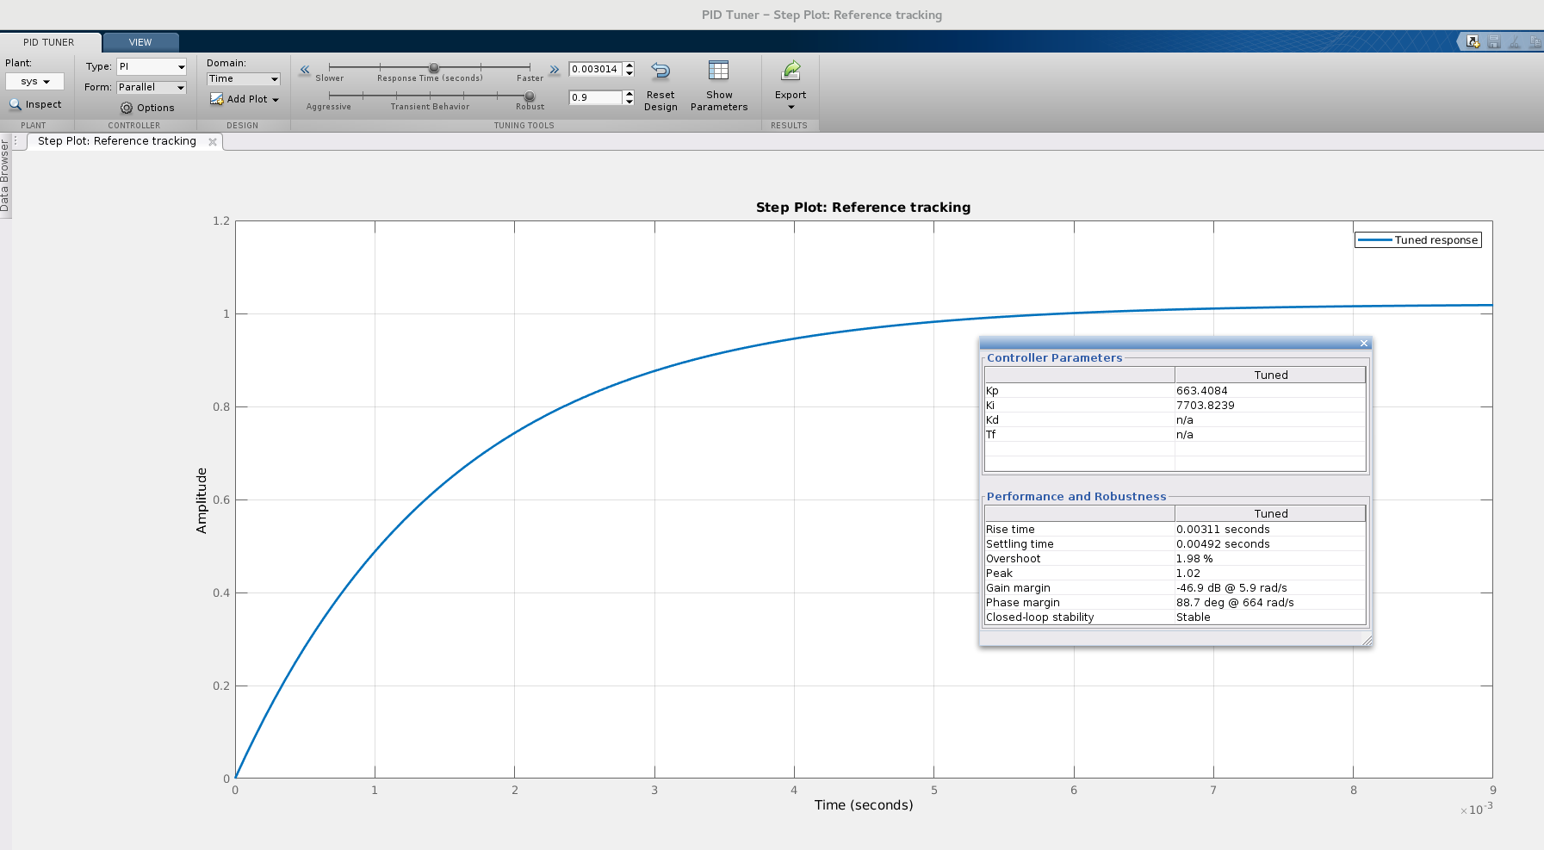

**The PD system**

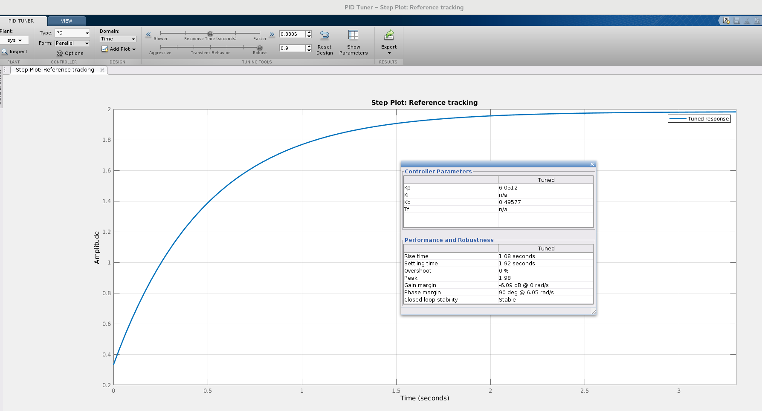

**The PID system**

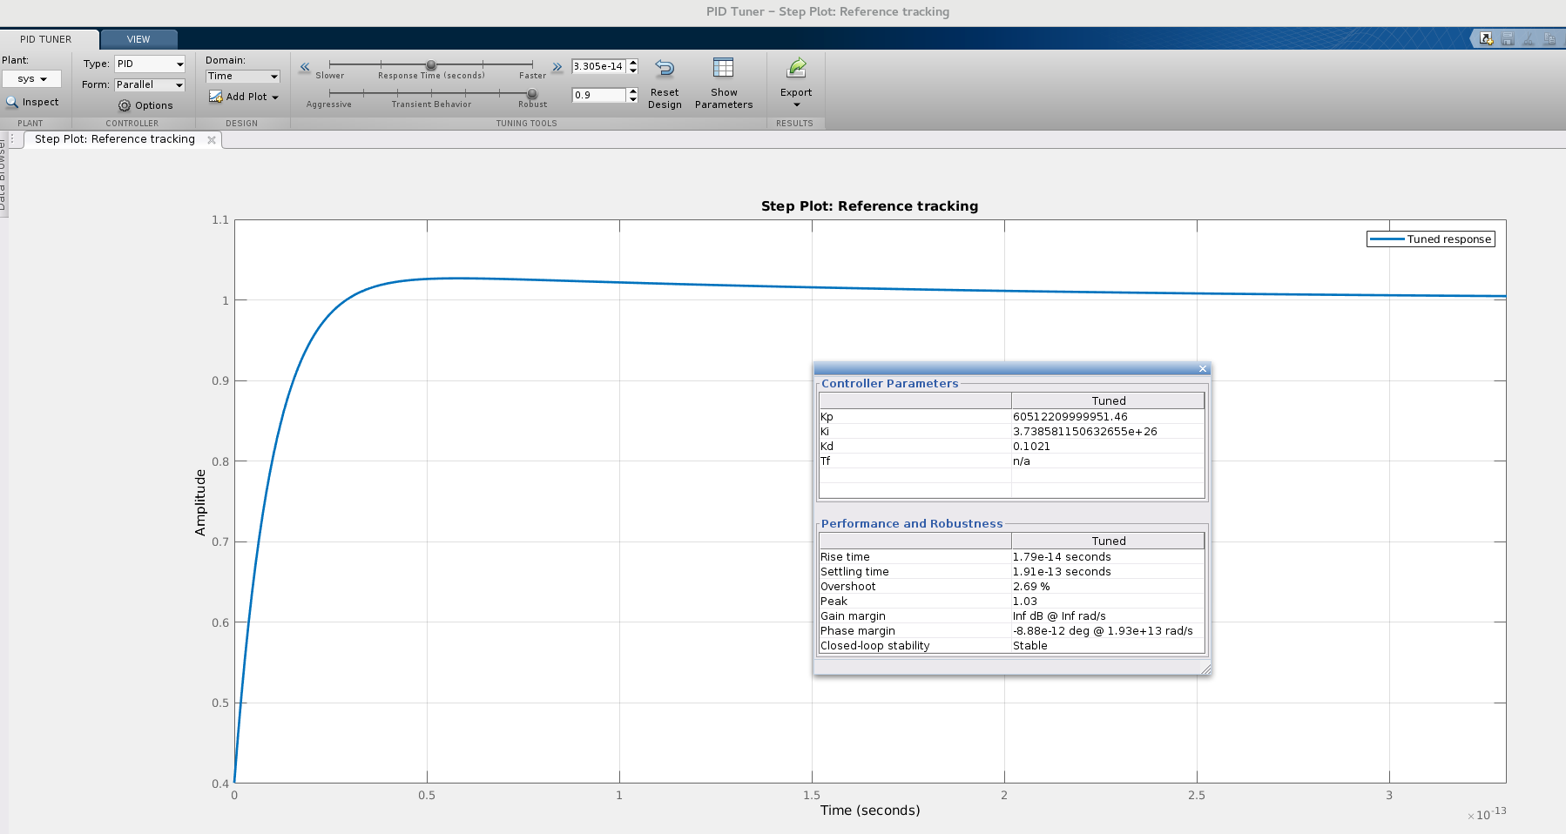

# DESIGN

We designed it using matlab and Simulink the end.

# IMPLEMENTATION

We implemented it using matlab and Simulink the end.