Monocrotaline-induced liver toxicity in rat predicted by a combined in vitro-physiologically based kinetic modeling approach

Suparmi Suparmi^{1,2*}, Sebastiaan Wesseling¹, Ivonne M.C.M. Rietjens¹
¹Division of Toxicology, Wageningen University and Research, Stippeneng 4, 6708 WE Wageningen, The Netherlands
²Department of Biology, Faculty of Medicine, Universitas Islam Sultan Agung, Jl. Raya Kaligawe KM 4, 50112 Semarang, Indonesia

*Corresponding author:
Suparmi. Division of Toxicology, Wageningen University and Research
Stippeneng 4, 6708 WE Wageningen, The Netherlands
Tel: +31 317 84357
Fax: +31 317 484931
E-mail addresses: s.suparmi@wur.nl, suparmi@unissula.ac.id
Orcid ID: 0000-0001-7914-870X

Supplementary materials 2. Data pharmacokinetic data of monocrotaline upon the IV administration of 60 mg/kg bw (10 µCi/kg) of [¹⁴C] monocrotaline (Estep et al. 1991)
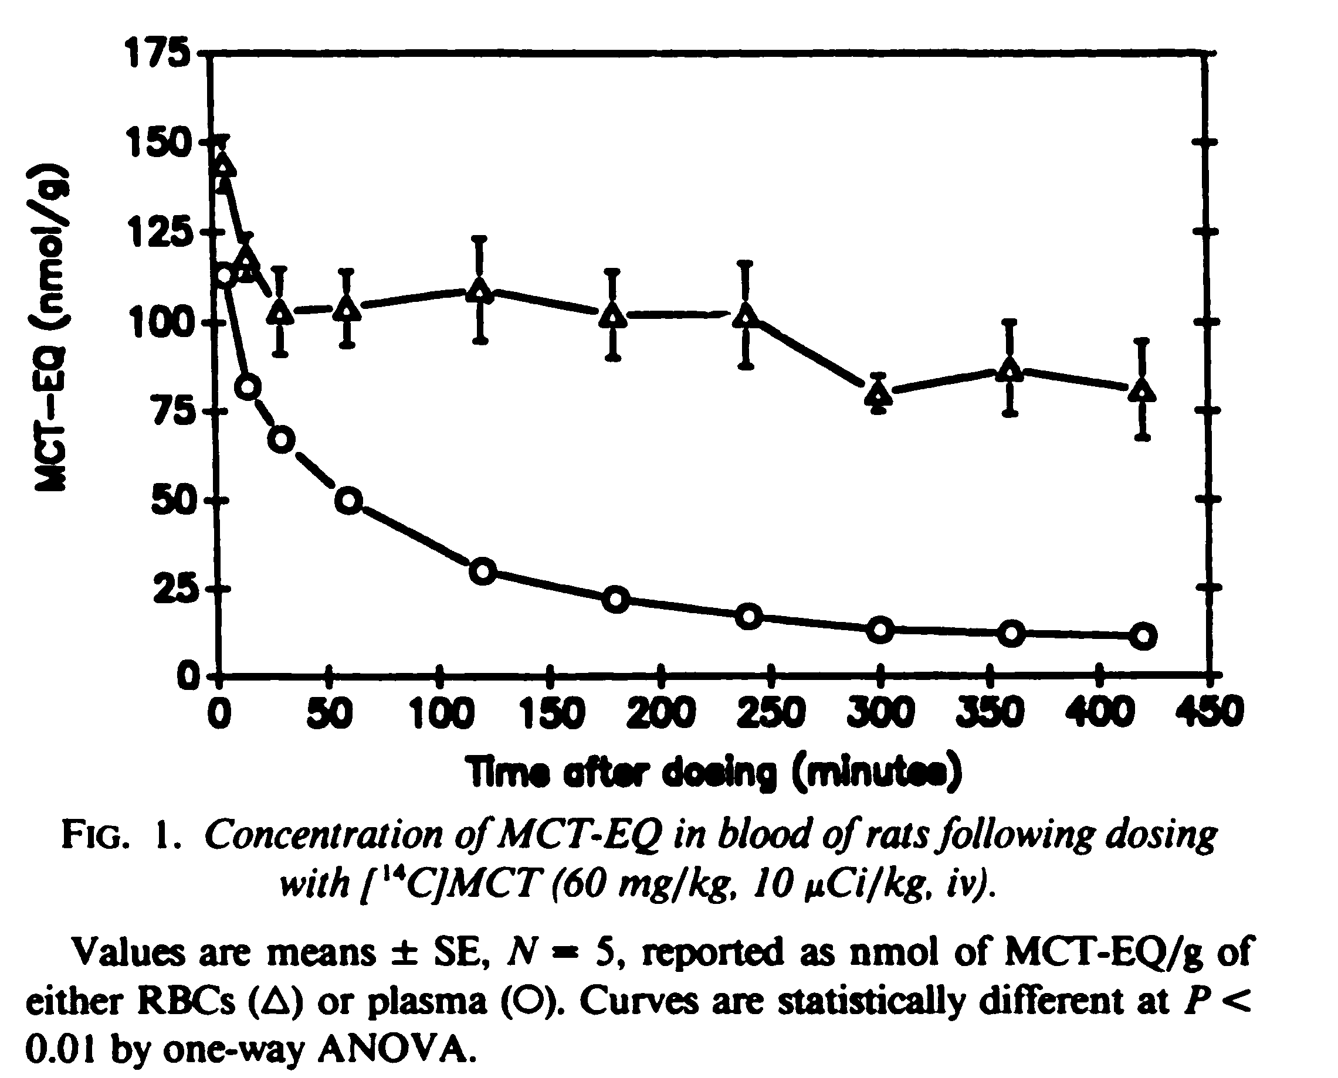
Figure S1. The screenshotted figure of monocrotaline equivalents (in nmol/g) against time (in h) reported by (Estep et al. 1991). The data symbolized as open circle (blood plasma) and triangle (red blood cells/RBCs) were added up to evaluate the concentration of monocrotaline in the whole blood for comparison to the PBK model predictions.

Table S1. The results of re-extrapolated data from reported figure.
In the PBK model, the volume of blood assumes to be equal to the weight of blood using this model
Monocrotaline equivalents (nmol/g) vs Time (min) data were created from the Figure S1 by WebPlotDigitizer Tutorial 3.6+ (https://automeris.io/WebPlotDigitizer/)
The reported concentration nmol/g is assumed to be equal to nmol/ml or µM. The reported blood concentration is calculated as the sum of the plasma and RBC concentration.

Time for Blood sampling |  |  | Reported concentration of monocrotaline equivalents (µM) |  |  |  |  |  | Predicted concentration of monocrotaline in blood (µM) |  | Ratio of predicted/reported
min | h |  | Plasma |  | RBCs |  | Blood
5 | 0.08 | 113.00 |  | 144.00 |  | 257.00 |  | 416.50 |  | 1.62
15 | 0.25 | 81.88 |  | 113.46 |  | 195.34 |  | 373.53 |  | 1.91
30 | 0.5 | 67.35 |  | 100.06 |  | 167.41 |  | 370.88 |  | 2.22
60 | 1 | 49.84 |  | 100.13 |  | 149.97 |  | 366.27 |  | 2.44
120 | 2 | 29.65 |  | 104.89 |  | 134.54 |  | 357.08 |  | 2.65
180 | 3 | 21.82 |  | 99.93 |  | 121.75 |  | 347.89 |  | 2.86
240 | 4 | 17.11 |  | 99.60 |  | 116.71 |  | 338.70 |  | 2.90
300 | 5 | 13.07 |  | 79.81 |  | 92.88 |  | 329.53 |  | 3.55
360 | 6 | 12.16 |  | 85.50 |  | 97.66 |  | 320.36 |  | 3.28
420 | 7 | 11.00 |  | 81.00 |  | 92.00 |  | 311.19 |  | 3.38

Reference
Estep JE, Lame MW, Morin D, Jones AD, Wilson DW, Segall HJ (1991) [¹⁴C]monocrotaline kinetics and metabolism in the rat. Drug Metab Dispos 19(1):135-9. http://dmd.aspetjournals.org/content/19/1/135.long

