## Simulation Framework

1. Helper functions
   1. Function: Calculate length of line intersected by circle
   2. Function: File naming
2. Calculation options
   1. Calculate line points
   2. Select start and end-points of drain segments
   3. Calculate length of each drain part
   4. Add drain levels
3. Length calculation function
   1. Define drain sequence for flow
   2. Calculate shortest distance from neighborhood to drain and ID drain
      1. dist2sewagedf
      2. 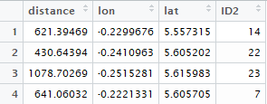
   3. Calculate distance of intersection point to drain endpoint
      1. 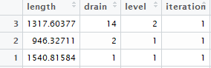
4. Endemic model
5. Pathogen calculation
   1. Run 1,2,3,4
   2. Output data frames:
      1. Dist2sewagedf
      2. Df
   3. Calculate travel time
   4. Calculate pathogen count for neighborhood (N0)
   5. Calculate pathogen count for all consecutive points (N1, N2, N3, etc.) until end-point is reached
   6. Calculate passed time and pathogens for each drain until endpoint reached
   7. Combine all data into one table. Consecutive drains, points, time, meters, neighborhood and pathogen counts (for 1000 days)

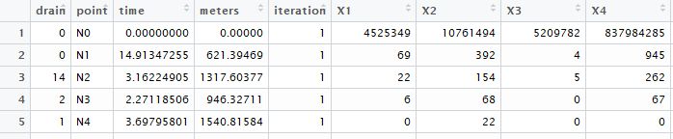

* 1. Save above table as CSV file. Pathogens_drain_all_new.csv.

1. Graphics
   1. Classification of neighborhoods and “sample station”
   2. Calculation of pathogen count per station
   3. Creation of various maps and gifs
2. Case matrix
   1. Classification of positive cases by defining of pathogen limit (107) at each station
   2. Calculation of positive samples based on sampling intervals