2.2.2 Photosynthesis and Canopy Gas Exchange
The computation of energy, moisture and CO₂ exchanges requires knowledge of stomatal and aerodynamic canopy conductances. We assume that the whole canopy has temperature T_{l} and that the air inside stomata is saturated and has specific humidity q_{sat}(T_{l}). Additionally, stomatal conductance has a vertical distribution g_{s}(LAI’)(mol H₂O/m²s), where LAI’ (m²/m²) is the cumulative leaf area, measured from the top of the canopy downward. A system of three equations with three unknowns, the stomatal conductance, g_{s}, the intercellular concentration of CO₂, C_{i} (mol/mol), and the net photosynthesis, A_{n}(mol CO₂/m²s), defines the plant uptake of CO₂ and the rate of non-water-stressed transpiration for a thin canopy layer dLAI’ at a temperature T_{l}(K)receiving an incident photosynthetically active radiation flux Q(LAI’) (Einstein/m²s) and surrounded by canopy air with vertically uniform specific humidity q_{ca}(kg/kg) and CO₂ concentration C_{ca}(mol/mol):
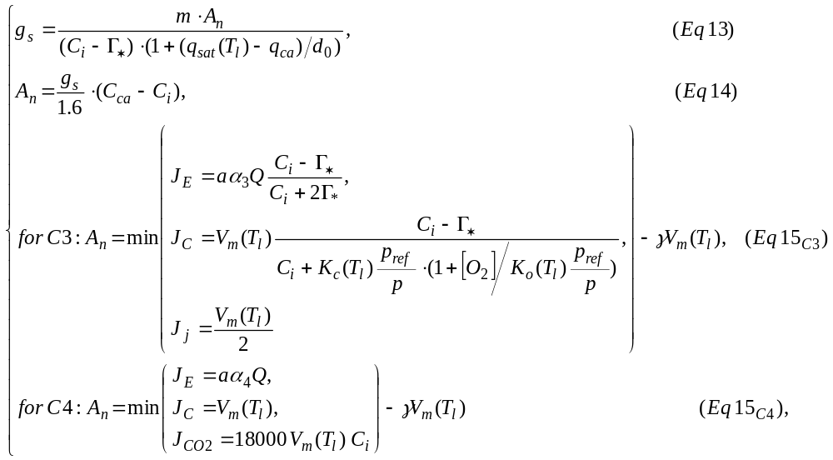
where a is the leaf absorptance of photosynthetically active radiation, α₃ and α₄ are the intrinsic quantum efficiencies, V_{m} is the maximum velocity of carboxylase in molCO₂/m²s,
Γ*₌ α_{co2} [O₂] K_{C} /(2K_{O}) is the compensation point, K_{C} and K_{O} are the Michaelis-Menten constants for CO₂ and O₂, [O₂] is the atmospheric oxygen concentration, p_{ref}=10⁵ Pa is the reference pressure and p is an atmospheric pressure. The temperature dependence of the Michaelis-Menten constants, the maximum velocity of carboxylase, and the compensation point are described by Arrhenius function 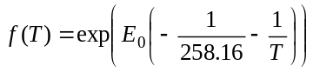 where T is the temperature (˚K) and E₀ is a temperature sensitivity factor (Foley et al. 1996) (see Table 1 for parameter values).
Equation 13 gives the leaf stomatal conductance for vegetation if the soil water is not limiting. It links the rate of stomatal conductance for water g_{s} to the net photosynthesis (A_{n}), intercellular concentration of CO₂ (C_{i}), and humidity deficit between intercellular space and external environment (q_{sat}(T_{l}) - q_{ca}). This equation is a simplification of Leuning’s (1985) empirical relationship assuming that contribution of cuticular conductance is negligible. Equation 14 is a one-dimensional gas diffusion law The factor of 1.6 is the ratio of diffusivities for water vapor and CO₂. We assume that the diffusion of CO₂ is mostly limited by stomatal conductance and not by leaf boundary layer conductance. Equations 15_{C3} and 15_{C4} are based on the mechanistic model of photosynthesis by Farquhar et al. (1980) and its extensions by Collatz et al. (1991, 1992).
The net photosynthesis is the difference between the gross photosynthesis and leaf respiration. The gross photosynthesis for C₃ plants is the minimum of three limited rates: the light limited rate J_{E}, the Rubisco limited rate J_{C}, and the export limited rate of carboxylation J_{j}. Similarly, in Collatz et al. (1992) the gross photosynthesis rate for C₄ plants is the minimum of the light limited rate J_{E}, the Rubisco limited rate J_{C}, and the CO₂ limited rate J_{CO2.} Leaf respiration is computed as R_{leaf} = γV_{m}(T_{l}). Although the formulation of Collatz et al (1991) is widely used in dynamic vegetation and land surface models, it requires computationally expensive iterative solutions. The simplifying assumption made in equation 13 that cuticular conductance is negligible, allows an analytical solution for the three unknowns.
Assuming that a PAR flux Q(LAI’) monotonically decreases through the C₃ canopy, the PAR flux Q(LAI_{eq}) can be defined at which the light limited rate J_{E}, is equal to the minimum of Rubisco limited rate J_{C} and the export-limited rate of carboxylation J_{j}. Above the canopy level L_{eq} the gross photosynthesis will be a function of the Rubisco or export limited rate and the below this level the gross photosynthesis will be a function of light limited rate, so that an average canopy net photosynthesis and average canopy stomatal conductance are
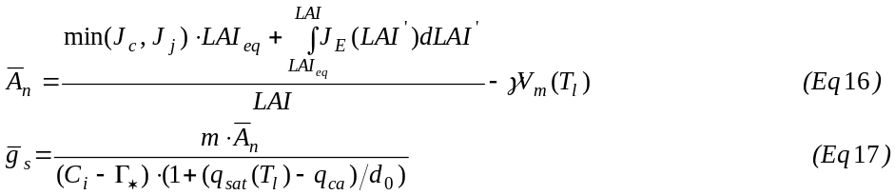
Average net photosynthesis for C₄ plants is computed in a similar fashion. If the water demand F_{d}
implied by the unstressed stomatal conductance exceeds water supply F_{s}
then the stomatal conductance and the net photosynthesis are scaled proportionally with available soil moisture W_{r}. The parameter φ represents the conductance of roots to water and C_{r} is the biomass of fine roots.

