R Notebook

## csect: proj-baseline

on-entry: open _scratchpad (.tactcal)  
ensure that required packages are installed  
  
per-machine .baseline (_future, use package manager)

source('./y2013.proj-baseline.d/_info.R')

## csect: proj-blippex

## csect: proj-rogera

insert data into rethinkdb (curr: s0)  
fetch facebook profile data (needs: fresh token; externalize tok)

## csect: proj-benchmark (revisited)

## attic

Try executing this chunk by clicking the *Run* button within the chunk or by placing your cursor inside it and pressing *Ctrl+Shift+Enter*.

Press *Ctrl+Alt+R* to run all.

plot(cars)

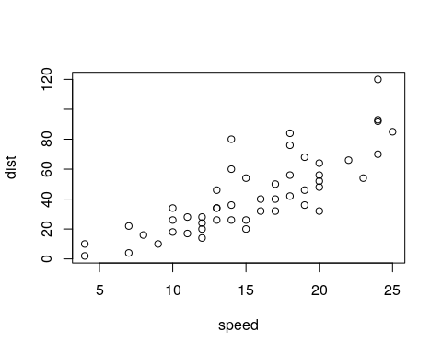

x1=c(c(1,2),c(1,3),c(2,3))  
plot(x1)

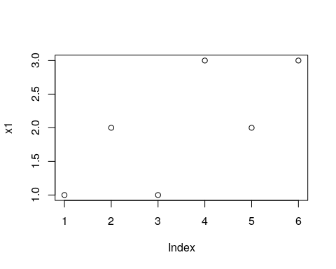

Add a new chunk by clicking the *Insert Chunk* button on the toolbar or by pressing *Ctrl+Alt+I*.

When you save the notebook, an HTML file containing the code and output will be saved alongside it (click the *Preview* button or press *Ctrl+Shift+K* to preview the HTML file).