Installation and configuration small radio telescope
Christian Monstein

1. Introduction, Frontend

The small radio telescope, observing in X-/Ku-band is meant to demonstrate solar radio radiation during eclipse. It can also by used to observe dynamic solar radio bursts or to measure the average disc temperature of the Moon. Main components are shown below and described in detail in this document.
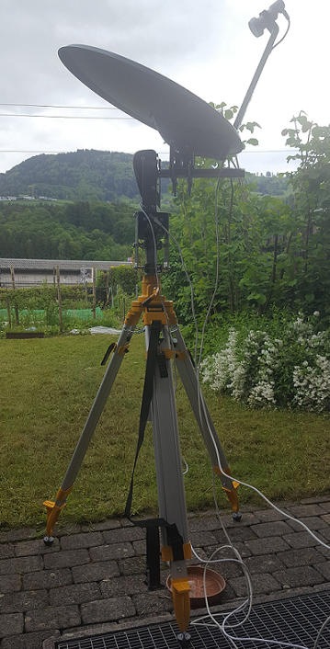

Figure 1 ~ View of the complete telescope (frontend), pointing to the sun. Main components are:
- Tripod (several versions possible)
- Azimuth rotor mounted to the tripod
- Elevation rotor on top of azimuth rotor
- Elevation axis
- Satellite dish with clamping adapter
- Low noise block LNB (wide band!)
- Coaxial cable for LNB
- Coaxial cable for azimuth rotor
- Coaxial cable for elevation rotor

All components will be described later in this document.

Not shown in this image left is the so-called backend which is composed out of:
- Option Sat-Finder to visualize RF-level and eventually hear the beeper sound
- Bias-Tee to feed in DC voltage 12V … 18V including power adapter
- Callisto frequency agile spectrometer including power adapter and USB-interface
- Windows Notebook or computer with power adapter and mouse.

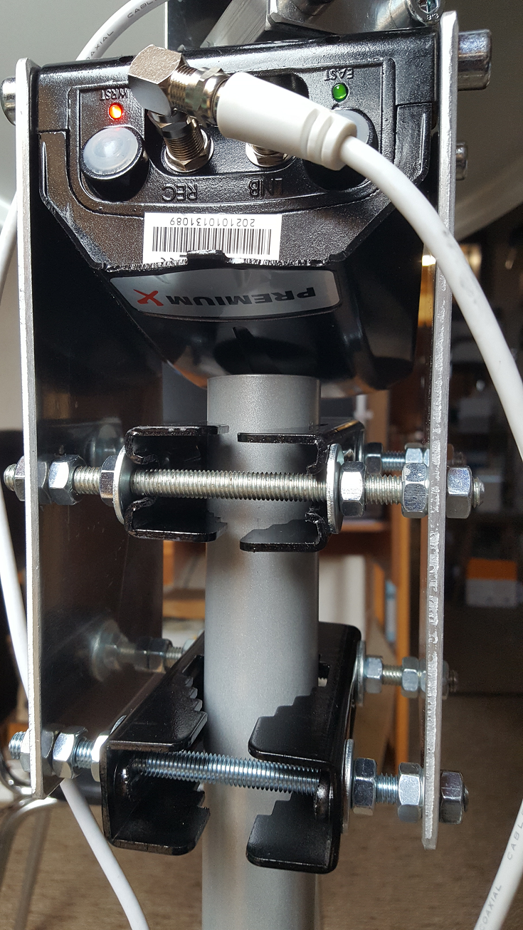
Figure 2 ~ Detail view of the azimuth rotor fixation on top of the tripod pole.
Mechanical components used are:
- One rotor with original axis removed
- 2 x large aluminium plates
- 4 x threaded screw bars M8
- 8 x washers
- 24 x hexagon nuts M8
- 1 x 90° F-adapter (REC)

All 4 black clamping profiles shall be mounted such that the slits are on one and the same side. Do not change position of the slits to guarantee absolute vertical mounting of the rotor package on top of the tripod. Use wrench number 13 to tighten the nuts. Try to install the rotor at lowest possible elevation to keep mechanical stability as good as possible.
Take care that the tripod is either standing on a flat, horizontally aligned platform and/or adjust the tripod legs in a way that the vertical pol is perfectly vertically aligned.

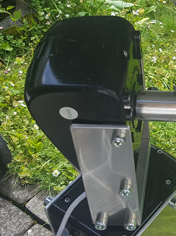
Figure 3 ~ Detailed view of elevation rotor on top of the azimuth rotor.
Mechanical components used are:
- 1 x rotor with original axis removed and replaced by a dedicated aluminium axis which will later hold the satellite dish.
- 2 x aluminium plates to fix the rotor on a flange adapter
- 1 x flange adapter to connect azimuth axis and elevation rotor package.
- 8 x hexagon socket screws M8 to mount plates
- 1 x hexagon socket screw M8 to fix flange adapter on azimuth axis
- Hex wrench (Allen key) type 6

Install elevation package such that the elevation axis is pointing to west, assuming cable of azimuth rotor is connected on the north side.
Take care that the elevation axis is perfectly aligned horizontally, use a balance for testing.

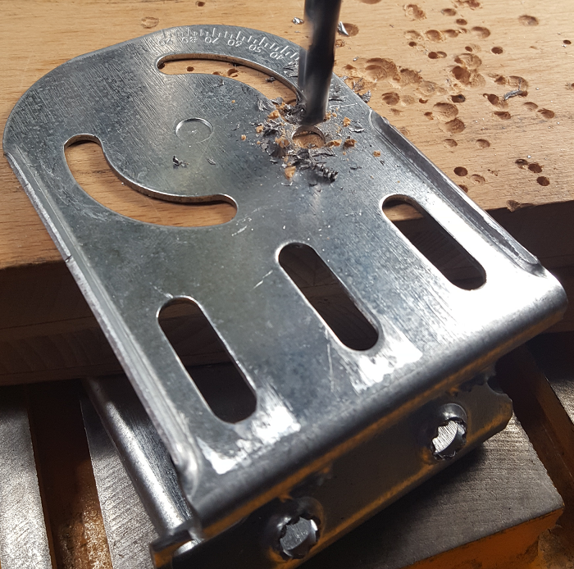
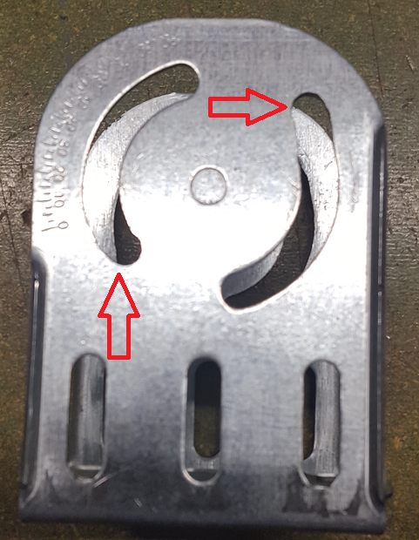

Figures 4a, b ~ Circular slits for antenna mounting need to extended by about 10 mm, such that the offset angle of the antenna can be fully compensated for. Drill a whole and file it wide enough as depicted in figure 4b (red arrows).

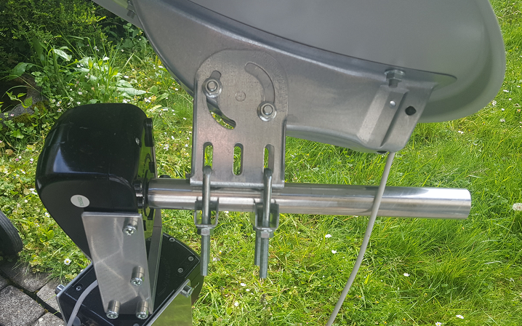
Figure 5 ~ Install antenna clamping adapter as close as possible to the elevation rotor to minimize moment on the elevation axis. While the axis is pointing west, mount dish such that feed arm and coaxial cable are also on the west side. Tighten the 4 hex-nuts with a wrench.
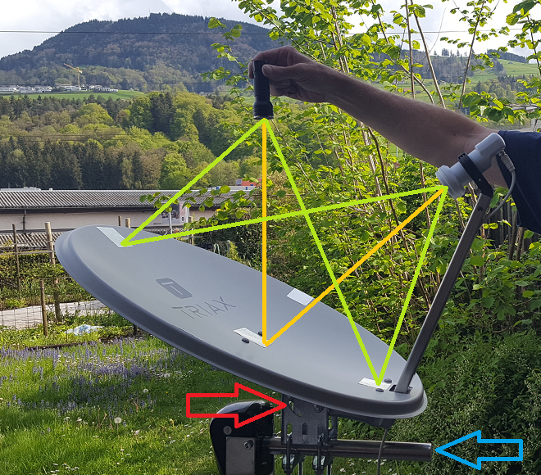
Figure 6 ~ To adjust respective compensate offset angle of the dish you may use a torch and hold it perfectly and vertically above the center of the dish. The light should then be reflected by 4…5 mirrors (glued onto the dish) to the center of the LNB cover. Ideally, this is done during the night or in a dark-room. Once aligned, tighten the screws (red arrow) which fixes the dish onto the clamping adapter. Take again care, that the elevation axis (blue arrow) is perfectly horizontal aligned. The main goal is, that the whole setup is aligned such, that the incoming radio radiation is perpendicular onto the elevation axis. Any error in this alignment scheme prevents the control system to track the source (e.g. Sun) for several hours.

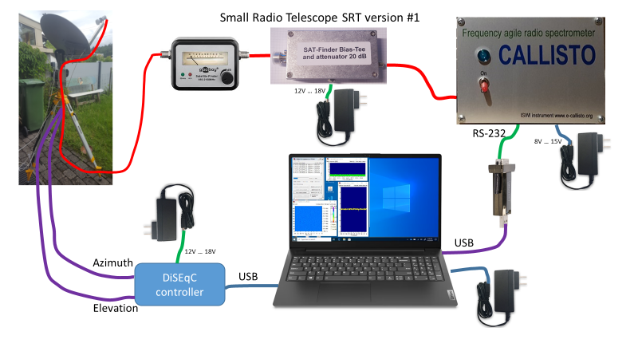
Figure 7 ~ Rough sketch of interconnection of cables and sub-systems. Sat-Finder shall be optional because it attenuates the incoming radio signal by a factor of up to 100. It is fine during configuration or demonstration but, during eclipse observation we recommend to short-cut the sat-finder and to connect LNB directly with the Bas-Tee. Red cables indicate coaxial cables carrying radio signals and are of type F/male both ends. Violet cables are also satellite cables with male F-connectors both ends but do not need to be of high quality in terms of rf-attenuation.

2. Orientation

The orientation of the telescope and the knowledge of all angles of the telescope is essential. The sketches and descriptions are for northern hemisphere, for southern part of the world several angles and directions need to be changed.
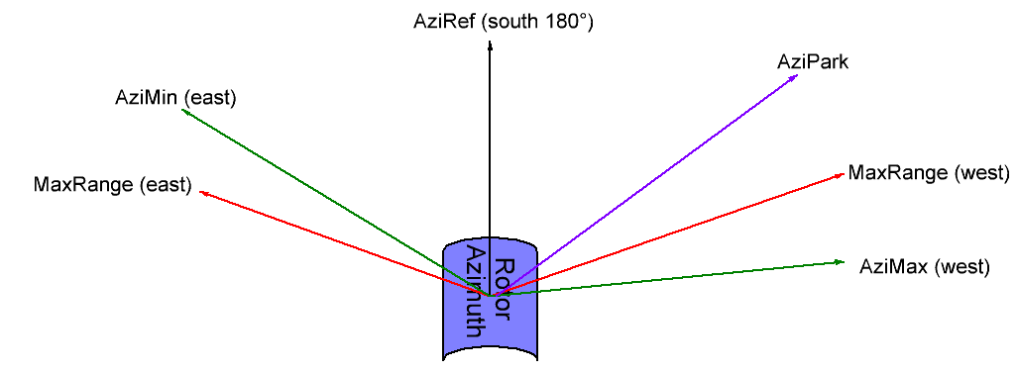
Figure 8 ~ Azimuth rotor, seen from above with east on the left side and west on the right side.
The constant value MaxRange describes the maximum rotation angle of the azimuth rotor. Depending on manufacturer they vary between 67° and 77°. Our current rotors can rotate by +/- 77°. AziRef denotes to azimuth reference, pointing usually to south. We have to distinguish between rotor azimuth and source azimuth. The telescope azimuth is usually chosen such that it fits with meridian transit or with totality of eclipse. Errors in mechanical azimuth alignment can be corrected by editing software reference AziRef. In my case with all the neighboring constrains due to bushes and houses AziRef is selected to 160°. AziMin and AziMax are software limits (green arrows) where we do not want to observe any source due to local constraints such as trees, houses or any other infrastructure. In case shown in figure 8 we cannot even reach the soft-limit due to the fact, that MaxRange is smaller (red arrow). In the east part the soft-limit is within MaxRange due to the house of the neighbor. Violett arrow AziPark denotes to an azimuth position where the telescope is waiting when no observation is performed, e.g. a position of a geostationary satellite. Alle these angles are constant values and part of the configuration, they need to be carefully selected and edited in the Python script sunpos_AZI_ELE.py.
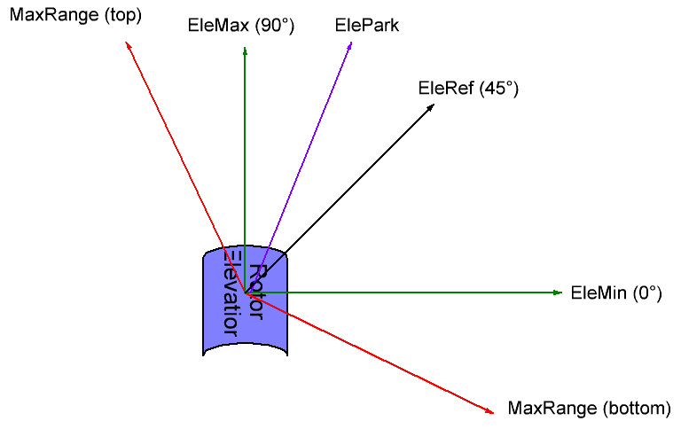
Figure 9 ~ Elevation rotor, seen from west side, south on the right and north on the left. Nadir at the bottom and zenith at the top of the sketch. In case of telescope switching mode for calibration, EleMin must be less than 0°, e.g. -15°. EleRef should be selected such that no measurements are taken at this angle to avoid endless nulling of the rotor electronics. In my case I selected 15° as eleref.

The constant value MaxRange describes the maximum rotation angle of the elevation rotor. Depending on manufacturer they vary between 67° and 77°. Our current rotors can rotate by +/- 77°. EleRef denotes to elevation rotor angle 0° and in rotor-reality, with respect to horizon at 45°. We try to adjust the antenna as good as possible to this angle but fine adjust is done by software by changing the value of EleRef in the Python script. EleMin describes the soft-limit of the lowest elevation we want to observe. To avoid ground spill over we select an angle in the order of 10° or so. And the top soft-limit we usually select it to 90° or less in case there is a tree or a roof in the line of sight. Constant ElePark describes the sleep-position of the telescope while no observation is taking place. It could point to the geostationary position of a satellite.

3. Backend

Backend comprises everything which doesn’t need to be outdoor and should be protected from snow, rain and direct sunlight.

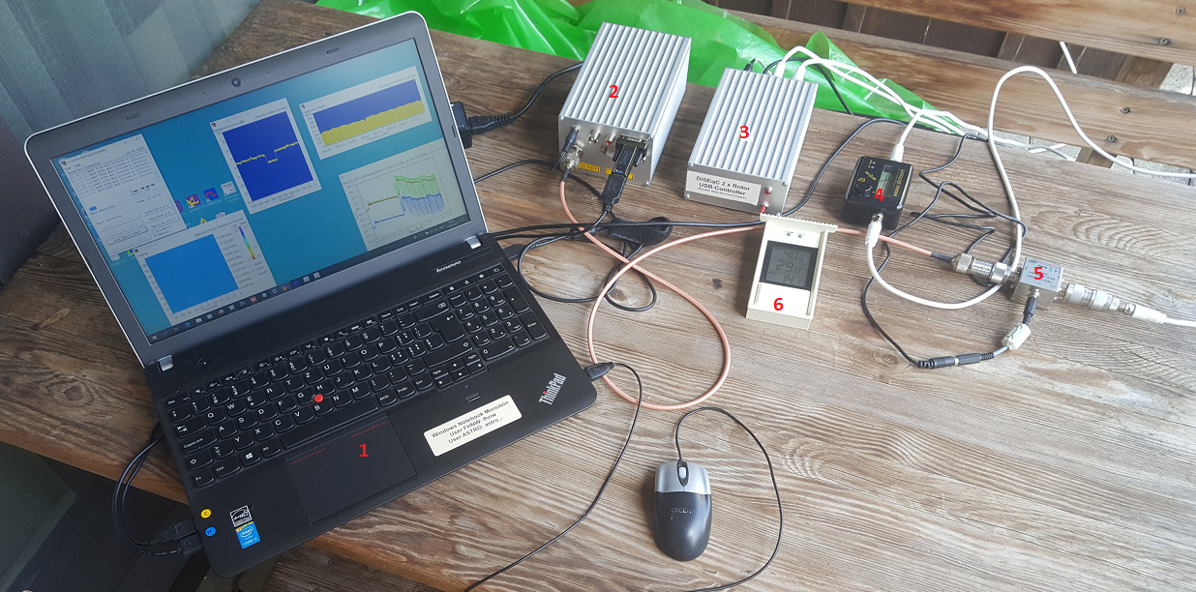
Fig. 10: Backend indoor-part of the instrument.

Components of the backend are:
- Computer or notebook with Windows operating system and at least 3 USB-ports (1 for CALLISTO, one for DiSEqC and one for mouse)
- CALLISTO frequency agile radio spectrometer (view of the backside)
- DiSEqC rotor controller (prototype) for two rotors
- Satellite finder with beeper and analog scale (optional because it produces standing waves)
- Bias-Tee to feed dc into the coax which goes to the LNB (prototype version)
- Temperature sensor for later calibration (if needed)
Power adapter for notebook, for CALLISTO 12 volts, for DiSEqC controller 12 …18 volts and for LNB 12…18 volts are not visible in this image. They are located behind the table on a common power bus with power switch. Notebook also provides AnyDesk and AnyViewer as well as TeamViewer for remote control, such that all the applications can be seen and controlled from anywhere on the world, assumed there is internet available. It ids recommende to keep all electronics on permanent power to keep temperature and thus gain and offset constant.

4. Example Eclipse 2023

Before the telescope can be installed and configured, we need to know where we want to perform the observation and at what time we want to concentrate our observations. For that we need any planning tool which allows to derive azimuth and elevation for any location, date and time.
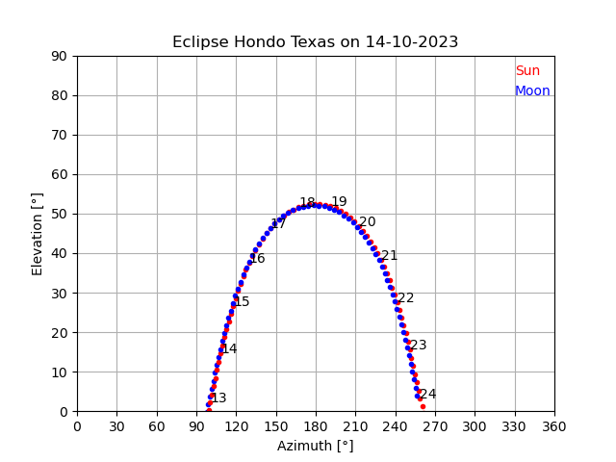
Figure 11 ~ Azimuth and elevation for Hondo in Texas during eclipse on October 14, 2023.

As the totality of the eclipse is at about 16:50 UT, we choose our azimuth reference AziRef to 150°. This is the position with azimuth rotor angle = 0°. Then we can cover +/- 77° from the reference which allows to start observation even before sun-set (150° - 77° = 73°). And after the eclipse we can observe till 150° + 77° = 227° which is about 21 UT. In case we want to observe longer the we need to rotate the telescope by let’s say 60° to AziRef = 210°. Then we can observe 210° + 77° = 287° which is later than sun-set.
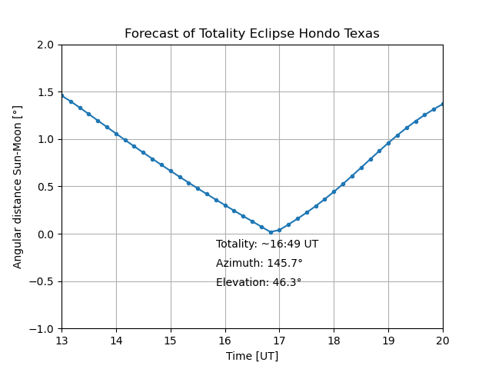

Figure 12 ~ Angular distance between Sun and Moon versus observation time in UT. This plot, generated by a Python script gives us a more detailed indication of reference position AziRef, in this case I’d choose 150° as starting value.

5. Checklist, process of installation & configuration

- Select location according to weather conditions, accessibility and object of observation
- Mount tripod on a flat, hard ground (no swamp, no grass), pole vertical by using a balance/inclinometer
- Install azimuth rotor, then elevation rotor, then dish and finally LNB
- Install all coaxial cables for LNB and rotor control
- Connect DiSEqC-interface and CALLISTO to computer and find out COM-port number and enter port-number for telescope control in configsun.ini (used by sunpos_AZI_ELE.py) and port number for CALLISTO in file callisto.cfg Use device manager to identify port numbers.
- Check date and time, we need UT to a precision of better than 10 seconds
- Get precise longitude, latitude, altitude with at least 3 decimals, temperature and air-pressure and edit configsun.ini
- Define azimuth reference AziRef, set the telescope in this direction as good as you can. Usually around meridian azimuth of the sun.
- Use PUTTY (9600 baud, 8 data bits, 1 stop bit, no parity and flow control None) to set azimuth- and elevation-rotors to reference (azi0 ENTER and ele45 ENTER) The antenna should now move from 45° south to zenith. Then you may mechanically fine adjust elevation using a balance. Using commands azi, rotate the system from -77° to 77° and measure if the elevation axis is perfectly horizontal. Use a digital balance/inclinometer with a resolution of 0.1° or better. Put values in a table to check linearity.
- Run script sunpos_AZI_ELE.py in Spyder and play with AziRef and EleRef until you get maximum signal from the sun, to be seen in the real-time light curve of CALLISTO. Before that, perform mechanical adjustment of the telescope by centering sun light on the cover of the LNB. Use a clean, white paper in front of the LNB to see whether the light is outside of the LNB.
- Once fine adjust is done (configsun.ini) and executed within Spyder, enable ssfree.exe script call for telescope control.
- Check and edit parameter for CALLISTO in file callisto.cfg, also read the related docs about CALLISTO.
- Perform a gain-sweep to find out best gain-setting of the spectrometer, using Python scripts callisto_gain_sweep.py and Plott_GainSweep.py. For hot point telescope to ground (azi0, ele-50) and for cold move telescope to cold sky (azi0, ele35). Find best gain and edit callisto.cfg parameter [agclevel]=120 for examples, see appendix, figures 14 and 15.
- Measure spectral overview with Callisto at hot-position, at cold-position and while pointing to the sun. Example, see appendix figure 17. Read and plot raw data as well as Y-factor of sun-cold as well as hot-cold. Repeat the same while pointing to a geostationary satellite and from that find about 10 quiet frequencies over the whole spectrum and select those frequencies in frequency program frq?????.cfg which is used to generate integrated light curves. To find azimuth and elevation of geostationary satellite, use python script GeoAzEl.py For an example, see appendix figure 16.
- Start observation either in manual or in automatic mode, see figure 10.

6. Mechanical tooling needed:
- Wrench #13 to mount rotors together
- Hex wrench (Allen key) #6 to mount rotors together
- Drill 8 mm to extend slit on dish clamping adapter
- Rasps (flat round, semi-round)
- Torch to adjust (compensate) offset of offset-dish
- Digital balance/inclinometer to check whether elevation axis is horizontal at all azimuth
- Screwdriver to adjust focus and polarization of the LNB
- Dedicated wrench to tighten F-connectors with maximum moment of 3 Nm

7. Focus LNB:
Once the telescope is adjusted to maximum signal from the sun, slowly move the LNB back and forth until the light curve on the computer reaches maximum. Then fix the LNB with screwdriver.

8. Polarization V/H:
For solar observations the polarization doesn’t play a role, as the radio noise is not linearly polarized. It may play a role in case of local, man-made interference which then would allow to position polarization at minimum interference. In case you need to observe a geostationary satellite for calibration experiments or to generate a map of geostationary satellites then you may rotate the LNB for maximum signal in the selected polarization V or H.

9. Software required:
- Windows operating system Win 7, 8, 10 or 11
- Python3.x with Anaconda and Spyder installed. Libraries ephem, serial installed
- System Scheduler ssfree.exe installed and configured for tracker
- PUTTY installed and configured for DiSEqC and CALLISTO for manual instrument control
- Callisto software installed and configured: https://e-callisto.org/Software/CallistoInstaller_V22.zip
- Tracking software sunpos_AZI_ELE.py installed and configured
- On desktop: device manager and task manager, Spyder, Anaconda prompt, DiSEqC-control
- Java RunTime system for using JavaViewer to visualize FIT-files
- Option: PERL in case FIT-files shall be uploaded to the central data server (ISWI-instrument archive)
- Option: PDF-reader to read documents
- Option: web browser
Do not use the instrument computer for playing, working or other activities which requires a lot of resources from the computer. The instrument software is kind of real-time system and requires most of the resources from the computer.

10. Observations (example):
To get an impression on what to expect, here some preliminary results from prototype era (without eclipse).

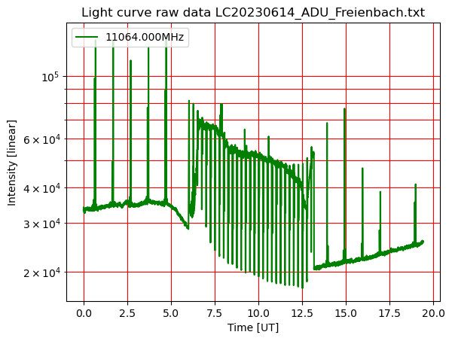
Fig. 13: Raw data from the spectrometer. Large positive peaks are due to interference from a moving satellite. Small positive peak with about the same amplitude as the solar radio noise is a so-called hot calibration while the telescope is looking into ground. Negative peaks (every 15 minutes) is when the telescope is looking to cold sky, ~10° away from the sun. This allows to perform calibration in antenna temperature and eventually in solar flux units (sfu). During sun-rise between 05 UT and 07:30 UT is interfered due to infrastructure of our neighbor in the east. Similarly, during sun-set there is interference due to our neighbor in the west.

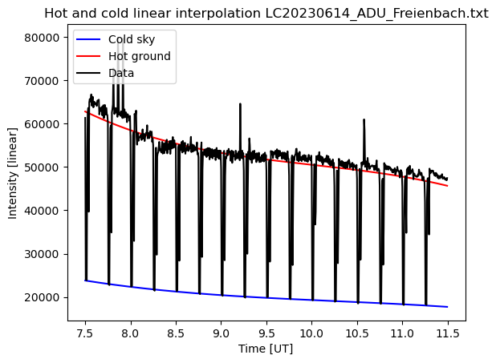
Fig. 14: Masked data with full view to the sun between 07:30 UT and 11:30 UT. Red lines denotes to an approximation of the hot-calibration peaks every 15 minutes while looking to the ground at about 300 kelvin. Blue plot denotes to a fit to the cold calibration peaks every 15 minutes. This allows to detrend thermal changes of instrument-offset and -gain.

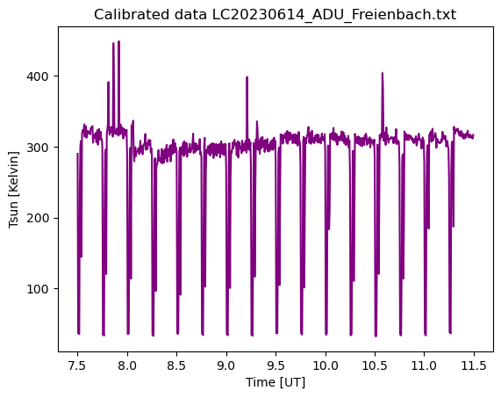
Fig. 15: Raw data detrended and calibrated in equivalent antenna temperature in the order of 300 kelvin … 320 kelvin on 20230614. Remaining positive peak are due to interference from satellites.
Solar events of the active Sun may also increase level of such light curves by several dB.

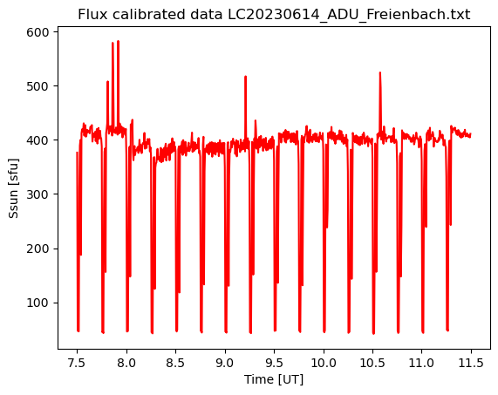
Fig. 16: Calibrated antenna temperature in solar flux units based on some assumptions of the antenna geometry and manufacturers specification.
Measurement of the 2D beam pattern with integration would allow to provide much better flux calibration.
Fine tuning can be performed by cross-calibrating with publications from NOAA.

10. Appendix

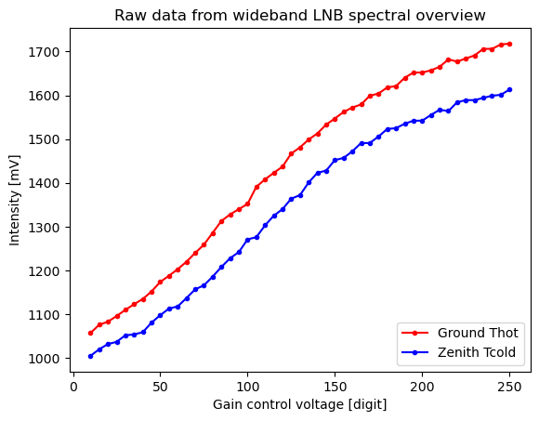
Fig. 14: Raw data of gain-sweep wideband LNB with two sources, Thot from ground and Tcold from sky.

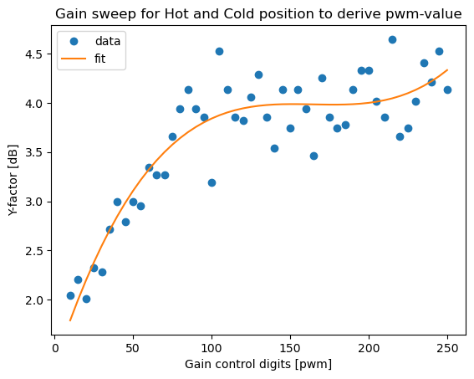
Fig. 15: Y-factor from gain-sweep of wideband LNB. Suggestion for pwm-value in configuration file Callisto.cfg is 120.
The higher the better but with the risk of saturation in case of satellites or solar radio bursts.
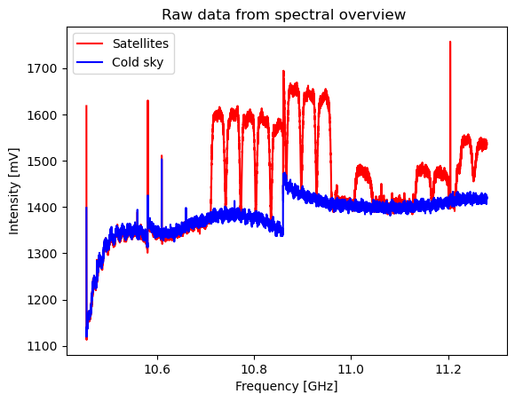
Fig. 16: Spectral overview of satellites and cold sky to find frequencies free from rfi to configure integrated light curves in configuration file frq99999.cfg.

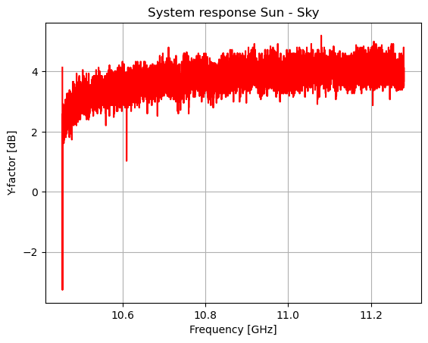
Fig. 17: Y-factor of Sun – cold sky. The higher frequency the more power we get. But the risk is higher due to smaller beam size to point to the sun.
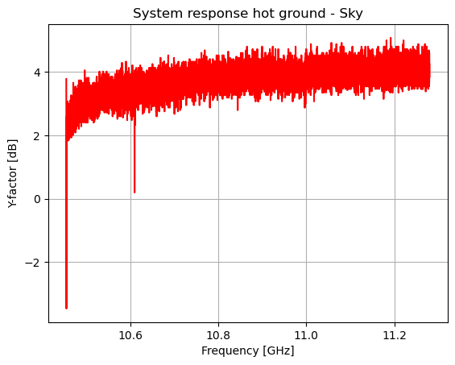
Fig. 18: Hot-/cold-measurement which is used for antenna temperature calibration. Looks almost identical to the Y-factor of Sun-cols sky which is good for calibration process.

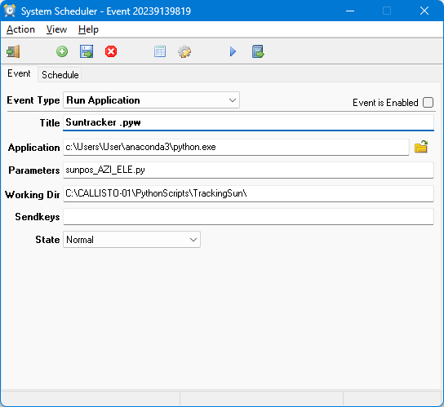
Fig. 19: Example on how to configure System Scheduler for antenna tracker. Python.exe can be replaced by Pythonw.exe and at the same time sunpos_AZI_ELE.py by sunpos_AZI_ELE.pyw.
User shall replace path by its own one.
Not to forget to configure Schedule. Hours in Europe about 07, 08, 09, ….17 (in UTC). In other countries accordingly.
In addition select every minute of time.
Then save configuration. In case of moon observations, we need different hours, depending on location and time. Do not forget also to configure spectrometer configuration file callisto.cfg to cover telescope time range.

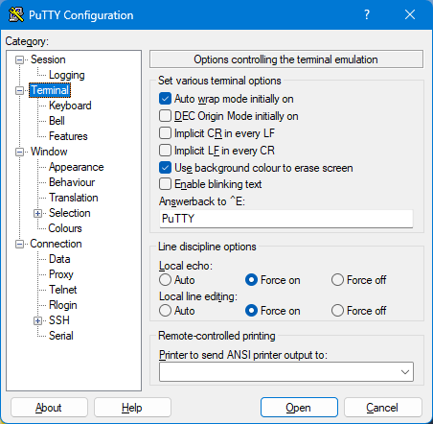
Fig. 20: PUTTY terminal configuration which allows to talk to the DiSEqC rotor interface.

Revision | Date
Draft | 12.05.2023
Updates | 16.06.2023
Updates | 05.07.2023
Updates | 25.08.2023
Updates | 14.09.2023

