Compensation of residual instrument squint and tilt
Christian Monstein

1. Introduction

It is quite difficult to align a transportable radio telescope on a soft ground such that axes are parallel respective perpendicular to ground. Even with digital balance and plumb bob it is almost impossible to manually adjust tripod and rotors such that residual error is less than 1°. The antenna beam size is in the order of 3° at X-band, therefore any error in pointing of even 0.5° reduces expected solar radio flux.

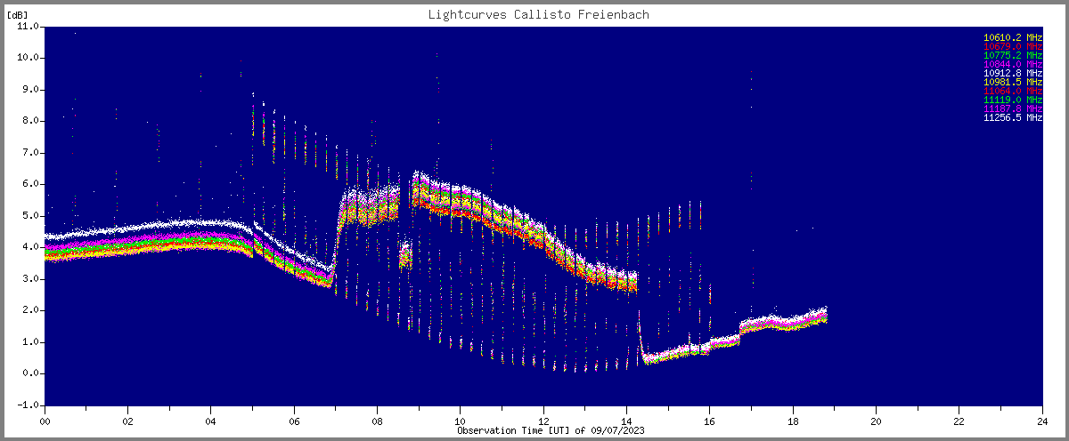

Figure 1 ~ Effect of tilt/squint error in one or more axis. In the morning and in the afternoon, telescope pointing is out of range leading to reduced flux. At ~08:30 UT telescope was re-aligned by manual software correction.

2. Concept of compensation
From current experience there are two ways to compensate errors in azimuth-, elevation- and feed-axis. The simplest method is to edit in real-time reference values aziref and eleref for telescope control in the Python script. As soon as one recognizes a drop of sun signal, compared to hot-reference one may ‘play’ with values of aziref and eleref. During a day this might be necessary 3… 4 times, depending on local circumstances such as tripod alignment, elevation and azimuth of the Sun as well as weather conditions (e.g. wet ground).
The second method is based on two steps which requires a day of preparation before any useful observation can be performed. Let the system track the Sun and perform following steps every hour or even every 30 minutes.
- Wait until a calibration sequence is finished usually at hh:03, hh:18, hh:33 and hh:48 or switch calibration completely off. Temperature calibration during these steps is not required.
- Disable System Scheduler ssfree.exe the application sunpos_AZI_ELE.py
- Remember current value of aziref and start a stepwise change of it, about current aziref +/- 4°
- For each step run the tracking Python script sunpos_AZI_ELE.py 1…3 times to ensure that current move of the Sun is considered.
- For each step take note of light curve value (in digits) and put it into a table together with aziref, see example in table 1.
- Put original value back for aziref and run the tracking script again
- Repeat the above sequence for eleref, again about current eleref +/- 4°
- Once the table for aziref and eleref is finished, enable System Scheduler (ssfree.exe) for sun tracker script. For a table example, see table 1 below.
- After tables completed, put them into Python script correctionHHMMut.py to fit data with a 2nd order polynomial, see example in figure 2a and 2b. HHMM stands for time of stepping process.
- Once the full day of several hours has been worked out you will get a set of ‘best’ aziref and ‘best’ eleref as function of observation time.
- Put these values into Python script correctionAll.py and run the script. Now you get a new set of polynomial coefficients for best aziref and eleref over time of the day.
- Put these coefficients into the new tracking script sunpos_AZI_ELE.py where the static aziref and eleref will then be replaced by the fit-functions for dynamic aziref and dynamic eleref.

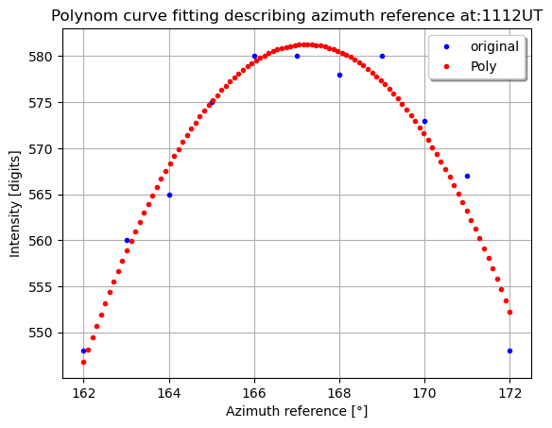 | 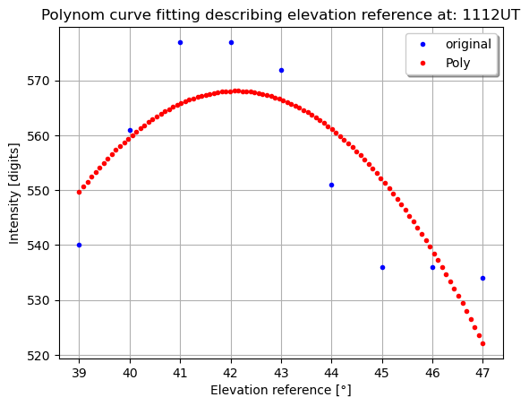
Figure 2a, 2b ~ Polynomial fit for best aziref and eleref at 11:12 UT. Remember peak values for aziref=167.3° and eleref=42.0°.

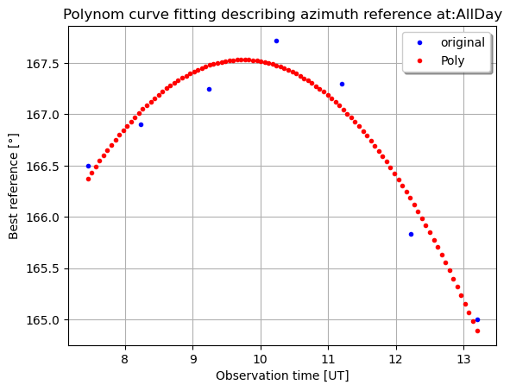 | 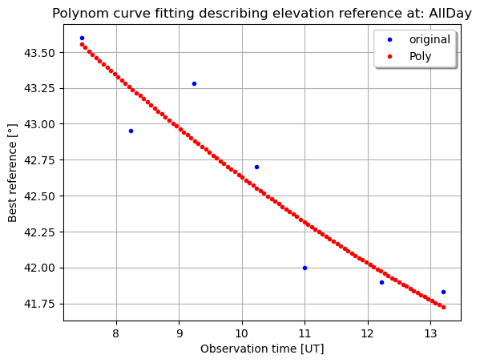
Figure 3a, 3b ~ Polynomial fit for all best aziref and eleref over a day of observation. We can see that in case of aziref under the current conditions changes from 166.5° in the morning to 167.5° during sun transit to 165.0° in the afternoon. On the other hand, eleref continuously changes during day from 43.5° to 41.75°

Aziref ° | 160 | 161 | 162 | 163 | 164 | 165 | 166 | 167 | 168 | 169 | 170 | 171 | 171
Digits | 546 | 552 | 562 | 572 | 576 | 580 | 582 | 578 | 572 | 567 | 560 | 548 | 543
Eleref ° | 39 | 40 | 41 | 42 | 43 | 44 | 45 | 46 | 47
Digits | 540 | 566 | 582 | 578 | 564 | 540 | 531 | 531 | 530
Table 1 ~ Stepwise through aziref and eleref while observing light-curve. Best aziref (preliminary) is 166° and best eleref is preliminary 41°. During the day we get ~7 tables similar to this one.

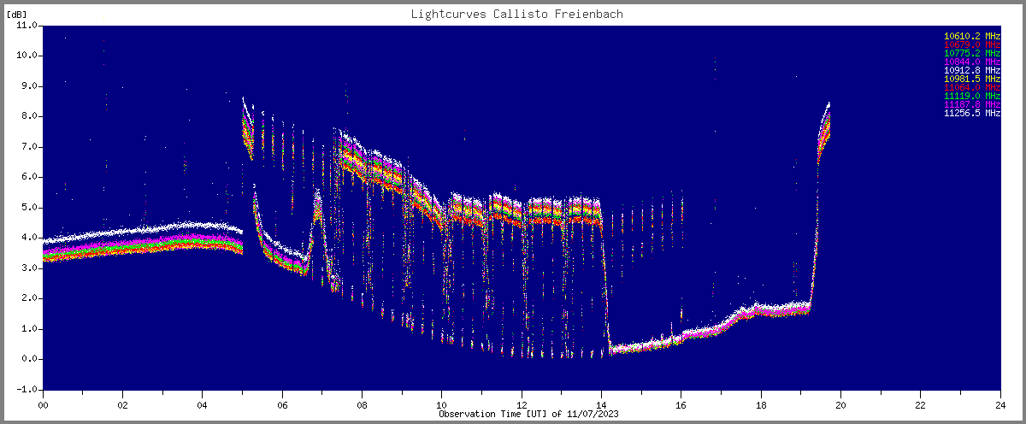
Figure 4~ Preparatory day with sun-rise at ~07 UT and sun out of field of view at ~14 UT. Reference steps for aziref and eleref have been performed at 07:27, 08:14, 09:14, 10:14, 11:12 12:13 and 13:12 UT. Each time both references for azi and ele showed a slightly better value to get constant flux from the sun. Any deviation > 0.5° decreases flux measurement. Negative peaks denote to cold sky while positive peaks denote to hot ground. Due to local thunderstorm at 20 UT the telescope was moved inside, therefore this high temperature. Slow baseline variation is due to huge temperature variation during the day.

3. Result

On Wednesday, 2023-07-12 the polynomial coefficients have been considered in the sun-tracker Python script sunpos_AZI_ELE.py. During the night there was a heavy thunderstorm with extreme rainfall, therefore the telescope was moved inside and re-positioned manually this morning. Immediately after sun-rise seen by the telescope the tripod was manually re-adjusted to get maximum intensity in the light-curve at around 07UT. This task was very difficult, the legs of the tripod had to be moved in all directions in the order of +/- 10 mm to find optimum position. But finally, it worked and the result looks promising, see figure 5. The solar flux was quite constant compared to hot-load and cold-load. There is still a strong variation due to high temperature gradients in the order of 15°. But these variations need to be calibrated, based on hot/cold measurements every 15 minute. As a result, we can confirm that the method of reference position interpolation in azimuth and elevation works with the disadvantage that it requires one day of commissioning. And after that, the telescope should not be moved any-more.

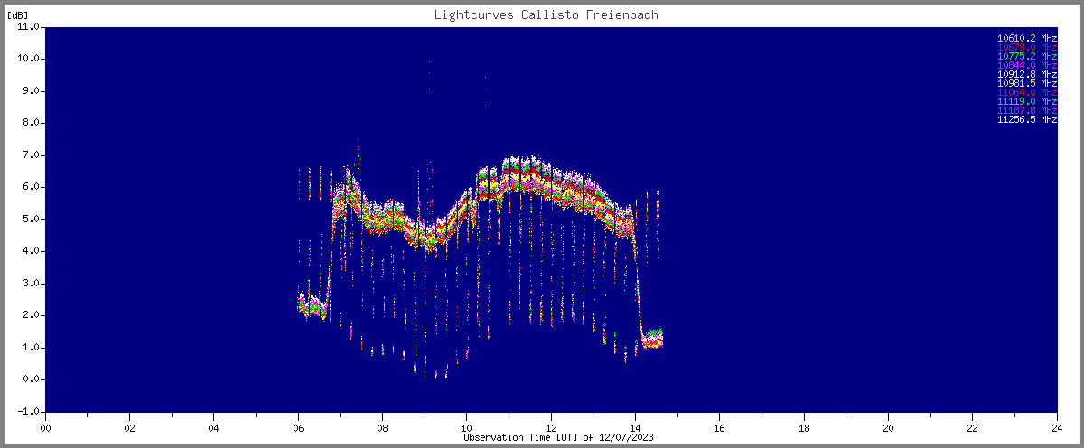
Figure 5~ Sun flux follows the hot-load all over the day which proves that the tracking process is perfect within better than +/- 0.5°. Strong baseline variations are due to high temperature changes during the day. They can be calibrated out.

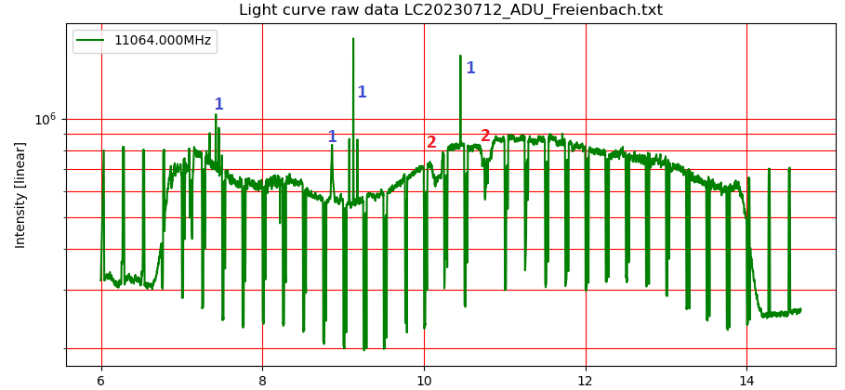
Figure 6~ Same data as in figure 5 above but with a different script. #1 are due to interference from satellites. #2 is due to heavy rain. Around 07UT the sun ‘walks’ into the antenna beam while around 13:50Ut the sun ‘walks’ out of the antenna beam.

