Compensation of residual instrument squint and tilt by raster fly scan
Christian Monstein

1. Introduction

As already described in a previous document, it is quite difficult to align a transportable radio telescope on a soft ground such that axes are parallel respective perpendicular to ground. Even with digital balance and plumb bob it is almost impossible to manually adjust tripod and rotors such that residual error is less than 1°. The antenna beam size is in the order of 3° at X-band, therefore any error in pointing of even 0.5° reduces expected solar radio flux.

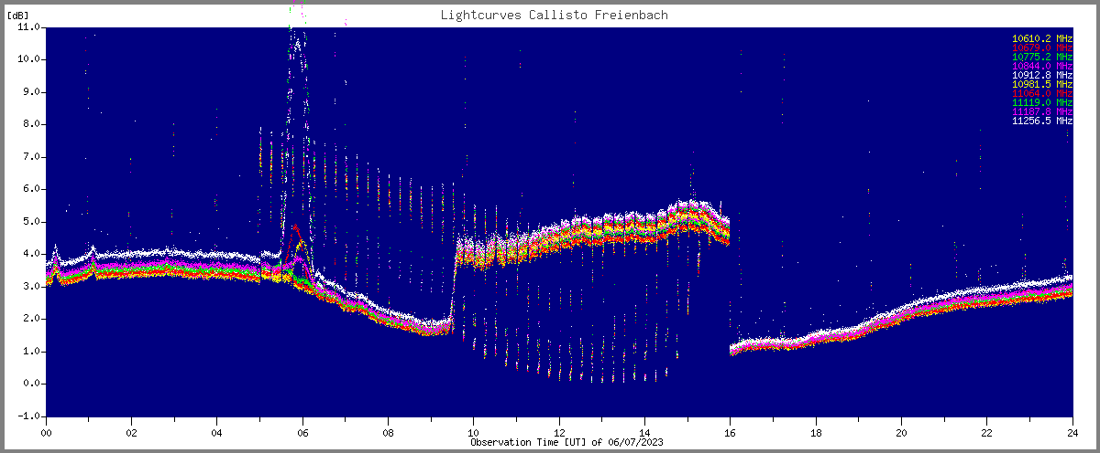

Figure 1 ~ Effect of tilt/squint error in one or more axis. In the morning, telescope pointing is out of range leading to reduced flux. Slow variations are due to high temperature changes during the day. Strong signal drop between 09UT and 10UT leading to wrong flux calibration. Gaussian like peak around 05:30UT is due moving of the telescope through the geostationary path of TV-satellites.

2. Concept of compensation
From current experience there is a third way to compensate errors in azimuth-, elevation- and feed-axis. The simplest method is to edit in real-time reference values aziref and eleref for telescope control in the Python script. As soon as one recognizes a drop of sun signal, compared to hot-reference one may ‘play’ with values of aziref and eleref. During a day this might be necessary 3… 4 times, depending on local circumstances such as tripod alignment, elevation and azimuth of the Sun as well as weather conditions (e.g. wet ground).
The second method is based on replacing static reference for azimuth (aziref) and elevation (eleref) by a polynomial approximation. But this is also time consuming and there is no guarantee that it works for days and weeks. As soon as elevation changes, there is the risk that the polynomial coefficients need to determined again. Therefore, a third method was tested, based on a method which I call raster fly scan (RFS). Beside optional calibration steps every 15 minutes the telescope scans every minute an area of +/-1.5° in elevation and +/-1.5° in azimuth.

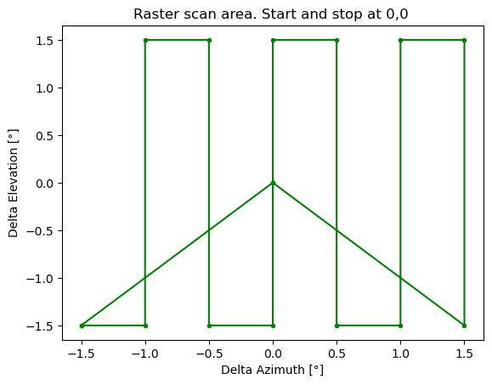
Figure 2 ~ Basic scan of an area of 3° x 3° around the calculated center of the Sun at 0°/0°. Scan starts in the center, moves to bottom left and finally ends again in the center where we expect the Sun center. Many other scanning processes are possible, up to now only this one has been tested.

The scanning of the Sun produces kind of on/off pattern as shown in figure 3 of the solar radio flux and the hope is, that we can find a maximum or peak value which then can be used for flux calibration.
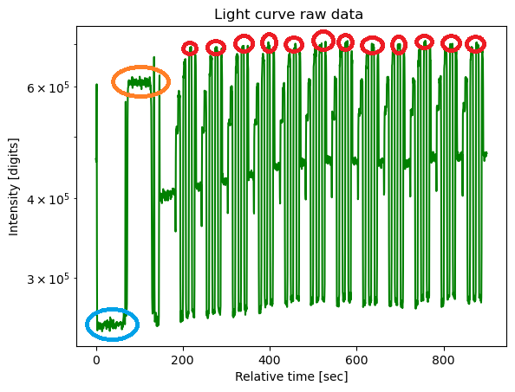
Figure 3 ~ Scanning result of 15 minutes of observation, corresponding to one FIT-file. Here we see the averaged (in frequency space) light curve from 10641 MHz till 10778 MHz. Far left we see cold sky (blue), then hot ground (orange), followed by 12 scans around the calculated Sun position (red). Scanning and tracking are combined. And one can clearly recognize a peak value in each scan which is quite close to the center of the scanning area

3. Result telescope on/off-mode
This method of raster fly scan is mainly meant for flux calibration and less for outreach activities and instrument demonstrations due to the ‘nervous’ activity of the antenna. There is permanent activity of both rotors all over the day.
Due to fast change of position we cannot make use of integrated light-curves which are available in real-time as ASCII-text file. Instead we need to work with FIT-files where we get full time resolution of 0.5 s (0.25 s). FIT-files are available after 15 minutes of observation. To get acceptable signal to noise ratio we need to integrate a few frequency channels. In the example shown in figure 3, 40 channels were averaged to get one single light curve, leading to a ‘good’ signal to noise ratio SNR of more than 20 dB.
In the example given above the result of a 15-minute observation is shown in table 1 below:

Observations & Results | Numerical value | Unit
Icold | 253031.8 | digit
Ihot | 609875.2 | digit
Calibration Y-factor | 3.82 | dB
Calibration SNR | 22.2 | dB
Peak Sun in 15 minutes | 709615.2 | digit
Average Sun in 15 minutes average (97% of peak) | 695721.4 | digit
Antenna temperature Sun | 357.7 | Kelvin
Y-factor Sun | 4.39 | dB
Effective aperture of 36 dB satellite dish | 0.249 | m^2
Solar radio flux at 10709.5 MHz calculated (basic) | 397.2 | SFU
Learmonth interpolation 8.8/15.4 GHz at 04:45 UT | 379.5 | SFU
Absolute flux difference X-band vs Learmonth | 4.7 / 0.2 | % / dB
Table 1: Result of a 15-minute observation on Friday, 2023-07-21 at 09:30 UT … 09:45 UT

Parameter | Numerical value | Unit
Tcold from literature | 12 … 35 | Kelvin
Thot from outdoor temperature | 22 / 295.15 | °C / Kelvin
Mean frequency in range 10.641 GHz … 10.778 GHz | 10709.5 | MHz
Radiometric bandwidth 40 x 300 KHz | 12 | MHz
Integration time per pixel / time resolution FIT-file | 1 / 0.5 | msec / sec
Boltzmann constant | 1.38E-23 | J/K
Speed of light | 3E8 | m/s
Table 2: Assumptions and measurements to get results, shown in table 1.

4. Variations of telescope on/off-mode
During the experiments with telescope on/off-mode some new ideas came up, changing the scanning process. Instead of on/off one can imagine many different modes. Two alternate ways will briefly be shown below. Firstly, an octagon (or nearly a circle) around the calculated position of the sun while tracking the sun. And secondly kind of spider- or star-like scanning pattern.

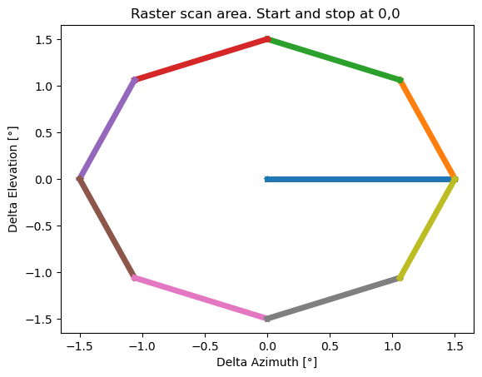
Figure 4 ~ Scanning an octagon around the calculated position of the sun while tracking the sun. Light curve is shown further down in figure 6. Light curve looks quite nice but there is the risk to miss peak flux, depending on the chosen radius of the octagon. In this example the radius was chosen as 1.5°.

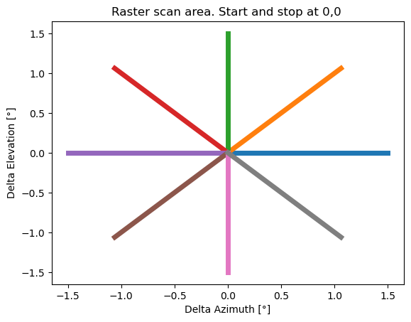

Figure 5 ~ Scanning a spider like or star-like pattern with same radius as in figure 4 above. This pattern ensures that one meets the peak flux of the sun with high probability. But when we see the light curve in figure 6 below, we see that the number of pixels depicting peak flux of the sun is very small. There are hardly sufficient pixels available for improving signal to noise ratio by integrating many pixels of sun peak flux.

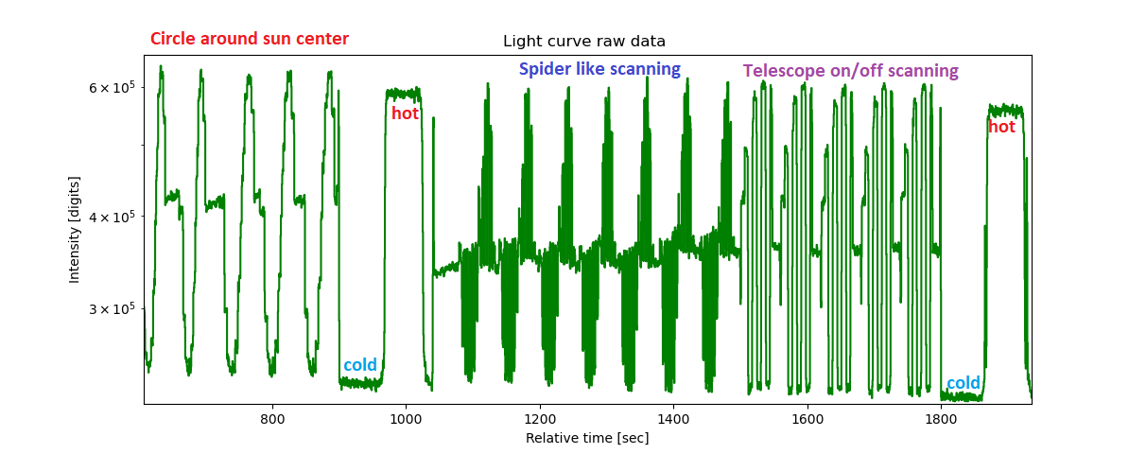
Figure 6 ~ Light curve of three different scanning modes within ~20 minutes of observation. Left: octagon- or circle-scanning, middle spider-like scanning and on the right the on/off-mode again as already presented at the beginning of this document. For orientation and calibration, we see twice cold sky of about 35 kelvin and twice hot ground of about 295 kelvin.

5. Conclusions
Among four tested versions to correct pointing errors due to mis-alignment of axis and antenna, the on/off-mode seems to be the best method at the moment in case flux measurement needs to be performed. Only this mode provides enough pixels at peak flux to get an acceptable signal to noise ratio by integrating several (>100) pixels while the other scanning modes do not provide enough pixels for integration. In common for all scanning modes is the permanent movement of both rotors which may reduce life-time of the tacking system. There are many more different scanning modes to be tested and discussed such as spirals or triangle like patterns etc.
In case of outreach activities or eclipse observations all these scanning modes are not ideal because the light curves look very odd, although perfect of automatic calibration, knowing the timing of the scanning pattern. Eclipse observations are better performed by manual adjustment of azimuth reference aziref and elevation reference eleref by editing the Python script in real time a few times per day, once one sees a slow drift of the observed flux.
Anyway, it is for all methods very important to align the telescope in a perfect way. Pole or mast or tripod absolute vertically aligned, elevation axis perfect horizontally as well as perfect compensation of the nasty offset-angle of the satellite dish. And not to forget a ground or basement which does not move or sink. Ideally, a concrete platform or a heavy steel plate which does not move when people stand nearby. And again, such a system requires precise longitude, latitude, altitude and time information, at least 4 decimals for geographical parameter and timing precision better than +/- 5 seconds. Also, temperature and humidity can be considered to correct for compensating errors due to refraction near the horizon.

