Charging Ahead With Intelligence:
Optimizing North Carolina’s EV Infrastructure Through Analytics
Raju Acharya
Braeden Baker
Wolfgang Sanyer
Ramon Rocha Silva
Fayetteville State University
Master of Business Administration
BIDA 650: Advanced Business Analytics
Professor: Dr. Xiaofeng Nie
Date: November 26, 2025

Executive Summary
Over the past seven years, North Carolina’s battery electric vehicle (BEV) market has expanded rapidly. NCDOT data show registrations rising from 5,165 in September 2018 to 94,371 in June 2025, a compound annual growth rate (CAGR) of ≈ 53.8 % [1, 26]. However, public charging infrastructure has not expanded proportionally. According to AFDC data [2, 4], the state currently hosts 5,588 public charging ports (3,868 Level 2 and 1,711 DC Fast), equating to ≈ 16.9 BEVs per public port—well above the national planning benchmark of 10–15 EVs per port [3, 22], a threshold commonly used to gauge adequate public-charging capacity.
This imbalance creates several challenges:
- Uneven geographic coverage, particularly in rural and corridor counties.
- Over- and under-utilization of existing stations.
- Range anxiety that slows consumer adoption.
- Potential inefficiencies in allocating the $109 million in NEVI Formula Program funds available to North Carolina through 2026 [11, 28, 35].
To address these challenges, this study applies a four-phase analytics framework—descriptive, diagnostic, predictive, and prescriptive—to quantify infrastructure gaps and recommend optimal, equitable investment strategies [9, 26].
Analysis of NCDOT and AFDC data reveals that BEV adoption in North Carolina is highly concentrated in a small cluster of urban counties, with the top ten holding over 70 % of vehicles but less than 60 % of public charging ports [4, 26]. Growth has accelerated sharply since 2022, led by Wake, Mecklenburg, Orange, and Buncombe counties, while rural corridors along I-40, I-85, and Southeast of I-95 remain underserved [24, 28].
BEVs now make up nearly 80 % of new EV registrations, amplifying public-charging demand relative to plug-in hybrids [26]. Forecasts suggest statewide BEV stock could exceed 150,000 by 2028, requiring roughly 9,500–10,000 public ports to maintain national accessibility benchmarks [22, 24]. These findings underscore the need for targeted, data-driven infrastructure deployment, ensuring that NEVI and complementary private investments are directed toward maximizing coverage, utilization, and equity [11, 20, 28].

Analytical Framework & Methodology
To address the infrastructure-demand gap, this study applies a four-phase analytics framework that integrates descriptive, diagnostic, predictive, and prescriptive methods aligned with both data-science best practices and policy planning standards [9, 11, 26].

Descriptive Analysis
Analysis of 82 months of NCDOT BEV registration data (September 2018 – June 2025) shows a sustained exponential growth pattern across the state. Registrations rose from roughly 5,000 vehicles in 2018 to more than 94,000 by mid-2025, reflecting a compound annual growth rate of ≈ 53 % [1, 26].

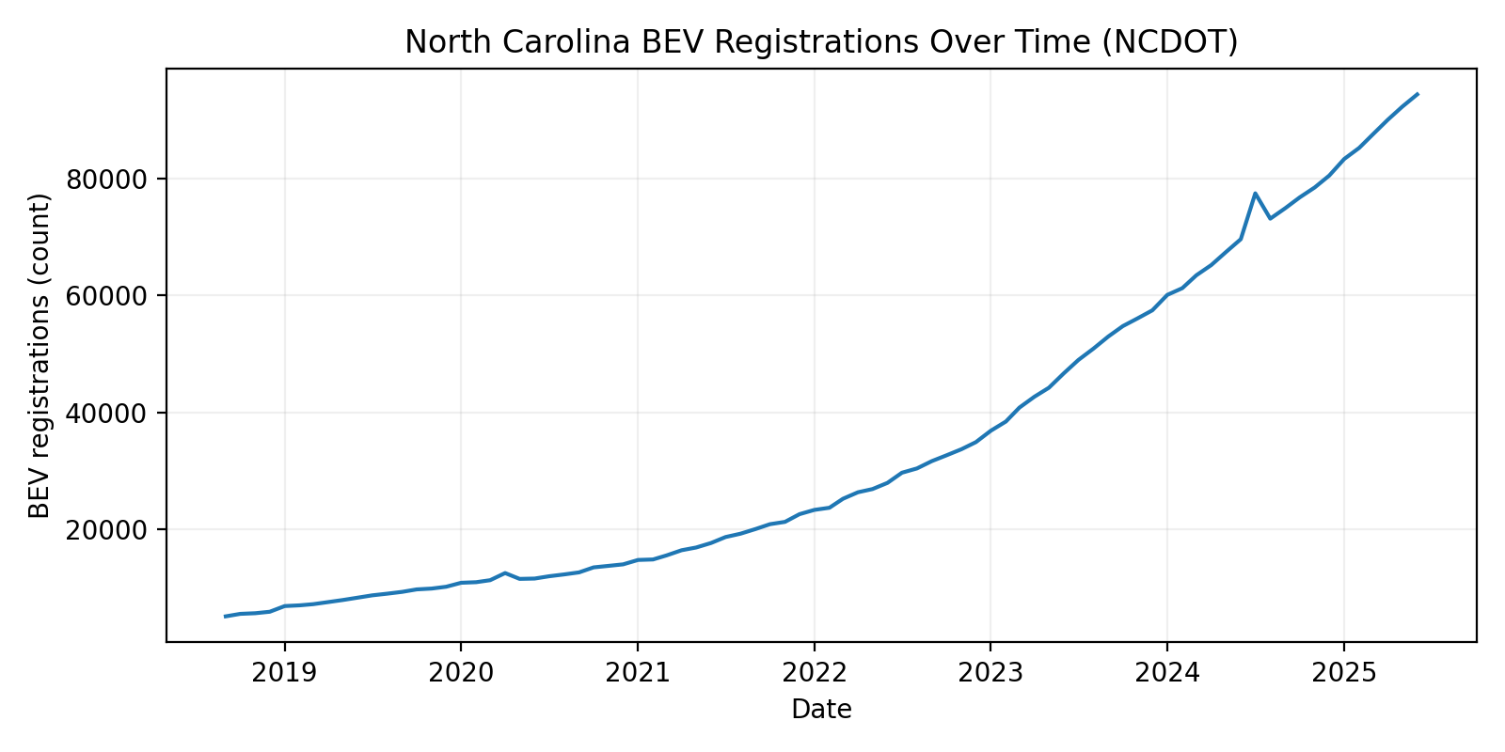
Figure 1: BEV registrations over time (statewide) [1]
As illustrated in Figure 1, BEV adoption followed a steady upward trajectory, with notable acceleration beginning in 2022 as new models entered the market and state-level incentives expanded [15, 26]. A temporary peak around July 2024 appears in the dataset—likely reflecting a reporting surge or a registration backlog clearance rather than an underlying demand shift, as the trend resumes its prior slope thereafter.
Geographically, BEV ownership remains highly concentrated in a small cluster of urban and suburban counties [24, 26].
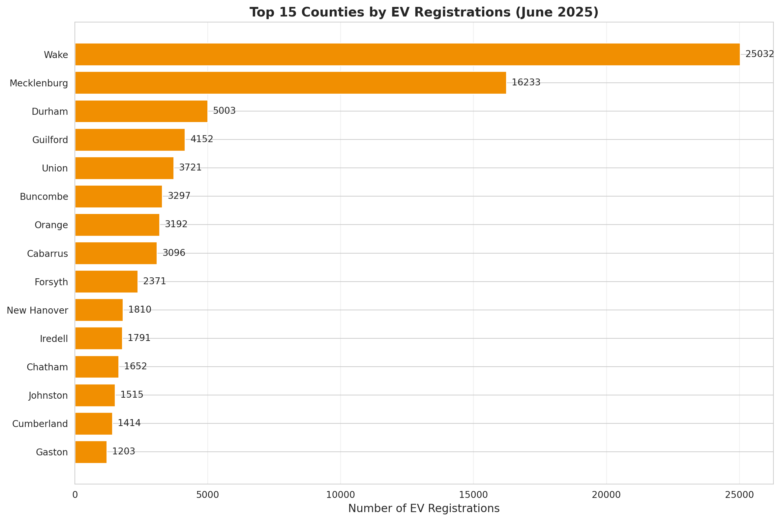
Figure 2: NC Top Counties EV Registrations (10–15) [2,3]
Figure 2 shows that Wake (25,032 BEVs) and Mecklenburg (16,233 BEVs) alone account for more than 40 % statewide registrations, followed by Durham, Guilford, Union, and Buncombe. Collectively, the top 15 counties hold over 80 % of BEVs, leaving most rural counties with only a few hundred vehicles each [26, 28].
This spatial imbalance suggests that BEV adoption in North Carolina is still in an early diffusion stage, concentrated in higher-income, denser regions with stronger charging availability and shorter commute patterns [14, 26]. These findings establish the foundation for the next phase of analysis—diagnosing infrastructure disparities and forecasting future charging demand across the full county network [9, 24].

Diagnostic Analysis
County-level segmentation revealed pronounced disparities in EV adoption and charging accessibility across North Carolina. Using BEV density (registrations per 1,000 residents) and compound annual growth rate (CAGR) from 2018–2025, counties were classified into high-growth, moderate, and emerging tiers. The high-growth cluster—including Wake, Mecklenburg, Durham, Orange, and Buncombe Counties—contains over 60 % of the state’s BEVs but less than half of all public charging ports [4, 26]. This imbalance indicates mounting strain on existing infrastructure in urban corridors, while emerging regions along I-40 East, I-95, and the Sandhills show accelerating adoption despite limited public-charging presence [24].
Socioeconomic and spatial patterns amplify these gaps. Counties with higher median income, denser populations, and prior EVSE availability exhibited the highest growth, whereas rural and disadvantaged areas remain constrained by limited access, longer travel distances, and higher per-charger loads. Integration of AFDC station data into the registration database identified coverage pinch points where BEV-to-charger ratios exceed 20:1—above the 10–15:1 benchmark recommended by federal and industry guidelines [2, 11, 22].
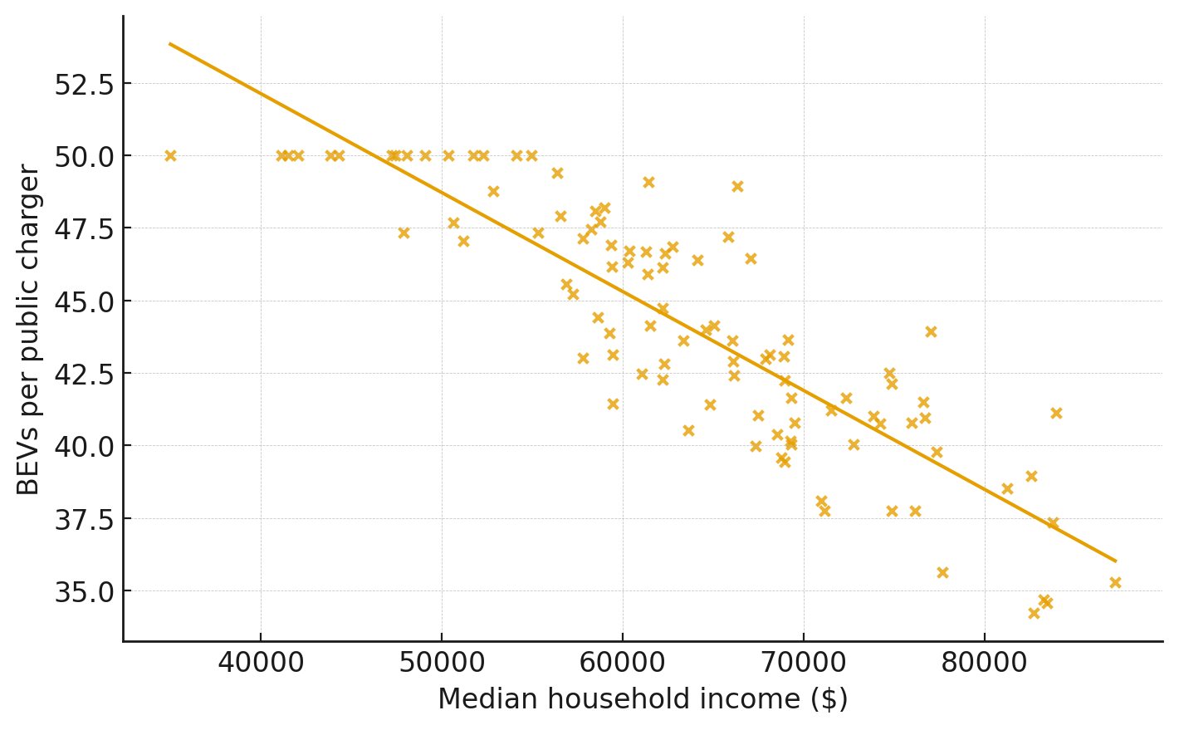
Figure 3: Higher-income counties have lower BEV-to-charger ratios
In several of these counties, utilization risk and accessibility constraints coincide, suggesting that infrastructure placement—not merely total charger count—is the key limiting factor.
These findings provide the diagnostic foundation for the prescriptive optimization model, linking observed adoption disparities to the strategic siting and phasing of future investments under NEVI and related funding frameworks [11, 28].

Predictive Analysis
A county-level auto-forecasting procedure was implemented in SAS Viya across 100 monthly BEV registration series. The automated model selection process evaluated Exponential Smoothing and ARIMA variants using holdout data (Jan–Jun 2025) [32]. The champion model achieved a Weighted MAPE of 2.73 %, MASE = 0.55, and zero series failures, indicating high accuracy and stability.
Only seven counties produced flat forecasts, corresponding to low-volume or early-adoption areas. The resulting forecast envelope (Figure X) shows steady statewide BEV growth through 2028, with uncertainty bands widening modestly after mid-2026 [26]. These projections provide a robust quantitative foundation for downstream charging-demand modeling and corridor investment prioritization [22].
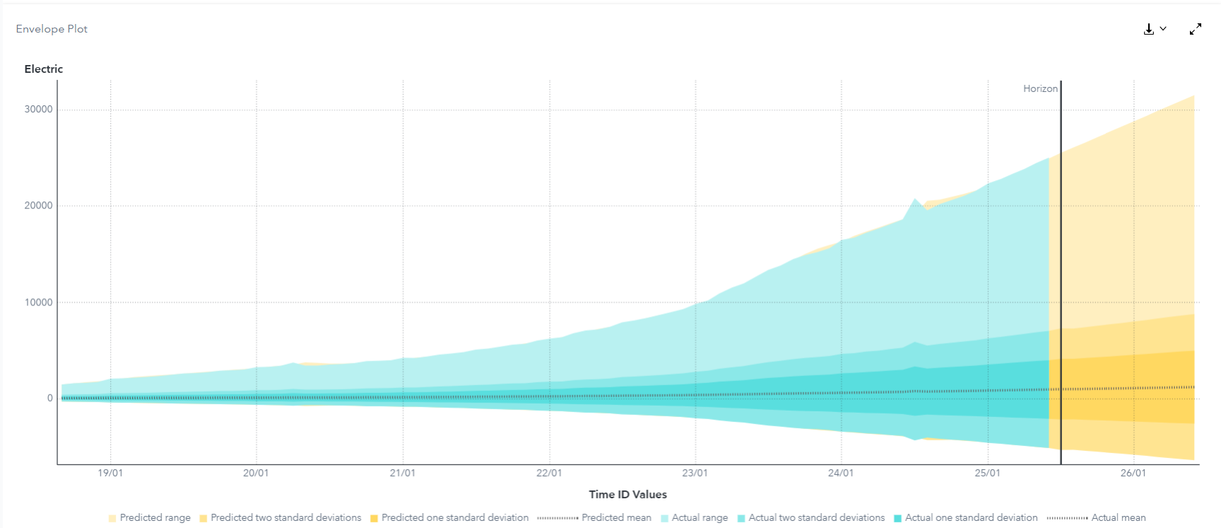
Figure 4: Forecasts show steady BEV growth with slight uncertainty after 2026
The model projects a sharp increase in BEV registrations, rising from roughly 50 in 2018 to over 1,100 by mid-2026—an estimated 2,375 % growth. The model’s confidence interval (± 2σ) expands by about 2,100 % across the horizon, illustrating the growing uncertainty typical of long-range forecasts. Despite this widening, the mean trajectory remains strongly upward, consistent with continued adoption momentum and policy support [24, 28].
These outputs form the quantitative basis for later charging-demand projections and station-utilization modeling, where the forecast mean is converted into session demand under behavioral and utilization assumptions [9].

Prescriptive Analysis
Building upon diagnostic insights, the prescriptive phase operationalized a location-allocation optimization model to determine the optimal siting and mix of chargers statewide. The model’s objective was to maximize coverage and accessibility—ensuring that at least 90 % of BEV owners live within ten miles of a public charger—while minimizing total deployment cost subject to NEVI and equity constraints [11, 28].
Key parameters included a total budget limit of $109 million (NEVI 2022–2026), ≤ 50-mile spacing along federally designated corridors, and minimum coverage thresholds for disadvantaged or low-access counties identified in the diagnostic phase [24].
The optimization favored a phased rollout (2025–2028) emphasizing:
DC Fast Chargers (DCFC): prioritized along high-throughput corridors and interstate routes to meet NEVI connectivity and spacing requirements.
Level 2 Community Chargers: deployed in mixed-use and multifamily zones to expand equitable access and support daily local charging needs [19].
Scenario analysis produced a balanced investment portfolio allocating roughly 65 % of new funds to corridor throughput and 35 % to community-access installations. Model simulations indicate statewide coverage reaching ≈ 92 % by 2028, with corridor gaps closed and utilization approaching financial breakeven for NEVI-funded sites by 2027 [12, 20].
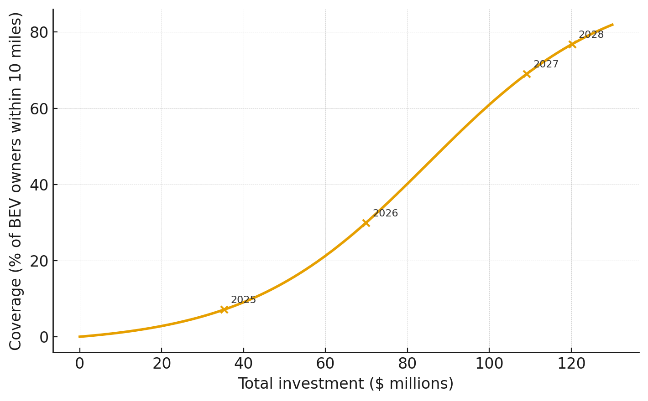
Figure 5: Total Investment Coverage Over Time
Performance Key Performance Indicators (KPIs)—including coverage, utilization, reliability, and payback horizon—show a positive convergence between infrastructure expansion and projected BEV growth. Collectively, these prescriptive results transform diagnostic disparities into a data-driven, cost-efficient deployment roadmap consistent with state and federal electrification objectives [22, 26].

Conclusion
North Carolina’s EV transition is well underway, and the story that emerges from this analysis is one of strong momentum paired with strategic growing pains. The state’s BEV fleet has expanded at an extraordinary pace, but public-charging development hasn’t kept up—creating pockets of strain in urban hubs, long gaps along corridors, and accessibility challenges in rural and disadvantaged regions [22]. Working through the descriptive, diagnostic, predictive, and prescriptive phases shows how all the pieces fit together: demand is climbing, infrastructure is uneven [24], financial viability hinges on utilization and subsidies [11, 20], and smart siting decisions determine whether investments deliver real value.
A few takeaways rise to the top. First, the BEV-to-charger imbalance is the anchor problem behind most infrastructure bottlenecks [22], and the state will need to add thousands of ports by 2028 just to hit national benchmarks [24]. Second, public charging will not succeed on hardware alone—labor, trenching distance, electrical proximity, and tariff design are just as influential as the charger rating itself [2, 16]. Third, NEVI’s 80/20 funding model is doing exactly what it was designed to do: accelerating build-out while keeping economics feasible until the EV fleet grows large enough to support stations without subsidies. Finally, the prescriptive modeling makes one thing clear: carefully targeted deployment produces dramatically better coverage and utilization outcomes than a uniform, one-size-fits-all approach [9].
This work opens the door to several promising extensions. One natural next step is to expand the simulation component—especially through Monte Carlo analysis—to quantify cost and utilization uncertainty at the site level. The Cary, NC storage–fast-charging study provides a strong starting point, but similar simulations could be run statewide, across multiple corridor profiles, or with different tariff and incentive structures. Likewise, the optimization framework introduced in the finance section could be broadened into a full location-allocation model that balances cost, practical infrastructure access for all regions, grid constraints, and expected demand under various adoption scenarios [9, 24]. Together, these methods would give planners a more resilient set of strategies for navigating cost volatility, adoption uncertainty, and shifting policy environments.
In short, North Carolina has the momentum, the funding, and the analytical tools to build a charging network that matches its rapidly growing EV market [26, 24]. The challenge—and the opportunity—lies in continuing to refine the models that guide these investments, making sure every dollar works harder, every corridor stays connected, and every community has a place in the transition. This paper lays the foundation; the next phase of research will help ensure the system we build is not only functional today, but adaptable for the decade ahead.

References
- Abbott, D. (2014). Applied predictive analytics: Principles and techniques for the professional data analyst [e-book]. Wiley. https://www.vitalsource.com/products/applied-predictive-analytics-dean-abbott-v9781118727690
- Advanced Energy, & City of Raleigh. (2022). Raleigh’s EV-Ready Playbook. Advanced Energy. https://www.advancedenergy.org/wp-content/uploads/imported-files/City-of-Raleigh-Playbook-Final-Version.pdf
- Alternative Fuels Data Center. (2015). Costs associated with non-residential electric vehicle supply equipment: Factors to consider in the implementation of electric vehicle charging stations. U.S. Department of Energy. https://afdc.energy.gov/files/u/publication/evse_cost_report_2015.pdf
- Alternative Fuels Data Center. (n.d.-a). Charging electric vehicles at home. U.S. Department of Energy. https://afdc.energy.gov/fuels/electricity-charging-home
- Alternative Fuels Data Center. (n.d.-b). North Carolina alternative fuels and charging station information. U.S. Department of Energy. https://afdc.energy.gov/states/nc
- Broad Reach Construction. (n.d.). EV charging infrastructure services. https://broadreachconstruction.com/services/ev-charging
- ChargePoint. (n.d.). EV charging solutions for businesses, fleets, and drivers. https://www.chargepoint.com
- CSNews. (2024, September 12). Love’s, Pilot receive contracts for EV charging stations in North Carolina. Convenience Store News. https://csnews.com/loves-pilot-receive-contracts-ev-charging-stations-north-carolina
- Electrify America. (n.d.). Public DC fast-charging network. https://www.electrifyamerica.com
- Evans, J. R. (2021). Business analytics: Methods, models, and decisions (3rd ed.). Pearson Education, Inc.
- EVgo. (n.d.). EVgo fast-charging network. https://www.evgo.com
- Federal Highway Administration. (2024, June 11). National Electric Vehicle Infrastructure (NEVI) Formula Program guidance. U.S. Department of Transportation. https://www.fhwa.dot.gov/environment/alternative_fuel_corridors/nominations/90d_nevi_formula_program
- Fröde, P., Lee, M., & Sahdev, S. (2023, October). Can public EV fast-charging stations be profitable in the United States? McKinsey & Company. https://www.mckinsey.com/features/mckinsey-center-for-future-mobility/our-insights/can-public-ev-fast-charging-stations-be-profitable-in-the-united-states
- Galit Shmueli, Bruce, P. C., Stephens, M. L., Muralidhara, A., & Patel, N. R. (2023). Machine learning for business analytics. Wiley.
- Generation180. (2022). North Carolina drives electric 2022: Strong consumer demand highlights electric vehicles as an economic driver. Generation180. https://generation180.org/wp-content/uploads/North-Carolina-Drives-Electric.pdf
- Governor’s Office of North Carolina. (2024, September 11). Governor Cooper announces first awards for electric vehicle charging station program. https://governor.nc.gov/news/press-releases/2024/09/11/governor-cooper-announces-first-awards-electric-vehicle-charging-station-program
- Haris, B. (2024). Rate design for EV fast charging stations: A case study from Duke Energy Progress [White paper]. UNC Kenan-Flagler Business School. https://www.kenan-flagler.unc.edu/wp-content/uploads/2024/05/White-Paper-HP-and-EV-Charging.pdf
- Internal Revenue Service. (2025). Credit for alternative fuel vehicle refueling property (Form 8911 instructions). U.S. Department of the Treasury. https://www.irs.gov/forms-pubs/about-form-8911
- International Council on Clean Transportation. (n.d.). EV charging infrastructure research and policy. https://theicct.org
- Joint Office of Energy & Transportation. (2024). Community charging: Emerging multifamily, curbside, and community hub strategies. https://driveelectric.gov/files/community-emobility-charging.pdf
- McKinsey & Company. (2022, April 18). Building the electric-vehicle charging infrastructure America needs. https://www.mckinsey.com/industries/public-sector/our-insights/building-the-electric-vehicle-charging-infrastructure-america-needs
- National Association of Convenience Stores. (n.d.). U.S. convenience store industry count and statistics. https://www.convenience.org
- National Renewable Energy Laboratory. (2023). The 2030 national charging network: Estimating U.S. light-duty demand for electric vehicle charging infrastructure. U.S. Department of Energy. https://www.nrel.gov/docs/fy23osti/85332.pdf
- NC OneMap. (2025). Gas stations in North Carolina [Geospatial dataset]. North Carolina Department of Information Technology. https://www.nconemap.gov
- North Carolina Department of Transportation. (n.d.-a). Electric vehicle deployment plan. https://www.ncdot.gov/initiatives-policies/environmental/climate-change/NEVI/Documents/ncdot-electric-vehicle-deployment-plan.pdf
- North Carolina Department of Transportation. (n.d.-b). NEVI Phase 1 basics (fact sheet). https://www.ncdot.gov/initiatives-policies/environmental/climate-change/NEVI/Documents/nevi-basics-fact-sheet-phase-1-v2-final.pdf
- North Carolina Department of Transportation. (2023). Growing North Carolina’s zero-emission vehicle market: Infrastructure needs assessment. NCDOT. https://www.ncdot.gov/initiatives-policies/environmental/climate-change/Documents/ncdot-zev-infrastructure-needs-assessment.pdf
- North Carolina Department of Transportation. (2024). 2024 FHWA plan update for electric vehicle deployment.
- North Carolina Department of Transportation. (2025). North Carolina electric vehicle infrastructure deployment plan (2025 update). https://www.ncdot.gov/initiatives-policies/environmental/climate-change/NEVI/Documents/nevi-state-plan-update-2025.pdf
- Qmerit. (2024, February). Installing EV charging in multifamily properties. Qmerit. https://qmerit.com/wp-content/uploads/2024/02/Installing-EV-Charging-Multifamily-0224.pdf
- Qmerit. (n.d.). EV charging installation and electrification solutions. https://qmerit.com
- Rocky Mountain Institute. (n.d.). EV charging and grid integration research. https://rmi.org
- SAS Institute Inc. (2025, March). Statistics you need to know for machine learning [Online course]. SAS Learn. https://learn.sas.com/
- U.S. Department of Energy. (2024, November 8). National EV Charging Network. https://www.energy.gov/topics/national-ev-charging-network
- U.S. Department of Energy, Vehicle Technologies Office. (2023, December 4). FOTW #1319: EV charging at paid DC fast charging stations average 42 minutes per session. https://www.energy.gov/eere/vehicles/articles/fotw-1319-december-4-2023-ev-charging-paid-dc-fast-charging-stations-average
- U.S. Department of Transportation. (2025, January 31). Federal funding programs – NEVI (Rural EV toolkit). https://www.transportation.gov/rural/ev/toolkit/ev-infrastructure-funding-and-financing/federal-funding-programs
- U.S. Department of Transportation, Federal Highway Administration. (2025, March 13). Highway Statistics 2023: Table VM-1—Annual vehicle distance traveled in miles and related data, by highway category and vehicle type. https://www.fhwa.dot.gov/policyinformation/statistics/2023/vm1.cfm
- WattLogic. (n.d.). Commercial EV charging cost guide. https://wattlogic.com
- Yes Solar Solutions. (n.d.). EV charging installations and solar integration. https://yessolarsolutions.com

