John W Munyi
Lab 2
18847-RW
Augmented and Virtual Reality Systems

Introduction:

In this lab the focus was on two main tasks
- On the first script being able to read an RGB image as the input and output a YUV image where either of the planes has been used to overwrite the other planes
- The second scripts reads an RGB image then plots a graph showing the frequency of each color intensity as represented in the image.
- Metrics for maximum and minimum color intensities and their corresponding variance and mean for image 2.

In the subsequent section I will be looking at the output images after each transformation from RGB to YUV and also an explanation of the graphs that show the frequency of color intensity distribution.

Section A

In the next section I will be posting the resulting images of the image_test01.bmp image

Y color plane:

The resulting image after over-writing the U and V color planes with Y is shown below:

U color plane:

The resulting image after over-writing the Y and V color planes with U is shown below:

V color plane:

The resulting image after over-writing the Y and U color planes with V is shown below:

Observations:

The V planes seems to only highlight the light colors while U plane image has the dark potions standing out more. The Y plane image has a decent balance which looks like a conversion of the image from a co loured to a black and white one.

In the next section I will be posting the resulting images of the colorbars.bmp image:

Y color plane:

The resulting image after over-writing the U and V color planes with Y is shown below:

U color plane:

The resulting image after over-writing the Y and V color planes with U is shown below:

V color plane:
The resulting image after over-writing the U and Y color planes with U is shown below:

The script used to generate the images is pasted below:

The script take the input image name, the color plane to edit in terms of Y, U or V and the output file name.

import numpy as np
import sys
import bmp_io_c

if len(sys.argv) != 4:
print("the usage is: python this_file_name input_image plane_to_edit output_file")
sys.exit()

color_planes = 3
constant_matrix = np.array([[0.299, 0.587, 0.114],
[-0.147, - 0.289, 0.436],
[0.615, - 0.515, - 0.100]])
# input the image
print(str(sys.argv[1]))
rows, cols, pixels = bmp_io_c.input_bmp_c(str(sys.argv[1]))
print("Input Image dimensions are: ", rows, cols)

# np array to hold newly edited pic
yuv = np.zeros((color_planes, rows, cols), np.uint8)
print("shape is =========", constant_matrix.shape)

for i in range(rows):
for j in range(cols):
yuv[:, i, j] = np.dot(constant_matrix, np.array(
pixels[:, i, j])) + np.array([0, 128, 128])

# printing the max and min in RGB
print("The max and min of R plane are: respectively",
pixels[0].max(), pixels[0].min())
print("The max and min of G plane are: respectively",
pixels[1].max(), pixels[1].min())
print("The max and min of B plane are: respectively",
pixels[2].max(), pixels[2].min())

# printing the max and min in YUV
print("The max and min of y plane are: respectively",
yuv[0].max(), yuv[0].min())
print("The max and min of u plane are: respectively",
yuv[1].max(), yuv[1].min())
print("The max and min of v plane are: respectively",
yuv[2].max(), yuv[2].min())

# converting to yuv depending on user plane selection
for i in range(rows):
for j in range(cols):
if str(sys.argv[2]) == 'y':
yuv[1] = yuv[0]
yuv[2] = yuv[0]
elif str(sys.argv[2]) == 'u':
yuv[0] = yuv[1]
yuv[2] = yuv[1]
else:
yuv[0] = yuv[2]
yuv[1] = yuv[2]

# output the image
bmp_io_c.output_bmp_c(str(sys.argv[3]), yuv)

Maximun and Minimum values:

- The max and min of R plane are: respectively 255 2
- The max and min of G plane are: respectively 255 0
- The max and min of B plane are: respectively 255 0
- The max and min of y plane are: respectively 254 0
- The max and min of u plane are: respectively 152 22
- The max and min of v plane are: respectively 193 113

Section B

In this section I will be looking at color intensity graphs as represented by their frequency in the image image_test01.bmp .

The script used to generate the graphs is shown below:

The script take the input image name and the color plane to edit in terms of R, G or B

import numpy as np
import matplotlib.pyplot as plt
import sys
import bmp_io_c

if len(sys.argv) != 3:
print("the usage is: python this_file_name input_image plane_to_edit")
sys.exit()

# input the image
print(str(sys.argv[1]))
rows, cols, pixels = bmp_io_c.input_bmp_c(str(sys.argv[1]))
print("Input Image dimensions are: ", rows, cols)
print("Pixels shape: ", pixels.shape)

# create an array of 256 different ,color intensities
plane = np.zeros((256), np.uint8)

# passing the plane to edit
if sys.argv[2] == 'R':
currentPlane = pixels[0].astype(int).flatten()
elif sys.argv[2] == 'G':
currentPlane = pixels[1].astype(int).flatten()
else:
currentPlane = pixels[2].astype(int).flatten()

print("current plane shape", currentPlane.shape)

plane = np.bincount(currentPlane)
print("Sum============", sum(plane))

norm_plane = []
print(plane.dtype)

for i in range(256):
x = plane[i] / sum(plane)
norm_plane.append(x)

print("The Normalized plane sum is: ", sum(norm_plane))

# variance and Mean
print("The mean of the normalized plane", np.mean(norm_plane))
print("The variance of the normalized plane", np.var(norm_plane))

# plotting
plt.plot(norm_plane, color='g')
plt.title("Normalized graph for color intesities")
plt.xlabel("Pixels Intensity")
plt.ylabel("Normalized values")
plt.show()

Below are the resulting graphs:

R color intensity graph:
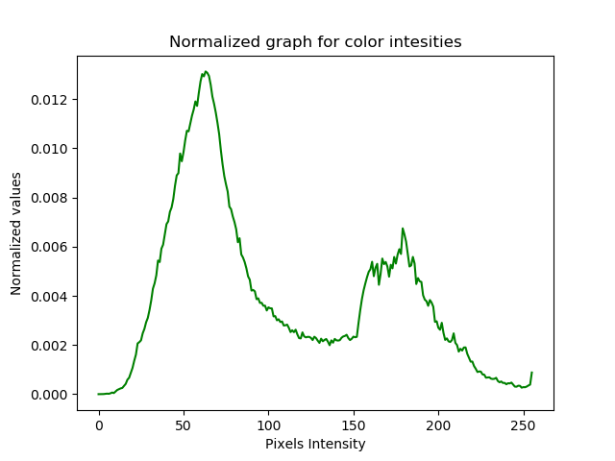
G color intensity graph:
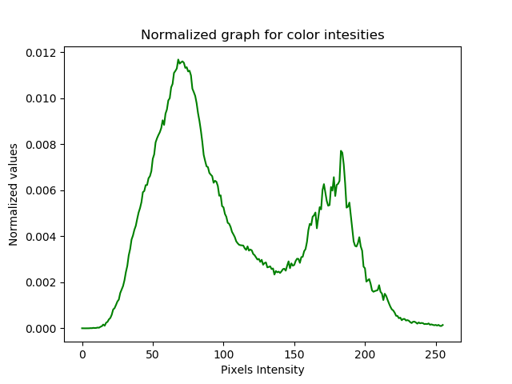

B color intensity graph:

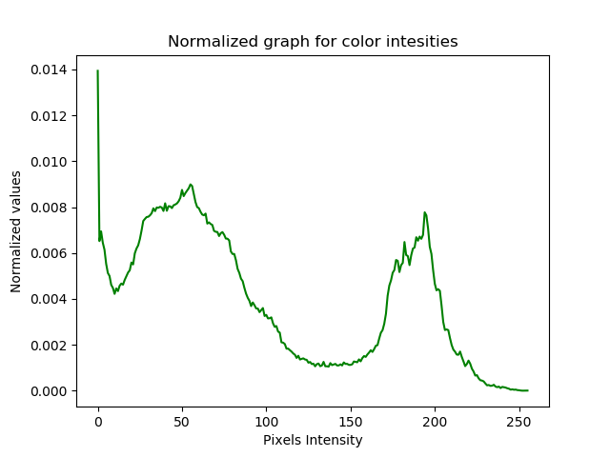

Section C:

Variance and mean R

- The mean of the normalized plane 0.00390625
- The variance of the normalized plane 1.0842275179e-05

Variance and mean G

- The mean of the normalized plane 0.00390625
- The variance of the normalized plane 1.0367204095e-05

Variance and mean B

- The mean of the normalized plane 0.00390625
- The variance of the normalized plane 8.06458882333e-06

