TECHNICAL REFERENCE GUIDE

Conquer the World
  - LAN Multiplayer Architecture & Extension Guide

A source-level walkthrough of the authoritative UDP server, LAN discovery, multiplayer rendering, character and sword class hierarchies, multi-rectangle hitboxes, 3D wall collision, configuration, testing, and future extension points.
Source basis: game-networked.zip | Protocol version 3
July 17, 2026

Reader orientation
This document explains the code as a complete system: what starts in each run mode, where the authoritative state lives, what crosses the network, how that state becomes rendered players and sword swings, and how collision is kept consistent on the server and clients. It is written for someone who will continue modifying the project.
MOST IMPORTANT IDEA Clients send intent, not trusted positions. The server owns the accepted player positions, wall results, attack creation, attack lifetime, and cooldowns. Clients predict presentation between snapshots, but the next server snapshot corrects them.

What is included
- Game runtime: libGDX application startup, update, and rendering flow.
- Networking: UDP discovery, connection, input, snapshots, timeouts, and reconnect behavior.
- Gameplay architecture: abstract player and attack parents, two character subclasses, and two sword subclasses.
- Collision: multiple 2D rectangles plus a collision height, evaluated as 3D volumes.
- Operations: same-computer testing, LAN setup, direct-IP fallback, and dedicated server mode.
- Extension recipes: the exact places to edit when adding a character, weapon, damage, or protocol field.

What the ZIP is—and is not
The archive is a Java source snapshot organized under game/. It contains the core game, network, object, and world classes plus a networking guide and smoke test. It does not include the full Gradle launcher-module structure or the referenced PNG assets. To run it, place these sources into the matching packages of the full libGDX project that owns the desktop launcher and assets such as players/player_2.png and tiles/stone_tiles_01.png.

Fast mental model
Component | Mental model
Main | Starts local, host, join, or direct-client mode; then renders World1.
World1 | Applies snapshots or offline simulation to the renderable client world.
UdpGameServer | Owns sessions, accepted movement, wall results, attacks, and snapshots.
UdpGameClient | Sends input and atomically exposes one complete latest snapshot.
Types + factories | Share portable stats/geometry and create the matching concrete classes.
Collision + layout | Keep the graphical world and headless server on identical wall geometry.

1. System architecture and ownership
Start here when deciding whether a change belongs on the server, client, or both.
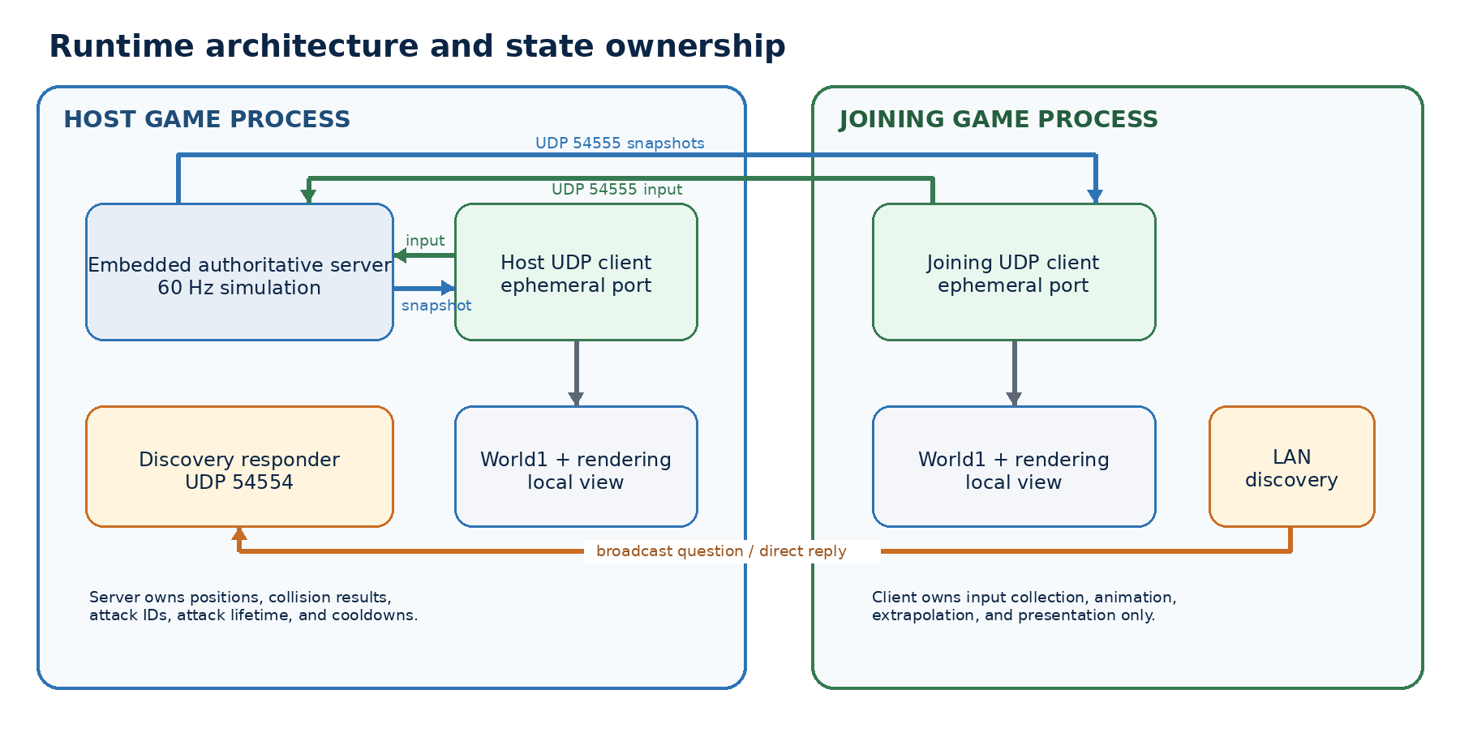
Figure 1. Host and joining-client process architecture.

Authoritative server
UdpGameServer is the source of truth for network play. A ClientSession stores the assigned player ID, private session token, chosen character and sword types, accepted movement vector, facing direction, current position, attack button state, cooldown, input sequence, and last heartbeat time. ServerAttackState stores each live swing until its SwordType duration expires.
- Accepted movement: finite vectors are normalized when their length exceeds one, preventing diagonal speed boosts and oversized client input.
- Collision: the server attempts X and Y independently against WorldLayout, producing wall sliding and blocking invalid positions.
- Attacks: Space transitions from up to down are recognized server-side; IDs, cooldowns, and lifetimes are server-owned.
- Removal: a client disappears after a five-second silence or an accepted DISCONNECT packet.

Client and presentation world
UdpGameClient owns the socket-facing client state and the newest immutable WorldSnapshot. World1 translates that snapshot into libGDX Player and AttackEntity objects. Main owns graphics resources, the camera, the render loop, multiplayer labels, and colored debug rendering for sword hitboxes.
OWNERSHIP RULE If a value changes game outcome, validate or compute it on UdpGameServer. If it changes only appearance or responsiveness, it can usually live in Main, World1, Player, or another client-side class.

Threads
Thread | Responsibility
libGDX render thread | Main.render → World1.update → drawing. Reads latest snapshot and collects keyboard input.
Client receiver | Blocking UDP receive; decodes WELCOME/SNAPSHOT and atomically replaces latestSnapshot.
Server receiver | Blocking UDP receive; handles CONNECT, INPUT, and DISCONNECT under stateLock.
Server tick | Runs simulation at 60 Hz and sends snapshots at 30 Hz under the same state lock.
Discovery responder | Waits on UDP 54554 and directly replies to compatible discovery questions.

The server protects clients and attacks with stateLock. The client uses volatile scalar fields for connection state and AtomicReference<WorldSnapshot> so the render thread always sees one complete snapshot rather than a partially updated collection.

2. Startup modes and process topology
The same game code supports offline play, an embedded host, LAN joining, and a separate headless server.
Mode | What starts | Best use
local | No sockets. World1 creates one configured Player and simulates movement/collision locally. | Default
host | Main starts UdpGameServer + discovery responder, then connects its own UdpGameClient over loopback. | First player
join | Main broadcasts discovery, chooses the lowest-latency reply, and starts a client. | Second/LAN player
client | Main connects directly to game.server.host and game.server.port; discovery is optional. | Direct IP
headless | GameServerMain runs UdpGameServer without libGDX rendering; clients use join or client mode. | Dedicated server

Main.create startup path
- Create SpriteBatch, ShapeRenderer, and a 400 × 300 orthographic camera.
- Read NetworkConfig. local builds World1 directly; all network modes enter startMultiplayer().
- In host mode, bind the server and discovery responder before constructing the host client.
- In join mode, collect LAN announcements and select the first result sorted by response time, then name.
- Construct UdpGameClient with the configured CharacterType and SwordType, start it, then give it to World1.
- Create BitmapFont for player labels and connection status; resize establishes integer scaling and letterboxing.

Why two players work on one computer
The server normally binds game port 54555. Each client binds local port 0, which asks the operating system to allocate a different ephemeral UDP port. The host client and joining client therefore have distinct source addresses even though both use 127.0.0.1. No virtual machine, container, or separate Java environment is required—only two simultaneous launcher processes or IDE run configurations.
COMMON IDE SETTING Enable the IDE option that permits multiple simultaneous instances. If the IDE terminates the first run when the second starts, the networking code never gets a chance to use its separate ephemeral port.

3. LAN discovery, connection, and synchronization
This chapter follows a player from room discovery through continuous world snapshots.

LAN discovery
- LanServerDiscovery generates a random nonce and encodes a DISCOVER datagram.
- It sends the question to 255.255.255.255, loopback, and every active interface-specific IPv4 broadcast address.
- LanDiscoveryResponder validates the discovery magic/version, then replies directly to the sender with the same nonce, room name, game port, and player count.
- The joining client ignores mismatched nonces, de-duplicates address/port pairs, and sorts results by round-trip time and then room name.
- Main selects the first result. A future room menu can display the full returned list instead.
NETWORK BOUNDARY Broadcast discovery normally stays inside one local broadcast domain. It is not an Internet matchmaking system and often will not cross routers, guest Wi-Fi isolation, VLANs, or VPN boundaries.

Connection handshake
Step | Direction | Action | Result
1 | Client → Server | CONNECT | Random client nonce, CharacterType ID, SwordType ID
2 | Server | Session creation | Assign player ID/token and deterministic spawn; preserve requested loadout
3 | Server → Client | WELCOME | Player ID, private session token, current server tick
4 | Client | Connected | Begin rate-limited INPUT packets; accept SNAPSHOT packets

The server keys sessions by UDP source SocketAddress. Repeated CONNECT packets with the same nonce reuse the session; a different nonce at the same source address creates a new one. This supports retry after packet loss without allocating a new player for every duplicate request.

Input-to-render cycle
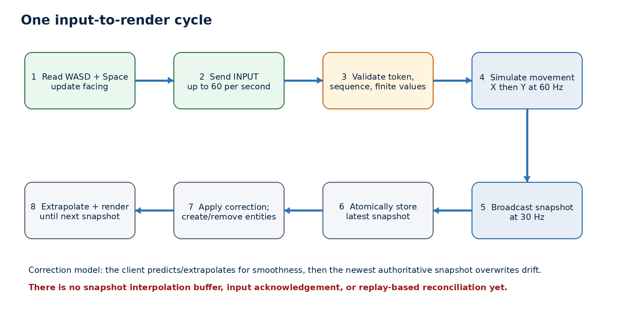
Figure 2. Continuous input, simulation, snapshot, correction, and rendering cycle.
The client sends at most 60 input packets per second. The server simulates at 60 ticks per second and emits a snapshot every two ticks, producing 30 snapshots per second. Every input also serves as a heartbeat. If either side hears nothing for five seconds, it considers the session gone; the client retries CONNECT every 500 ms.

Prediction, extrapolation, and correction
After applying the newest snapshot, World1 continues moving every network Player from the movement vector contained in that snapshot. The local player also refreshes its vector from current keyboard input. This makes motion visually continuous between 30 Hz snapshots. When a newer server tick arrives, World1 sets the exact authoritative X/Y values before continuing. This is a simple snap-correction model—not a buffered interpolator or replay-based client prediction system.
CURRENT TRADE-OFF The model is small and understandable, but latency or packet loss can produce visible correction jumps. Production movement normally adds input acknowledgements, replay reconciliation for the local player, and snapshot interpolation for remote players.

4. Binary UDP protocol
NetworkPacketCodec defines a compact, versioned binary format using Java data streams.

Common header
Every gameplay datagram begins with six bytes: a four-byte magic value 0x43545747 (ASCII CTWG), one protocol-version byte, and one packet-type byte. The current version is 3. Packets with the wrong magic, version, type, or minimum length are rejected before gameplay fields are used.
Packet | Direction | Bytes | Payload
1 CONNECT | Client → server | 16 | nonce; character ID; sword ID
2 WELCOME | Server → client | 22 | player ID; session token; server tick
3 INPUT | Client → server | 32 | ID/token; sequence; move X/Y; facing; attackDown
4 SNAPSHOT | Server → clients | 14 + 22P + 18A | tick; player records; attack records
5 DISCONNECT | Client → server | 18 | player ID; session token

UDP SIZE LIMIT MAX_PACKET_SIZE is 1,400 bytes to stay below common Ethernet MTUs and avoid IP fragmentation. The codec refuses to create a snapshot that exceeds the limit. At current record sizes, the practical player/attack capacity depends on their mix and should be managed explicitly as the game grows.

Snapshot records
Player field | Encoding | Bytes | Meaning
playerId | int | 4 | Stable ID assigned by server
x, y | 2 floats | 8 | Authoritative origin position
moveX, moveY | 2 floats | 8 | Accepted normalized movement intent
facingRight | boolean | 1 | Sprite and attack direction
characterType | unsigned byte | 1 | Permanent CharacterType network ID

Attack field | Encoding | Bytes | Meaning
attackId | int | 4 | Server-generated swing identity
ownerPlayerId | int | 4 | Player who initiated it
x, y | 2 floats | 8 | Static swing origin captured at creation
facingRight | boolean | 1 | Chooses normal or mirrored rectangles
swordType | unsigned byte | 1 | Permanent SwordType network ID

Security properties
The session token and source-address match prevent an unrelated local UDP sender from trivially controlling an existing player, and input sequence numbers suppress reordering/replay within a session. These are useful prototype safeguards, not authentication. Traffic is unencrypted, tokens are sent over the network, and there is no account identity, authorization, anti-cheat attestation, or denial-of-service protection.

5. Client game loop and rendering
Main and World1 turn authoritative snapshots into a responsive libGDX scene.

Per-frame order
- Read Gdx.graphics.getDeltaTime() and call World1.update(delta).
- Clear the screen and apply the integer-scaled viewport.
- Update the orthographic camera and begin SpriteBatch.
- Render props and entities in World1's sorted renderable order.
- Render multiplayer player labels and connection status, then end SpriteBatch.
- Use ShapeRenderer in a separate pass to draw each sword hitbox rectangle.

World1 in offline mode
World1 creates one Player through PlayerFactory using the configured character. Each frame the player reads WASD and Space, the world applies X and Y movement with collision, and a Space press creates a negative local attack ID. Local attacks decrement their own remainingSeconds and are removed when expired. Offline mode does not currently apply the network server's cooldown rule; the key edge still requires release before another press.

World1 in network mode
World1 first applies a new server tick, creating or replacing concrete Player objects when a character type changes. Players missing from the snapshot are disposed and removed. It performs the same identity-based maintenance for AttackEntity objects, using attack IDs and sword types. It then animates and extrapolates all players, captures current local input, and hands that input to UdpGameClient.

Drawing order and camera
The logical world is 400 × 300. resize() chooses the largest whole-number scale that fits the real window, then centers the viewport to preserve crisp pixel art and avoid fractional scaling. World1 sorts by vertical elevation first; otherwise objects with higher world Y are drawn earlier and lower-Y objects later, creating the expected top-down overlap illusion.
Player sprites come from an eight-frame arrangement in players/player_2.png: four right-facing regions on the first row and four left-facing regions on the second. The shared sprite is tinted light blue for Knight and light green for Rogue. Sword attacks currently have no sprite; their rectangles are intentionally rendered as colored debug geometry—quick cyan/orange and heavy blue/red depending on local ownership.

6. Character and sword class design
Abstract parents share behavior; enums carry portable data; factories isolate construction decisions.
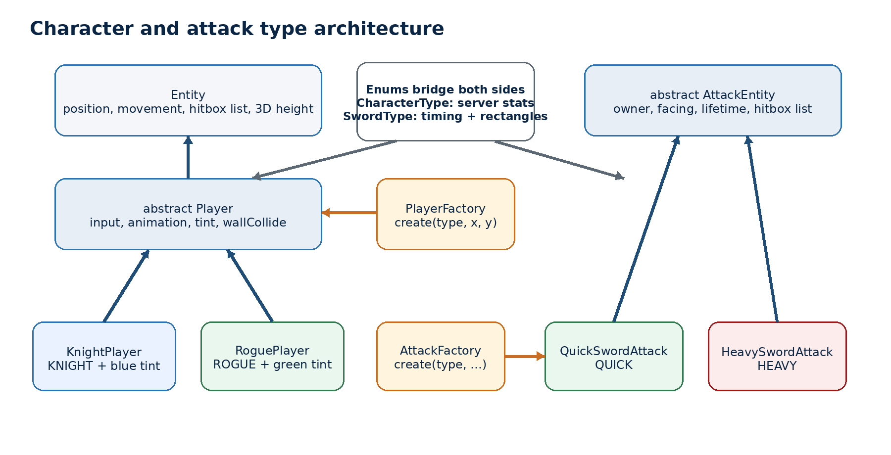
Figure 3. Concrete types, abstract parents, data enums, and factories.

Why Player is an abstract class
Player needs substantial shared state and behavior: texture ownership, animation regions, keyboard handling, movement state, facing, attack edge detection, tint rendering, disposal, and the default wall response. An interface would describe methods but would not naturally centralize that implementation. Making Player abstract prevents direct generic construction while allowing KnightPlayer and RoguePlayer to inherit the common code.

Why an enum exists beside each subclass
A headless server should not construct libGDX Player objects or load textures simply to learn movement speed and collision geometry. CharacterType is therefore the portable specification: permanent network ID, display name, speed, collision height, and immutable hitbox list. The concrete subclass represents the client-side renderable identity. PlayerFactory is the one place that maps between them.
Type | ID | Class | Speed | Height | Body rectangles | Tint
Knight | 1 | KnightPlayer | 80 | 32 | (6,2,20,14) | Light blue
Rogue | 2 | RoguePlayer | 110 | 26 | (9,2,14,10); (11,12,10,8) | Light green

Sword attack hierarchy
AttackEntity is a short-lived, non-solid Entity. The abstract parent stores attack ID, owner ID, facing, SwordType, and remaining lifetime. QuickSwordAttack and HeavySwordAttack only choose the appropriate enum. SwordType supplies duration, cooldown, and the right-facing multi-rectangle shape; AttackFactory constructs the matching subclass on every client.
Type | ID | Class | Duration | Cooldown | Rects | Debug colors
Quick Sword | 1 | QuickSwordAttack | 0.22 s | 0.30 s | 3 | Cyan / orange
Heavy Sword | 2 | HeavySwordAttack | 0.36 s | 0.60 s | 4 | Blue / red

STATIC SWING ORIGIN A network sword swing captures the player's X/Y when the server creates it. It does not follow the player during the remaining fraction of a second. Change that intentionally if future attacks should be attached to a moving bone, weapon socket, or animation frame.

7. Hitboxes and 3D wall collision
Sprites, collision footprints, and vertical collision volumes are deliberately independent.
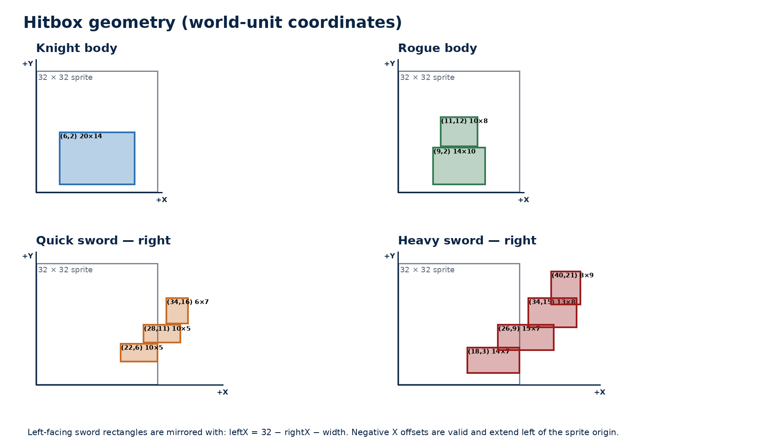
Figure 4. Exact body and right-facing sword rectangles.

Hitbox value object
Hitbox stores xOffset, yOffset, width, and height. Offsets may be negative, but all values must be finite and width/height must be positive. Entity defensively copies the supplied list, rejects nulls, exposes an immutable view, and derives compatibility collisionWidth/collisionDepth values from the total bounding span.
new Hitbox(xOffset, yOffset, width, height)
worldRectX = entity.gameX + xOffset
worldRectY = entity.gameY + yOffset

3D overlap test
CollisionMath.overlaps3D performs strict axis-aligned interval overlap on X, Y, and Z. Touching exactly at an edge is not overlap because the comparisons use < and > rather than ≤ and ≥. Any non-positive width, depth, or height makes the volume non-colliding.
overlap = x1 < x2 + width2 && x1 + width1 > x2
&& y1 < y2 + depth2 && y1 + depth1 > y2
&& z1 < z2 + height2 && z1 + height1 > z2;
HitboxCollision iterates every rectangle pair for entity/entity collision and every entity rectangle for entity/prop collision. The first overlapping 3D pair returns true. This preserves gaps in curved or segmented shapes instead of replacing them with one oversized bounding box.

Wall response and sliding
- World1 computes intended X displacement and attempts it with Y unchanged.
- If a solid Entity overlaps a solid Prop, World1 calls entity.wallCollide(wall).
- Player returns true, so World1 restores the previous coordinate for that axis.
- World1 repeats the process for Y. One axis may succeed while the other is blocked, creating natural sliding.
- UdpGameServer mirrors the same X-then-Y decision against WorldLayout before modifying authoritative coordinates.
HEIGHT VS. SPRITE SIZE drawWidth/drawHeight control pixels. Hitbox width/height control the X/Y collision footprint. collisionHeight controls the Z volume. zHeight represents the object's top for render sorting. They are related only when a constructor deliberately supplies the same number.

Sword mirroring
SwordType stores only right-facing rectangles. For left-facing attacks it creates a new immutable list using leftX = PLAYER_DRAW_SIZE − rightX − width. With a 32-unit player sprite, rectangles that extend beyond x=32 produce negative left offsets, correctly placing the arc on the player's left side. Y, width, and height remain unchanged.

8. Shared world layout and rendering map
A single geometry definition prevents the headless server and graphical client from disagreeing about walls.
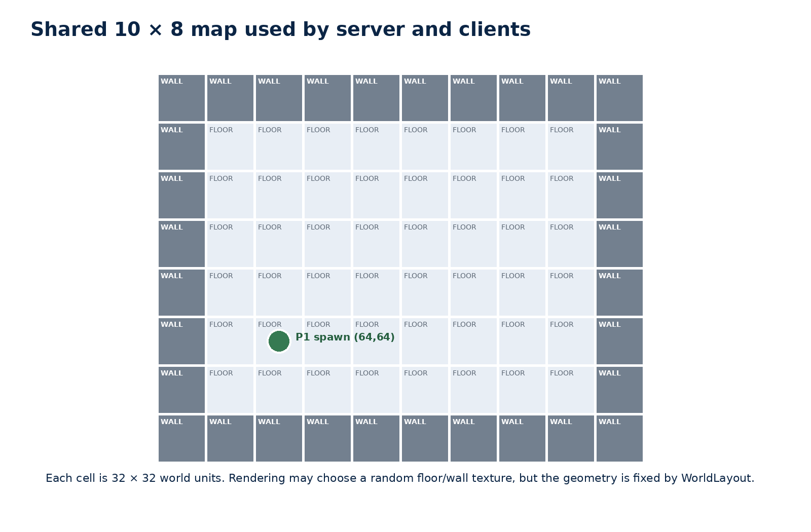
Figure 5. WorldLayout geometry and first-player spawn.

WorldLayout
The map is an 8-row by 10-column integer array. −1 means random floor art and −2 means random wall art. Every tile is 32 × 32 world units because a 16-pixel source tile is drawn at multiplier 2. The outer row/column is wall; the interior is floor. copyMap() protects the canonical array from accidental mutation.
worldX = column * 32
worldY = (mapHeight - 1 - row) * 32
World1 uses the map to construct textured Prop objects. WorldLayout.collidesWithWall uses the same coordinates without textures, making it safe for the headless server. Random texture selection changes appearance only; all wall collision remains deterministic.

Spawning
Player 1 spawns at (64,64). Later IDs use 12-unit offsets in a five-column, then five-row pattern. This does not validate occupancy: many players can overlap or eventually reuse positions, and player/player collision is not enforced.

9. Configuration and connection recipes
Every runtime option can be supplied as a Java system property or an environment variable.
Setting | System property | Environment | Default | Notes
Mode | game.mode | GAME_MODE | local | local | host | join | client
Server address | game.server.host | GAME_SERVER_HOST | 127.0.0.1 | Direct client target or discover
Server bind | game.server.bind | GAME_SERVER_BIND | 0.0.0.0 | Listen on all interfaces
Game port | game.server.port | GAME_SERVER_PORT | 54555 | Gameplay UDP
Room name | game.server.name | GAME_SERVER_NAME | Conquer the World LAN | Discovery display name
Discover | game.server.discover | GAME_SERVER_DISCOVER | false | Force discovery in client mode
Discovery port | game.discovery.port | GAME_DISCOVERY_PORT | 54554 | LAN broadcast/reply UDP
Discovery timeout | game.discovery.timeout | GAME_DISCOVERY_TIMEOUT | 1200 | Milliseconds
Client bind | game.client.bind | GAME_CLIENT_BIND | 0.0.0.0 | Local interface
Client port | game.client.port | GAME_CLIENT_PORT | 0 | Automatic ephemeral port
Character | game.character | GAME_CHARACTER | knight | knight | rogue
Sword | game.sword | GAME_SWORD | quick | quick | heavy

PROPERTY PRECEDENCE A non-blank Java -D system property wins over its environment variable. If neither is present, NetworkConfig uses the documented default. Invalid character/sword names fail fast; numeric ports must be 0–65535, while discovery itself requires a nonzero port.

Two players on the same computer
# Terminal / run configuration 1
GAME_MODE=host
GAME_SERVER_NAME="Local Test"
GAME_CHARACTER=knight
GAME_SWORD=quick
# Terminal / run configuration 2
GAME_MODE=join
GAME_CHARACTER=rogue
GAME_SWORD=heavy
Launch the same desktop run task once from each environment. On PowerShell use $env:NAME = "value"; on macOS/Linux prefix the command or export the values. The exact Gradle task depends on the full project (commonly lwjgl3:run). The source ZIP alone does not contain that launcher task.

Two computers on one LAN
- Put both computers on the same non-isolated LAN or Wi-Fi network.
- Start the first computer in host mode, bound to 0.0.0.0.
- Allow inbound UDP 54554 and 54555 through the host firewall.
- Start the second computer in join mode. It should discover and select the host.
- If discovery fails, use direct client mode with the host's LAN IPv4 address and UDP 54555.
GAME_MODE=client
GAME_SERVER_HOST=192.168.1.50
GAME_SERVER_PORT=54555
GAME_CLIENT_BIND=0.0.0.0
GAME_CLIENT_PORT=0

Dedicated headless server
com.conquerTheWorld.game.network.GameServerMain \
--bind 0.0.0.0 --port 54555 \
--discovery-port 54554 --name "Dedicated Room"
# Add --no-discovery when every client connects directly.

Troubleshooting checklist
- Second window replaces the first: allow multiple simultaneous IDE instances.
- No room found: verify host mode, UDP 54554, firewall rules, and Wi-Fi client isolation; then try direct IP.
- Connects but no movement: verify both builds use protocol version 3 and gameplay UDP 54555 is allowed.
- Address already in use: only one server can normally own 54555 and one responder 54554; clients should keep port 0.
- Wrong loadout: set variables before launching each process; existing sessions keep the loadout chosen in CONNECT.

10. Extension cookbook
Use these checklists to extend the hierarchy without creating server/client disagreement.

Add a third character
- Reserve an ID: add a CharacterType entry with a unique, permanent networkId. Never reuse an ID for a different character.
- Define authoritative stats: choose display name, speed, body collision height, and one or more immutable Hitbox rectangles.
- Create the subclass: extend Player and pass the new CharacterType plus its tint or skin decision to super(...).
- Update PlayerFactory: map the enum to the new concrete constructor.
- Update configuration text: expand CharacterType.fromConfig's error message and user-facing guide/menu choices.
- Test both sides: connect that character, verify snapshot type, measured speed, collision bounds, rendering, removal, and reconnect.
MAGE(
3, "Mage", 92f, 28f,
Arrays.asList(
new Hitbox(8f, 2f, 16f, 11f),
new Hitbox(10f, 13f, 12f, 7f)
)
)

Add a third sword attack
- Reserve an ID: add a unique permanent SwordType networkId.
- Define timing and shape: set duration, cooldown, and the right-facing rectangle list.
- Create the subclass: extend AttackEntity and pass the new SwordType to super(...).
- Update AttackFactory: map the enum to the concrete attack class.
- Update presentation: choose debug/sprite rendering in Main and add assets or animation if desired.
- Test mirroring and synchronization: verify every rectangle, attack ID, owner, type, expiry, and cooldown on two clients.

Add health and damage
Damage should be resolved in UdpGameServer, not by a client. At each relevant server tick, compare each live ServerAttackState shape against eligible player body hitboxes, exclude the owner, apply team/invulnerability rules, and remember which targets that attack has already hit. Extend PlayerSnapshot or add reliable event messages for health changes, death, respawn, and one-time hit effects.
- Move the sword rectangle definitions into a shared server-safe geometry helper if ServerAttackState needs direct collision access.
- Track per-attack hit target IDs so a multi-tick swing does not damage the same player every server tick unless intended.
- Add damage, knockback, team, invulnerability, and health to authoritative state rather than trusting client claims.
- Decide reliability semantics: repeated snapshots work for health totals, while one-time audiovisual events may need IDs and acknowledgement/deduplication.

Protocol-change checklist
- Change writer and reader together and update all fixed record-size constants.
- Bump NetworkPacketCodec.VERSION when old and new builds are not wire-compatible.
- Keep packet size below 1,400 bytes or introduce chunking/delta snapshots deliberately.
- Reject malformed counts and invalid enum IDs before allocating large collections or mutating state.
- Run the two-client smoke test using mixed character and sword types.

11. Verification, limitations, and next priorities
The implementation is a tested prototype foundation, not a complete online-combat stack.

What NetworkSmokeTest verifies
Area | Assertion
Modes | host is both server-hosting and client; join enables discovery
Discovery | room name, game port, and player count before/after two connections
Sockets | two clients receive distinct IDs and distinct ephemeral UDP ports
Characters | Knight and Rogue types synchronize and Rogue measurably moves faster
Attacks | Quick and Heavy types, IDs, owners, visibility to both clients, and expiry
Hitboxes | secondary rectangles participate; separated lists do not falsely collide
Mirroring | every sword rectangle mirrors by the defined formula; shapes differ
Walls | authoritative left/top bounds stop Knight and Rogue using their own geometry
Snapshots | both clients receive both player states after movement

The latest validation compiled all 34 Java sources against Java 8-compatible libGDX stubs, connected two real loopback UDP clients to an ephemeral server port, exercised LAN discovery, movement, attacks, collision, and snapshot sharing, and completed with PASS. The test does not replace a full graphical integration run with the actual launcher, native libGDX backend, and PNG assets.

Current limitations
Area | Current state
Reliability | UDP inputs/snapshots can be lost; only newer state supersedes older state.
Movement smoothing | No interpolation buffer, input ACK, replay reconciliation, or lag compensation.
Combat | Attacks render and synchronize but do not apply damage, health, knockback, or death.
Security | No encryption, accounts, real authentication, rate limiting, or public-server hardening.
Scaling | Full snapshots are capped at 1,400 bytes and no interest management/delta compression exists.
Room UX | No room-selection UI; join mode automatically takes the first sorted discovery result.
Assets | One player sprite is tinted; sword visuals are debug rectangles; ZIP omits referenced PNGs.
Spawning | Simple ID-based offsets; no occupancy search, player/player collision, or spawn safety.
Offline parity | Offline attacks expire locally but do not enforce the server's sword cooldown.

Recommended next priorities
- Add server-authoritative health/damage and per-attack hit deduplication.
- Add a minimal character/loadout selection screen instead of environment-only configuration.
- Add remote snapshot interpolation and local input acknowledgement/reconciliation.
- Use dedicated character and weapon assets; avoid one Texture per Player where possible through shared asset management.
- Add packet rate limiting, maximum player limits, malformed-packet metrics, and stronger session/authentication design before Internet exposure.
- Add Gradle launcher modules/assets to create a self-contained runnable distribution and graphical integration tests.

Appendix A. File-by-file reference
Use this section as a map when locating the implementation behind a behavior.
File | Responsibility
Constants.java | World, sprite, tile, collision, render-color, and sword timing constants; includes compatibility aliases.
Main.java | libGDX lifecycle, mode startup, embedded server/discovery, camera/viewport, labels, and attack debug rendering.
NETWORKING.md | Operational LAN guide and concise hierarchy/extension notes.
assets/TileSet.java | Loads a tile texture and returns TextureRegion slices.
worlds/World1.java | Client/offline world state, snapshot application, prediction/extrapolation, entity maintenance, collision, and render ordering.
worlds/WorldLayout.java | Canonical 10 × 8 map and headless wall collision against hitbox lists.
worlds/CollisionMath.java | Strict 3D axis-aligned box overlap primitive.
objects/RenderableObject.java | Common update/render and geometry access contract for props and entities.
objects/Entity.java | Movable/renderable base with position, speed, hitbox list, collision height, solidity, and wall hook.
objects/Prop.java | Static world object implementation used for floors and walls.
objects/Hitbox.java | Validated immutable offset rectangle value object.
objects/HitboxCollision.java | Iterates entity hitbox rectangles against props or other entities using 3D overlap.
objects/Player.java | Abstract shared player input, animation, facing, attack edge, rendering, wall response, and texture lifecycle.
objects/KnightPlayer.java | Concrete light-blue Knight client representation.
objects/RoguePlayer.java | Concrete light-green Rogue client representation.
objects/CharacterType.java | Permanent IDs and server-safe character stats/hitboxes.
objects/PlayerFactory.java | CharacterType-to-concrete-Player construction switch.
objects/AttackEntity.java | Abstract short-lived non-solid swing with owner, ID, facing, type, and hitboxes.
objects/QuickSwordAttack.java | Concrete QUICK attack type.
objects/HeavySwordAttack.java | Concrete HEAVY attack type.
objects/SwordType.java | Permanent IDs, timing, right-facing rectangles, mirroring, and config parsing.
objects/AttackFactory.java | SwordType-to-concrete-AttackEntity construction switch.
network/NetworkConfig.java | Properties/environment parsing, defaults, rates, timeouts, and loadout selection.
network/NetworkPacketCodec.java | Gameplay protocol version 3, packet encoding/decoding, size and validation checks.
network/UdpGameClient.java | Client socket, connection retries, input rate limiting, receive thread, timeout, and atomic snapshots.
network/UdpGameServer.java | Authoritative sessions, receive/tick threads, validation, movement, collision, attacks, and snapshots.
network/GameServerMain.java | Optional headless server CLI and shutdown hook.
network/LanDiscoveryProtocol.java | Discovery protocol magic/version and DISCOVER/ANNOUNCE serialization.
network/LanDiscoveryResponder.java | Host-side UDP discovery listener and direct response.
network/LanServerDiscovery.java | Broadcast-address enumeration, response collection, deduplication, and sorting.
network/DiscoveredServer.java | Immutable room discovery result with address, population, and round-trip time.
network/WorldSnapshot.java | Immutable server tick plus player and attack lists.
network/PlayerSnapshot.java | Immutable authoritative player state including CharacterType.
network/AttackSnapshot.java | Immutable live attack state including owner, facing, and SwordType.
network/NetworkSmokeTest.java | End-to-end loopback discovery/network/collision/hierarchy regression test.

Appendix B. Key constants at a glance
Constant | Value
Logical world | 400 × 300 units
Tile/sprite draw size | 32 × 32 units
Gameplay UDP | 54555
Discovery UDP | 54554
Client local port | 0 (automatic ephemeral)
Server simulation | 60 ticks/second
Client input cap | 60 packets/second
Snapshot rate | 30 packets/second
Connection timeout | 5,000 ms
Reconnect interval | 500 ms
Discovery timeout | 1,200 ms
Maximum gameplay datagram | 1,400 bytes
Gameplay protocol | CTWG, version 3
Discovery protocol | CTWD, version 1

FINAL DESIGN RULE Keep authoritative outcome logic server-side, keep portable stats and geometry free of rendering dependencies, and make every wire-format or network-ID change deliberately compatible—or bump the protocol version.

