WindowsVideoRecorder

1. Call the Function of StartRecording in WindowsVideoRecorderSubsystem.
2. then set videoRecorderconfig Param,you can set resoulution ,FPS,bitrate,IsAudio,Isshow UI,FileName and Filepath.(tips:if filename and filepath is nullptr,it will not record Video.)

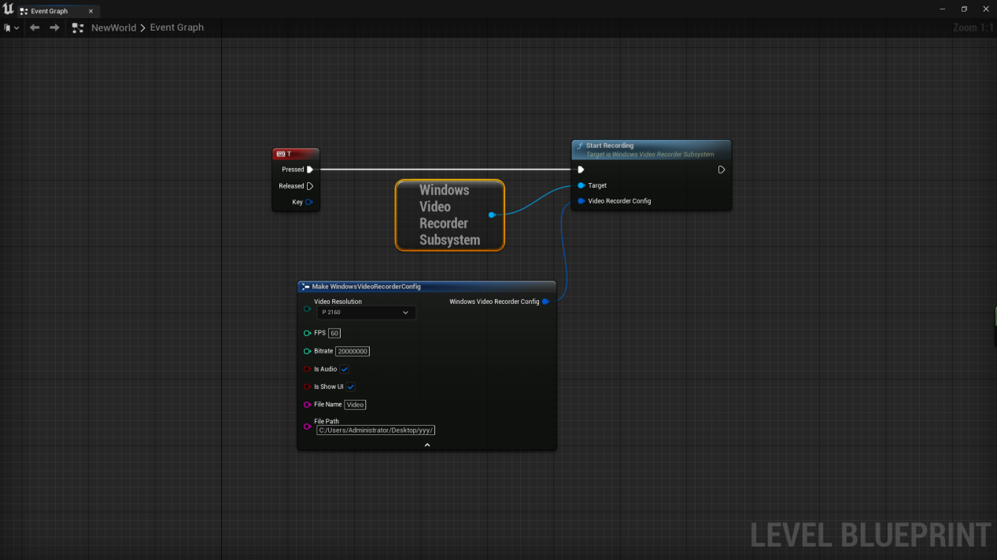

1. if you want to pause video of recording,you can call the Function of PauseRecordingin WindowsVideoRecorderSubsystem.And you can call the Function of ResumeRecording to Resume Recording.

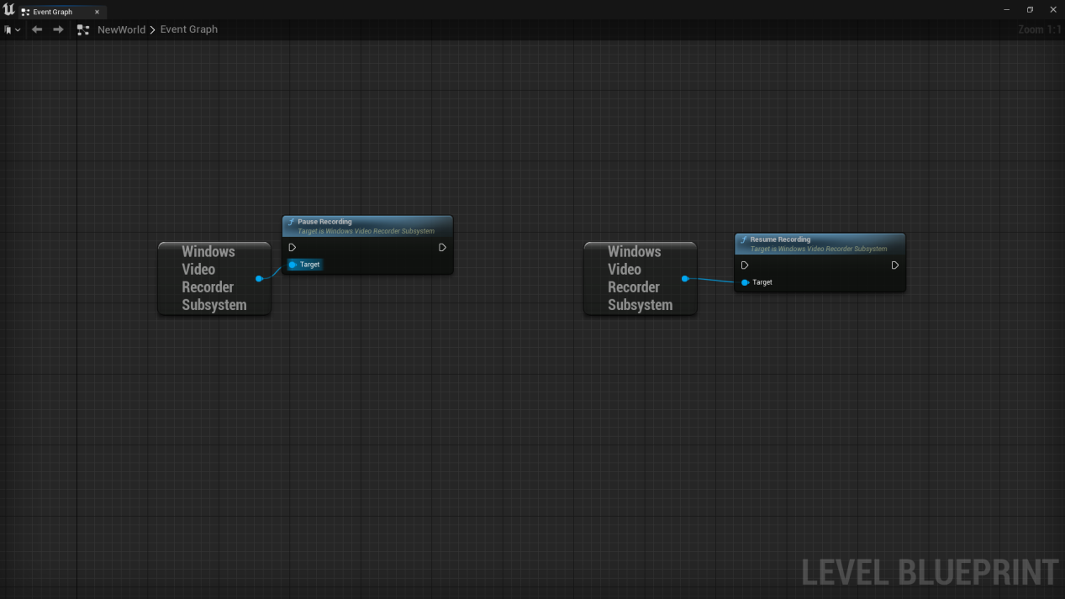

1. Finally,call the Function of FinalizeRecording to finish video recording.And there is a callback of video finished ,will return a variable of bool which represent success and a string which represent the file path of video recording.

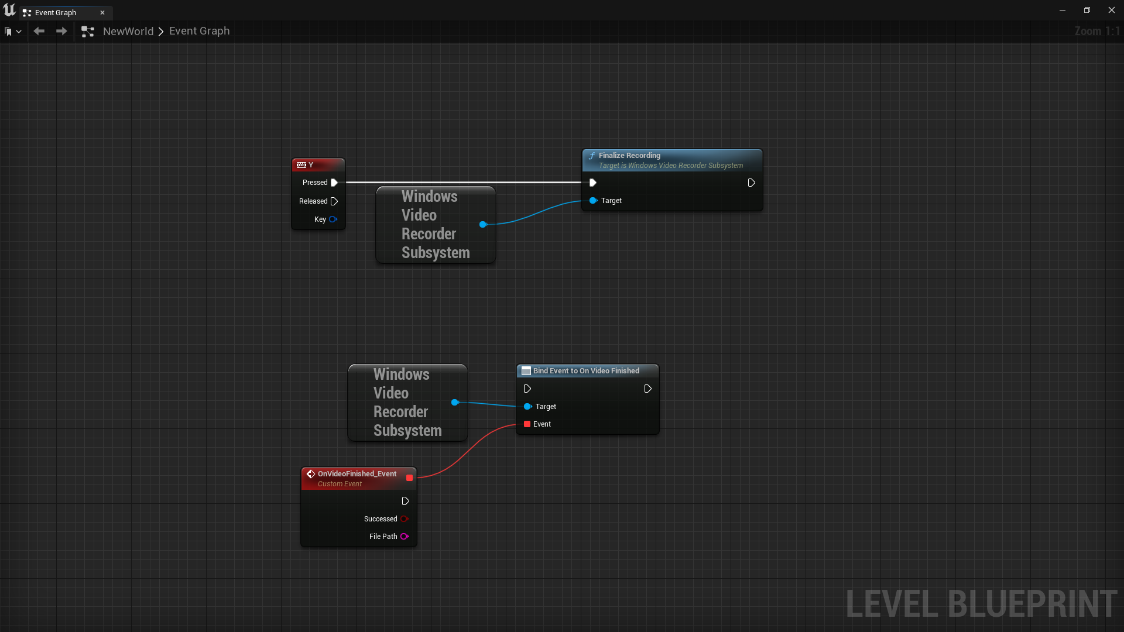

1. you can find a video as below.

