solution no.:1

('solution:', (0.935166442719553, 4.60901878924346, 0.767613626564677, 3.558172744410984, 1.855015633127919, 2.076577927595854, 3.55111317524964))

/opt/sagemath-8.7/local/lib/python2.7/site-packages/sage/repl/ipython_kernel/__main__.py:8: DeprecationWarning: Substitution using function-call syntax and unnamed arguments is deprecated and will be removed from a future release of Sage; you can use named arguments instead, like EXPR(x=..., y=...)

See <http://trac.sagemath.org/5930> for details.

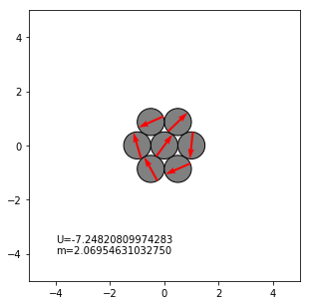

solution no.:2

('solution:', (-0.366063283744633, 3.98861109548895, 6.542640811829600, 2.169917359076525, 3.18243157588389, 4.278203240967215, 7.07588657097046))

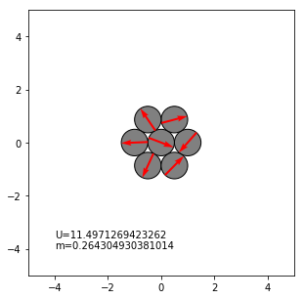

solution no.:3

('solution:', (-0.523598754451836, -0.4168911504489822, 5.75958670639739, 5.65287959564158, 5.86629439213736, 5.75958670690163, 5.65287934383298))

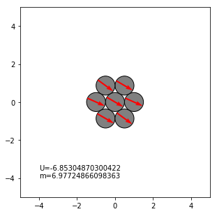

solution no.:4

('solution:', (-0.929010214477099, 7.57286607425245, 3.333039315940811, 8.13616222775488, 7.32268240520950, 2.17988939815575, 5.39064057498927))

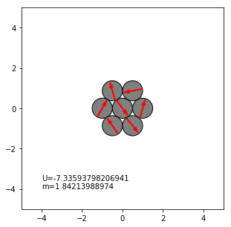

solution no.:5

('solution:', (1.973378658980664, 0.998083693363702, 6.01230155193543, 1.145904482094263, 6.72292920526922, 3.890451766786223, 5.16145340322297))

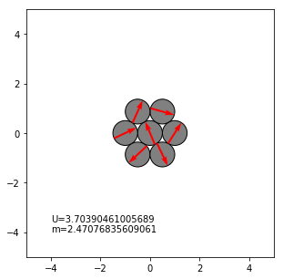

solution no.:6

('solution:', (0.506743751798554, 2.42868251166059, 1.659735341130269, 1.255743538882373, 3.24501663933991, 4.11685230756298, 5.69140096813135))

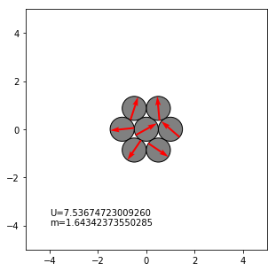

solution no.:7

('solution:', (0.0416237430694852, 0.925121488582705, 1.703902239821652, 0.976926675535537, 6.42013274138286, 4.44782750003437, 1.488147691298000))

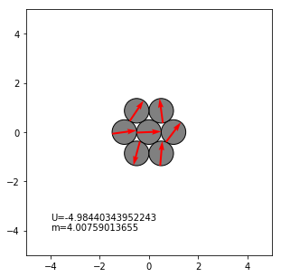

solution no.:8

('solution:', (-1.530056395400185, 0.3605698567425243, 4.725174499872565, 6.54932589585394, 7.54083492146860, 3.44039334790947, -0.04039120358622356))

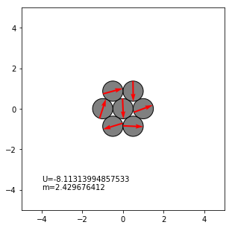

solution no.:9

('solution:', (-1.05310236623605, 4.00829564576942, 3.114915138614275, 3.27471373143107, 1.53376343739089, 0.1149247277515156, 2.11968516732870))

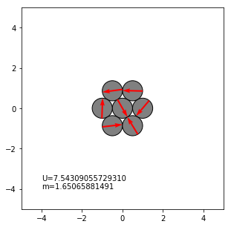

solution no.:10

('solution:', (-0.437102236685053, 4.30183564592813, 1.147568902601251, 4.890779167177421, 3.77101355322649, 3.142837248061378, 0.825766376243515))

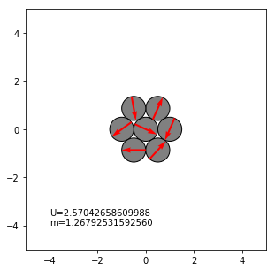

solution no.:11

('solution:', (-4.01195549244098e-7, 6.28318479875853, 3.07132081055585, 3.21186551514769, -3.91847303381098e-7, 3.071320925629642, 3.211865574488253))

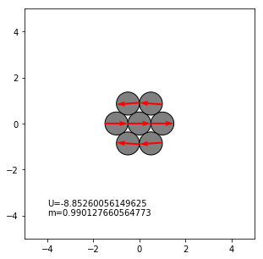

solution no.:12

('solution:', (-0.1737994023204375, 3.574782417615524, 0.657617675557402, 0.01470493678562136, 1.242275272876806, 2.463096937116288, 1.046614728022170))

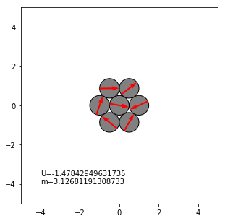

solution no.:13

('solution:', (-1.570796661520353, 1.570796446232200, 5.97174935789755, 5.36062390981489, 4.712389453877884, 4.06415457339688, 3.45302786014216))

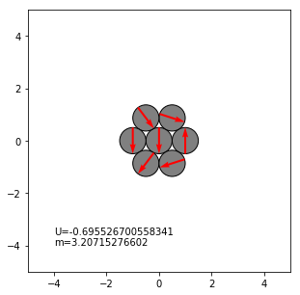

solution no.:14

('solution:', (-0.4054138934456057, 4.21178879583972, 2.38482875640353, 1.28167271054566, 3.162833411558326, 5.23882599504971, 1.574976780459563))

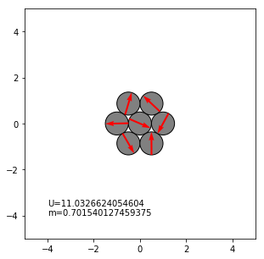

solution no.:15

('solution:', (0.721746437820651, 4.78757186624411, 0.975333837587331, 2.72983597730859, 6.16260305698437, 3.37472356878449, 0.1843123244568577))

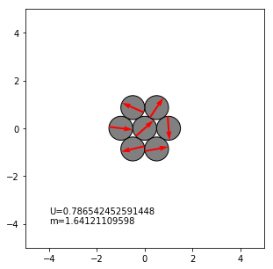

solution no.:16

('solution:', (-0.0885833032494859, 4.60907555873190, 2.401328939084617, 3.970565417704322, 5.39900962874401, 4.89018928740742, 4.466420320935201))

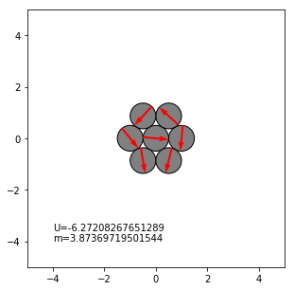

solution no.:17

('solution:', (1.047197516833084, 5.55012943514734, 1.047197479648964, 2.827451066671982, 2.296221468631516, 1.047197609768816, -0.2018263384461612))

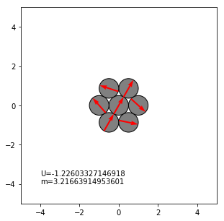

solution no.:18

('solution:', (-2.95252886516987, 2.36203291040159, 2.053338371530065, 1.152849245497736, 8.07459314992154, 3.53761390432144, 1.907671853363866))

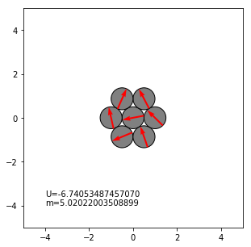

solution no.:19

('solution:', (1.047199980459146, -1.929981432815431, 7.16987997070283, 2.825201151203485, 5.55237318283698, 1.207690479454614, 4.02437754333547))

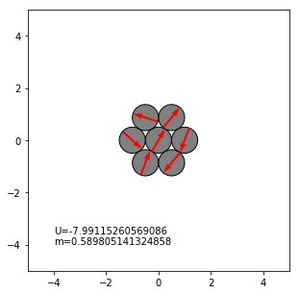

solution no.:20

('solution:', (1.570796004505614, 1.570796786197835, 1.052155913170503, 1.269723247190267, 7.85398101129170, 1.87187088332290, 2.089438029716091))

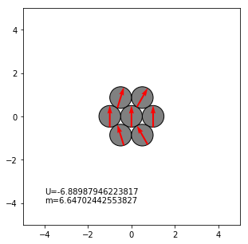

solution no.:21

('solution:', (-2.617993873009798, 3.25370857239587, 4.07667424552651, 2.199888459529330, 3.010265489076370, 4.32011733933878, 5.130494419076927))

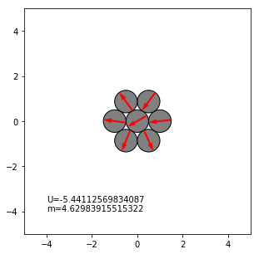

solution no.:22

('solution:', (1.047197837724747, 3.81671725006004, 1.047197588324660, 4.56086275861024, 7.16795142110759, 1.047197265082544, 1.209629355778662))

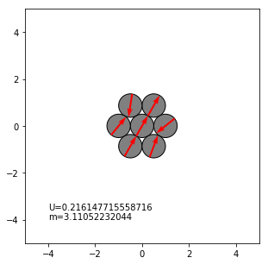

solution no.:23

('solution:', (1.047197321417724, 2.299666475872083, 1.047197509317615, -0.205270959275917, 2.299666026482176, 7.33038294839562, 6.077914040168181))

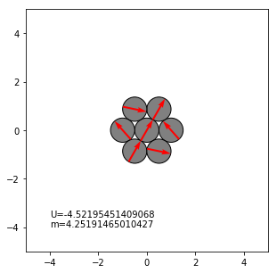

solution no.:24

('solution:', (0.608926992242519, 3.96278588119071, 0.709309969293772, 5.409436836723899, 2.621335061761328, 4.21913659389329, 6.61476846715105))

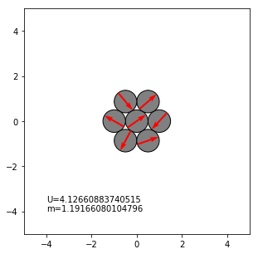

solution no.:25

('solution:', (0.653328261013995, 2.11931863121867, 2.057864648040212, 3.388029856628361, 2.11931847709256, 2.05786467681070, 3.388029896559790))

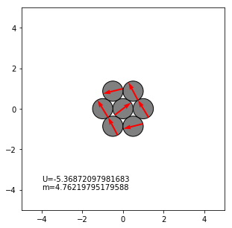

solution no.:26

('solution:', (1.04719796726395, 0.334708462336831, 1.04719763114337, 1.759686805986551, 3.05800508875512, 4.18879020064128, 5.31957508539676))

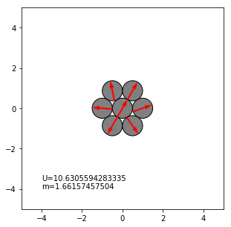

solution no.:27

('solution:', (0.523598805992461, 0.1553773847142688, 0.891820146396747, 5.41473795257076, 2.36635053824775, 4.96403230603805, 1.915644950717566))

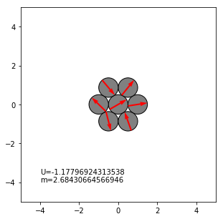

solution no.:28

('solution:', (-1.891615663882278, 8.60334945711132, -0.4286376108378587, 3.738096218176645, 0.1853854239283154, 7.07211932226194, 2.711364278325920))

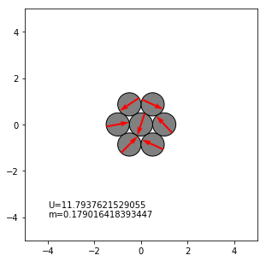

solution no.:29

('solution:', (-0.3387399073221576, 2.48734363318529, 2.09823660547671, 1.586690339271681, 0.906046575772835, 2.29264991677645, 4.60688343919008))

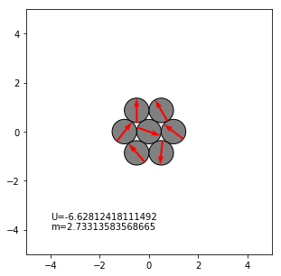

solution no.:30

('solution:', (-0.00001530093681840388, -0.0000318430330159877, 2.738282413242724, 4.24443135324194, 3.141631355231669, 2.038726198959354, 3.545012964413119))

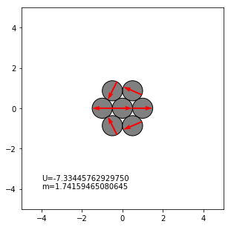

solution no.:31

('solution:', (-3.665191416922512, 5.02233065975590, 2.617993687011800, 6.49684309041818, -2.61518227886138, 5.75958705627770, 1.567984044573643))

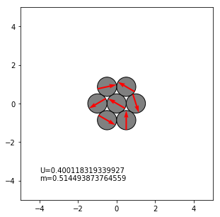

solution no.:32

('solution:', (-0.3652822502977011, 0.0927821752781998, 2.600308219616186, 4.59495688514889, 0.976111053320987, 2.762277846540210, 3.599594904380714))

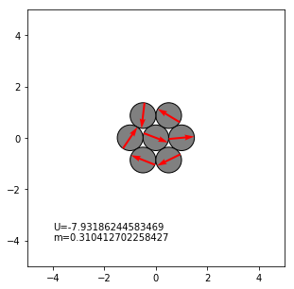

solution no.:33

('solution:', (0.523598869504149, 2.06380967603444, 5.26657314742004, 3.66519171861411, 2.063809555730287, -1.016611941872078, 3.66519102314746))

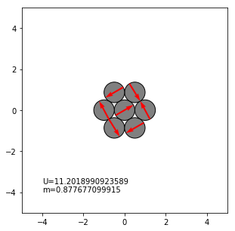

solution no.:34

('solution:', (-0.523597360253170, 0.0560641423990569, 0.733071655775611, 2.077983691759321, 3.15800407339874, 4.50291442877320, 5.17992538427224))

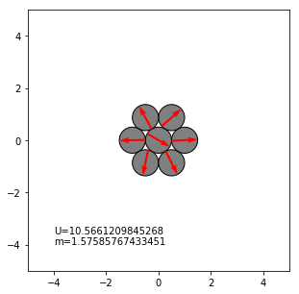

solution no.:35

('solution:', (-0.523598767391545, 4.73597317152330, 7.535827994401052, 1.836277194218975, 3.39971055410716, 3.98334505536123, 6.78319988568812))

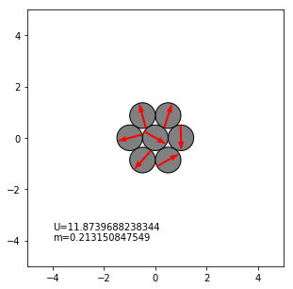

solution no.:36

('solution:', (1.570796362777776, 1.570796311830203, 1.46540592571770, 4.84896722195782, 1.570796288749543, 4.57581069567406, 1.676186749567257))

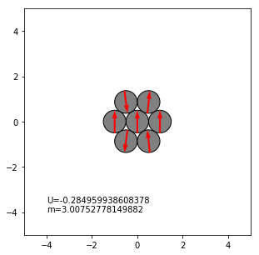

solution no.:37

('solution:', (2.09439510195496, 0.794469980614528, -2.303357886438711, 2.094395117318491, 6.49214808104775, 3.394320272171685, 5.23598770304999))

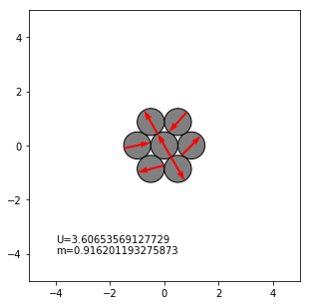

solution no.:38

('solution:', (-1.047196795018643, 6.14855416491927, 4.32342111202912, 1.376645662051200, 3.98694438335242, 6.48502929519085, 2.812144401101795))

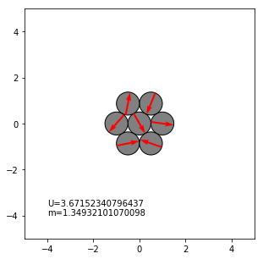

solution no.:39

('solution:', (-0.425186969017299, 6.32745523492196, -0.2063788507142654, 0.0435185503426690, 1.274212783002546, 2.15366660725420, 0.838092586807884))

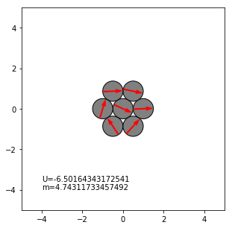

solution no.:40

('solution:', (1.04719757974730, 2.482631269469430, 1.04719756163766, -0.388236168890440, -0.3025157156306729, 4.18879016096733, 2.39691083117343))

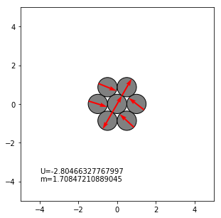

solution no.:41

('solution:', (0.523598701592261, 3.247296645165966, 4.08308624294596, 5.84653301140955, 2.19564784519824, 5.13473534604424, 1.48385004930817))

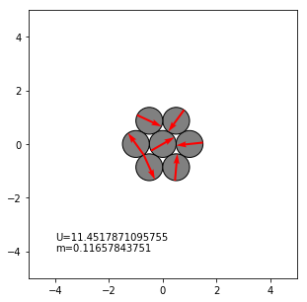

solution no.:42

('solution:', (0.523598643123868, 4.79752833412576, 1.073796504263589, 3.66519162903934, -0.0265986673059675, 2.532854350919762, 3.665191589230993))

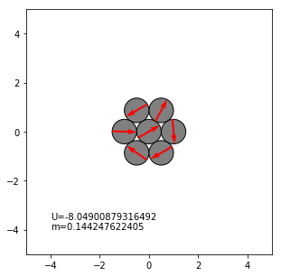

solution no.:43

('solution:', (1.145905934037454, 2.817386188270236, 4.33061699227834, 5.11128787350271, 1.768248795148864, 4.15088634209200, -0.03041749308710024))

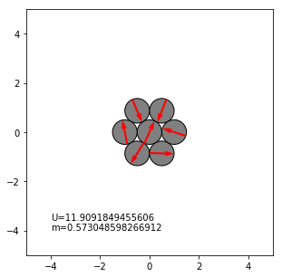

solution no.:44

('solution:', (1.570791556424003, 1.570793367835817, 2.214245313291007, 3.34352819295018, 4.71239071046696, 6.08125167404846, 0.927346634450046))

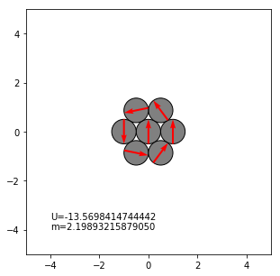

solution no.:45

('solution:', (0.523598764220060, 3.58245009269690, 3.74793277669311, 0.523598899341192, 3.582449477272026, 3.747933387262266, 0.523598717289972))

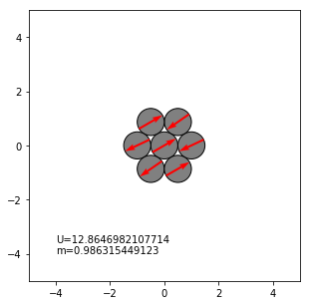

solution no.:46

('solution:', (1.57079565071237, 1.570797277175032, 4.07208483145347, -0.1282235138400402, 4.71238865649018, 3.26981637289740, 5.35269474402107))

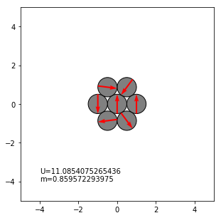

solution no.:47

('solution:', (1.047185375472269, 1.280586331557914, 2.220244342353899, 3.482771775423115, 4.894816587679744, 6.15733787379985, 7.09698436863931))

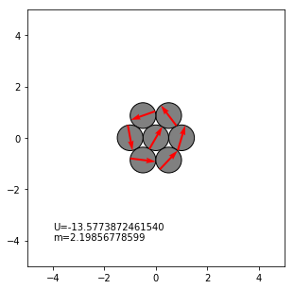

solution no.:48

('solution:', (2.811710090407678e-8, 6.28318530976397, 6.79556475041470, 5.770806023434249, 6.28318534903699, 6.79556472230377, 5.770805866488781))

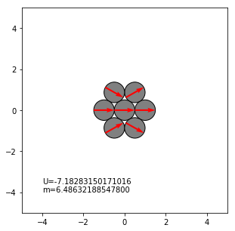

solution no.:49

('solution:', (1.365144975703834e-7, 3.141592685086667, 4.82615875547709, 4.54058729549974, 3.14159247925283, 1.742598227888476, 1.457026432375416))

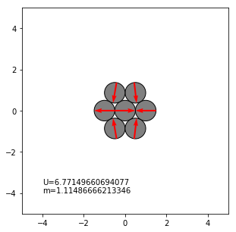

solution no.:50

('solution:', (-0.523599016130576, 0.848129856913827, 2.61799424410194, 4.38785811745537, 0.848129745769763, 2.617993914813174, 4.38785844666278))

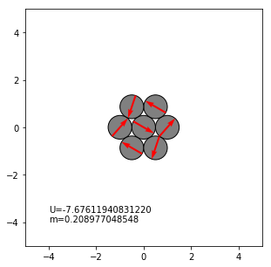

solution no.:51

('solution:', (-0.523598817973160, 3.856956715628889, 2.617993910437731, 1.37903090246287, 1.005101850009887, 2.61799391523605, 4.23088604780839))

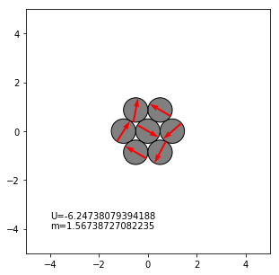

solution no.:52

('solution:', (1.047197580383157, -0.582290210221493, 4.188790308179970, 2.67668514757915, 5.70089524564575, 4.18879019358929, 2.67668528118367))

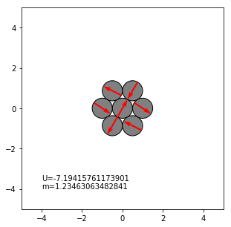

solution no.:53

('solution:', (1.538488167731536e-7, 6.28318488512540, 1.435494372624114, 4.84769086165019, -6.95164547064341e-8, 1.435494136497681, 4.84769072553344))

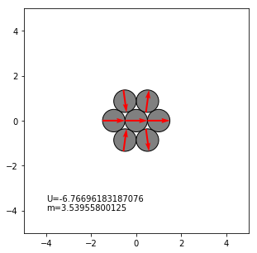

solution no.:54

('solution:', (3.91652322727786e-8, 3.141592633691135, 5.478307677156256, 2.082079416453679, 3.14159272078045, 4.20110570185294, 0.804877462113426))

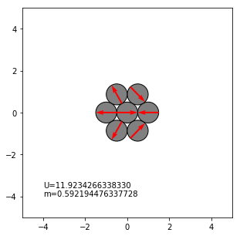

solution no.:55

('solution:', (-3.957904831604358e-8, 3.141592645768180, 4.83122438898982, 1.451960737208415, 3.141592673261395, 4.83122463164576, 1.451961037455270))

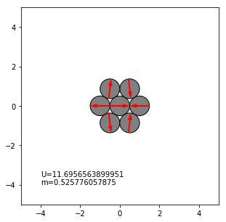

solution no.:56

('solution:', (0.920908556954616, 5.24480027408858, 4.43778076777420, 2.94090185053499, 5.01626201904889, 0.891952754284521, 10.39726956277679))

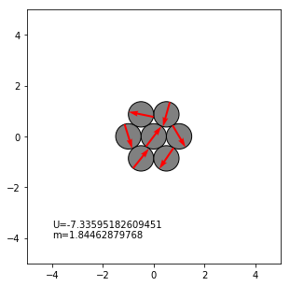

solution no.:57

('solution:', (0.1112911337041460, 0.1530822761907103, 2.35670085593294, 4.37228161492788, 2.907498787059608, 2.087305468052125, 3.237356628422520))

