Aim

Have the intention of achieving

I Love the Whole World

The World is Just Awesome

|  |  |
| --- | --- |
| (Dialogue)  Astronaut 1: It never gets old, huh?  Astronaut 2: Nope.  Astronaut 1: It kinda makes you want to...  Astronaut 2: Break into song?  Astronaut 1: Yep.  I love the mountains,  I love the clear blue skies  I love big bridges  I love when great whites fly  I love the whole world  And all its sights and sounds  Boom-de-ah-da, boom-de-ah-da  Boom-de-ah-da, boom-de-ah-da  I love the planet  I love real dirty things  I love to go fast  I love Egyptian kings  I love the whole world  And all its craziness  Boom-de-ah-da, boom-de-ah-da  Boom-de-ah-da, boom-de-ah-da  I love tornadoes  I love arachnids  I love hot magma  I love the giant squids  I love the whole world  It's such a brilliant place  Boom-de-ah-da, boom-de-ah-da,  Boom-de-ah-da, boom-de-ah-da (repeat until fade) [1] | (Astronauts still singing refrain from last commercial)  Astronaut 1: Man, I cannot get that song out of my head.  Astronaut 2: Totally, I’m going again.  (Melody begins, astronauts begin to sing)  Astronaut 2: I love the mountains,  Astronaut 1: I love the sun so bright.  I love crustaceans,  I love the stars at night.  I love the whole world,  So many things to see.  Boom-de-ah-da, boom-de-ah-da,  Boom-de-ah-da, boom-de-ah-da,  I love to catch fish,  I love the lemur eyes.  I love the future,  I love when humans fly.  I love the whole world,  No place I’d rather be.  Boom-de-ah-da, boom-de-ah-da,  Boom-de-ah-da, boom-de-ah-da,  (spoken) Still dirty, still loving it.  I love to blast off,  I love adrenaline,  I love the big bang,  I love where air is thin.  I love the whole world,  And being part of it.  Boom-de-ah-da, boom-de-ah-da,  Boom-de-ah-da, boom-de-ah-da (repeat until fade) [2] |

* Discovery Channel “I Love The Whole World”

# Problem Solving

Problem solving consists of using generic or ad hoc methods, in an orderly manner, for finding solutions to problems. The ability to understand what the goal of the problem is and what rules could be applied represent the key to solving the problem. Sometimes the problem requires some abstract thinking and coming up with a creative solution. [3]

|  |  |
| --- | --- |
|  |  |

Ways Of Problem Solving [4]

|  |  |
| --- | --- |
|  |  |

[Problem Solving Cartoons](http://buburuza.net/2013/06/problem-solving-cartoons/) [5]

## Barriers to Problem Solving

### Confirmation Bias

Confirmation bias is the tendency to search for, interpret, or recall information in a way that confirms one's beliefs or hypotheses. [6] [7] It goes against the scientific method, and is a type of systematic error of inductive reasoning. [8] It contributes to overconfidence in personal beliefs and can maintain or strengthen beliefs in the face of contrary evidence. [9] [10]

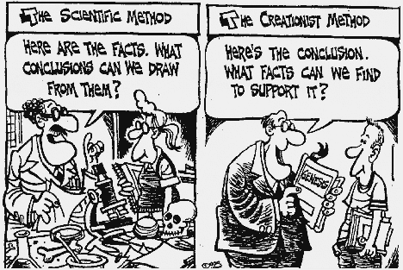

Left = Unbiased, Right = Confirmation Bias [11]

### Mental Set

Mental set describes one's inclination to attempt to solve problems in such a way that has proved successful in previous experiences. Such methods for finding a solution that have worked in the past may not be adequate or optimal for certain new but similar problems. It is often necessary for people to move beyond their mental sets in order to find solutions. [12]

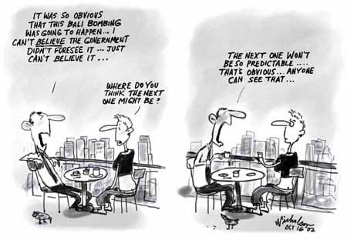

Nicholson Hindsight [11]

### Functional Fixedness

Functional fixedness hinders people in solving a problem due to their knowledge of an object's conventional function." It limits the ability for people to solve problems accurately by causing one to have a very narrow way of thinking. [13] Ex- A man sees a bug on the floor, but the only thing in his hand is a can of air freshener. If he starts looking around for something to kill the bug with instead of realizing that the can of air freshener could in fact be used, he is said to be experiencing functional fixedness. [3]

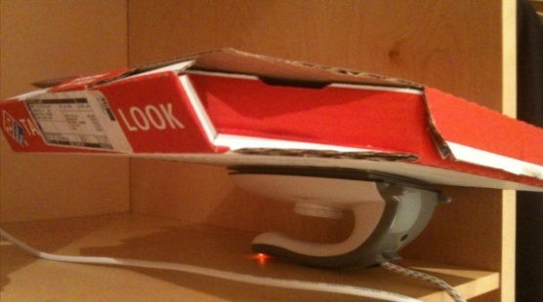

Jugaad Concept [11]

### Unnecessary Constraints

Unnecessary constraints are the boundaries placed subconsciously on the task at hand which prevents the problem from being solved. [14] Taking on the mindset of the rest of the group members, can also act as an unnecessary constraint while trying to solve problems. [15]

Ex- 9 dots, 3 vertical and 3 horizontal. Join all dots without lifting the pencil with no more than 4 lines. [3] Here, subjects assume that they must connect the dots without going outside the square, which inhibits them to think beyond the bound of dots. [16] Standardized procedures like this can often bring mentally invented constraints of this kind, [17] and researchers have found a 0% correct solution rate in the time allotted for the task to be completed. [18] It is from this phenomenon that the expression "think outside the box" is derived. [16]



9 Dot Problem [19]

### Irrelevant Information

Irrelevant information is information presented within a problem that is unrelated or unimportant to the specific problem. [14] It is often makes solving otherwise relatively simple problems much harder. [20] Ex- Fifteen percent of the people in Topeka have unlisted telephone numbers. You select 200 names at random from the Topeka phone book. How many of these people have unlisted phone numbers? [16] People see that there is information present and they immediately think that it needs to be used. This of course is not true. [3]

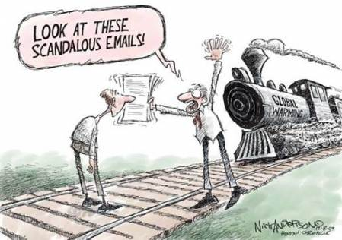

Irrelevant Information Distracts Us [21]

## Problem Solving Strategies

How to Solve It (1945) is a small volume by mathematician George Pólya describing methods of problem solving. [22] It suggests the following steps:

1. First, you have to understand the problem. [22]
2. After understanding, then make a plan. [22]
3. Carry out the plan. [22]
4. Look back on your work. How could it be better? [22]

How to Solve It [23]

|  |  |
| --- | --- |
| Abstraction | solving the problem in a model of the system before applying it |
| Analogy | using a solution that solves an analogous problem |
| Divide and conquer | breaking down a large, complex problem into smaller, solvable problems |
| Reduction | transforming the problem into another problem for which solutions exist |
| Research | employing existing ideas or adapting existing solutions to similar problems |
| Brainstorming | suggesting numerous ideas and combining them for an optimum solution |
| Lateral thinking | approaching solutions indirectly and creatively |
| Method of focal objects | synthesizing seemingly non-matching characteristics of different objects into something new |
| Hypothesis testing | assuming a possible explanation to the problem and trying to prove (or, in some contexts, disprove) the assumption |
| Proof | try to prove that the problem cannot be solved, the point where the proof fails will be the starting point for solving it |
| Means-ends analysis | choosing an action at each step to move closer to the goal |
| Morphological analysis | assessing the output and interactions of an entire system |
| Root cause analysis | identifying the cause of a problem |
| Trial-and-error | testing possible solutions until the right one is found |

Problem Solving Strategies [3]

# Problems

Everybody has problems. Everybody worries about it. But have you ever thought about every people in the world? Have you ever had noted what problems our world faces today? Have you ever asked people around you “what do you think is the biggest problem in the world today?” Well, if you do, you certainly are going to get a lot of different answers. [24]

We might be loaded with technology. But with the advancement in our lifestyle, we now have to face many issues. There are a whole lot of things that bothers a whole of population in the world today. Yes, we should think about solving the problems. But to solve a problem, we first need to identify and understand it. In order to make our earth a better place to live for our children and our children’s children, we need to know what problems our world faces and how we can solve them. [24]

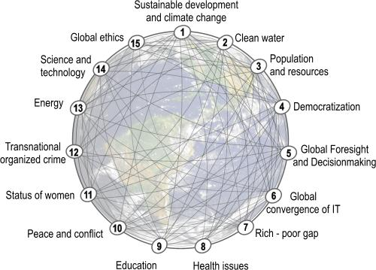

Global Challenges For Humanity [25]

## Hierarchy of Needs

Abraham Maslow proposed a theory of the hierarchy of needs in his 1943 paper "A Theory of Human Motivation" in Psychological Review, after studying the healthiest 1% of college student population. [26] [27] He used the terms "physiological", "safety", "belongingness" and "love", "esteem", "self-actualization", and "self-transcendence" to describe the pattern that human motivations generally move through. [28]

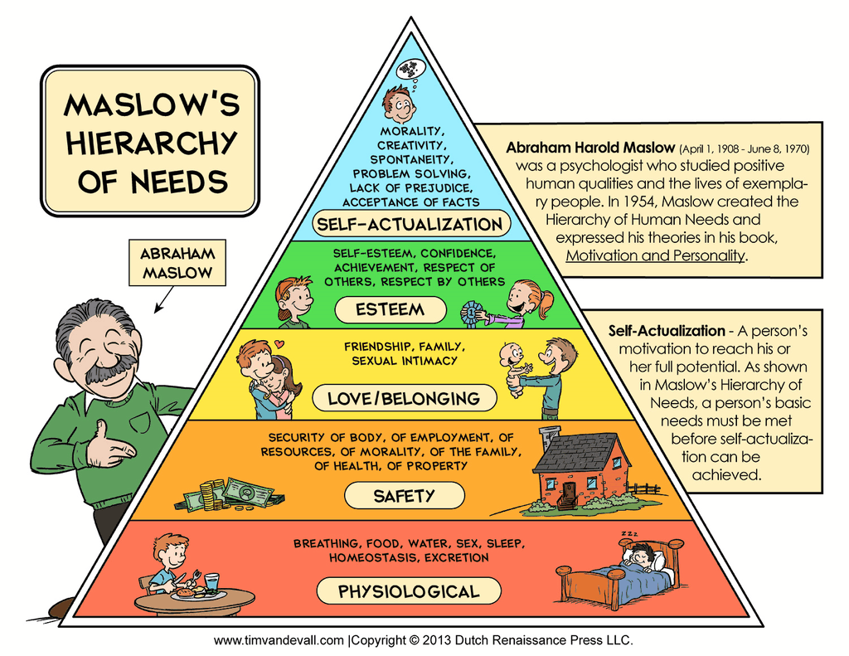

Maslow’s Hierarchy Of Needs [29]

## Physiological Needs

Physiological needs are the physical requirements for survival. If these are not met, body cannot function properly and will ultimately fail. Physiological needs are thought to be the most important; they should be met first. Air, water, and food are metabolic requirements for survival in all animals, including humans. Clothing and shelter provide necessary protection from the elements. [26]

### Air

WHO survey finds Delhi is the most polluted city in the world, with PM2.5 levels, the most dangerous particulates, at annual average of 153µg/m3 [30] (Beijing = 56 µg/m3, London = 16 µg/m3, [*list*](https://docs.google.com/spreadsheets/d/19Vk8zyEIvrtktV60rcqMmqXo_-1z7vFIIW6-AZJTZqw/edit?usp=sharing)*,* [*map*](http://www.theguardian.com/news/datablog/interactive/2014/may/08/exposure-air-pollution-city-map)*,* [*real-time*](http://aqicn.org/map/world/)) [31] [32]. This is 6 times the WHO’s recommended maximum, 12 times US standards, and more than twice the level considered safe by Indian authorities. [30] PM refers to small solid or liquid particles (PM2.5: ≤ 2.5µm in diameter) made up of different substances, including carbon, sulphur, nitrogen and metal compounds. These are linked with increased rates of chronic bronchitis, lung cancer and cardiovascular disease as they penetrate deep into the lungs and pass into the bloodstream. [31] [33] [34] [35] [36]

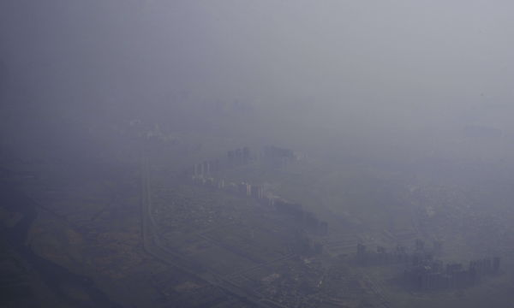

Smog covers buildings in the Indian capital, Delhi [37]

During the winter, when lower temperatures and fires intensify the pollution, concentrations of PM2.5, PM10 and other pollutants routinely spike much higher, reaching levels described by experts as “hazardous” for humans. One Indian study found the concentrations could be 50% higher than usually recorded if measured close to roads. The problem is compounded by construction and systematic burning of waste. [30] Outdoor air pollution in both cities and rural areas was estimated to cause 3.7 million premature deaths worldwide in 2012. [34]

In fact, Delhi’s air quality may be even worse. [30] The central pollution control board compared some India-made PM2.5 samplers with international ones a couple of years ago. A manufacturer of samplers candidly said: “There was a 100% difference in readings.” While some instruments leaked air from the sides, others evaluated a lower-than-stipulated volume of air. [38]

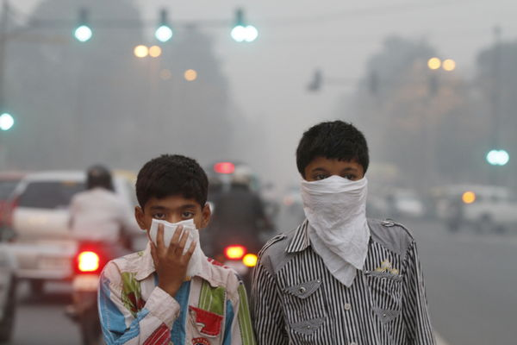

Children cover their faces as a precaution against air pollution in Delhi, India [39]

Users of these faulty instruments then fudge this flawed data. Since the early 1990s, industrial units have had to install air quality measuring units and send the data to the appropriate state pollution control boards. If emissions peak, the industrial unit may be shut down. So industries fabricate 90% of the data by changing the calibration of their machines, or by injecting clean air into the intakes or by placing them away from the plant and in a nearby wood or between trees. [38]

The problem is not restricted to the capital. 13 of the dirtiest 20 cities in the world are in India, the WHO said. Another survey – the Environmental Preference Index – ranked India 155 out of 178 countries for air quality last year. The local effects of the pollution are increasingly clear. The WHO has also found that India has the world’s highest rates of death from respiratory disease, with 159 per 100,000 in 2012, around 10 times that of Italy, 5 times that of the UK and twice that of China. [30] 99.5% of India's people are breathing in pollution levels above what the WHO deems as safe. The filthy air is cutting 660 million lives short by about 3 years, which comes to a staggering total of 2.1 billion years for the entire nation. [40]

In metal extraction industries, lead, arsenic and cadmium is released into the air, which then can travel for miles. Lead recycling, mostly from lead acid batteries, is also a culprit. In India, much of the energy to cook, heat and light houses come from burning coal, wood and animal dung. The smoke from these fires is one of the main causes of indoor air pollution. [33] Some 4.3 million premature deaths were attributable to household air pollution in 2012. [34]

Delhi has had some success combating pollution in the past. Following a 1998 court decision, the city converted its bus and rickshaws to compressed national gas, which had a major impact on pollution. But Delhi’s 8,000 buses are only a small fraction of total traffic. A new metro has made little impact, experts say, as most of its users previously travelled by buses, bicycles or on foot. Car users have remained reluctant to switch to public transport. [30]

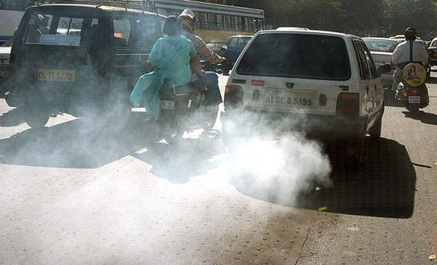

Vehicle exhaust smoke in New Delhi [41]

Between 1991 and 2011, the population of Delhi and its adjoining cities more than doubled from approximately 10 million to 22 million while the number of registered cars and motorbikes increased from 1.6 million in 1991 to around 8.5 million today. [30] [35]

Air pollution in India has become so severe that yields of crops are being cut by almost half, scientists have found. Researchers analyzed yields for wheat and rice alongside pollution data, and concluded significant decreases in yield could be attributed to two air pollutants, black carbon and ground level ozone. The finding has implications for global food security as India is a major rice exporter. [42]

Black carbon, which constitutes most of the PM2.5 that can lodge and fester in human lungs, is also blamed for up to 20% of global warming. [43] It is mostly caused by rural cook stoves, and ozone forms as a result of motor vehicle exhaust, industrial emissions, and chemical solvents reacting in the atmosphere in the presence of sunlight. Both are “short-lived climate pollutants” that exist locally in the atmosphere for weeks to months, with ozone damaging plants’ leaves and black carbon reducing the amount of sunlight they receive. [42]

Indian authorities have done little compared with their counterparts in China, where air pollution is one of the top items on the government’s agenda since a choking smog dubbed the “airpocalypse” engulfed key Chinese cities in January 2013. India is under pressure to disclose its plans to cut greenhouse gas emissions before UN talks from 30 November to 11 December in Paris. [30]

The Indian environment minister has promised to tackle this “better than the rest of the world has ever done” amid growing concern at the health impact on hundreds of millions of people living in the overcrowded cities. Delhi has so far baulked at committing itself to major cuts, arguing that it will not set itself targets that undermine efforts to end poverty. [30]

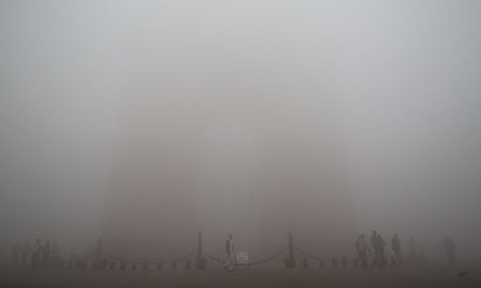

The iconic India Gate in Delhi, shrouded in smog, is barely visible [44]

### Water

More than half the rivers in India are polluted, and this has risen from 121 to 275 in the last five years, with increased levels of sewage a primary cause. [43] Indian cities produce nearly 40,000 million liters of sewage, 80% of which is untreated and flows directly into the rivers, polluting the main sources of drinking water. [45] Bacterial contamination level in the Ganga has exceeded the maximum permissible limit at many locations. [46] Waterways have also suffered badly in recent years, with vast quantities of municipal and industrial waste discharged into them every day. [43]

The untreated waste dumped into rivers seeps into groundwater, thereby creating a ticking health bomb in India. Weak or non-existent enforcement of environmental laws, rapid urban development and a lack of awareness about the dangers of sewage are all blamed for water pollution. Only 160 out of nearly 8,000 towns had both sewerage systems and a sewage treatment plant. Thousands of small factories dump untreated sewage into rivers and toxic waste is being mixed with fresh water. Almost the entire country has nitrate levels higher than the prescribed levels -- a result of sewage leaching into groundwater supplies. [45]

Water is the biggest crisis facing India in terms of spread and severity, affecting one in every three persons. The rapidly rising population and changing lifestyles have increased the need for fresh water. Intense competitions among users in agriculture, industry and domestic sector is pushing the ground water table deeper. Even in Chennai, Bangalore, Shimla and Delhi, water is being rationed and India's food security is under threat. It is rationed twice a week in Bangalore, for 30 minutes a day in Bhopal; 250 tankers make 2,250 trips to quench Chennai's thirst. Mumbai routinely lives through water cuts from January to June, when some areas get water once in 3 days in Hyderabad. [47]

Despite the installation of more than 3.5 million hand pumps and over 116 thousand piped water supply schemes, in many parts of the country, the people face water scarcity almost every year. In many rural areas, women still have to walk a distance of about 2.5 km to reach the source of water, both in the morning and evening. Women have to make at least three trips at 5 am, 11 am and 5 pm, with a total distance of 9-10 km or more, and time spending of about 6-9 hours. Each pot of water they bring is only 10-15 liters. On average, a rural woman walks more than 14000 km/year just to fetch water. This time lost in fetching water is more costly than the often-normal rates charged in urban areas. This for 150 million women days each year, translates into a whopping 10 billion rupees per year. [47]

In Kottayam district at some places, the water scarcity is so acute that people hesitate to offer a glass of water to the visitor, which hitherto was a common custom. In the upper Kuttanadu area of the district during summer people collect water from a distance of 3-4 km. Water supply from public taps is erratic and very often even after standing for an hour in the queue; people are not able to get a bucket of water. [47]

In Orissa drinking water is being privatized. The government first insisted on the formation of water associations and conveniently passed the responsibilities on to these associations. When this proved inefficient, water distribution rights were given away to private contractors. Titlagarh, the hottest town in India (highest = 52°C), has acute water problem. In the month of May and June the rate of water increase three times, from ₹ 2 per dabba to ₹ 8 per dabba (container). This is the picture of urban areas, but in rural areas the problem is worse, where the tube wells all are becoming dry but people have no money to buy water. Due to the water problem some villagers are migrating to other places. [47]

Water in the Jaunsar area of district Tehri Garhwalis mostly acidic in nature. The water problem in Chi tar and Gangoa villages is very severe, where men and women carry water on mules from 8-10 Km to the village. Because of the poor water quality, most of the villagers in the regions are suffering from many diseases related to skin and teeth. The grim situation of water is Bundelkhand may be best illustrated by one saying which roughly translates as "let the husband die but the earthen pot of water should not be broken". [47]

Punjab; the name stands for abundance of water, but the present situation of water resources in the state is highly critical. The ground water availability is drastically hampered. Near Talwandi Sabo, for some villages, the source for drinking water is about 8 km away. Near Jajjal due to contaminated water, women are suffering from a number of diseases including cancer. There have been several deaths attributed to polluted water. [47]

Karnataka is facing the worst kind of water crisis. In Bangalore, only 35% of the city gets water on daily basis, the rest on alternative days. In Hosapalya locality women get severe joint pain in their shoulders, hips and knees due to carrying water pits from water sources outside their colony. In Peenya industrial area, many street fights occur among the women over water. Social conflict and tension is high due to water crisis. [47]

Modi has made cleaning the Ganges, the major river that is holy to Hindus, a key policy goal. There has been little progress so far on a project which has defeated successive administrations, despite substantial funding. [43]

### Land

### Clothing

### Shelter

Poverty – Unemployment – Wealth Inequality – Food – Drinking Water – Toilet

Climate Change – Global Warming – Environmental Pollution – Littering

Bribery – Corruption (need stricter rules – fines) – Dreaded Socialism (won’t work)

Blindness – Disease – Human health –

India is the home of largest number of blind people

Wealth Inequality (in US)

The fact that the largest share of consumer court cases in our country is related to Real Estate developers tells us why!

My Dad, JFK, Was for Free Trade. Democrats Today Should Be Too.

<https://en.wikipedia.org/wiki/Water_pollution_in_India>

<http://www.yourarticlelibrary.com/water-pollution/5-major-causes-of-water-pollution-in-india/19764/>

<http://www.commonfloor.com/guide/what-are-the-major-causes-of-water-pollution-in-india-27741.html>

<https://projectsmileindia.wordpress.com/2010/07/01/effects-of-water-pollution-solutions/>

<http://www.indiaenvironmentportal.org.in/category/28/thesaurus/water-pollution/>

<http://www.azadindia.org/social-issues/water-problem-in-india.html>

<http://thewaterproject.org/water-in-crisis-india>

<https://en.wikipedia.org/wiki/Water_supply_and_sanitation_in_India>

<http://www.oneindia.com/feature/no-drinking-water-india-2040-how-will-government-tackle-1492796.html>

<http://www.nbr.org/research/activity.aspx?id=356>

<http://qz.com/353707/india-is-already-facing-a-water-crisis-and-it-is-only-going-to-get-worse/>

<http://www.mapsofindia.com/my-india/society/water-the-next-looming-crisis>

WHO: <http://www.who.int/mediacentre/factsheets/fs313/en/>

<http://www.mnn.com/earth-matters/wilderness-resources/photos/the-10-worst-pollution-problems-in-the-world/bad-form>

<https://en.wikipedia.org/wiki/Air_pollution>

<http://www.nytimes.com/2015/02/15/world/asia/delhi-wakes-up-to-an-air-pollution-problem-it-cannot-ignore.html?_r=0>

<http://www.conserve-energy-future.com/top-10-worst-toxic-pollution-problems.php>

<http://wwf.panda.org/who_we_are/wwf_offices/china/environmental_problems_china/>

<http://www.vox.com/2014/9/15/6150713/the-deadliest-environmental-problem-today-is-indoor-air-pollution>

<http://www.sustainablebabysteps.com/kinds-of-environmental-pollution.html>

<https://en.wikipedia.org/wiki/Pollution>

<http://www.millennium-project.org/millennium/challenges.html>

<http://www.globalissues.org/article/806/action-cheaper-than-inaction>

<http://www.factofun.com/top-10-problems-world-today/>

<http://www.businessinsider.com/the-10-biggest-problems-in-the-world-according-to-the-eu-2011-10?IR=T#and-1-poverty-hunger-and-lack-of-drinking-water-10>

<http://www.conserve-energy-future.com/15-current-environmental-problems.php>

<http://www.usatoday.com/story/news/world/2014/01/16/wef-biggest-risks-facing-world-2014/4505691/>

<http://www.arlingtoninstitute.org/wbp/portal/home>

<http://www.toptenz.net/top-10-issues-facing-our-youth-today.php>

<http://www.quora.com/What-are-the-big-problems-that-the-world-is-facing-today-and-why>

<https://www.youtube.com/watch?v=QPKKQnijnsM&feature=youtu.be>

<http://www.zmescience.com/medicine/seeds-purify-water-kill-bacteria-0423423/>