**Flood Prediction and Alert System**

**Introduction**

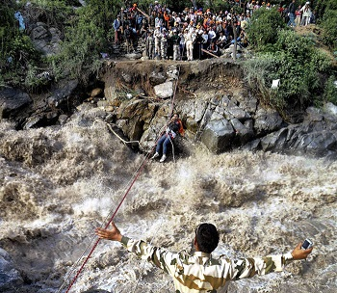In June 2013, a multi-day cloudburst centered on Uttarakhand, and caused devastating floods and landslides in India as the worst natural disaster since the 2004 Indian Ocean tsunami. According to the figures provided by the Uttarakhand government, more than 5,700 people were “presumed dead”, which included 934 local residents. Destruction of bridges and roads left about 100,000 pilgrims and tourists trapped in the valleys, leading to three of the four Hindu Chota Char Dham pilgrimage sites. The Indian Air Force, the Indian Army, and paramilitary troops evacuated more than 110,000 people from the flood ravaged area [1 - Wikipedia].

Fig 1: Soldiers rescuing people in Uttarakhand

Floods are the most common form of natural disaster in India, and cause huge loss of life, and property. Table 1, shown below shows the damage caused by floods in India [2 - NIDM]. Central Water Commission (CWC), India has installed around 175 flood forecasting stations in India, with only 3 forecasting sites in the Uttarakhand state. Due to this insufficiency of flood forecasting stations, CWC was only able to forecast a medium-level flood at Rishikesh and Haridwar on June 18, 2013. This led to a huge loss of life, and expenditure of around ₹1100 crore.

|  |  |  |
| --- | --- | --- |
| Category | Average | Maximum (Year) |
| Area Affected (Million Hectare) | 7.55 | 17.50 (1978) |
| Crop Area Affected (Million Hectare) | 3.54 | 10.15 (1988) |
| Population Affected (crore) | 3.286 | 7.045 (1978) |
| Human Lives Lost (Nos.) | 1,589 | 11,316 (1977) |
| Cattle Lost (Nos.) | 94,839 | 6,18,248 (1979) |
| Houses Damaged (Nos.) | 12,17,918 | 35,07,542 (1978) |
| Value of damage to crops (crore) | 710.63 | 4246.62 (2000) |
| Value of damage to house (crore) | 270.59 | 1307.89 (1995) |
| Value of damage to public utilities (crore) | 820.75 | 5604.46 (2001) |
| Value of damage to crops, houses & public utilities (crore) | 1805.18 | 8864.54 (2000) |

Table 1: Flood damage in India during 1953 to 2005

**Literature Review**

* Xiang Yang Li, K. W. Chau, Chun Tian Cheng, Y. S. Li. A Web-based flood forecasting system for Shuangpai region.Advances in Engineering Software 37 (2006), 146-158.
* Bartosz Balis, Marek Kasztelnik, Marian Bubak, Tomasz Bartynski, Tomasz Gubala, Piotr Nowakowski, Jeroen Broekhuijsen. The UrbanFlood Common Information Space for Early Warning Systems. Internaltional Conference on Computational Science, ICCS 2011.
* Ibrahim Demir, Witold F. Krajewski. Towards an Integrated Flood Information System: Centralized data access, analysis, and visualization. Environmental Modeling & Software 50 (2013), 77-84.
* V.V. Krzhizhanovskaya, G.S. Shirshov, N.B. Melnikova, R.G. Belleman, F.I. Rusadi, B.J. Broekhuijsen, B.P. Gouldby, J. Lhomme, B. Balis, M. Bubak, A.L. Pyayt, I.I. Mokhov, A.V. Ozhigin, B. Lang, R.J. Meijer. Flood early warning system: design, implementation and computational modules. International Conference on Computational Science, ICCS 2011.
* W. Al-Sabhan, M. Mulligan, G.A. Blackburn. A real-time hydrological model for flood prediction using GIS and the WWW. Computers, Environment and Urban Systems 27 (2003), 9-32.
* Design and FPGA Prototyping of a Flood Prediction System. Sandeep Gandla, Waleed K. Al-Assadi, Sahra Sedigh and Raghu A. R. Rao.

**Scope of Project**

The aim of this project is to design and implement a Web-based Flood Monitoring System for the Mahanadi river basin. This includes the design of low-power, cost-effective sensor-devices, internet gateways, application software, web server software, and river data access platform.

**Milestones**

|  |  |  |
| --- | --- | --- |
| S. no. | Objective | Status |
| 1 | Send sensor data from device to mobile using SMS, and access internet | To-do |
| 2 | Develop sensor-device / gateway standard library | Ongoing |
| 3 | Create a working sensor-device / gateway test setup and program | To-do |
| 4 | Design sensor-device / gateway PCB and test its operation | To-do |
| 5 | Upgrade devices for energy-efficiency and cost reduction | To-do |
| 6 | Develop application server software for managing sensor devices | Ongoing |
| 7 | Develop web server software for user interface | To-do |
| 8 | Develop river data access platform for C/C++, C#, Java, MATLAB | To-do |
| 9 | Full system test in lab-environment | To-do |
| 10 | Field test and deploy the new system | To-do |

Table 2: Roadmap of the project

**Overall Concept**

As per the project plan, multiple sensor-devices will be deployed throughout the length of the river, and its tributaries. These sensor devices shall be monitoring factors such as, water level, flow-rate, and rainfall. Each site would have at-least one internet/SMS gateway device, which would allow these sensor-devices to connect to an application server and save their data on it. These sensors will transmit data to the server only when a sufficient change in the monitored parameter is detected, thus allowing them to save energy, during non-flood periods. Due to the presence of multiple sensor-devices at each site, it will be possible to intelligently detect faulty data and report a faulty sensor-device to the server.

Shown in Fig 2, is an example map of application of the system on the Mahanadi River. Here, the brown dots represent water level and flow-rate sensor-devices, blue dots represent rain-gauge sensor-devices, and black dots represent internet/SMS gateways.

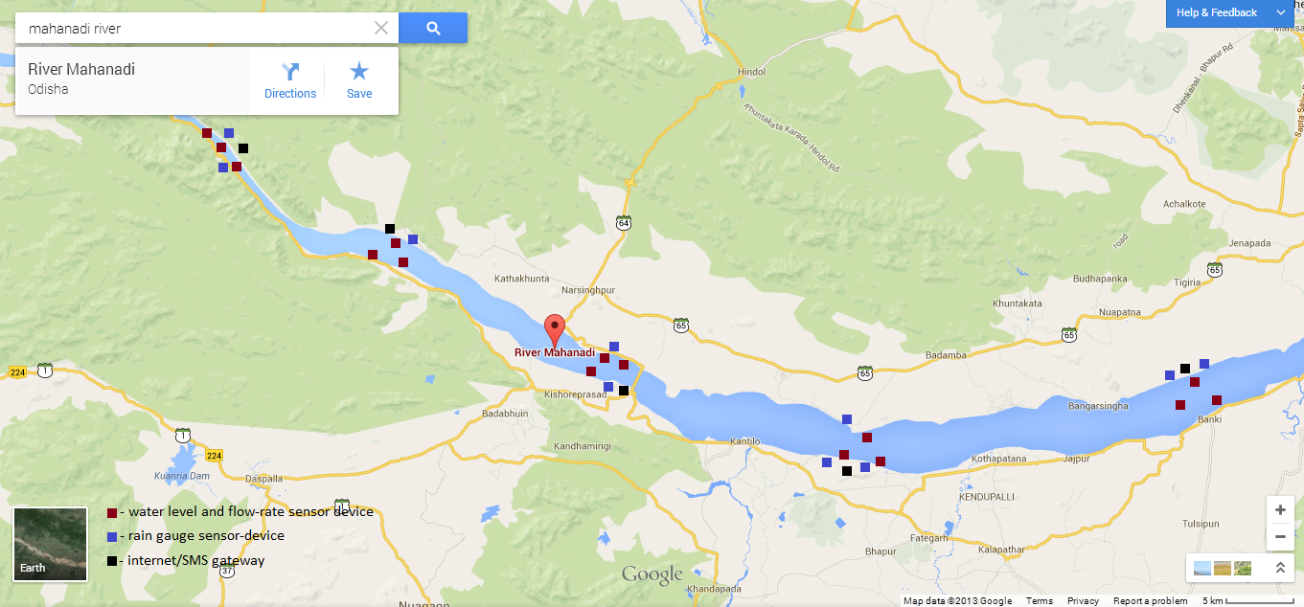

**System structure**

Each sensor-device shall have one or multiple sensors; signal conditioning block , for allowing sensor data to be read by an MCU; an MCU for data processing, storage and intelligent communication control; a USB port for local firmware upgrade; a low-cost 2.4 GHZ wireless communication unit, for wireless communication with other sensor-devices and internet/SMS gateways; a power control unit, for managing power generation, storage and usage; a power generating device, such as, a wind/water turbine, or a solar panel; and a battery for energy storage.

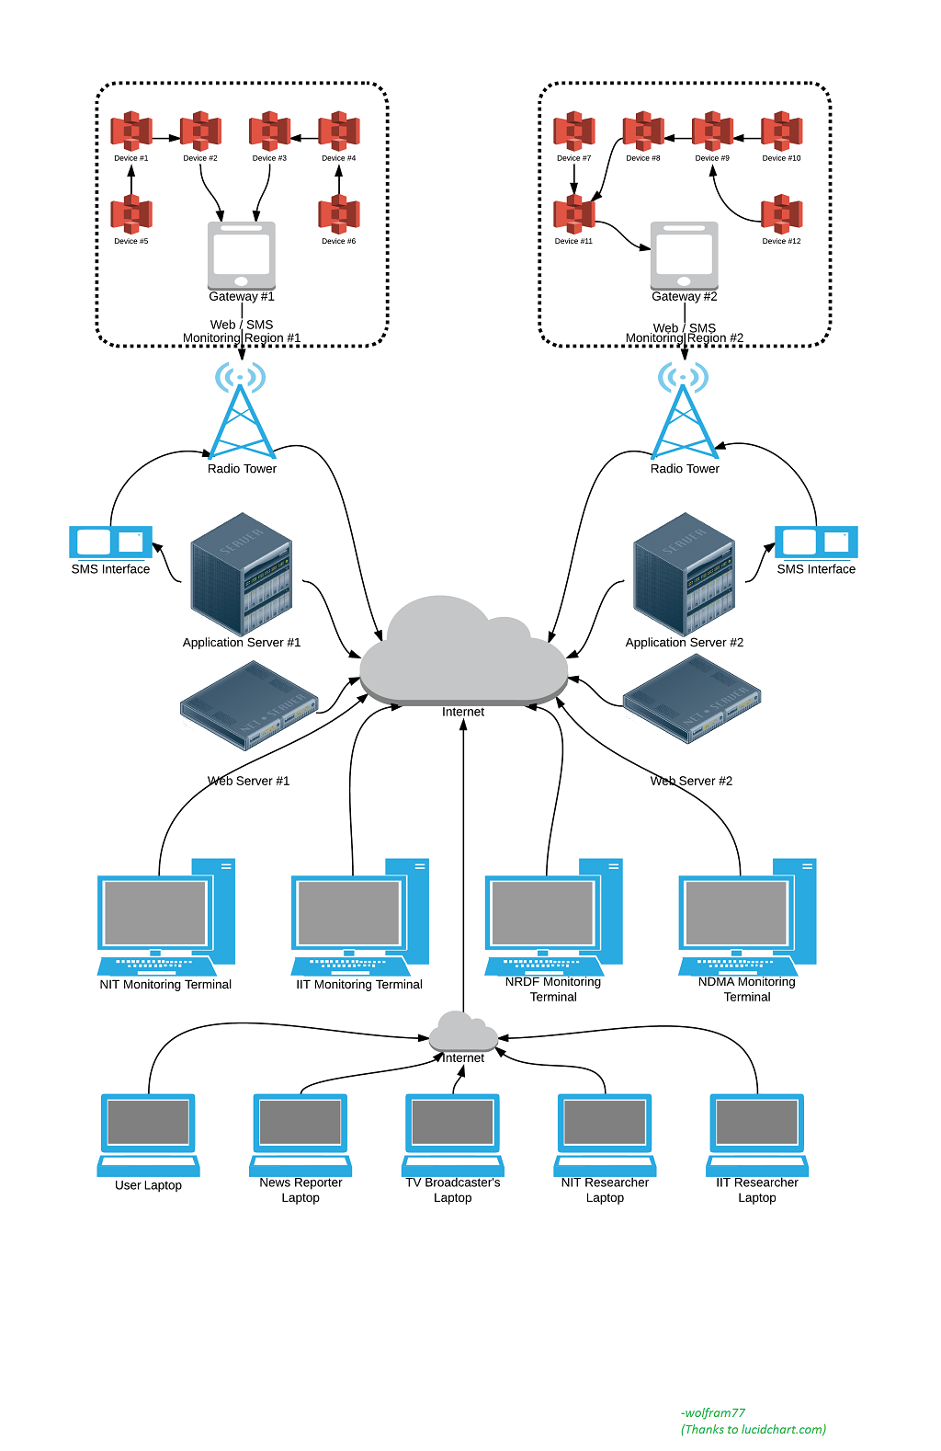

A gateway device shall have all of the parts, as a sensor device, but additionally has a module, such as, Ethernet, WLAN, or GSM/GPRS module for connecting to the internet, which allows it to act as a gateway device for the sensor-devices in its region.

Data collected by sensor-devices, is sent to an application server using an Application Layer Protocol. The Application server tracks data and status collected from each sensor, and supports functions such as sensor-to-device grouping, sensor-to-sensor grouping, device-to-device-to-gateway grouping, sensor location tracking, and routing lists. It shall provide data to a user as per request, i.e., for a given time and location range / group, which could be used for flood prediction, or generating a new data from available data.

A Web server shall be designed to provide an easy way for users to access the data present in application server, and get visual representations of it.

A data access platform shall be designed, which would be a collection of libraries, to allow programs written in various languages to access the application server.

**System Model**

We are attempting to model the working of our system as an entity-oriented system, where all each individual “logical” sensor is an entity. Each entity is of a specific type, and thus has a specific set of associated properties and performable operations. This is similar to the object-oriented model used in programming where, we work with a set of objects, each belonging to a specific class. The associated properties of an entity are similar to the data members of an object. Similarly, the member functions of an object relate to the performable operations associated with an entity.