No Primitives

- Wrap all primitive values (number, string, ...)
- No primitive values as arguments
- Challenge: max. 2 attributes per class
- Exceptions:
  - constructors may take primitive arguments
  - local variables

Example
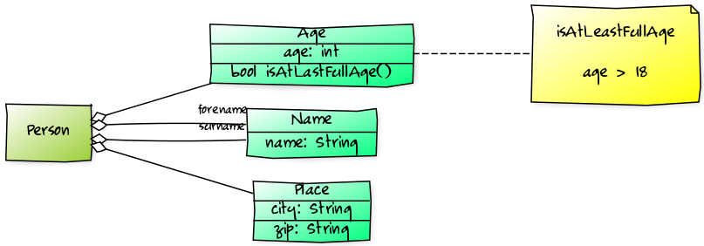
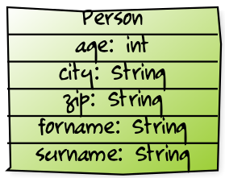

Advantages
- Easier to change internals (e.g. type of zip)
- Easier to reuse
- SRP: More small specialized classes (e.g.. isAtLeastFullAge on Age instead Person)
class Person {
constructor(age, forename, surname) {
this.age = age;
this.forename = forename;
this.surname = surname;
}
}
class Age {
constructor(age) { this.age = age; }
isAtLeastFullAge() {
return this.age > 18;
}
}
class Name {
construct(name) {
this.name = name;
}
}
let someone = new Person(oop
new Age(35),
new Name('John'),
new Name('Smith')
);

