CPC 223 B – Web Application and Development

*(Activity number)*

**TASK CONTRIBUTION**

**Subject and Section: WebDev**

**Leader: Angelo V. Trucilla**

**Members: (Alphabetically arranged by Surname)  
Date: May 26,2023**

**Rodrigo Fajardo Jr.  
Warren Naguiat  
Ronnie Tapnio   
Allen Tubig  
Jomari Vestil  
Ashley Jade Yap  
Abigail Yumul**

1. **Task of each members of the group: (Bullet Form)**

Fajardo, Dri Y. : (Give points in scale of 1-10) **10pts**

* Html text

Naguiat, Warren V.: (Give points in scale of 1-10) **10pts**

* Trending Page HtML
* Backgrounding

Tapnio, Ronnie M.: (Give points in scale of 1-10) **10pts**

* Css Color
* Trending

Tubig, Allen G.: (Give points in scale of 1-10) **10pts**

* Text

Vestil, Jomari S.: (Give points in scale of 1-10) **10pts**

* Suggesting event
* Collecting picture

Yap, Ashley Jade M.: (Give points in scale of 1-10) **10pts**

* Background pages
* Event Gif

Yumul, Abigail E.: (Give points in scale of 1-10) **10pts**

* Editing picture
* Collecting picture

1. **Screenshots of Meeting, Discussion, Tasking (via Message or Call), Brainstorming etc.**

Caption1:

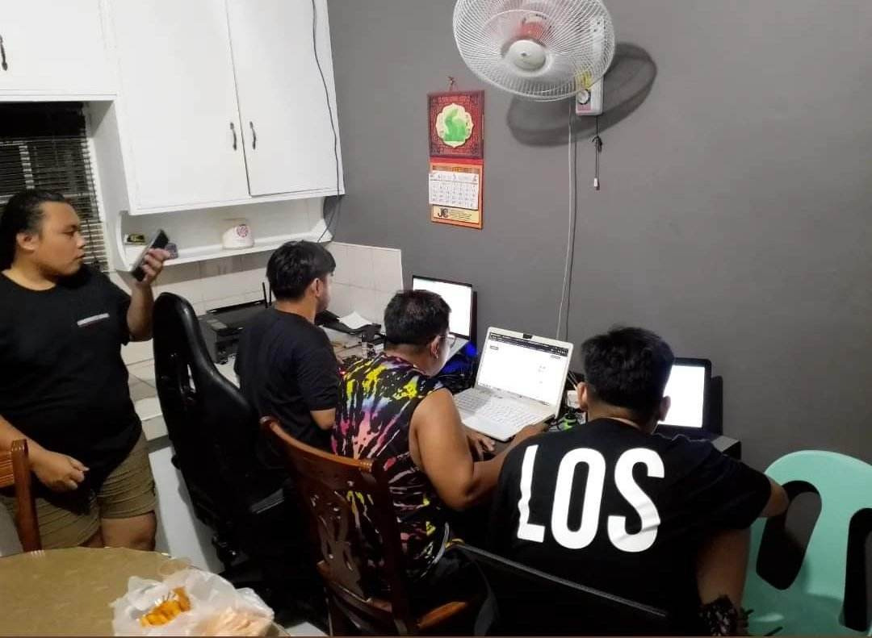

SCORE: _____________