**Matthew Marsh**

**CS340**

**December 12th, 2024**

**Project 2 README**

**About the Project**

**The Grazioso Salvare Canine Rescue Training Dashboard is a project developed by Global Rain to assist Grazioso Salvare, an innovative rescue-animal training company. One of the goals that they wish to achieve is to identify and categorize dogs capable of search-and-rescue training.**

**This project takes the data from 5 different non-profit animal shelters in the Austin, Texas region. This will help Grazioso Salvare to efficiently identify potential candidates for their training programs. Some of the features that this program offers are the ability to filter dogs based on their age, breed, color, name, and other characteristics that may show that the animal is suitable for the rescues in which they are searching, such as water rescue, mountain rescue, and disaster recovery.**

**Motivation**

**This project’s goal was to create a program that would address the critical need to find dogs that are suitable for search-and-rescue training. This program was created to help improve the effectiveness and impact of Grazioso Salvare’s rescue training programs.**

**The goal is to create a program that is open sourced to allow collaboration and to aid in finding the animals needed for the rescue animal training community. Our hope is that this program can also help other organizations to adopt this software and adapt it to suit their own needs that they have, which will help to enhance the impact of canine rescue efforts around the globe.**

**Getting Started**

**To get a local copy, follow these simple steps (note that these are examples):**

* **Open a command prompt**
* **Uploaded the new csv file with the coordinates added and replaced the old file.**

* **Ensure that the MongoDB shell is active.**

* Add a user to ensure that the user authentication is linked to the database and the collection.

* Run the ProjectTwoDashboard ipymb file on Jupyter Notebook
* Open <http://127.0.0.1:13622/>

**Usage and Testing**

Some of the tasks the dashboard can accomplish are as follows:

* Display a pie chart or bar graph with the breed of dog and how many there are of that breed.
* Sort and filter the data from any column.
* Have a map that displays the location of the animals.

**Screenshot:**

The initial startup with all animals shown.

This shows all Water Rescue Animals with the pie chart and the location map:

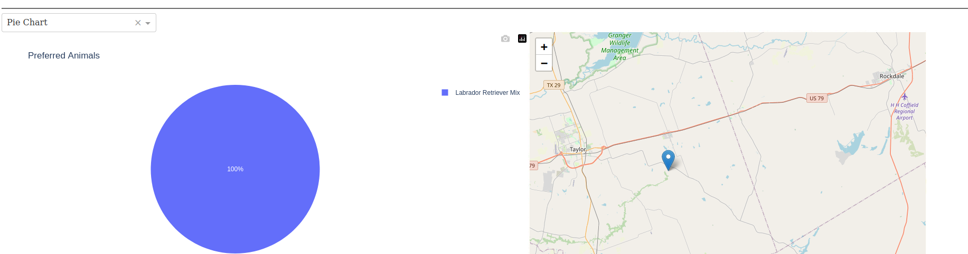

This shows Mountain or Wilderness Rescue and bar graph chart and the location map:

This shows all Disaster or Individual Tracking Rescue with the pie chart and the location map:

**Challenges**

The challenging part for me was figuring out how to run it on the network as I kept getting error messages about the CRUD file not being found. I finally emailed the professor and got the help I needed to continue with the schoolwork and complete everything that I needed to do. I enjoyed working on this project, but the constant error messages were very frustrating and made it difficult to enjoy coding. I won’t let it stop me though, as I enjoy doing the work.