|  |  |  |
| --- | --- | --- |
|  | **Rochester Institute of Technology**  **Golisano College of Computing and Information Sciences**  **School of Interactive Games and Media**  **2145 Golisano Hall – (585) 475-7680** |  |

**Data Structures & Algorithms for Games & Simulation II**

**IGME 309**

**E05: Transformations**

You have starting code through ReEngine, you may use your own solution if you want to, but the translation of starting code is entirely your responsibility. Startup code is available at: <https://github.com/labigm/ReEngineApp_2015s> under the **E05_Transformations** project. It will generate this:

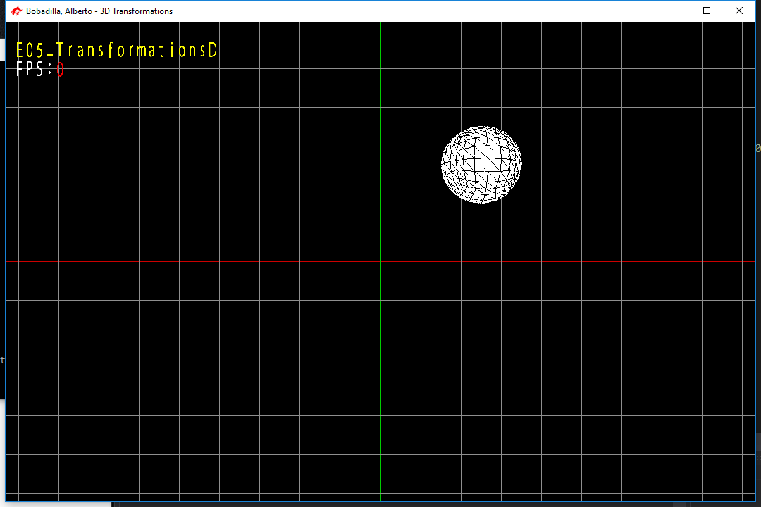

The goal of this in-class exercise is to get practice generating shapes and performing translations on them under a common coordinate system.

Using the provided code replicate the image show below to the best of your abilities:

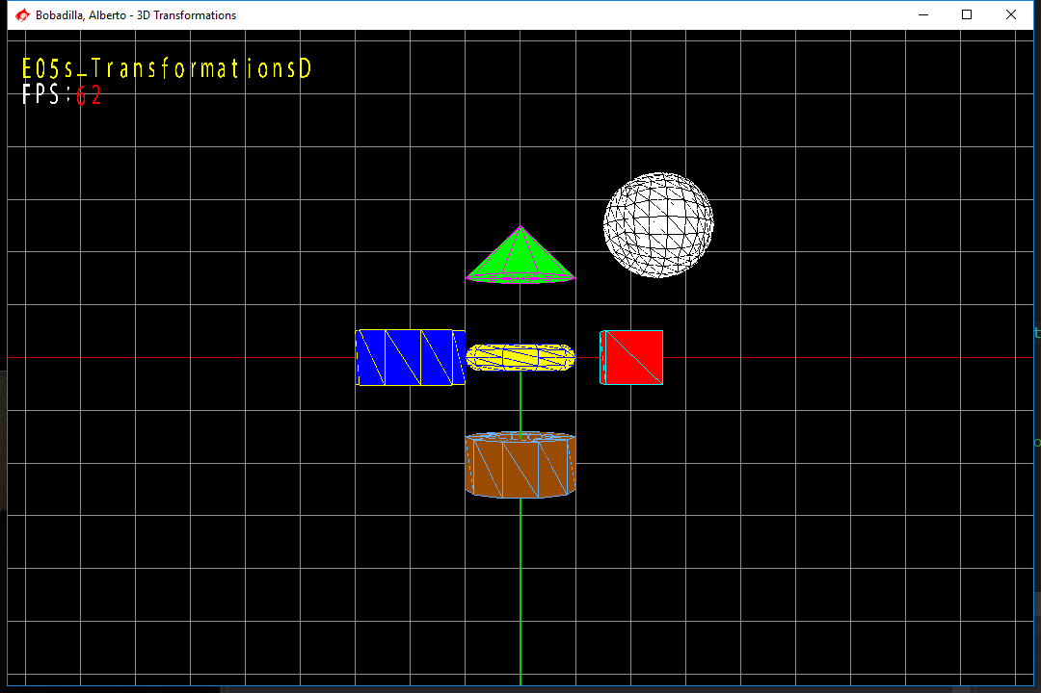

All shapes has a radius of 0.5f and are 0.5f units per side, you can use other colors if you want.

The following are some values for the PrimitiveClass to call methods with:

GenerateCone(0.5f, 0.5f, 10, REGREEN);

GenerateCylinder(0.5f, 0.5f, 10, REBLUE);

GenerateTube(0.5f, 0.25f, 0.5f, 10, REBROWN);

GenerateSphere(0.5f, 5, REWHITE);

GenerateTorus(0.5f, 0.25f, 10, 10, REYELLOW);

Take in account the following:

* You should use said methods for each object appropriately.
* The positions are about one unit away from the center in each case (except for the sphere).
* The only file you need to modify is the AppClass.cpp.
* The transformations should be assigned to the proper matrices. Which should be added to the renderer.

Show this to the professor or TA and submit to the dropbox labeled E05 Translations.

Remember to delete the Z_Delete file, the .SDF folder and the projects you are not using for this solution.